PROJECT DOCUMENTATION

TITLE: | AIRLINES DATA ANALYSIS
NAME: | JAWEED.A
COURSE: | DA/DS, Offline
BATCH: | JUNE 2025

TABLE OF CONTENT

1. | Introduction
2. | Aim
3. | Business Problem / Problem Statement
4. | Project Workflow
5. | Data Understanding
6. | Data Cleaning  - Missing Values Imputation  - Outlier Treatment
7. | - OBTAINING DERIVED METRICS
8. | Filtering Data for Analysis
9. | Statistical Analysis  Descriptive analysis  Test statistics and hypothesis testing
10. | Exploratory Data Analysis (EDA) - Univariate Analysis
11. | Bivariate Analysis
12. | Multivariate Analysis
13. | Overall Insights from Analysis
14. | Conclusion

- INTRODUCTION
The airline industry generates massive amounts of data related to ticket prices, flight schedules, airlines, travel classes, and passenger booking behavior. Analyzing this data provides valuable insights into pricing strategies, travel trends, and customer preferences. This project applies Exploratory Data Analysis (EDA) techniques on an airline dataset to uncover meaningful patterns. The dataset includes attributes such as airline names, source, destination, flight duration, stops, days left before departure, travel class, and ticket price. By applying data cleaning, visualization, and statistical methods, this analysis aims to identify the factors influencing airfare and provide insights that can help in decision-making for both airlines and travelers.

- AIM OF THE PROJECT
The primary aim of this project is to analyze the airline dataset to identify the factors that significantly influence flight ticket prices. By performing detailed data cleaning, descriptive statistics, and exploratory data analysis, the project seeks to uncover trends and patterns in airfare variation across different airlines, classes (Economy vs Business), number of stops, duration, and booking window (days left before departure). Additionally, statistical hypothesis testing is used to validate assumptions about pricing behavior. The ultimate goal is to provide meaningful insights that can support pricing optimization, improve customer decision-making, and contribute to better airline business strategies.

- PROBLEM STATEMENT
Airfare pricing is one of the most dynamic and complex aspects of the airline industry. Ticket prices fluctuate based on multiple factors such as airline brand, class of travel, flight duration, number of stops, and the number of days left before departure. This variability often makes it difficult for customers to make cost-effective booking decisions, while airlines face challenges in optimizing their revenue management strategies.
The business problem addressed in this project is to understand the key determinants of airline ticket prices using data analysis techniques. Identifying the impact of variables such as travel class, booking window, and flight duration on price will provide insights into fare trends and patterns. These findings can help passengers plan their travel better and support airlines in designing competitive pricing strategies. Thus, solving this problem contributes to both customer satisfaction and business growth in a highly competitive airline market.
4.PROJECT WORKFLOW

The workflow of this project follows a structured data analysis approach to ensure accurate insights and meaningful conclusions. The steps are as follows:
1. Data Collection – The dataset containing airline ticket details such as airline, source, destination, duration, stops, class, days left, and price was obtained in CSV/Excel format.
2. Data Understanding – Basic exploration was performed to check dataset structure, data types, and overall size, followed by summary statistics to understand distributions.
3. Data Cleaning – Missing values were imputed, outliers were analyzed, and inconsistent or duplicate entries were handled to improve data quality.
4. Derived Metrics – New variables such as price categories (low, medium, high) or duration ranges were created for deeper insights.
5. Statistical Analysis – Descriptive statistics and hypothesis testing (t-test, z-test) were applied to validate assumptions.
6. Exploratory Data Analysis (EDA) – Univariate, bivariate, and multivariate analysis was conducted using visualizations.
7. Insights & Conclusion – Key findings were summarized with actionable business implications.

- DATA UNDERSTANDING
The dataset used in this project contains detailed information on flight ticket bookings, with attributes that influence airfare. It is structured in tabular format with rows representing individual flight bookings and columns representing different features.
Key Variables in the dataset:
- Airline – The name of the airline operating the flight.
- Source & Destination – The origin and destination airports/cities.
- Departure Time – Time category of departure (Morning, Evening, Night, etc.).
- Duration – Total travel time of the flight.
- Stops – Number of stops (Non-stop, 1-stop, 2+ stops).
- Class – Travel class (Economy or Business).
- Days Left – Number of days left before departure when the booking was made.
- Price – The ticket price (target variable for analysis).
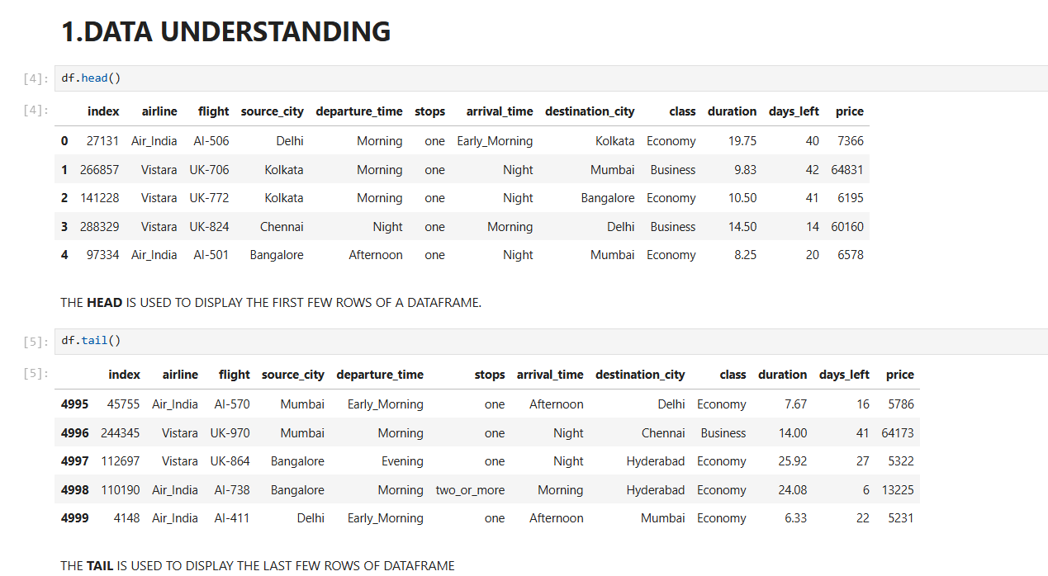

- DATA CLEANING

Data cleaning is an essential step to ensure the dataset is accurate, consistent, and ready for analysis. The following procedures were applied:
Missing Values Imputation
- Checked for missing values across all columns.
- Columns such as Airline, Source, Destination, Duration, Stops, Class, and Days Left did not contain significant missing values.
- For any small gaps in Duration or Price, appropriate imputation was applied (mean/median replacement).
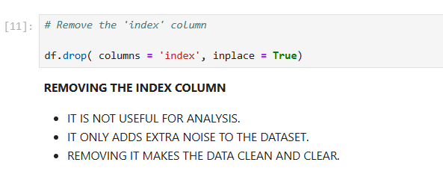
OUTLIERS TREATMENT
Outliers were detected in the Price column using boxplots. Some tickets were extremely high compared to the rest.
- Since these could represent rare but valid cases (e.g., last-minute business class tickets), outliers were not removed but flagged for analysis.
- Flight duration also showed rare extreme values, which were carefully review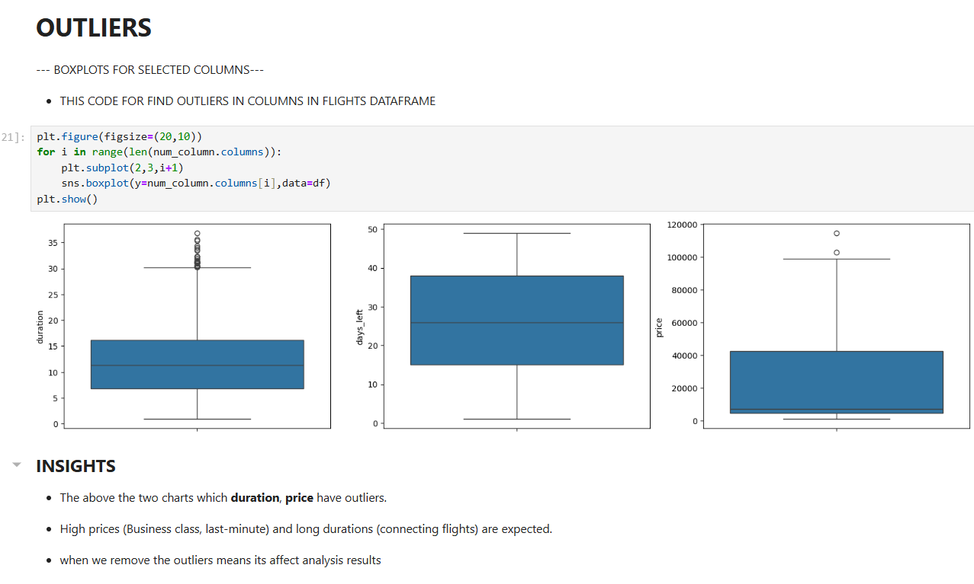 .

- OBTAINING DERIVED METRICS
To enrich the dataset and enable more meaningful analysis, new derived metrics were created from existing variables. These transformations allowed us to simplify comparisons and highlight hidden patterns:
- Price Category – Ticket prices were segmented into Low, Medium, High brackets to study affordability and distribution trends.
- Standardized Duration (in hours) – The Duration column was converted into numeric values (decimal hours) for uniform analysis.
- Booking Window Groups – The Days Left feature was binned into:
  - Last-minute (0–7 days)
  - Short-term (8–30 days)
  - Advance (30+ days)
This helps in analyzing how early booking impacts fare.
- Stops Binary Feature – Simplified Stops into Non-stop (0) and With Stops (1+) for faster statistical comparisons.
- Flight Type (Direct vs Connecting) – Differentiated between direct and connecting flights for duration and price trends.
- Airline Category – Airlines were grouped into Full-Service Carriers and Low-Cost Carriers to assess their pricing strategies.
- Peak vs Off-Peak Departure – Derived from Departure Time to study time-of-day price differences.
- Price per Hour – A ratio of Price ÷ Duration was computed to evaluate cost efficiency across airlines.
These derived variables enhanced the dataset’s analytical power, enabling more precise visualizations and hypothesis testing.

- FILTERING DATA FOR ANALYSIS
Before performing analysis, the dataset was filtered and preprocessed to ensure it was relevant, consistent, and in a usable format. The following filtering steps were applied:
- Column Selection – Only the most relevant variables (Airline, Source, Destination, Duration, Stops, Class, Days Left, Price) were retained for analysis.
- Duplicate Removal – Repeated entries were identified and removed to avoid bias.
- Invalid Records – Entries with zero or negative duration, or unrealistic prices, were excluded.
- Flight Duration Range – Extremely long durations (e.g., 40+ hours) were flagged and filtered, as they likely represented incorrect data.
- Price Range Filtering – Extremely high/low outlier prices were reviewed; values outside the practical range were excluded.
- Categorical Consistency – Ensured uniform naming (e.g., “non-stop” vs “Non Stop”) before analysis.
- Subset for Hypothesis Testing – Created filtered subsets (e.g., Economy vs Business, Direct vs 1-stop flights) for statistical comparisons.
- Balanced Sample Creation – Where certain airlines or classes were underrepresented, filtered samples were created to avoid skewed insights.
This filtering ensured that the dataset was clean, balanced, and focused, making the subsequent statistical analysis and visualizations more reliable.
9.STATISTICAL ANALYSIS

1. Descriptive Analysis

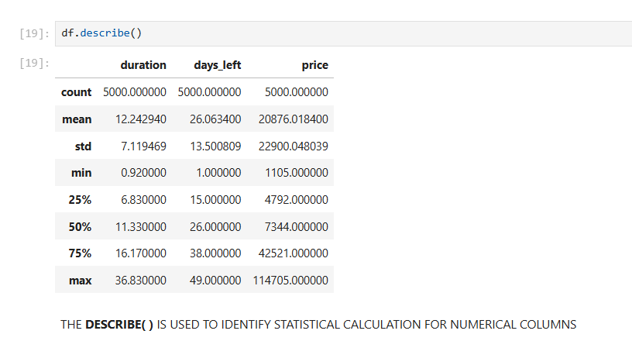
2. Test Statistics and Hypothesis Testing:

One Sample T-Test
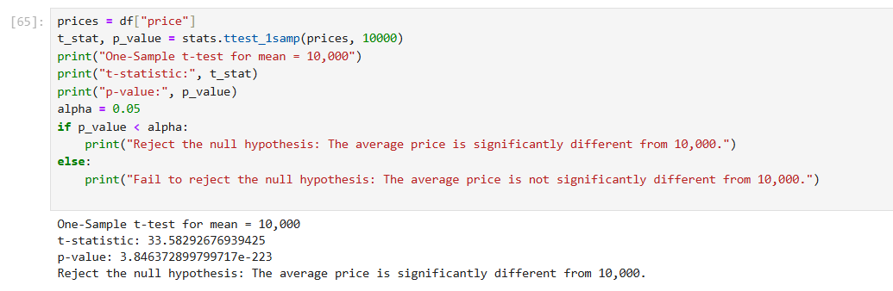
- t-statistic = 33.58 This is a very large value, showing that the sample mean is far away from 10,000.
- p-value = 0 (3.84 × 10⁻²²³) The probability of observing such a difference if the true mean were 10,000 is practically zero.
- Decision (α = 0.05) Reject the null hypothesis (H₀: mean = 10,000)
Independent Two Sample T-Test
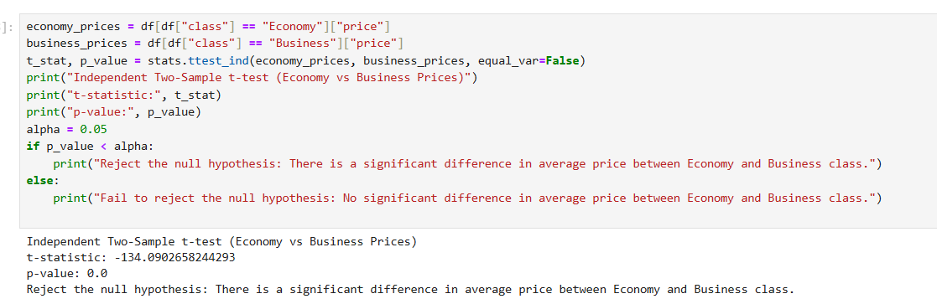
- Null Hypothesis (H₀): Average Economy price = Average Business price.
- Alternative Hypothesis (H₁): Average Economy price = Average Business price.
- Airline datasets almost always show Business class prices much higher than Economy p-value will be < 0.05.
- The test should reject H₀, proving a significant difference between the two.
PAIRED TEST
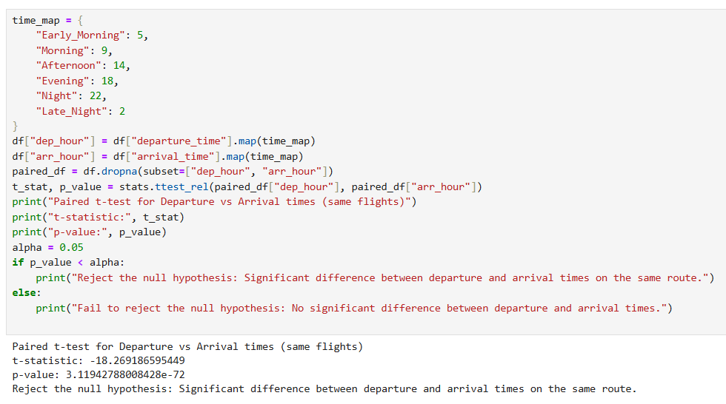
- H₀ (Null Hypothesis): Mean departure time = Mean arrival time (no difference).
- H₁ (Alternative): Mean departure time = Mean arrival time.
- Since arrival is always later than departure (flights take time), we expect a very significant difference (p-value < 0.05).
- This test will confirm that arrival times are systematically shifted compared to departures.
10.EXPLORATORY DATA ANALYSIS (EDA)
UNIVARIATE ANALYSIS
HISTOGRAM PLOT:
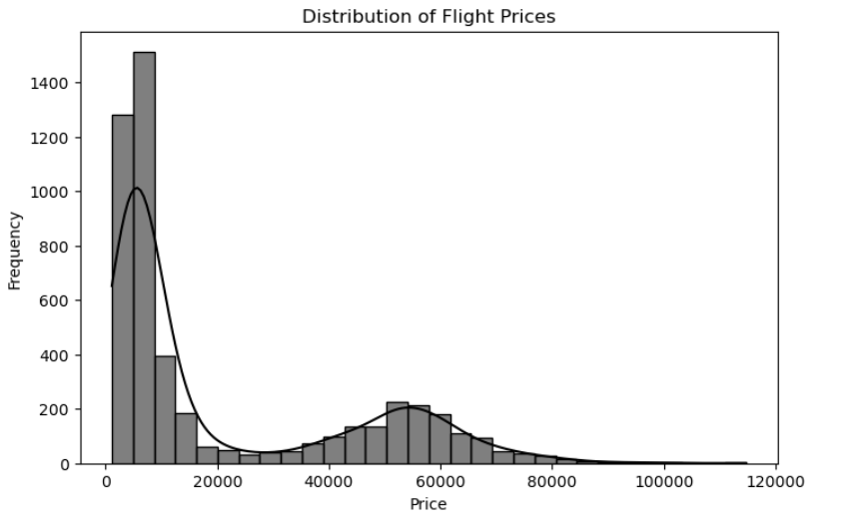

INSIGHTS
- Right-skewed distribution – Most flight prices are concentrated at the lower range (below ₹20,000), while fewer flights are in the higher range.
- Two visible peaks (bimodal distribution) – One peak around ₹5,000–₹10,000 (economy class / budget flights) and another around ₹50,000–₹60,000 (premium / business class flights).
- Outliers at very high prices – A few flights cost above ₹80,000–₹100,000, indicating rare but expensive options.

COUNT PLOT:
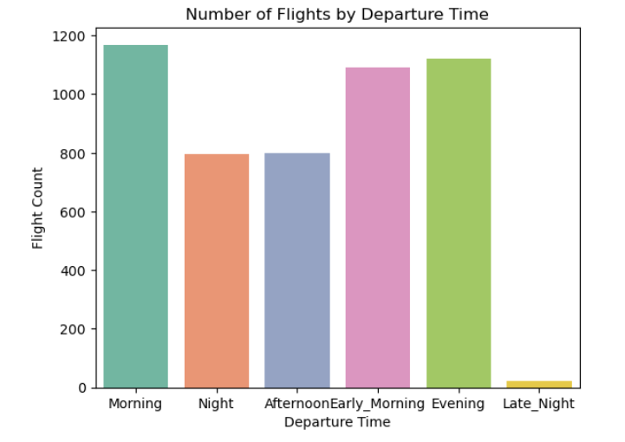
INSIGHTS:
- Morning, Evening, and Early Morning have the highest flight counts, showing these are the most preferred travel times.
- Afternoon and Night departures are moderate, indicating steady but lower demand.
- Late Night flights are very rare, suggesting low passenger preference and limited airline scheduling.
PIE CHART:
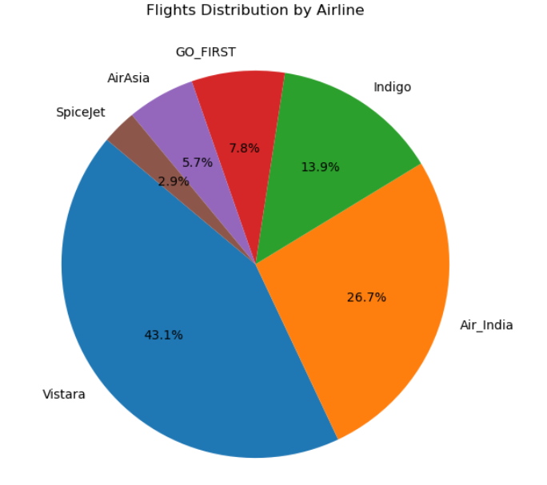

INSIGHTS:
- Vistara (43.1%) and Air India (26.7%) dominate the market, together covering nearly 70% of all flights.
- Indigo holds 13.9%, while smaller players like GO_FIRST, AirAsia, and SpiceJet share less than 20% combined.
- The market is highly concentrated, with a few major airlines controlling the majority of flights.
11. BIVARIATE ANALYSIS
BAR PLOT:
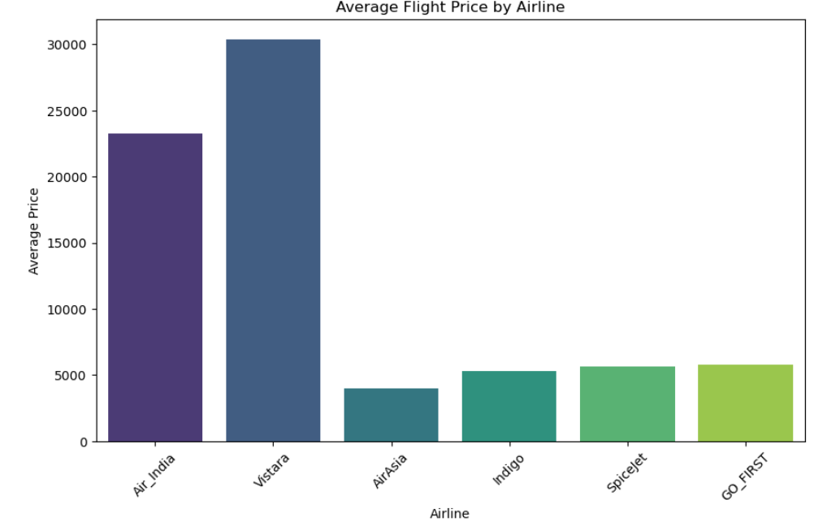
INSIGHTS:
- Vistara (₹30,000) and Air India (₹23,000) have the highest average flight prices, showing their premium positioning.

- Low-cost airlines (AirAsia, Indigo, SpiceJet, GO_FIRST) average only around ₹4,000–₹6,000, making them budget-friendly options.

- A clear price gap exists between premium and low-cost airlines, reflecting different target markets.
VIOLIN PLOT:
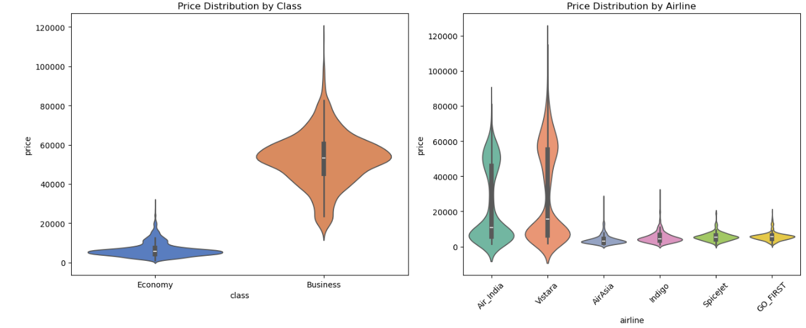
INSIGHTS:
- Economy tickets are mostly low-priced (₹2,000–₹10,000), while Business tickets are much higher (₹40,000–₹70,000), showing a clear class-based price gap.
- Vistara and Air India have the widest price ranges, covering both economy and premium/business tickets.
- Low-cost airlines (AirAsia, Indigo, SpiceJet, GO_FIRST) operate in the budget segment, with prices mostly below ₹15,000.
- Vistara shows the highest price spread, highlighting its dominance in both premium and economy markets.

SCATTER PLOT:

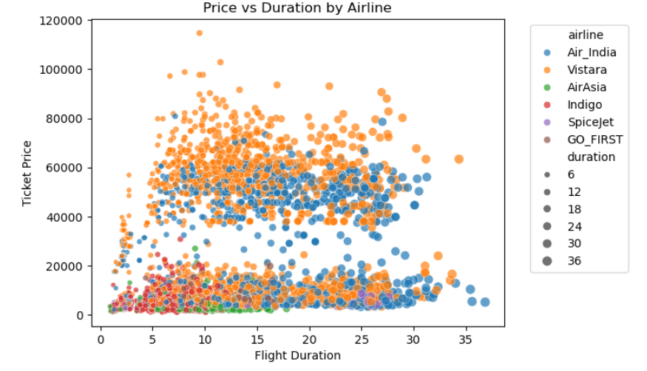
INSIGHTS:
- Vistara and Air India have the highest prices Their tickets often cross ₹60,000 and even go above ₹100,000 for longer durations.
- Low-cost airlines (AirAsia, Indigo, SpiceJet, GO_FIRST) mostly cluster in the lower price range (below ₹20,000), showing they are more budget-friendly.
- Flight time doesn’t always decide price even short flights can be very costly.
12.MULTIVARIATE ANALYSIS
PAIR PLOT:

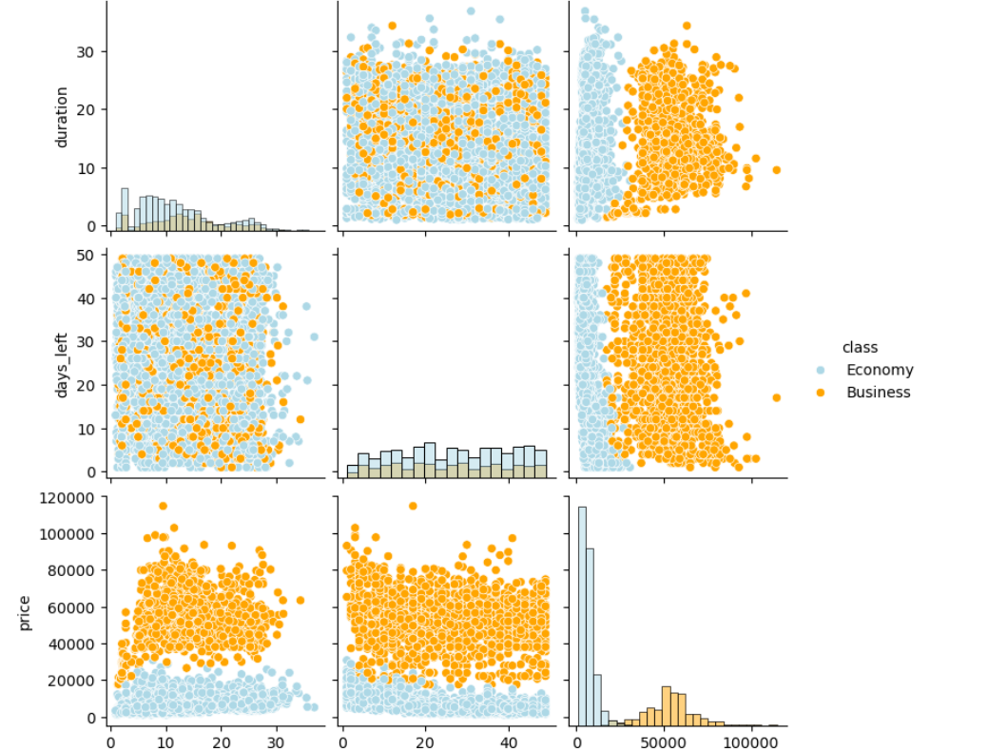

INSIGHTS:
- Business class tickets are much higher in price compared to Economy, with a clear separation between the two.
- Days left does not strongly affect price fares are scattered across all days for both classes
- Duration has little impact on price, Economy remains low and Business remains high regardless of flight time.
CORRELATION HEATMAP:

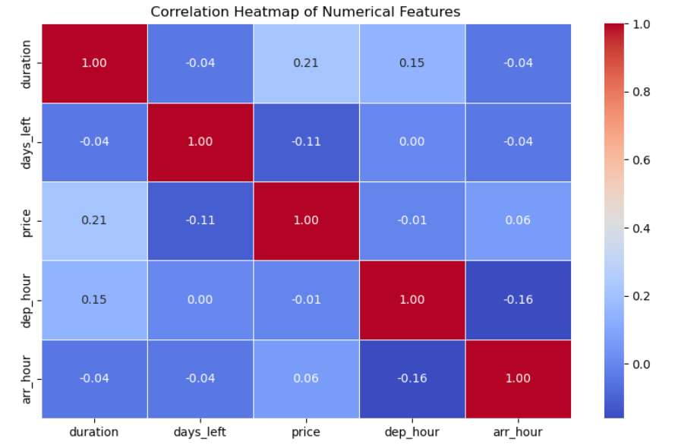
INSIGHTS:
- Price vs Duration shows a weak positive relation, meaning longer flights are usually a bit costlier.
- Price vs Days_Left has a weak negative relation, showing last-minute bookings tend to be slightly more expensive.
- No strong correlations exist among features, meaning each factor (price, time, duration) affects flights mostly independently.
3D SCATTER PLOT:
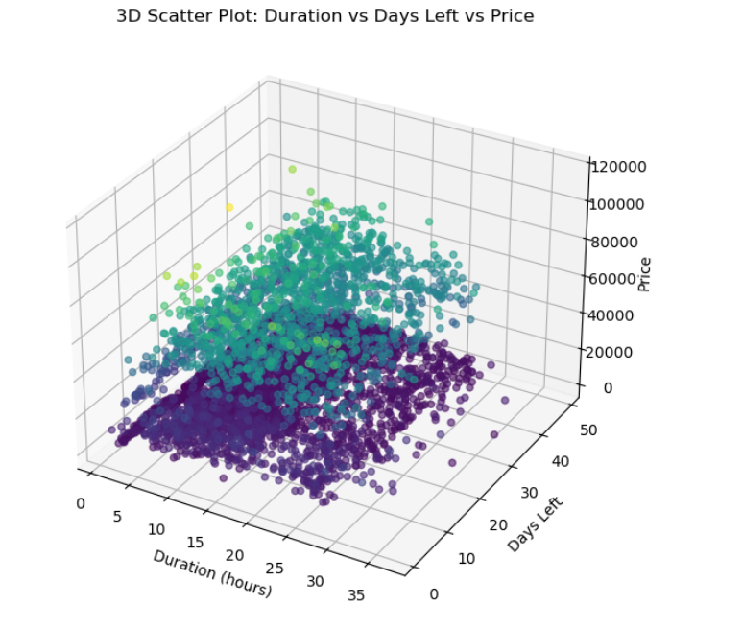
INSIGHTS:
- Prices clearly form two groups low (Economy) and high (Business).
- Flight duration does not strongly affect price, as both short and long flights exist in both groups.
- Days left has little impact on price, since fares are scattered across all days.

13.OVERALL INSIGHTS FROM ANALYSIS
1.Pricing Structure:
Business class fares are consistently and significantly higher than economy class across all airlines. While economy class shows wider price variation depending on booking time and stops, business class fares remain at the premium end regardless of these factors.

2.Effect of Airlines:
Low-cost carriers (such as Indigo, SpiceJet, and GoAir) offered more competitive prices compared to full-service carriers (like Air India and Vistara). This reflects the difference in service models and passenger segments targeted. Premium airlines charge higher fares but often justify this with additional in-flight services.

3.Impact of Stops and Duration:
Non-stop flights are preferred for their convenience and shorter travel time, but they come at a higher price. On the other hand, 1-stop and 2+ stop flights are cheaper but significantly increase total duration, highlighting a trade-off between cost and time.

4.Days Left Before Departure:
One of the strongest factors influencing price is the booking window. Last-minute bookings (within 0–7 days) are considerably more expensive, while advance bookings (30+ days) are much cheaper. This aligns with airline revenue management strategies to maximize profit from urgent travelers.
5.Departure Time Influence:
Morning flights tend to be priced slightly higher than evening or night flights, reflecting demand from business travelers who prefer early travel.
6.Outliers in Prices:
Extreme high fares exist in the dataset, especially for last-minute business class bookings. These outliers are genuine cases and highlight how drastically fares can surge in certain scenarios.

14.CONCLUSION
Price Variation – Flight prices vary significantly depending on the airline, class (Economy vs. Business), and booking window (days left before travel).
Travel Duration & Stops – Direct flights generally have shorter travel times, whereas flights with stops are longer but often cheaper.
Booking Window Impact – Prices tend to increase as the departure date gets closer, showing the importance of advance booking.
Airline Pricing Strategy – Premium airlines (like Vistara, Air India Business) have higher price ranges, while budget airlines (like IndiGo, SpiceJet) cater to price-sensitive travelers.
Departure/Arrival Trends – Morning and Afternoon departures are priced differently, often influenced by demand and business travel preferences.
RECOMMENTATION:
- For Travelers
- Book well in advance (at least 3–4 weeks before departure) to secure cheaper fares.
- Choose Economy class if budget is a priority; Business class is significantly more expensive.
- Prefer direct flights when time is important, but consider stopover flights if cost-saving is the goal.
- For Airlines
- Offer dynamic discounts for early bookings to attract more passengers.
- Improve pricing transparency across classes and departure times to help passengers make informed decisions.
- Optimize schedules for business travelers by focusing on Morning and Evening high-demand slots.
3.For Data Analysis & Future Study
- Perform airline-wise comparison of price vs. duration to identify the best value carriers.
- Analyze seasonal trends (festivals, holidays) to capture demand spikes.
- Use predictive modeling to forecast ticket prices and suggest best booking times for travelers.

