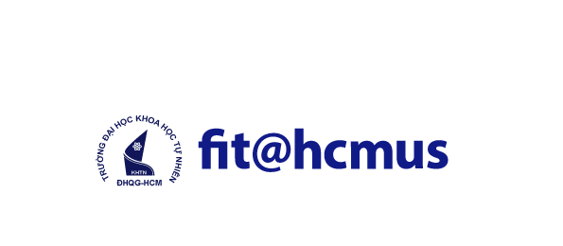 | UNIVERSITY OF SCIENCE  ADVANCED PROGRAM IN COMPUTER SCIENCE

Thesis Proposal
Thesis title:
RESEARCH AND BUILD A SYSSECOPS SYSTEM PROCESS FOR A HYBRID CLOUD ENVIRONMENT
Thesis advisor: PhD. Tran Trung Dung, MSc. Chung Thuy Linh
Students: Huynh Tuan Minh (22125055) – Nguyen Chinh Thong (22125102)
Type of thesis: Technology with demo application
Duration: 30th September 2025 to 4th August 2026
Contents of thesis:
- Introduction
Traditional software development in hybrid cloud environments usually follows a linear process: requirements, design, implementation, testing, and deployment. Although CI/CD automation has accelerated testing and release, the coding and secure design stages remain costly and slow. Recent advances in large language models (LLMs) make automatic code generation from natural language practical, reducing development effort and delivery time.
However, AI-generated code is probabilistic and can contain logic errors, insecure patterns, dependency risks, and policy violations. These risks become more critical in hybrid cloud deployments, where workloads span public cloud and on-premises infrastructure, each with different trust boundaries, network controls, and compliance requirements.
This thesis proposes a SysSecOps workflow that combines AI-assisted code generation with layered security controls and automated operations. The workflow includes prompt governance, pre-execution validation, static and dependency analysis, risk scoring, sandbox execution, runtime monitoring, and automated incident response.
The architecture explicitly addresses:
- Cross-environment identity and access control (cloud IAM + on-prem policy).
- Data and artifact movement between cloud and on-prem zones.
- Consistent security checks across heterogeneous runtime environments.
- Failover and observability across distributed infrastructure.
- Objectives
Primary objective:
Design and implement a SysSecOps pipeline that enables the secure, compliant, and reliable use of AI-generated code in a hybrid cloud model.
In this context:
- Secure: prevent vulnerabilities through multi-layer security analysis, including static code analysis, dependency scanning, and sandbox validation.
- Compliant: enforce organizational and industry security policies, such as avoiding hardcoded secrets and adhering to secure coding standards (e.g., OWASP guidelines).
- Reliable: ensure stable execution and operation through validation, monitoring, and automated incident response mechanisms across hybrid cloud environments.
Specific objectives:
- Build an AI code generation module using an LLM API (Qwen3-Coder-30b class model) to transform natural language requirements into source code templates and implementation code.

  - Syntax validation: Ensures code follows correct grammar and structure (e.g., no missing brackets or invalid syntax).
  - Semantic validation: Ensures logical correctness and meaningful operations (e.g., no undefined variables or type mismatches).
  - Policy conformance validation: Ensures code complies with security and organizational rules (e.g., no insecure functions or hardcoded secrets).
- Implement a multi-layer security analysis stage using:
- SonarQube (SAST and code quality rules)
- Semgrep (custom security rules)
- Trivy or Snyk (dependency and container vulnerability scanning)
- Checkov (Infrastructure as Code misconfiguration scanning)
- Develop a risk scoring engine to prioritize findings by severity, exploitability, and runtime exposure.
- Execute generated code in an isolated Docker sandbox before release.
- Integrate monitoring and response with CloudWatch (cloud side), Prometheus/Grafana (on-prem side), and automated alert-to-action rules.
- Evaluate improvements in efficiency, vulnerability detection, and runtime reliability compared with a baseline pipeline without security gating.
3. Scope of the Thesis
Included scope:
- End-to-end prototype implementation of AI-to-deployment SysSecOps workflow.
- Hybrid cloud testbed (AWS + on-prem virtualized cluster).
- Security validation of AI-generated application code and IaC artifacts.
- Quantitative and comparative evaluation.
Excluded scope:
- Training LLMs from scratch.
- Enterprise-scale production.
- Advanced cloud cost optimization.
4. Technology Stack
AI and orchestration:
- OpenAI API (LLM-based code generation)
- Python orchestration service (FastAPI)
Security pipeline:
- SonarQube, Semgrep, Trivy/Snyk, Checkov
- OWASP Dependency-Check (optional secondary validation)
Execution and deployment:
- Docker sandbox for isolated execution
- On-prem environment: VMware/VirtualBox-based Linux nodes or local Kubernetes (k3s)
- Terraform for reproducible infrastructure provisioning
Monitoring and response:
- Prometheus + Grafana (on-prem workloads)
- Alertmanager/webhook automation for quarantine, rollback, or block actions
5. Methods:
This research adopts a design-and-evaluation methodology to develop and validate the SysSecOps workflow.
- System Design
A modular architecture will be designed to integrate AI-based code generation with multiple security layers, including validation, analysis, sandboxing, and monitoring components.
- Implementation
A prototype system will be developed using appropriate tools and technologies, such as large language model APIs for code generation, static analysis tools for vulnerability detection, and container-based environments (e.g., Docker) for sandbox execution.
- Security Analysis Techniques
The system will incorporate:
  - Static code analysis for identifying known vulnerability patterns.
  - Dependency and library scanning for supply chain risks.
  - Risk scoring algorithms to prioritize potential threats.
- Experimental Setup
The workflow will be tested using predefined scenarios in a hybrid cloud environment.
- Evaluation Metrics
The system will be evaluated based on:
  - Code generation and validation time.
  - Vulnerability detection rate.
  - False positive and false negative rates.
  - System reliability and stability during execution.
- Limitations
Despite the effectiveness of the proposed SysSecOps workflow in mitigating risks associated with AI-generated code, several limitations remain:
Dependence on LLM Training Data:
  - The model may produce outdated practices, insecure patterns, or suboptimal designs if such patterns exist in its training corpus.
  - The model may not fully capture domain-specific requirements or contextual constraints.
False Positives vs. False Negatives Trade-off:
  - Static analysis and security scanning tools (e.g., SonarQube, Semgrep) may generate false positives, identifying issues that are not actual vulnerabilities.
  - Reducing false positives by relaxing detection rules can increase the risk of false negatives, where real vulnerabilities are missed.
System Overhead:
  - Additional computational overhead, increasing build time and resource consumption compared to traditional pipelines.

Incomplete Coverage:
  - Not guarantee that all execution paths are fully tested or validated, even with sandbox execution and automated testing mechanisms.
6. Expected results:
The proposed workflow is expected to:
- Reduce secure delivery time compared with traditional development pipelines.
- Increase vulnerability detection coverage for AI-generated code and IaC.
- Reduce production risk by enforcing sandbox validation and runtime response automation.
- Demonstrate stable and policy-consistent operation across hybrid cloud infrastructure.
Final deliverables:
1. A working SysSecOps prototype for AI-generated code.
2. A hybrid cloud experimental environment definition (Terraform + deployment scripts).
3. Evaluation dataset and benchmark scenarios.
4. Comparative performance and security analysis report.

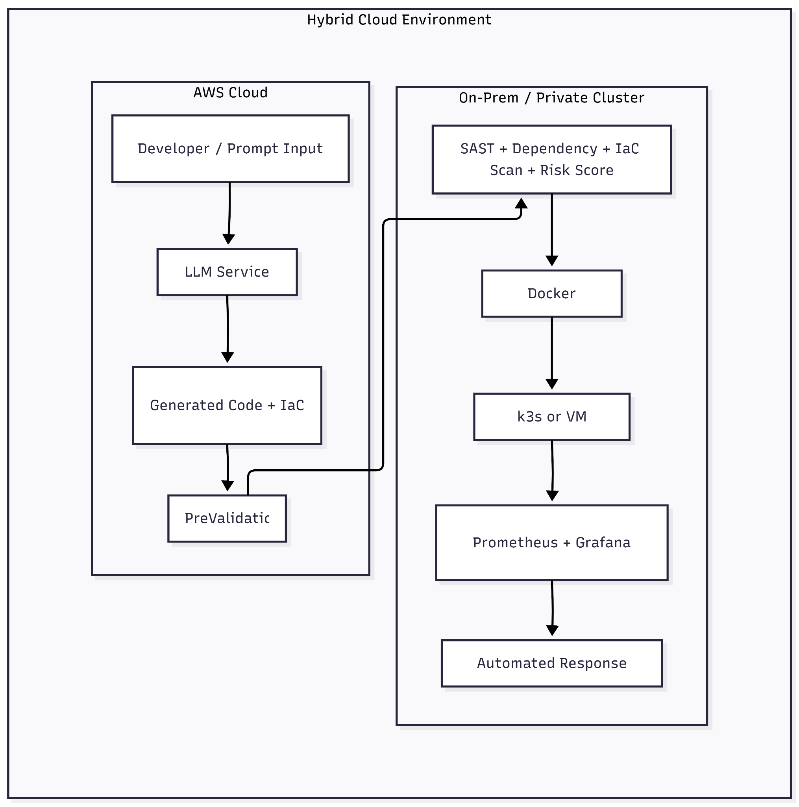
This diagram shows the end-to-end flow of AI-generated code across the hybrid cloud boundary. The AWS side handles prompt intake, generation, and pre-validation, while the on-prem side performs deeper security analysis, sandbox execution, runtime hosting, and response automation. The separation highlights how security controls and observability are distributed across both environments.
Research timelines:

Tasks | Time | Duration | Individual
Study AWS cloud infrastructure | 9/2025 | 3 months | Minh, Thong
Design pipeline | 1/2026 | 1 month | Minh
Select AI model | 1/2026 | 1 month | Thong
Select service | 3/2026 | 1 week | Thong
Configure service, IAM policies, secure API | 15/3/2026 | 1 week | Thong
Draw and fix pipeline | 15/3/2026 | 1 week | Minh, Thong
Implement pre-validation | 15/3/2026 | 2 weeks | Minh
Bring pre-validation to service | 29/3/2026 | 1 week | Minh, Thong
Implement security analysis | 5/4/2026 | 2 weeks | Minh
Setup sandbox execution | 5/4/2026 | 2 weeks | Thong
Bring security analysis and sandbox to service | 19/4/2026 | 1 week | Minh, Thong
Implement risk scoring | 5/2026 | 1 month | Minh
Setup runtime monitoring | 5/2026 | 1 month | Thong
Write paper | 6/2026 | 2 moths | Minh, Thong
Evaluate and finalize paper | 8/2026 | 1 week | Minh, Thong

Reference:
[1] R. Santos, A. Correia, and J. P. Sousa, "Security Best Practices for Cloud-Native Applications: A Systematic Review," IEEE Access, vol. 11, pp. 45230-45245, 2023.
[2] HashiCorp, "Terraform: Infrastructure as Code," HashiCorp Documentation, 2024. [Online]. Available: https://developer.hashicorp.com/terraform/docs.
[3] OWASP Foundation, "OWASP Top 10," 2021 (vulnerability taxonomy baseline).
[4] Shetti, Milan, Nubes: Towards building a Secure and Scalable Hybrid Cloud Infrastructure (University of Minnesota thesis, 2021)
[5] Shaileshbhai, Khushi, Security Challenges and Mitigation Strategies in Hybrid Cloud Environments (January 31, 2025). Available at SSRN: https://ssrn.com/abstract=5118715 or http://dx.doi.org/10.2139/ssrn.5118715
Approved by the advisor | Ho Chi Minh city, 06/04/2026
Signature of advisor | Signature(s) of student(s)

