**PRACTICAL-1**

**Aim**: To create table and insert data

# Query: CREATE

create table Student (

Student_ id int not null,

First_ name varchar (40) not null,

Last_ name varchar (30) not null,

Address varchar (100) not null,

Primary Key (Student_ id),

Unique (First_ name)

);

**O**

**utput:**

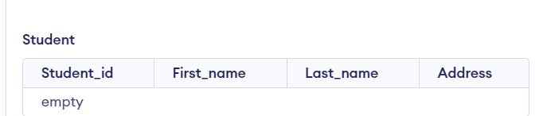

# Query: INSERT

INSERT INTO Student (Student_ id, First_ name ,Last_ name, Address)

VALUES(1,"ISHAAN","PATEL","AHMEDABAD");

INSERT INTO Student (Student_ id, First_ name ,Last_ name, Address)

VALUES(2,"HARSHIT","TRIVADI","NIKOL");

INSERT INTO Student (Student_ id, First_ name, Last_ name, Address) VALUES(3,"LISA","DEO","RANIP");

INSERT INTO Student (Student_ id, First_ name, Last_ name, Address)

VALUES(4,"RINA","JAIN","GOTA");

INSERT INTO Student (Student_ id, First_ name ,Last_ name, Address)

VALUES(5,"AKSHAT","PATEL","GANDHINAGAR");

**Output:**

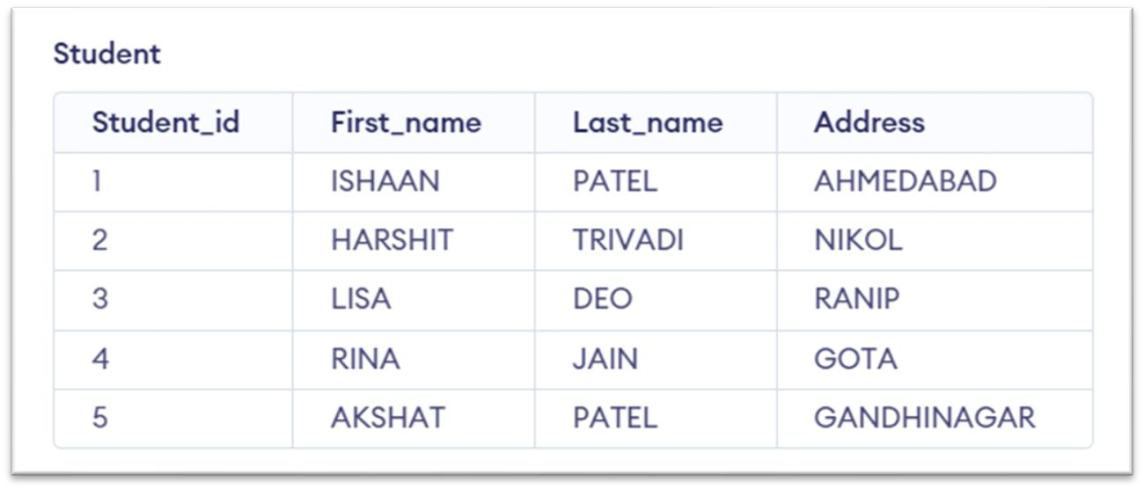

# PRACTICAL-2

**Aim**: To Make changes in the following table using various DDL and DML commands (alter, update, drop, select).

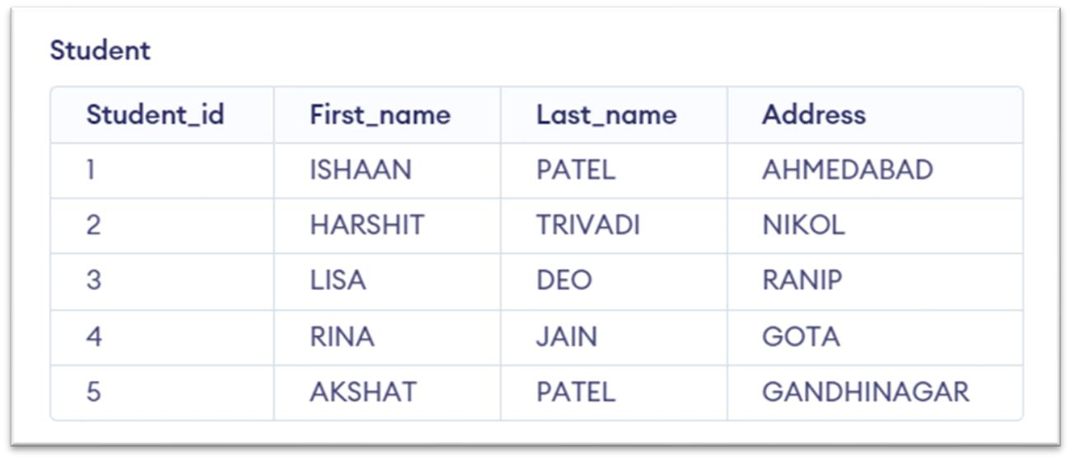

**Query**: ALTER

alter table Student add email varchar (34); select * from student;

**Output:**

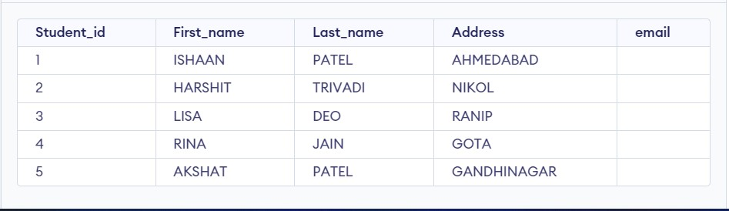

## **Query**: UPDATE

update Student set email = "ishaan@sql.com" where Student_id =1; select * from student;

**Output:**

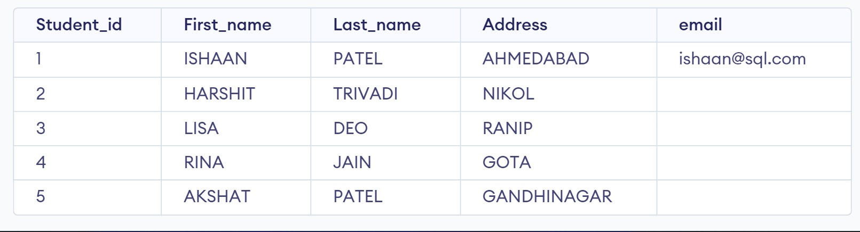

# PRACTICAL-3

**Aim**: To perform various DML commands, aggregate functions and sorting concept on created tables.

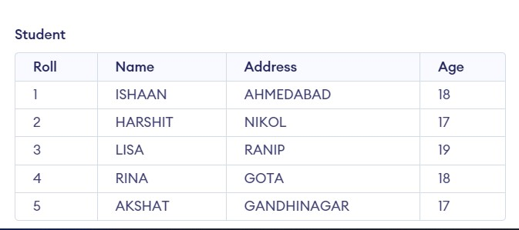

**Query**: LIKE

select* from Customers where Country like '__A%'; select* from Customers where first_ name like 'J_%'; select* from Customers where customer_ id like '3';

**Output:**

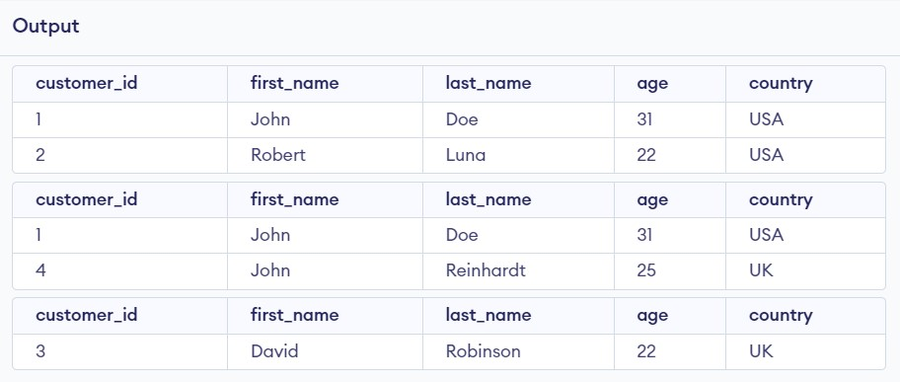

## **Query**: BETWEEN

select* from Customers where age Between 25 and 28; select* from Customers where age>22 and age<31;

**Output:**

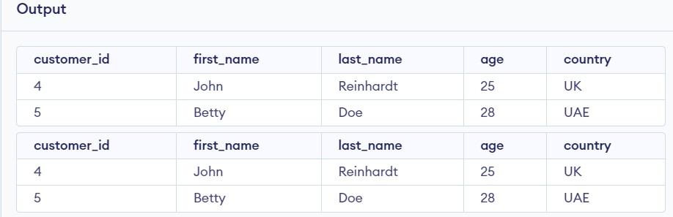

**Query**: IN

select *from Customers where age in (22,28); **Output:**

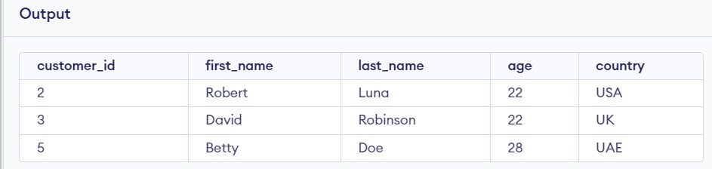

## **Query**: AVERAGE

select avg (age) from Student;

**Output:**

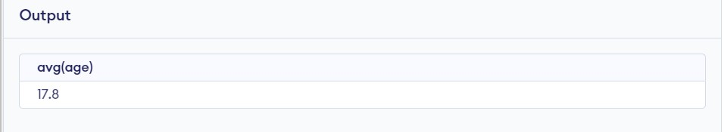

**Query**: COUNT

select count(distinct age) from Student; select count(*) from Student where age>18;

**Output:**

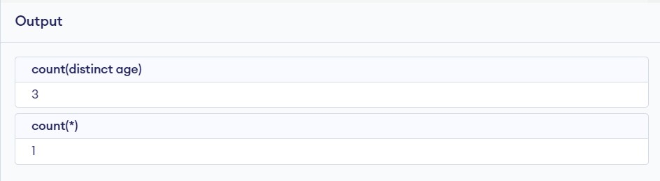

**Query**: SUM

select sum(age) from STUDENT;

**Output:**

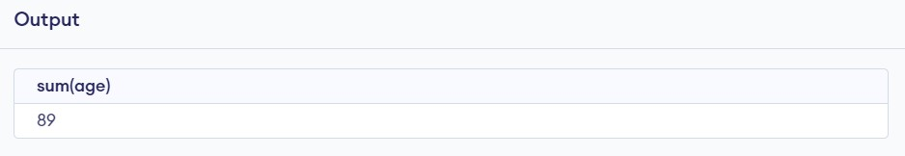

## **Query**: MAXIMUM

select max(age) from Student;

**Output:**

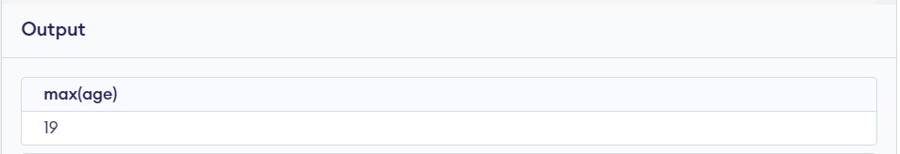

## **Query**: MINIMUM

select min(age) from Student;

**Output:**

