A

PROPOSAL

ON

SURVELLIANCE DRONE

(PANCHII)

SUBMITTED TO:

Naxa Pvt. Ltd.

Nagpokhari Road, Naxal,kathmandu

SUBMITTED BY:

BIMAL KHADKA (073BEX411)

BIPLAB KARKI (073BEX412)

JAY KISHAN PANJIYAR (073BEX414)

NAVIN RAI (073BEX418)

Pulchowk campus

IOE, Tribhuvan University

May 29, 2019

# Abstract

This proposal is about the project which consists of drone efficiently using energy with the capability of running on solar power for the purpose to monitor/surveillance the flow of traffic with the autopilot feature, monitoring the various sections of the road automatically with the potentiality to reach the far area of the city whenever assigned to monitor. It automatically provides information about the traffic flow rate, number of vehicles at various sections of the road, traffic jam, and the critical conditions in the specified area assigned to monitor. Thus analyzing the traffic from low-density period to high-density period with real-time video streaming for the purpose of analyzing and viewing the area under the worst case scenario. The administrator can also view the various sections of the road at any time through an attractive web responsive interface with the feature to set the drone on auto or manual mode.

Table of Contents

Abstract 2

Introduction 4

Statement of problem 4

Objectives 4

Methodology / procedure 5

Project Management 7

Time Management 3

Cost estimate 4

Conclusion 5

References 5

# Introduction

## Statement of problem

Traffic jam is a burning issue in the Kathmandu valley as well as in the major cities all over the globe. Every day thousands of civilians traveling on the various routes of the valley get suffered due to the long jam where clearance is a matter of discussion while on the locomotives. Hundreds of life are scarified every month as the Ambulances get stroked on the jam with not a single inch of clearance. Despite large manpower being involved to control the flow of traffic before, during and after the traffic congestion occurs, those traditional methods were proved to be inefficient. Traffic division together with various departments have deployed a large number of cameras at various junctions to coordinate the flow of traffic but those static cameras also lacked the expected outcome. Despite large manpower and investment in the traffic sector, the problem still exits. In fact, it’s growing linearly day by day. The manpower required to observe and monitor the traffic flow is relatively high and the task is tedious.

## Objectives

* To make a drone which runs on solar power
* Auto pilot and manual driving feature
* To reduce the workload of the Traffic police
* To calculate the no. of vehicles running or at traffic jam at certain instant
* To monitor the traffic density
* To alert and make decision at location on the road
* One click live streaming the various sections of the road

# Methodology / procedure

In this project first, we will make a drone with runs on solar power and is capable of reaching far distances which is not possible using normal drones; wherever the mobile network is available. It consists of a GSM module connected with the pi, to give the pi internet access. The speed, height, temperature, humidity, location coordinates data are collected and send to pi which in turn sends it to the Amazon cloud and from the cloud, the data can be accessed via web responsive app. The web app is designed in such a way that the drone can be controlled from the ground manually as well as set in autopilot mode, in which it can be assigned to reach any particular location. The web app displays the live videos taken via drone camera. The images captured via cameras are analyzed through AI algorithms to arrive at the conclusion.

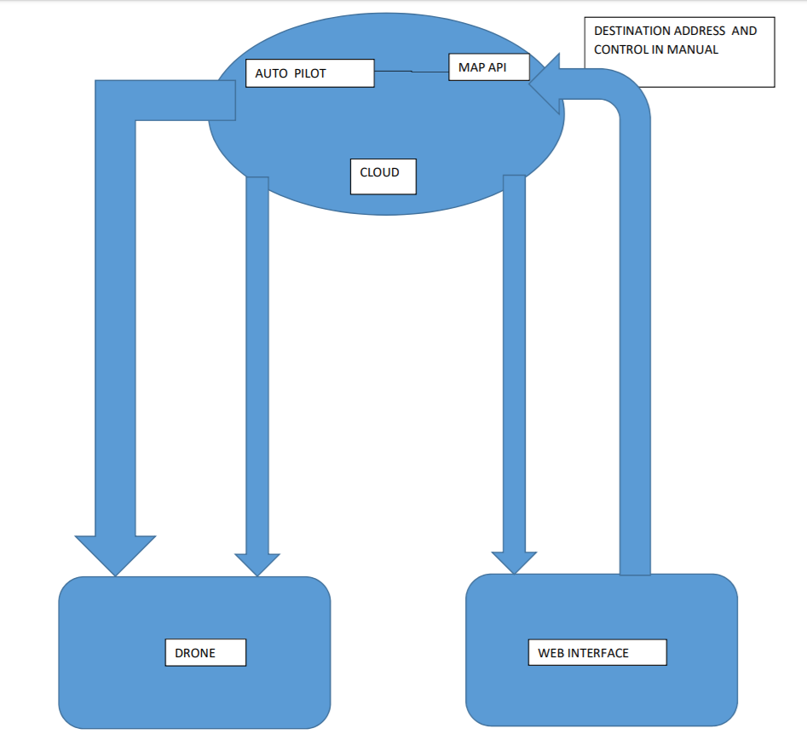

# 

# Project Management

The entire project is divided phases among all the four members of the team which will be synchronized parallel

1. Making drone

A drone is made of four brushless dc motor as in general quadcopter. It is equipped with a camera for taking live video footage. Its flight controller is made using MPU6050 as accelerometer and gyroscope and using the PID controller to stabilize the drone. The barometric pressure sensor is used to approximate its altitude which is also a part of flight controlled. This drone can be navigated using two modes that are manual mode and auto navigating mode. In manual mode, simply drone is controlled via the control signal given by the user. In auto navigating part, the drone is trained using Reinforcement training and it is taught to navigate itself given the destination for it to reach. The main part of this phase is to make stable drone with less power consumption as possible. The estimated time for this part is about a month.

1. Running drone on solar power

The drone power consumption will be calculated and on the basis of that, the required power to drive the drone efficiently using solar is found. The desired power is to be obtained using solar. Using the alternative battery for charging using the solar cell and when the primary battery discharges, and then the alternative battery comes in action and the primary battery goes on charging and this process is continued for and running drone for a longer duration of time using dual battery concept by charging the battery at its maximum charging capacity using solar cells.Solar panel gets energy from sunlight and converts it into electrical energy which is used for charging batteries. Relay switches the charging of battery1 and battery2. When battery1 is charging, battery2 provides supply for the operation of drone. When supply of battery2 falls below specified level, relay immediately switches it for charging and battery1 provides supply for the operation of drone and vice versa.

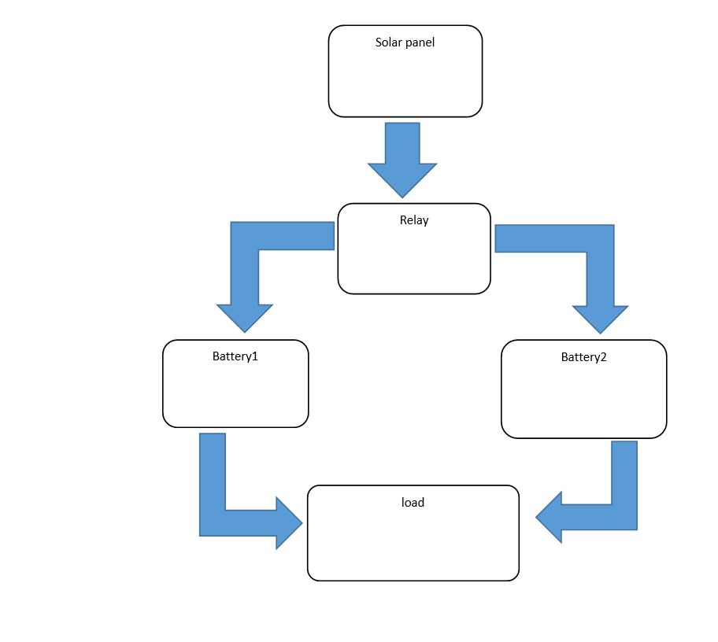

1. Making the drone interface and connecting it to cloud

We will be using AWS IoT Core, Kinesis, Recognition, NoSQL Database likes DynamoDB, Virtual Machines (EC2), AWS S3, AWS Robomaker for the entire setup of the project. We will be using IoT Core feature in order to monitor the entire drone data and mapping stored to the database. The same feature will be used by our web application to control the drone and analyze the data. Kinesis will be used for live streaming of camera attached in the drone to the application. Recognition will be used in the case of Computer Vision.EC2 will be used to create a web server for web application and data science. S3 will act as a common interface for data storage of various kinds including pictures taken by the drone. AWS Robomaker will be used to train the drone.

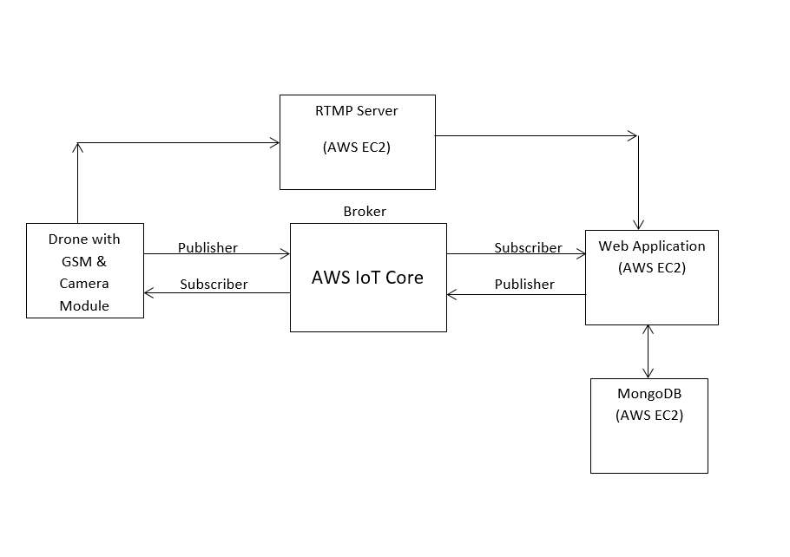

1. Detecting the vehicles and calculating the density of vehicles

The captured videos from the drone are processed via different AI algorithms to calculate the number of vehicles. On the basis of the calculated density and the attached GPS on the drone, the traffic density is calculated at each section of the road. The density tells us which section is supposed to have a greater density of traffic jam/vehicle congestion. Thus appropriate actions could be taken.

# Time Management

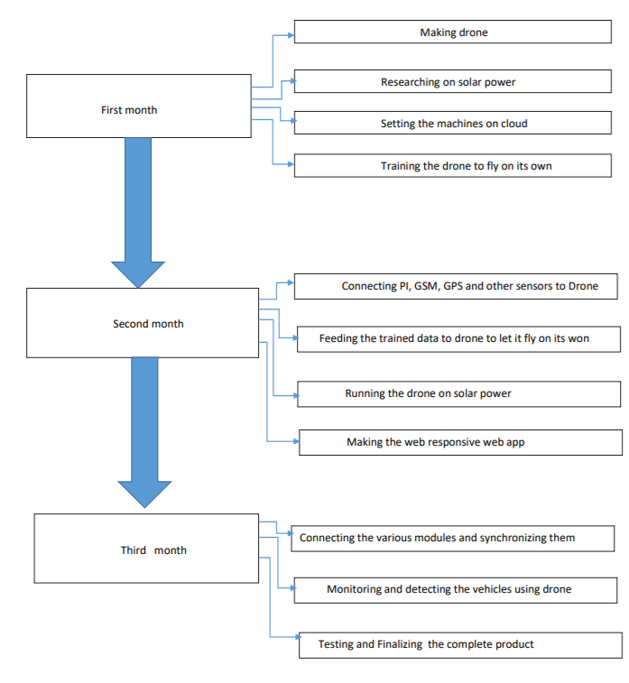

# Cost estimate

The cost of the project is estimated as:

**Hardware**

|  |  |  |  |
| --- | --- | --- | --- |
| S.N | Device | Quantity | Cost (Approx) |
| 1. | Raspberry pi | 1 | 5600 |
| 2. | Gsm module | 1 | 2800 |
| 3. | Logitech camera | 1 | 3000 |
| 4. | Solar cell |  | 1000 |
| 5. | Lipo battery | 2 | 4000 |
| 6. | ESC | 4 | 3800 |
| 7. | Brushless motor | 4 | 4000 |
| 8. | Frame | 1 | 2000 |
| 9. | MPU6050 | 1 | 600 |
| 10. | BEC | 1 | 300 |
| 11. | Temperature sensor | 2 | 400 |
| 12. | Pressure Sensor (BMP) | 1 | 400 |
| 13. | Propeller | 4 | 800 |
| 14. | PCB | 1 | 500 |
| 15. | Jumper Wires & Connectors |  | 500 |
| 16. | Sim Card | 1 | 100 |

Grand total(estimated): 29,800

**Software Cost**

AWS EC2 (for ML): - $37.38/per month (730 hours, 2 CPUs, 8 GB Memory)

AWS EC2 (for Web Server with MongoDB): - $37.38/ per month (730 hours, 2 CPUs, 8 GB Memory)

AWS S3: - $2.21/ per month (100 GB, 10 Requests, 10 GB per request)

AWS Rekognition: - $5/ per month (1000 Image approximately)

AWS IoT Core: - $2/ per month (10,000+ messages)

AWS CloudFront+SNS: - $3/ per month

AWS Robomaker: - $67.2/ one time (7 days)

# Conclusion

In this project, we are making a quadcopter(drone) which is used for the application of assisting Traffic polices for analyzing  the condition of the Traffic and the worst case scenario of various sections of road. Traffic police would not have continuously monitor the road sections and can easily monitor the road sections without worrying to have knowledge for operating the drone. Thus enhancing and modernizing the old traditional methods of controlling the traffic. This project is  assist the traffic control division through fully automated  aerial view and instant results for the purpose of controlling and diverting the flow of traffic to less congested and safer area.

# References

* Ardupilot.org. (2019). *ArduPilot Open Source Autopilot*. [online] Available at: http://ardupilot.org/ [Accessed 29 May 2019].
* *Docs.aws.amazon.com*. N.p., 2019. Web. 29 May 2019.
* "Dronekit." *DroneKit*. N.p., 2019. Web. 29 May 2019.
* "Mavproxy — Mavproxy 1.6.4 Documentation." *Ardupilot.github.io*. N.p., 2019. Web. 29 May 2019.
* "Introduction · Mavlink Developer Guide." *Mavlink.io*. N.p., 2019. Web. 29 May 2019.
* &raquo;, More. "The Ultimate Guide To Drones." *Instructables*. N.p., 2019. Web. 29 May 2019.