JOB PORTAL WEBSITE

MADE BY :-

Name : JAY KUMAR SAHU

Email : jay20_ug@cse.nits.ac.in

Phone : 7972974765

Folder : InternJob

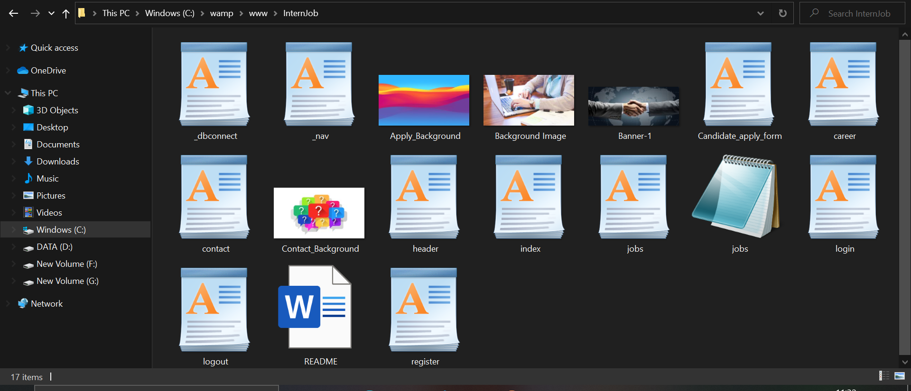

Some images for MYSQL using phpMyAdmin :

DATABASE name : jobs

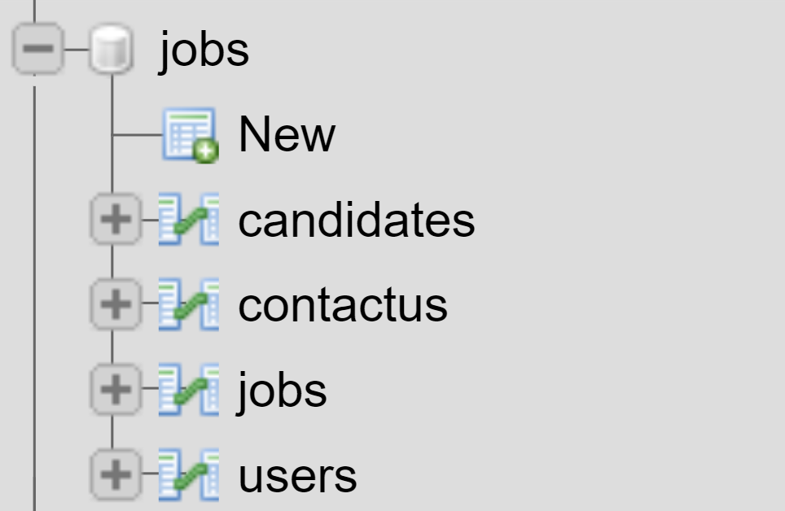

STRUCTURE : jobs >> users , new users are registered here

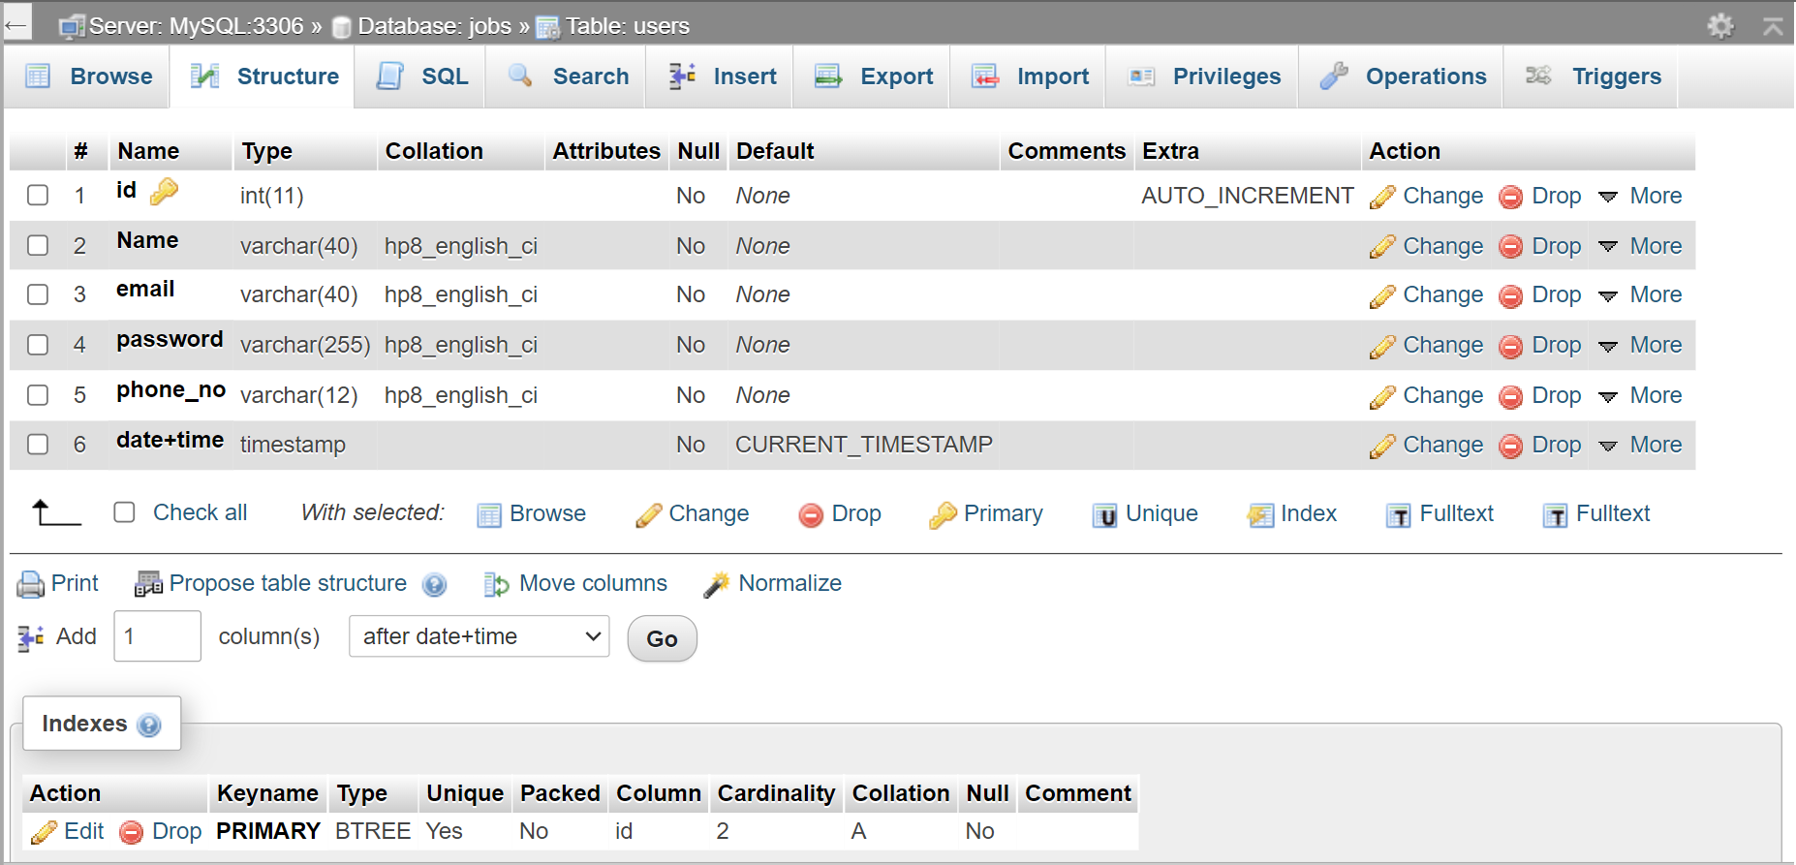

STRUCTURE : jobs >> jobs , new jobs are registered here by companies

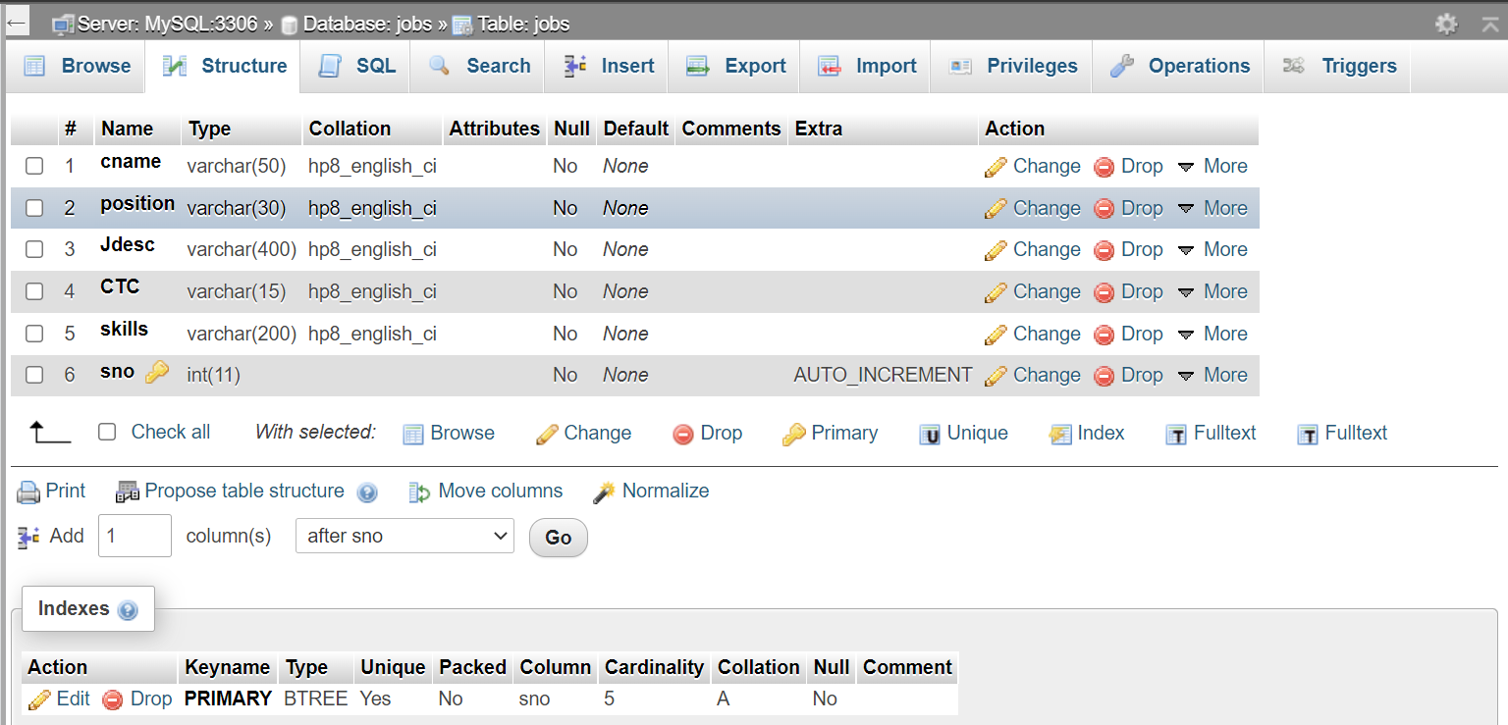

STRUCTURE : jobs >> candidates , job applicants are registered here by companies

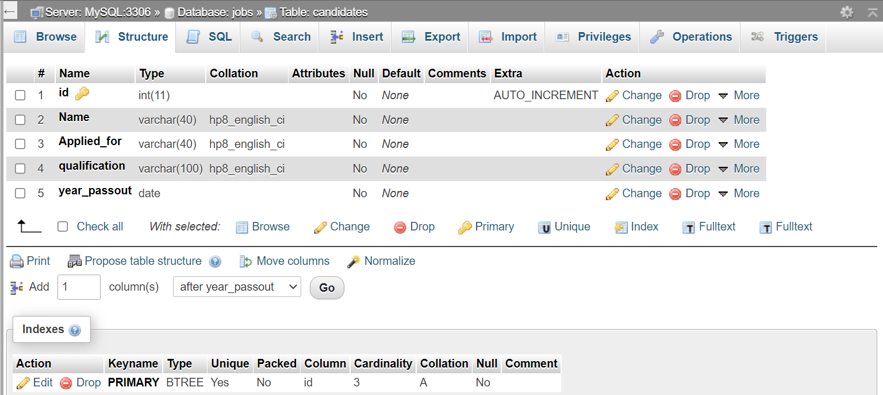

STRUCTURE : jobs >> contactus , doubts are asked here by users, companies, etc.

