Customer Campaign Briefs
Digital Out-of-Home Campaign Portfolio
CLIENT BRIEF 1: ZEPHYR EV — THE FUTURE HAS NO TAILPIPE
Company Name | Voltaic Motors Inc. (Brand: Zephyr EV)
Industry Vertical | AUTOMOTIVE / ELECTRIC VEHICLES
Campaign Objective | Brand Awareness & Test-Drive Bookings
Target Audience | Urban professionals and eco-conscious upgraders (Ages 28-50)
Campaign Budget | USD 40,000
Campaign Duration | 45 Days (Proposed: Q1 2027 — pre-monsoon launch window)

1. Executive Summary & Objective
Voltaic Motors is launching the Zephyr EV, its first mass-premium electric sedan, in Las Hackland ahead of a citywide dealership rollout. The campaign must build credible brand presence in a category where commuters default to established fuel-vehicle brands, while driving measurable test-drive bookings through a QR-linked scheduling flow. The creative direction favors calm, premium confidence over aggressive discounting.

2. Target Audience & Persona
The target buyer is a homeowner or senior professional currently driving a fuel vehicle, financially comfortable enough to consider an upgrade but requiring reassurance on range, charging convenience, and resale value before committing. They commute by car during peak hours but pass through metro and business-district transit corridors regularly for meetings, meaning transit advertising still reaches them even though they don't ride transit daily. They research heavily before buying and respond to clean, factual messaging over hype.

3. Digital Screen Selection & Location Requirements
- High-Dwell Business-District Platforms: Metro platform boards in the city's primary commercial and financial districts, where affluent professional commuters typically spend three to six minutes waiting on the platform.
- Auto-Retail Arterial Corridors: Roadside-adjacent transit screens on major arterial routes with a dense concentration of car dealerships, positioned to intercept shoppers already actively comparing vehicles.
- Exclusion Criteria: Exclude bus-rear screens and value-tier inventory in high-density residential areas — the campaign is intentionally not mass-market and should avoid diluting the premium positioning.

4. Visual / Mockup Details & Slot Parameters
Voltaic Motors will supply a premium static/motion hybrid asset. The creative features matte charcoal and electric-blue gradients, a single hero product shot of the Zephyr EV silhouette, and minimal copy. Layout is optimized for an ultra-wide 16:9 digital display to read clearly from across platform tracks. Leasing structure requested: 1 rotating slot (15 seconds per minute) on digital screens only.
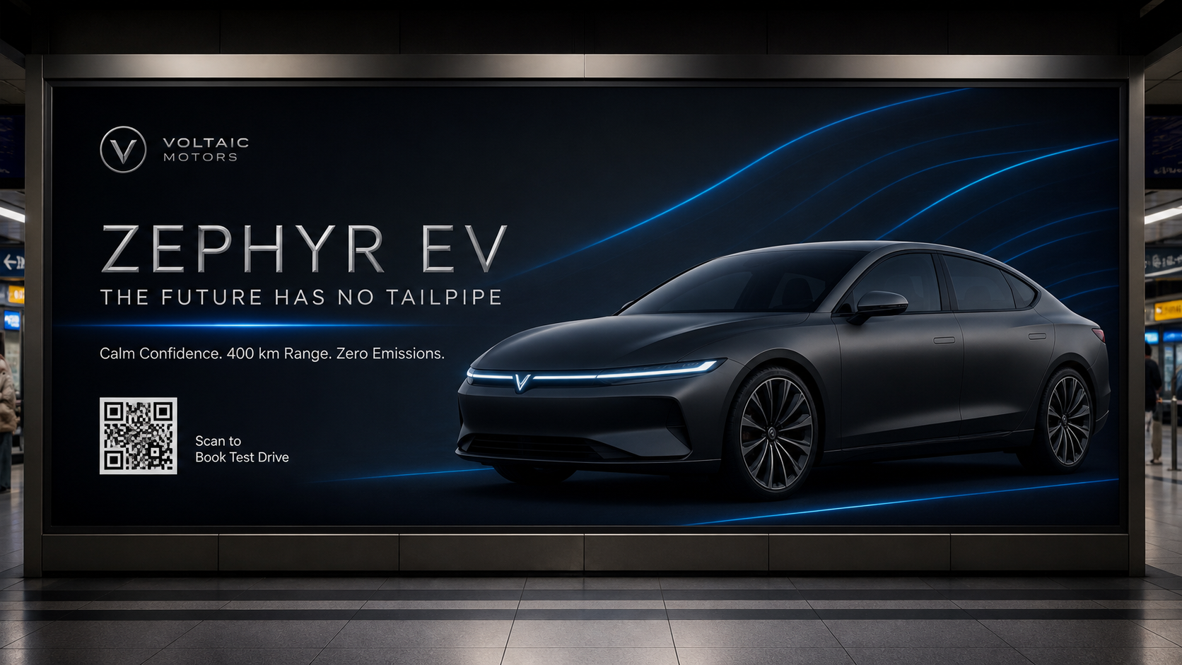
Reference Mockup A — Premium Minimalist — Matte Charcoal & Electric Blue
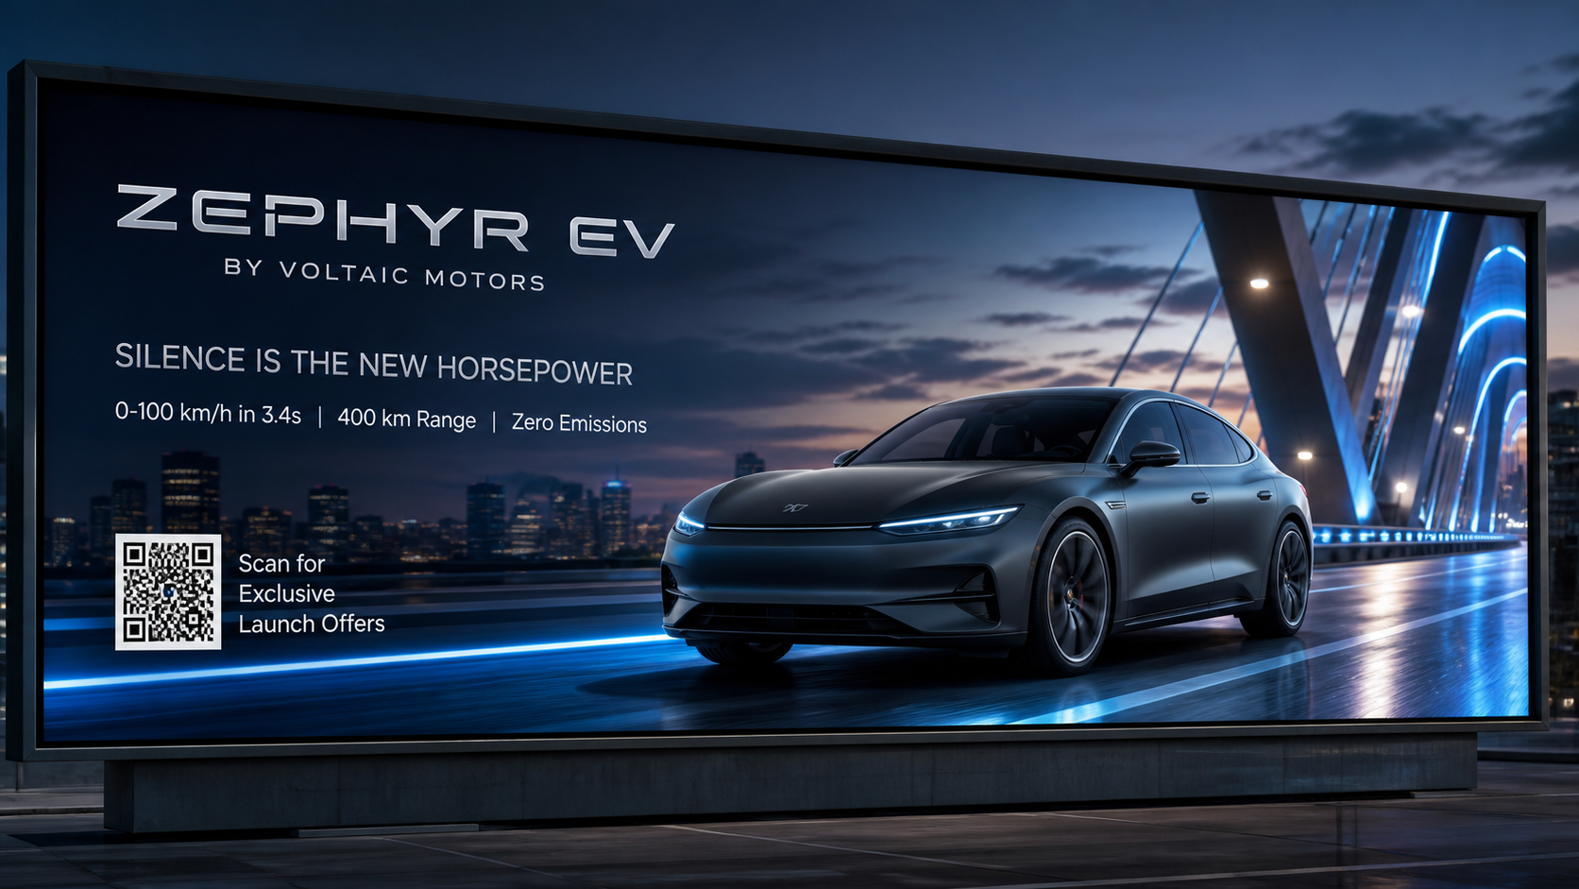
Reference Mockup B — 16:9 Metro Platform Wide-Screen Display

5. RFP Requirements (Sales Team Response)
To accept this campaign brief, the Urban Media commercial intelligence agent must generate a formalized response containing:
1. A curated shortlist of screens across the premium business-district platforms and auto-retail arterial corridors described above, ranked by affluent-commuter affinity.
2. An optimal price recommendation reflecting premium-node demand, platform dwell time, and proximity to competing dealerships.
3. Projected weekly impressions and test-drive-booking potential, with logical justification for each recommended location.

