CLIENT BRIEF 5: SKYNIMBUS AIRLINES — FLY FURTHER, FEEL CLOSER
Company Name | SkyNimbus Airlines Ltd.
Industry Vertical | TRAVEL & AVIATION
Campaign Objective | New Route Awareness & Bookings
Target Audience | Frequent flyers, business and leisure travelers (Ages 28-55)
Campaign Budget | USD 35,000
Campaign Duration | 40 Days (Proposed: Route-launch window, Q2 2027)

1. Executive Summary & Objective
SkyNimbus is launching twelve new international direct routes from Las Hackland and needs to build awareness among both business travelers who book frequently and leisure travelers planning ahead. The campaign favors aspirational, premium creative over discount messaging, with a secondary goal of driving direct bookings via the airline's app.

2. Target Audience & Persona
The audience splits into two overlapping groups: frequent business travelers who move through the city's financial core on a predictable schedule, and higher-income leisure travelers who plan trips well in advance. Both groups pass through the city's primary airport-transit corridor and premium business nodes regularly, making those corridors the natural anchor for reach.

3. Digital Screen Selection & Location Requirements
- Airport Transit Corridor: Premium wide-format screens along the primary airport access corridor — the single highest-relevance environment for a travel campaign, reaching an audience already in a travel mindset.
- Premium Business Core: Screens across the city's premium commercial core, reaching frequent business travellers on their daily commute.
- Financial District Coverage: Supplementary placement at major financial-district metro nodes for repeated business-traveller exposure across the campaign window.

4. Visual / Mockup Details & Slot Parameters
SkyNimbus will supply a premium motion asset. Sky-blue gradients transitioning to white, aspirational aerial photography style, and clean sans-serif typography reading "Fly Further. Feel Closer." Canvas optimized for wide-format premium transit corridor screens.
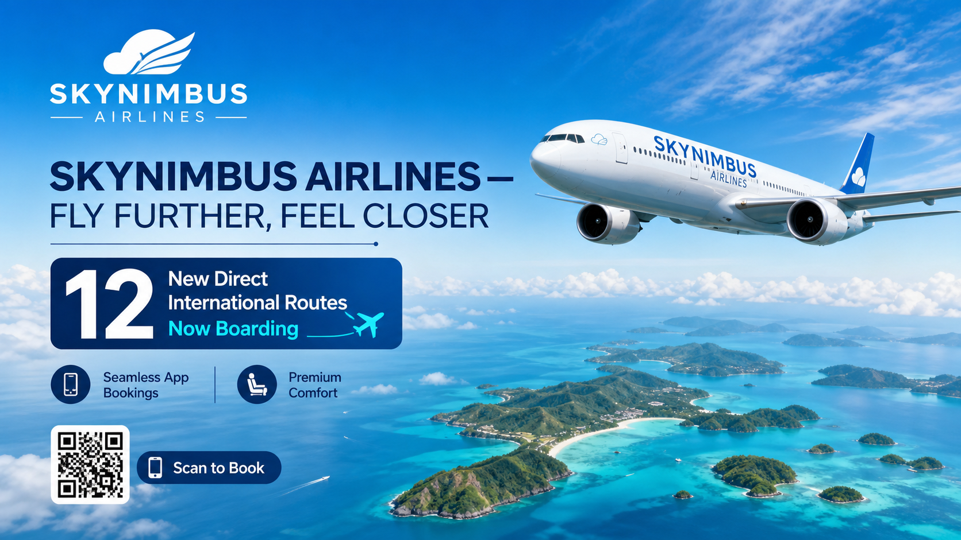
Reference Mockup A — Aspirational Premium — Sky Blue & White
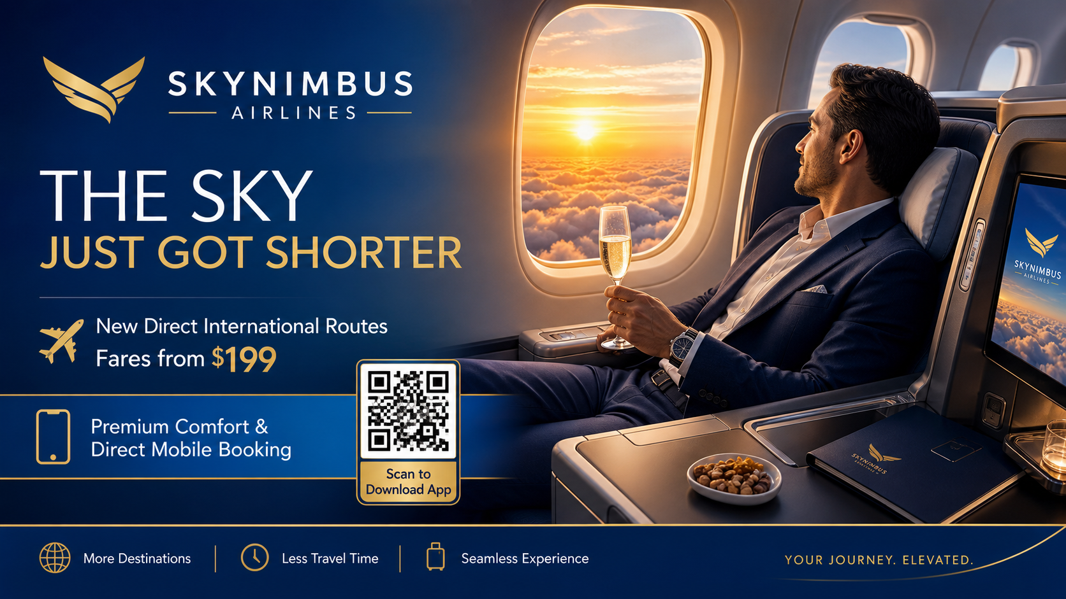
Reference Mockup B — 16:9 Airport Transit Corridor Wide-Screen Display

5. RFP Requirements (Sales Team Response)
To accept this campaign brief, the Urban Media commercial intelligence agent must generate a formalized response containing:
1. A curated list of screens anchored on the airport transit corridor and the premium business core.
2. Pricing reflecting premium-corridor demand and the overlap between the business and leisure traveller audiences.
3. Projected reach across the 40-day window, with separate estimates for repeat business-traveller frequency and one-time leisure-traveller exposure.

