CLIENT BRIEF 6: LUMIÈRE COSMETICS — GLOW ON YOUR TERMS
Company Name | Lumière Cosmetics Group
Industry Vertical | BEAUTY & PERSONAL CARE
Campaign Objective | New Product Launch Awareness
Target Audience | Young women, beauty-conscious commuters (Ages 18-34)
Campaign Budget | USD 20,000
Campaign Duration | 25 Days (Proposed: Spring product launch)

1. Executive Summary & Objective
Lumière is launching a new radiance serum and wants to build product awareness among beauty-conscious commuters ahead of in-store availability. The campaign leans on elegant, aspirational creative rather than discount-driven messaging, positioning the product as a premium addition to an existing skincare routine rather than an impulse buy.

2. Target Audience & Persona
The audience is young, beauty-engaged women who follow skincare trends closely and shop at both mall beauty counters and standalone retail. They are frequent mall visitors and regular metro commuters, and respond to elegant, editorial-style visuals over bold discount signage — the brand experience matters as much as the offer.

3. Digital Screen Selection & Location Requirements
- Mall Beauty-Retail Entry: Premium vertical screens at shopping centre entrances adjacent to beauty and lifestyle retail concessions, reaching shoppers moments before they pass a beauty counter.
- High-Street Retail Corridors: Vertical screens along high-street shopping strips with a concentration of competing beauty retailers.
- Central Metro Entry Coverage: Supplementary vertical placements at central metro entry points, for repeated commuter exposure ahead of weekend shopping trips.

4. Visual / Mockup Details & Slot Parameters
Lumière will supply a static editorial visual — soft blush pink and gold tones, elegant product photography, and refined serif-adjacent typography reading "Glow On Your Terms." Canvas optimized for tall vertical formats at mall and metro entry points.
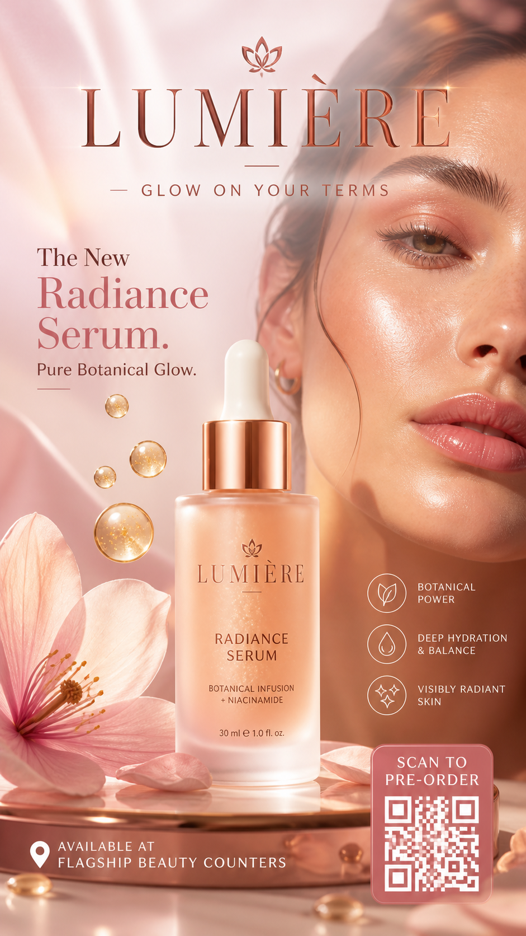
Reference Mockup A — Elegant Editorial — Blush Pink & Gold
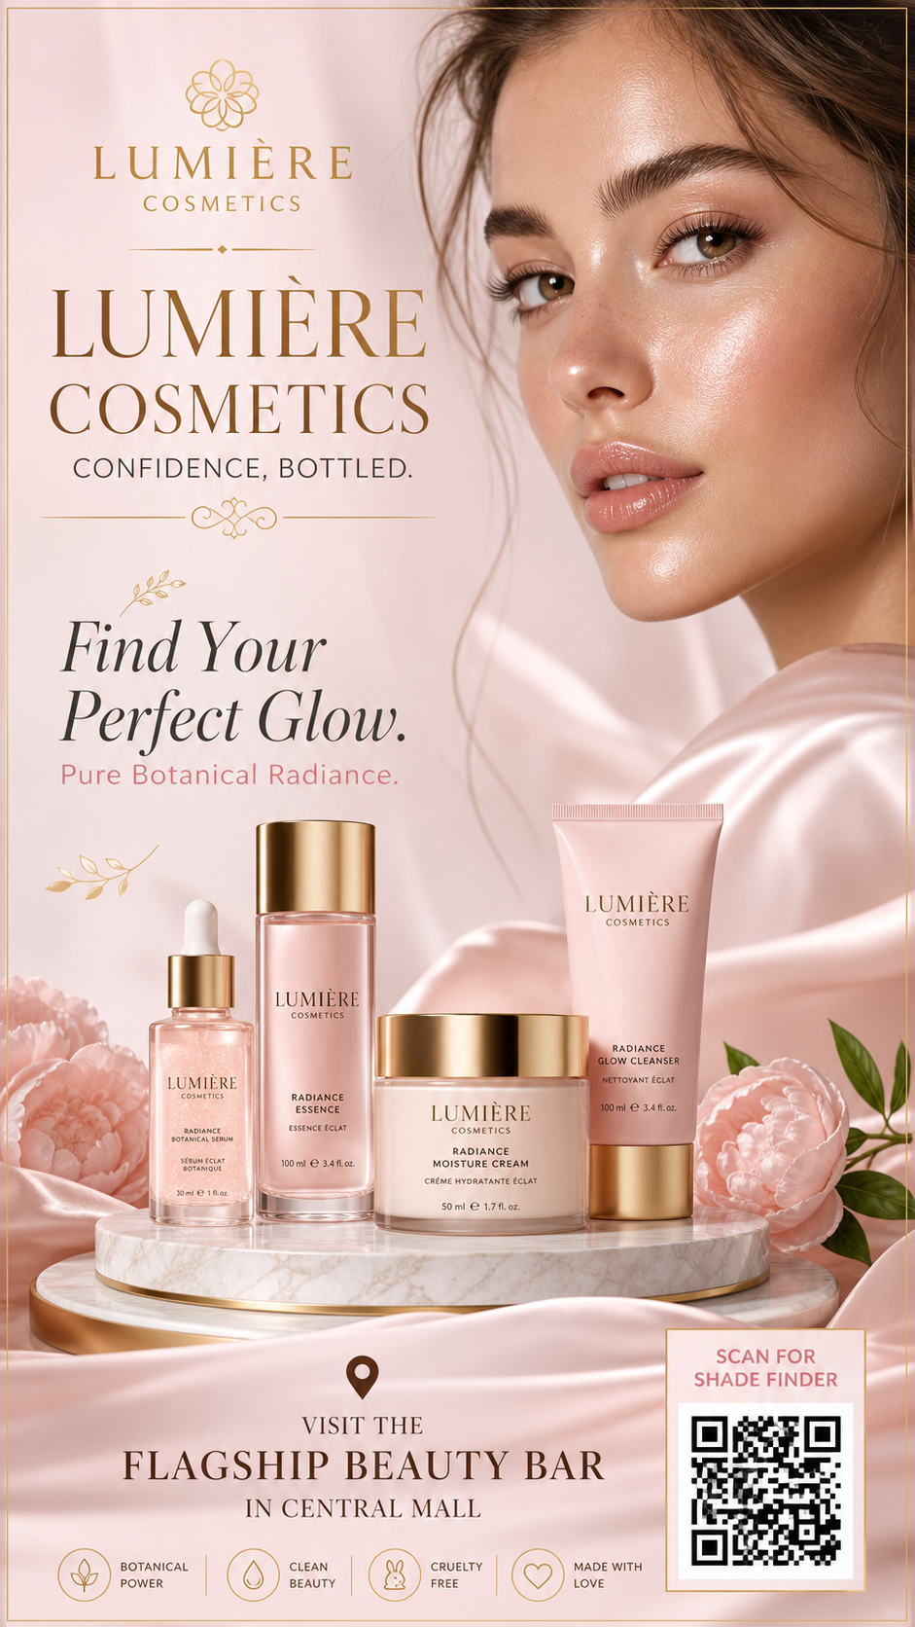
Reference Mockup B — 9:16 Vertical Mall / Metro Entry Poster

5. RFP Requirements (Sales Team Response)
To accept this campaign brief, the Urban Media commercial intelligence agent must generate a formalized response containing:
1. An inventory plan anchored on mall beauty-retail entry points and high-street retail corridors, with supplementary central metro entry coverage.
2. Pricing reflecting premium mall-entry positioning and the value of beauty-retail adjacency.
3. A projected reach estimate for the 25-day window, with reasoning tied to beauty-audience affinity at each recommended node type.

