Dataset Report
Retail Product Recommendation Using GNN - Amazon Reviews 2023, Video Games
Team: [Team member names] Enrollment: [Enrollment numbers] Guide: [Guide name]

1. Source
Amazon Reviews 2023, collected by the McAuley Lab (UC San Diego) and hosted on Hugging Face (McAuley-Lab/Amazon-Reviews-2023). We use one category, Video_Games, and two kinds of files: the benchmark 5-core interaction files split by timestamp (train / valid / test CSV) and the raw item metadata file (meta_Video_Games.jsonl). 'Core' means every user and every item in the full data has at least five interactions.

2. Schema
File | Field | Meaning
Interactions CSV | user_id | anonymised reviewer ID (string)
Interactions CSV | parent_asin | product ID; variants of one product share it
Interactions CSV | rating | 1.0 - 5.0 stars
Interactions CSV | timestamp | review time, Unix milliseconds
Metadata JSONL | parent_asin | product ID (joins to the interactions)
Metadata JSONL | title | product name
Metadata JSONL | categories | list: Video Games > platform > type > ...
Metadata JSONL | price | USD, missing for many items

Other metadata fields (images, description, store, details) exist but are not used by the model.

3. Raw data size
Split | Rows | Users | Products | Mean rating | Period
Train | 736,827 | 91,562 | 22,976 | 4.27 | Oct 1999 - Aug 2021
Valid | 34,510 | 15,655 | 7,620 | 4.18 | Aug 2021 - Jul 2022
Test | 43,249 | 13,963 | 7,671 | 4.31 | Jul 2022 - Sep 2023

The authors split by global time, so every test review is later than every training review. The earliest training reviews are from around 2000. Review volume is concentrated in recent years.
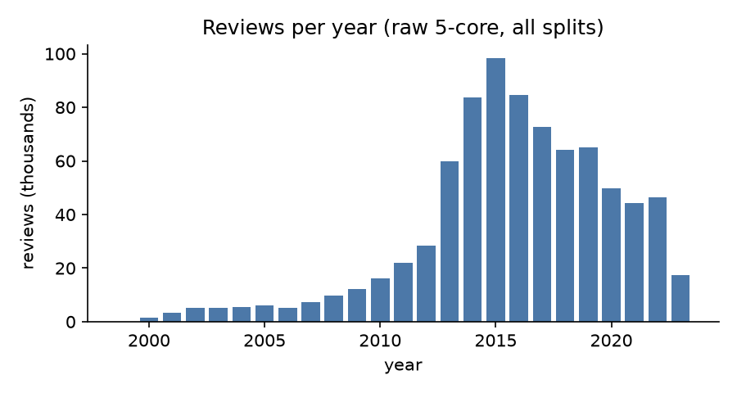
Figure 1. Reviews per year.
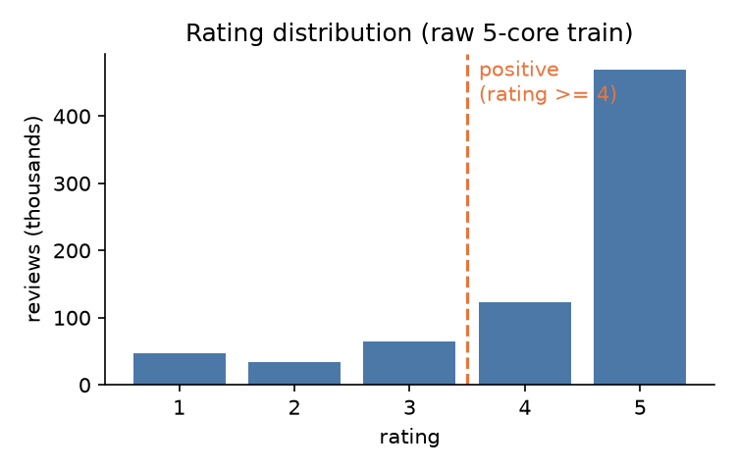
Figure 2. Ratings are strongly skewed positive.
80% of training reviews are rated 4 or 5. We therefore treat rating >= 4 as a positive implicit interaction and discard lower ratings rather than turning them into negatives.

4. Preprocessing and the kept subset
Step | Interactions | Users | Products
Raw 5-core train reviews | 736,827 | 91,562 | 22,976
Keep positives (rating >= 4) | 592,599 | 90,221 | 22,895
Subsample users + min-degree filter (final train) | 147,013 | 22,269 | 7,811

Subsampling keeps training on a laptop CPU to about two minutes. Users with activity in the validation or test periods are kept first (otherwise almost no sampled user would have future data to evaluate on), then random users fill up to 30,000; afterwards users with fewer than 3 and products with fewer than 5 positive training interactions are removed repeatedly until stable. Validation and test rows are then restricted to the kept users and products. Selection depends on which users appear later, but only for choosing who is modelled; no later interaction enters the graph or training. The kept users are somewhat more active than the full population.
Split | Positive interactions | Users
Train | 147,013 | 22,269
Validation | 5,640 | 3,888
Test | 2,912 | 2,111

Final graph (training edges only): 22,269 customers, 7,811 products, 147,013 edges, density 0.00085 (0.085% of possible pairs).

5. Distributions
Statistic | Mean | Median | Max | Min
Interactions per customer | 6.6 | 5 | 271 | 3
Interactions per product | 18.8 | 10 | 878 | 5

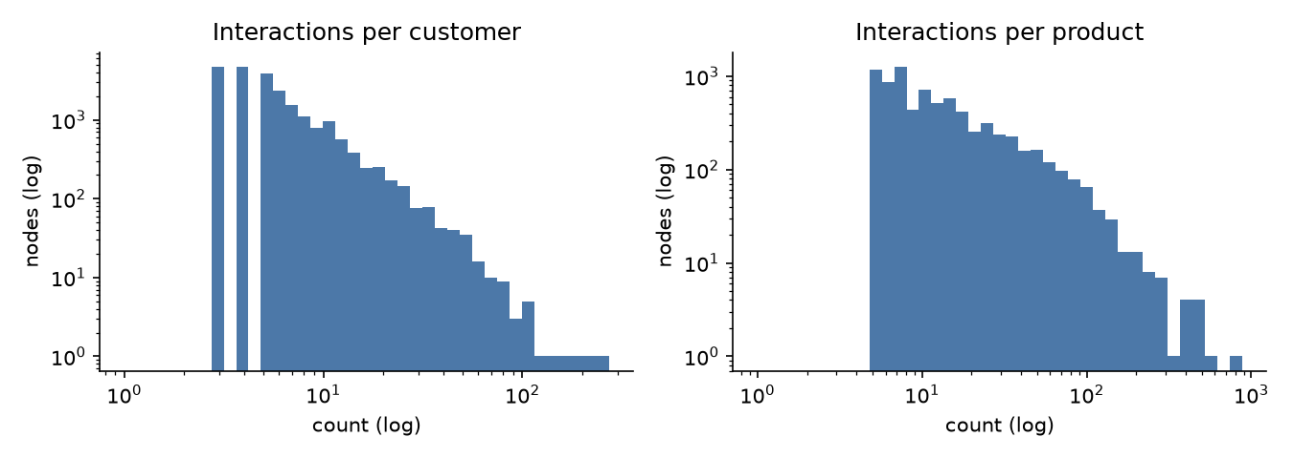
Figure 3. Both degree distributions are long-tailed.
The most popular 1% of products (78 items) account for 12.0% of training edges, a moderate concentration; most interactions are spread over the long tail. A popularity ranking is still a reasonable baseline, while the many low-degree customers make per-user embeddings hard to learn without graph smoothing.

6. Item metadata quality
Field | Coverage among kept products
title | 100.0%
category path | 100.0%
price | 72.7%

Items without a metadata record keep their ID as the title. Price is often missing, so it is shown in the demo but not used as a model feature.
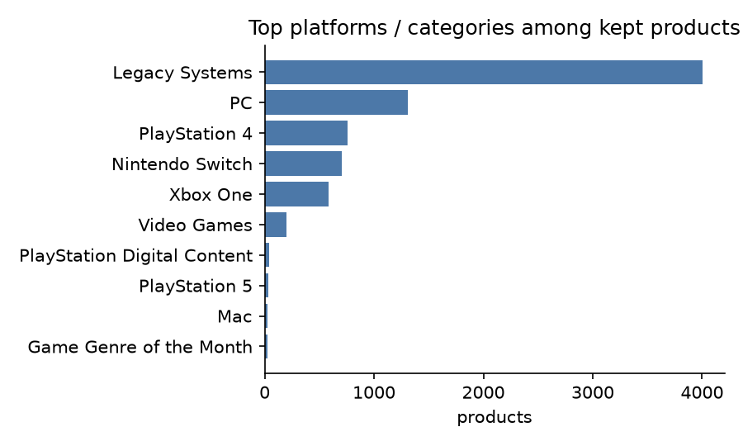
Figure 4. Leading top-level categories (platforms) among kept products.

7. Data quality, bias and ethics
- Reviews are not purchases: a review is a proxy for a purchase, and only people who chose to review appear.
- Positive skew: most ratings are 4-5, so ratings carry little negative signal; we use only positives.
- Popularity bias: a few products dominate interactions, which recommenders tend to amplify.
- Subsample bias: our users are more active than average; results may not carry to the whole population.
- Privacy: user IDs are anonymised hashes; no personal text is used by the model. The dataset is public for research use; check its terms before any commercial use.

8. Reproduction
Run `python -m src.data` to download the files from Hugging Face and regenerate data/processed/ (train.csv, val.csv, test.csv with columns user, item, timestamp; users.csv and items.csv are ID maps, the latter with metadata). Random seed 42.

9. Citation
Hou, Y., Li, J., He, Z., Yan, A., Chen, X., McAuley, J. Bridging Language and Items for Retrieval and Recommendation. arXiv 2024 (Amazon Reviews 2023).

