Helmet Detection and License Plate Recognition System for Rider Safety Enforcement
###-#-####-####-#/##/$31.00 ©2023 IEEE

Authors Name/s per 1st Affiliation (Author)
line 1 (of Affiliation): dept. name of organization
line 2: name of organization, acronyms acceptable
line 3: City, Country
line 4: e-mail address if desired
Authors Name/s per 2nd Affiliation (Author)
line 1 (of Affiliation): dept. name of organization
line 2: name of organization, acronyms acceptable
line 3: City, Country
line 4: e-mail address if desired

Abstract— Road safety is still a major public health problem due to the fast rise in urban motorization, especially for two-wheeler riders who are more likely to sustain brain injuries in collisions. Despite being required in many places, helmets are frequently ignored, hence new technology is needed to ensure compliance. This study offers an AI-powered solution that can automatically identify helmet wear and record license plate data, allowing for automated warnings and alerts to encourage adherence to safety protocols. In order to identify riders without helmets in real-time from photos, our system makes use of sophisticated computer vision and deep learning models, particularly YOLO (You Only Look Once). The system isolates the rider's face and activates a backup model to find the motorcycle's license plate when it detects a helmet infringement. In order to precisely extract the license plate text for identifying reasons, we use Optical Character Recognition (OCR) with EasyOCR. Through this identification procedure, registered motorcyclists can receive personalized email notifications that include visual proof of the infraction and promote helmet wear while reminding them of safety precautions. The system's accuracy and resilience under trying circumstances are demonstrated by the use of sophisticated machine learning models, such as OCR for text extraction and YOLO for object identification. This research provides a scalable and effective way to help companies and law enforcement agencies enforce rider safety regulations by automating helmet recognition and documentation. The work suggests a revolutionary step towards improving road safety compliance with AI-based interventions, outlining the technical implementation, model accuracy, limitations, and future possibilities.
Key features: Yolo , easyocr, smtplib, from email.mime.text import MIMEText.

Introduction (Heading 1)
The sharp rise in two-wheeler traffic in recent years has raised worries about road safety globally and greatly increased urban traffic congestion. Road traffic injuries are the primary cause of death for young adults, according to the World Health Organization. Because two-wheelers offer little physical protection, riders are especially susceptible to serious injuries. Helmet wearing is one of the most important safety precautions for motorcycle riders, as it can lower the risk of fatalities by 42% and head injuries by almost 70%. Although many regions have laws requiring the use of helmets, compliance varies, therefore efficient monitoring and enforcement systems are required, Conventional techniques for ensuring helmet compliance, such law enforcement's manual monitoring, are frequently ineffective, resource-intensive, and prone to human mistake. There is a great chance to use the emerging fields of artificial intelligence (AI) and machine learning (ML) to automate helmet identification and boost traffic surveillance systems' effectiveness. To close this gap in road safety enforcement, our study suggests an AI-enhanced helmet detection and license plate recognition system. This method seeks to boost helmet use among two-wheeler riders by automatically detecting helmet violations and identifying non-compliant riders, thereby lowering accident-related injuries and fatalities. Modern object detection and optical character recognition (OCR) techniques are integrated into the system to offer a complete automated rider identification solution. The system's main technology is the YOLO (You Only Look Once) object identification model, which is well-known for its quickness and high accuracy in recognizing several items in a single image. In the event of a violation, YOLO is used in two stages: first, to determine whether a rider is wearing a helmet, and second, to isolate and record the rider's vehicle's license plate. Once the license plate has been detected, the registered owner of the car can be identified by using the EasyOCR library to extract text from the plate image. This automatic identification and detection process is further enhanced by an integrated notification system. The system tells the registered owner via email when it finds evidence of helmet infringement, including a photo of the cyclist without a helmet. The email contains evidence of the violation and a customized reminder on the need of wearing a helmet in order to motivate motorcycle riders to follow safety rules. This research is innovative because it seamlessly combines OCR technology with deep learning models to produce a scalable, real-time helmet compliance monitoring solution. The research investigates how AI can improve public safety while addressing the shortcomings of the enforcement strategies in place. The study also addresses the difficulties in text extraction and image detection, the ethical issues with privacy in AI-based enforcement, and the technological implementation of the system, model training, and testing procedures. By offering a useful implementation of deep learning in road safety enforcement, this study advances the expanding field of artificial intelligence in public safety and has the potential to be implemented in cities across the globe. In conclusion, this study shows how AI-driven solutions may revolutionize helmet compliance monitoring from a labor-intensive, manual process to a productive, automated one. This system offers a cutting-edge tool that supports international objectives for improving traffic safety by tackling non-compliance and making roads safer.

Methodology
The four primary phases of the research technique are automatic email notification, license plate text extraction, helmet detection, and license plate detection. In order to build a smooth, automated system that recognizes the rider's vehicle, detects helmet infractions, and swiftly warns them, each step uses particular AI models, computer vision techniques, and data processing approaches.
2.1Helmet Detection: The system's initial step is to determine if a cyclist is wearing a helmet. Because of its accuracy and speed in real-time applications, the YOLO (You Only Look Once) object identification model is used in this process. Because YOLO's architecture divides an image into a grid and predicts bounding boxes and class probabilities for each grid cell, it can recognize numerous objects within an image at once. A specially trained YOLO model is employed, with distinct classes for "helmet" and "rider." A dataset of pictures of riders wearing and not wearing helmets was used to train the model, guaranteeing that it can distinguish between the two situations with accuracy.The YOLO model processes the input image, which is usually taken by a traffic or roadside camera. Bounding boxes containing the class labels and confidence scores of the discovered items are produced by the model.
Violation Identification: The model marks a rider as in violation if it detects that the rider is not wearing a helmet, as shown by the "helmet" class not being included in the bounding boxes linked to the rider class. Coordinates for the bounding box surrounding the rider are also output by the model and will be utilized in the following stages.Example In order to illustrate a scenario in which no helmet is detected, it is suggested that you include an image of an example input frame with bounding boxes surrounding a rider and helmet
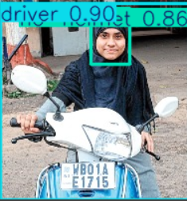
Figure 1: Helmet Detection
2.2 Licence Plate Detection:
The system then uses the license plate to identify the rider's vehicle when a helmet violation has been verified. A YOLO model, which has been individually trained to detect license plates particularly, is also used to do this.
Model Deployment: Only pictures of cars with license plates were used to train the license plate detection model, which employs a distinct set of weights. This guarantees that it recognizes the license plate region on a range of cars with accuracy.
Bounding Box Extraction: The YOLO model creates a bounding box around the identified license plate after
processing the cropped rider picture from the previous stage. In order to isolate the license plate for additional processing during the text extraction stage, this bounding box is utilized.
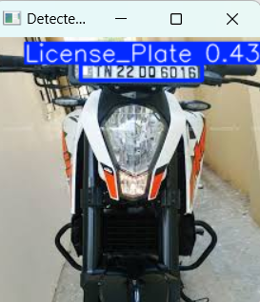
Figure 2: Licence Plate Detection

2.3License Plate Text Extraction:
Extracting the alphanumeric text from the license plate is the next step once the image has been isolated. Optical Character Recognition (OCR) via EasyOCR, which can handle a variety of font styles and backgrounds frequently seen on license plates, is used in this stage.
Image preprocessing: The license plate image is first made grayscale in order to increase OCR accuracy. To improve text contrast and facilitate the OCR process, further image processing methods like thresholding are used.
OCR Application: EasyOCR extracts the text from the license plate by reading the processed image. A string of characters representing the vehicle's unique identifying number is the output.
Text Validation: The retrieved text is checked against common license plate types to guarantee accuracy.
Figure 3: License Plate Text Extraction

2.4Email Notification System:

Notifying the registered owner of the car via email is the last step after the license plate text has been properly extracted. This alert acts as a reminder to follow helmet safety guidelines.
SMTP Email Configuration: Email notifications are sent by the system via the Simple Mail Transfer Protocol (SMTP). For this purpose, a special email account is set up with the appropriate security settings (such TLS) and authentication to guarantee secure communication.
Email Attachment and Content: The email message highlights the significance of wearing a helmet for safety and provides a brief explanation of the helmet violation. As proof, a picture of the cyclist sans a helmet is included. For reference, the retrieved license plate information is also included in the email.
Automated Delivery: The registered email address linked to the vehicle's license plate receives the email content automatically after it has been prepared. Every notification is recorded by the system for future reference.
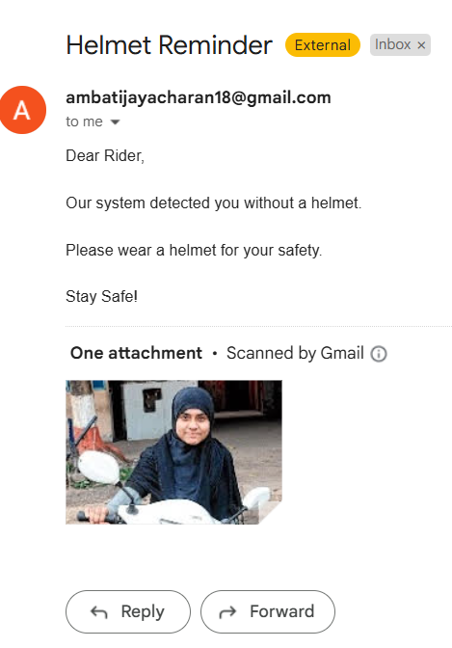
Figure 4: Email Notification System

Related works
[1] By using sensors to identify elevation changes and offer haptic feedback, the smart insole shoe helps blind people navigate stairs and obstacles. Stability on stairs is ensured via a heel-locking mechanism. Design that prioritizes safety and aims to increase the freedom of visually impaired people is informed by modeling, surveys, and patent research.[2] By identifying impediments and providing navigational guidance, the "Smart Shoes" technology helps people with visual impairments. An Arduino receives data from embedded sensors and uses it to connect to a smartphone app for auditory notifications. The app encourages independence and safe mobility by integrating with Google Maps to deliver instructions and obstacle notifications.[3] By employing ultrasonic sensors to identify obstructions at the knee, ground, and side levels, the "Smart Shoe System" helps those with vision impairments. It is controlled by an Arduino microcontroller and allows autonomous navigation by providing audio feedback through headphones. GPS integration for destination navigation is one possible future improvement.[4] A research team created smart shoes with GPS navigation and 89.5% accurate obstacle recognition based on Arduino for the blind and visually handicapped. The system provides vibrations and audio-visual alerts via sensors,
Bluetooth, and a smartphone app. Although it has limits when it comes to recognizing small things, testing revealed an average response time of 3.08 seconds.[5] A research team created smart shoes with GPS navigation and 89.5% accurate obstacle recognition based on Arduino for the blind and visually handicapped. The system provides vibrations and audio-visual alerts via sensors, Bluetooth, and a smartphone app. Although it has limits when it comes to recognizing small things, testing revealed an average response time of 3.08 seconds.

Result And Discussion
The results of our helmet and license plate identification system are presented in this section, with particular attention paid to model performance in various scenarios and the potential for enhancement through further training and sophisticated designs. The first model was trained for just five epochs and was based on the YOLOv8 framework, which was chosen for its successful trade-off between accuracy and computational efficiency. This brief instruction served as a helpful starting point for assessing the system's initial performance. Despite being fast to deploy, the model's accuracy was only modest, indicating a number of areas that needed work, particularly in situations with complicated backgrounds, different lighting conditions, and partially hidden license plates or helmets.
The model's accuracy for helmet detection was about 80%, but it had trouble with false positives and false negatives, especially when the helmets were partially hidden or seemed smaller. Similar difficulties were encountered by license plate detection, which only achieved about 75% accuracy. The quality of the OCR-based text extraction for plates fluctuated, sometimes encountering issues when the plates were either blurry or in low light, which occasionally led to inaccurate or partial text interpretations.
Increasing the number of training epochs is one of the simplest ways to improve the system's performance. Longer training would expose the model to more data, improving its comprehension of intricate patterns and, thus, its capacity for generalization. It is anticipated that helmet identification accuracy would increase to above 90% when training epochs are increased from 5 to 50 or more. This is because the model's parameters will better accommodate the dataset's diversity. When paired with realistic and varied training scenarios, this expansion may assist lower false positives and false negatives. But it's crucial to have a comprehensive dataset that includes a variety of lighting situations, occlusions, and background objects in order to reduce the risk of overfitting.
Investigating the YOLOv11 architecture presents further opportunities for accuracy gains beyond prolonged training with YOLOv8. In order to recognize helmets and license plates in difficult scenarios, YOLOv11 offers architectural improvements that improve feature extraction for small items in complex environments. Because of its deeper layers and increased detection capabilities, we expect YOLOv11 to have better detection precision and fewer errors. The growing model complexity and greater datasets required for training, however, also necessitate the use of more computational resources, especially high-capacity GPUs with sufficient VRAM. By allowing the system to handle more data and speeding up training timeframes, such resources would increase the accuracy and resilience of the model.
Realizing the promise of YOLOv11 and later epochs still requires increasing processing resources, especially when implementing in real-time applications. Despite its promising accuracy, YOLOv11's increased complexity may somewhat slow down inference, which would affect responsiveness in real time. Making the system workable for real-time applications requires striking the correct balance between operational effectiveness and accuracy. According to the results, helmet and license plate detection might be much enhanced by both prolonged epochs and investigating YOLOv11, resulting in a more reliable and flexible system.
In conclusion, the significance of repeated model refining is demonstrated by this examination of preliminary findings and suggested enhancements. As demonstrated by this study, increasing the length of training epochs and taking into account more recent architectures like YOLOv11 can improve detection reliability and increase the system's applicability in a variety of difficult situations. For a deployment to be both feasible and effective, it is crucial to strike a balance between the availability of computational resources, deployment limits, and accuracy increases

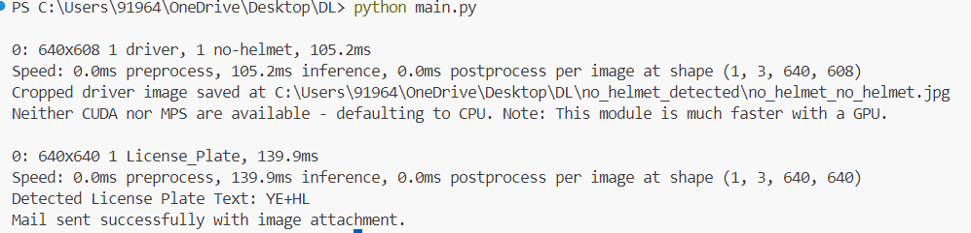
Figure 5:Final result of detection of helmet and number pate,and sent request mail.

Referance Paper
[1]J.Chiverton, “Helmet Presence Classification with Motorcycle Detection And Tracking”,IET Intelligent Transport Systems,Vol. 6, Issue 3, pp. 259–269, March 2012. [2]. Rattapoom Waranusast, Nannaphat Bundon, Vasan Timtong and Chainarong Tangnoi, “Machine Vision techniques for Motorcycle Safety Helmet Detection”, 28th International Conference on Image and Vision Computing New Zealand, pp 35-40, IVCNZ 2013.
[3]. Romuere Silva, Kelson Aires, Thiago Santos, Kalyf Abdala, Rodrigo Veras, Andr´e Soares, “Automatic Detection Of Motorcyclists without Helmet”, 2013 XXXIX Latin America Computing Conference (CLEI).IEEE,2013.
[4]. Romuere Silva, “Helmet Detection on Motorcyclists Using Image Descriptors and Classifiers”, 27th SIBGRAPI Conference on Graphics, Patterns and Images.IEEE, 2014.
[5]. Thepnimit Marayatr, Pinit Kumhom, “Motorcyclist‟s Helmet Wearing Detection Using Image Processing”, Advanced Materials Research Vol 931- 932,pp. 588-592,May-2014.
[6]. Amir Mukhtar, Tong Boon Tang, “Vision Based Motorcycle Detection using HOG features”, IEEE International Conference on Signal and Image Processing Applications (ICSIPA).IEEE, 2015.
[7]. Abu H. M. Rubaiyat, Tanjin T. Toma, Masoumeh Kalantari-Khandani, “Automatic Detection of Helmet Uses for Construction Safety”, IEEE/WIC/ACM International Conference on Web Intelligence Workshops(WIW).IEEE, 2016.
[8]. XINHUA JIANG “A Study of Low-resolution Safety Helmet Image Recognition Combining Statistical Features with Artificial Neural Network”.ISSN: 1473-804x
[9]. Kunal Dahiya, Dinesh Singh, C. Krishna Mohan, “Automatic Detection of Bike-riders without Helmet using Surveillance Videos in Real-time”, International joint conference on neural network(IJCNN). IEEE, 2016.
[10]. Maharsh Desai, Shubham Khandelwal, Lokneesh Singh, Prof. Shilpa Gite, “Automatic Helmet Detection on Public Roads”, International Journal of Engineering Trends and Technology (IJETT), Volume 35 Number 5- May 2016, ISSN: 2231-5381.

- Table Type Styles
a. Sample of a Table footnote. (Table footnote)

- Example of a figure caption. (figure caption)
We suggest that you use a text box to insert a graphic (which is ideally a 300 dpi TIFF or EPS file, with all fonts embedded) because, in an MSW document, this method is somewhat more stable than directly inserting a picture.
To have non-visible rules on your frame, use the MSWord “Format” pull-down menu, select Text Box > Colors and Lines to choose No Fill and No Line.

References
The template will number citations consecutively within brackets [1]. The sentence punctuation follows the bracket [2]. Refer simply to the reference number, as in [3]—do not use “Ref. [3]” or “reference [3]” except at the beginning of a sentence: “Reference [3] was the first . . .”
Number footnotes separately in superscripts. Place the actual footnote at the bottom of the column in which it was cited. Do not put footnotes in the reference list. Use letters for table footnotes.
Unless there are six authors or more give all authors' names; do not use “et al.”. Papers that have not been published, even if they have been submitted for publication, should be cited as “unpublished” [4]. Papers that have been accepted for publication should be cited as “in press” [5]. Capitalize only the first word in a paper title, except for proper nouns and element symbols.
For papers published in translation journals, please give the

