* main goal is to make a robot move from point A to point In a safe way

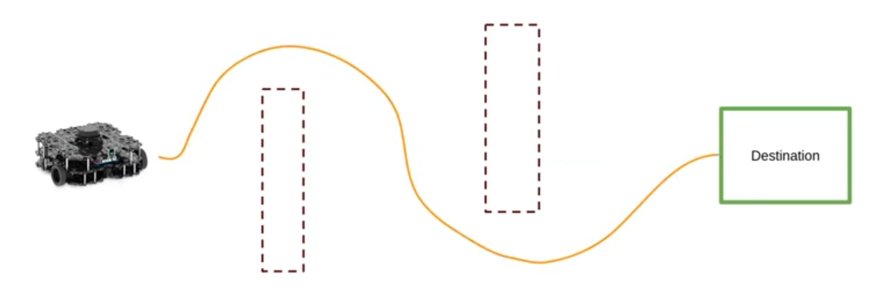

* To achieve this we need to do two things

1. Create a map(with slam)
2. Make the robot navigate from point A to point B

**Creating a map**

* For creating a map first we need to launch turtlebot3

**ros2 launch turtlebot3_gazebo turtlebot3_world.launch.py**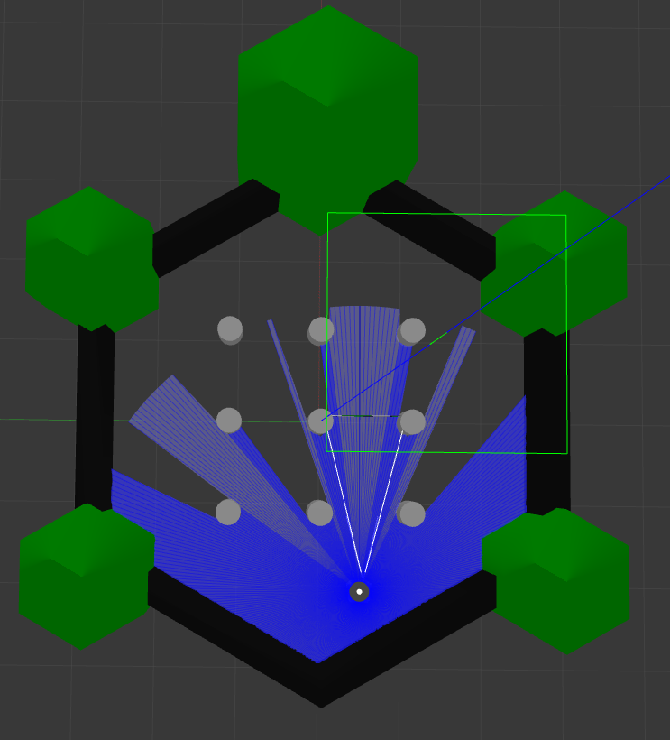

* Know we need to open Rvis to to create a map

**ros2 launch turtlebot3_cartographer cartographer.launch.py use_sim_time:=True**

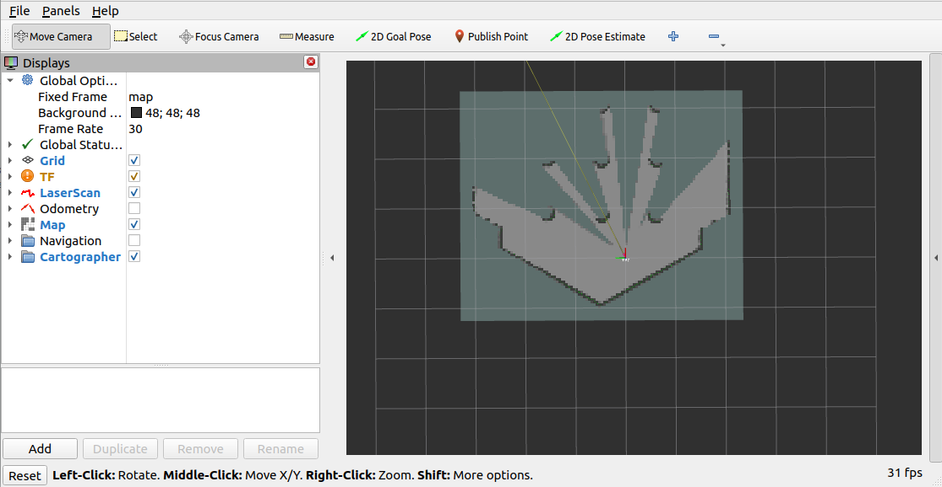

* It is an another software which is used to represent the map which your object is know by using lider
* Now we have to use teleop to move the object manually to create a whole map by using lider as of know or we can use drive and also we can create a whole map automatically

Manually - **ros2 run turtlebot3_teleop teleop_keyboard**

Automatically - **ros2 run turtlebot3_gazebo turtlebot3_drive**

* **By using any of these we should prepare map**

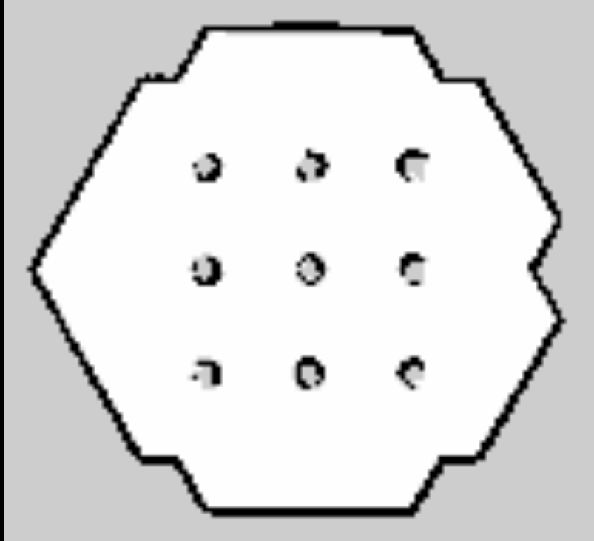

* Ones after creating the map we need to save the map

**Ros2 run nav2_map_server map_saver_cli -f maps/my_map**

* Understanding the map

1. Black - obstacle
2. White - free space
3. Brown - unknow space

* Ones after creating and saving the map we need to import the map in Rvis

**ros2 launch turtlebot3_navigation2 navigation2.launch.py use_sim_time:=True map:=maps/my_map.yaml**

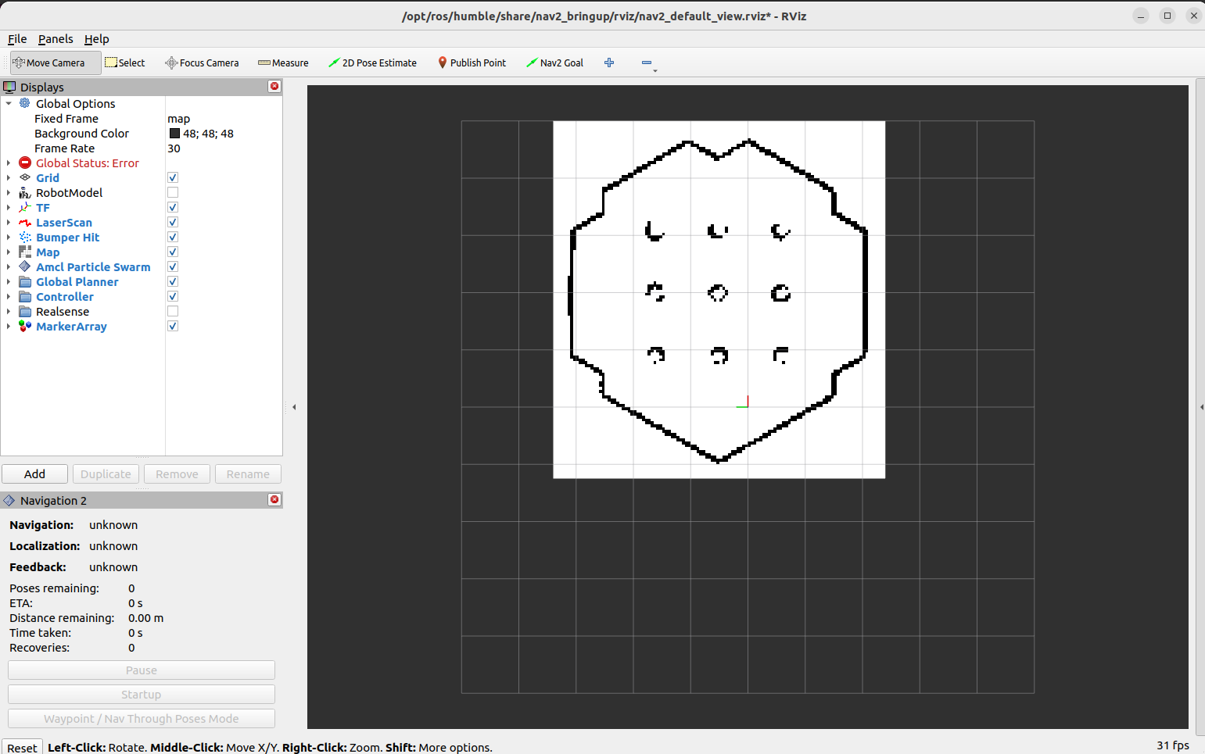

* Ones after importing the map in Rvis we need to set the origin and destination then the object will take it’s own direction

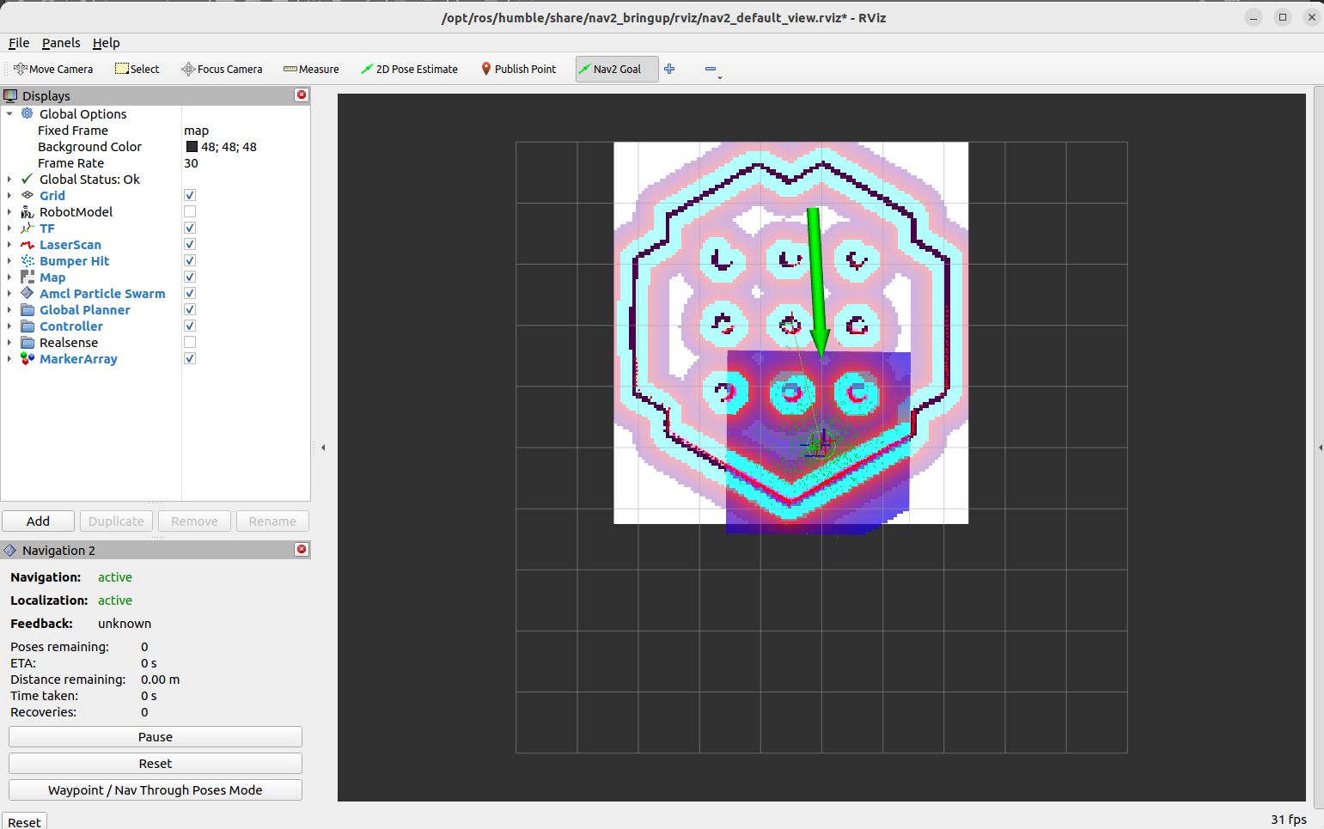

* We can set multiple destination points also so it will go in the path we say

