Titanic Dataset Analysis
Data Analysis Project — Week 4, Data Science with Python

1. Objective
This report analyzes the Titanic passenger dataset (891 passengers) to identify patterns in who survived the disaster and why, examining the effects of sex, passenger class, and age on survival outcomes.

2. Data Cleaning
The raw dataset had missing values in the Age (177 missing) and Embarked (2 missing) columns, and was almost entirely missing for Cabin (687 missing). The following steps were applied:
- Age: filled missing values with the median age
- Embarked: filled missing values with the most common port
- Cabin, Ticket, Name, PassengerId: dropped as not relevant to this analysis

3. Key Findings
Overall, 38.4% of passengers in the dataset survived. Breaking this down by group reveals clear patterns:
- Sex was the strongest predictor of survival: women survived at 74.2%, compared to 18.9% for men — consistent with a "women and children first" evacuation policy.
- Passenger class mattered significantly: 1st class passengers survived at 63.0%, versus 47.3% for 2nd class and only 24.2% for 3rd class, reflecting differences in cabin location and lifeboat access.
- Class and sex compounded: 1st class women survived at 96.8%, while 3rd class men survived at just 13.5% — the widest gap in the dataset.
- Children had a survival advantage: the Child age group (0–12) had the highest survival rate at 58.0%, while Seniors (60+) had the lowest at 22.7%.

4. Visualizations
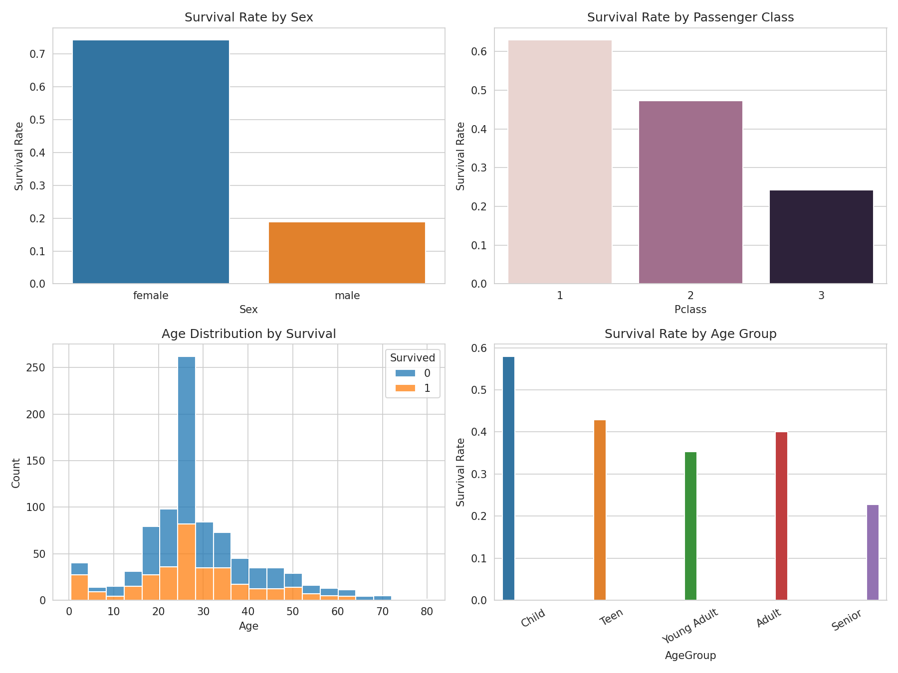

5. Conclusion
Survival on the Titanic was not random: it was strongly shaped by social factors. Being female, traveling in a higher class, and being a child were all associated with a much higher chance of survival, while adult men in 3rd class faced the worst odds by a wide margin. These findings are consistent with the historical account of the disaster and the evacuation priorities of the time.

