**DAY 3 TASK(02-07-2020):**

**1. Create a collections of 10 students.**

db.user.insertMany([

{

"name" : "Student 1",

"age" : 20,

"marks" : {

"english" : 60,

"maths" : 45,

"pthysics" :50 ,

"biology" : 30

},

"skills" : ["Drawing","Dancing"]

},

{

"name" : "Student 2",

"age" : 20,

"marks" : {

"english" : 40,

"maths" : 15,

"pthysics" :50 ,

"biology" : 30

},

"skills" : ["Drawing","Dancing"]

},

{

"name" : "Student 3",

"age" : 20,

"marks" : {

"english" : 30,

"maths" : 20,

"pthysics" :50 ,

"biology" : 30

},

"skills" : ["Drawing","Dancing"]

},

{

"name" : "Student 4",

"age" : 20,

"marks" : {

"english" : 90,

"maths" : 40,

"pthysics" :50 ,

"biology" : 30

},

"skills" : ["Drawing","Dancing"]

},

{ {

"name" : "Student 5",

"age" : 20,

"marks" : {

"english" : 80,

"maths" : 45,

"pthysics" :50 ,

"biology" : 30

},

"skills" : ["Drawing","Dancing"]

},

{

"name" : "Student 6",

"age" : 20,

"marks" : {

"english" : 30,

"maths" : 10,

"pthysics" :50 ,

"biology" : 30

},

"skills" : ["Drawing","Dancing"]

},

{

"name" : "Student 7",

"age" : 20,

"marks" : {

"english" : 40,

"maths" : 32,

"pthysics" :50 ,

"biology" : 30

},

"skills" : ["Drawing","Dancing"]

},

{

"name" : "Student 8",

"age" : 20,

"marks" : {

"english" : 20,

"maths" : 56,

"pthysics" :50 ,

"biology" : 30

},

"skills" : ["Drawing","Dancing"]

},

{

"name" : "Student 9",

"age" : 20,

"marks" : {

"english" : 60,

"maths" : 56,

"pthysics" :50 ,

"biology" : 30

},

"skills" : ["Drawing","Dancing"]

},

{

"name" : "Student 10",

"age" : 20,

"marks" : {

"english" : 50,

"maths" : 5,

"pthysics" :50 ,

"biology" : 30

},

"skills" : ["Drawing","Dancing"]

}

]);

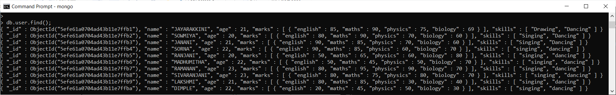

**2.Find all students who scored more than 40 marks in english**

db.student.find({

"marks.english":{

"$gt":40

}

});

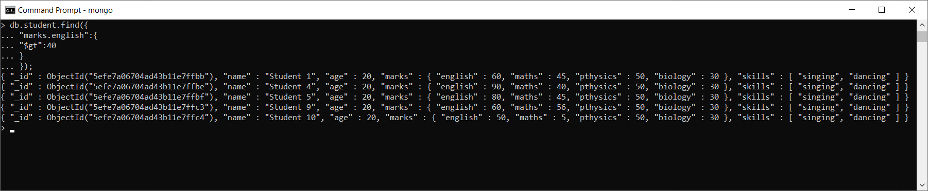

**3.Find all students who scored less than 25 marks in maths**

db.student.find({

"marks.maths":{

"$lt":25

}

});

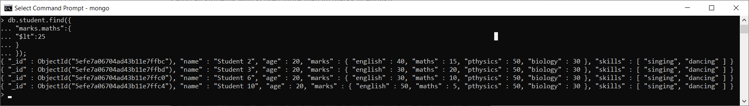

**4.Find the average of student 7**

db.student.aggregate(

[

{$match:{name:"Student 7"}},

{

$group: {

_id:"$name" ,

Average: { $avg: { $avg: [

"$marks.english",

"$marks.maths",

"$marks.pthysics",

"$marks.biology"

]

}

}

}

}

])

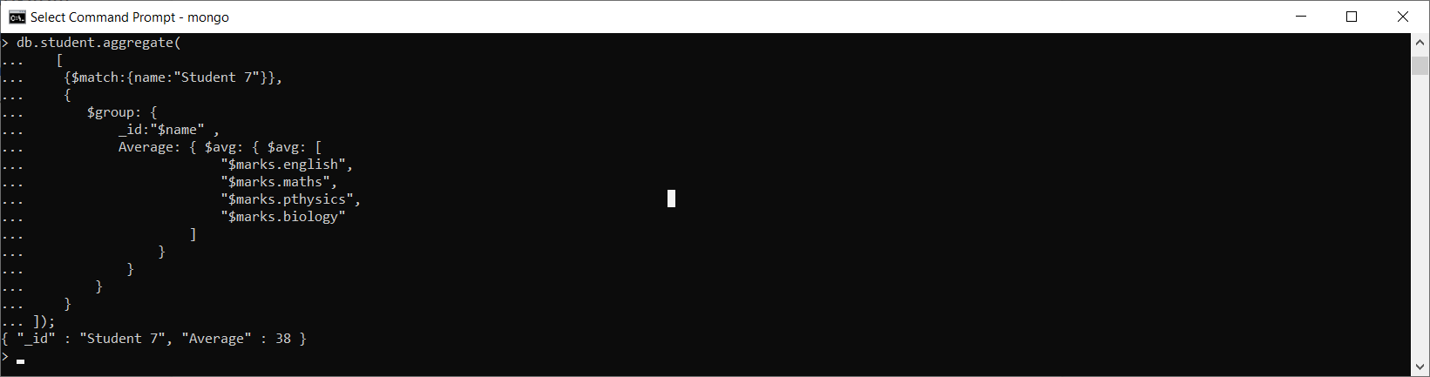

**5.Find the total mark of Student 10**

db.student.aggregate(

[

{$match:{name:"Student 10"}},

{

$group: {

_id:"$name" ,

Total: { $sum: { $sum: [

"$marks.english",

"$marks.maths",

"$marks.pthysics",

"$marks.biology"

]

}

}

}

}

]);

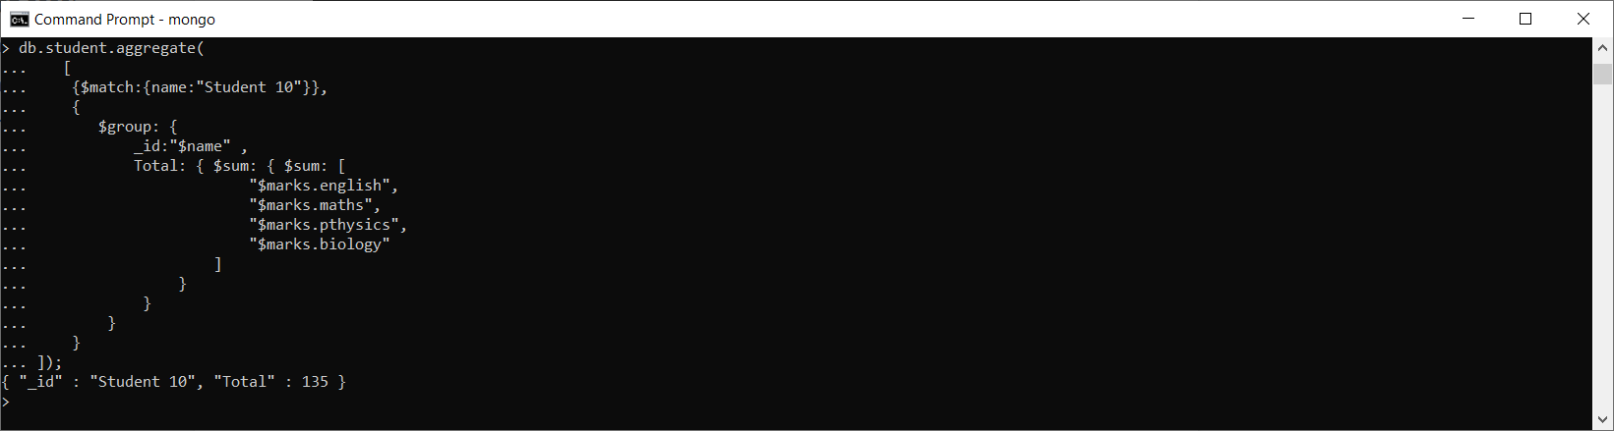

**6.Add a skill calling “sports” to a student**

db.student.update(

{name:”Student 5”},

{$push:{skill:”sports”}}

);

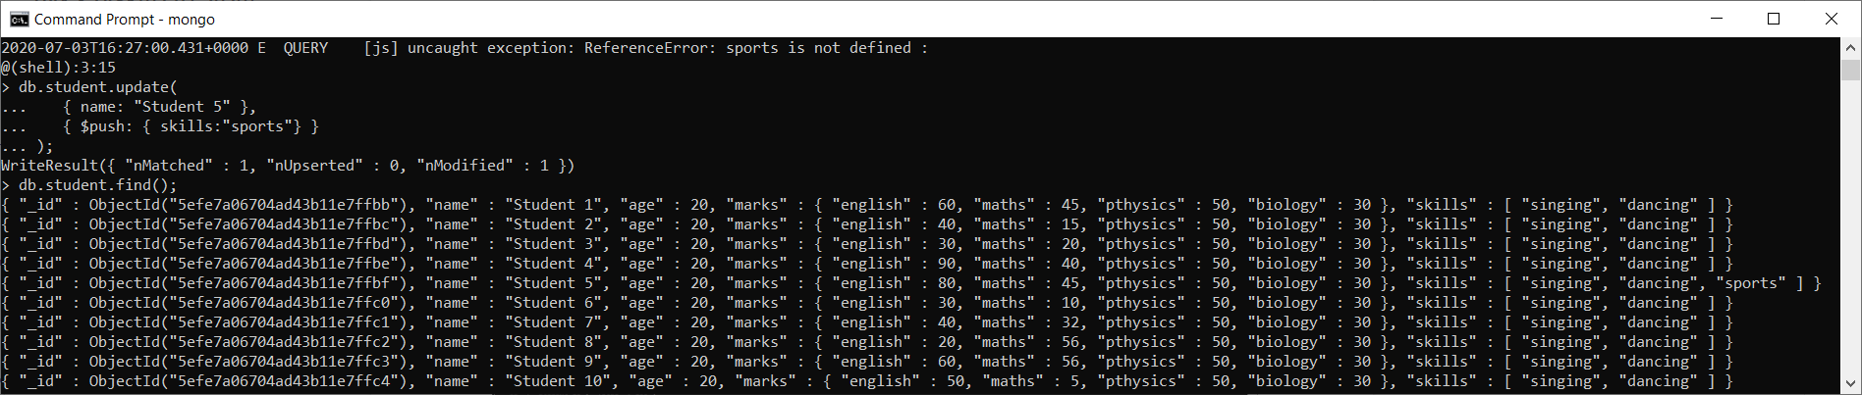

**7. Remove "dancing" skill from Student 3 and Student 4**

db.student.update(

{name:"Student 3"},

{$pull:{skills:"dancing"}}

);

db.student.update(

{name:"Student 4"},

{$pull:{skills:"dancing"}}

);

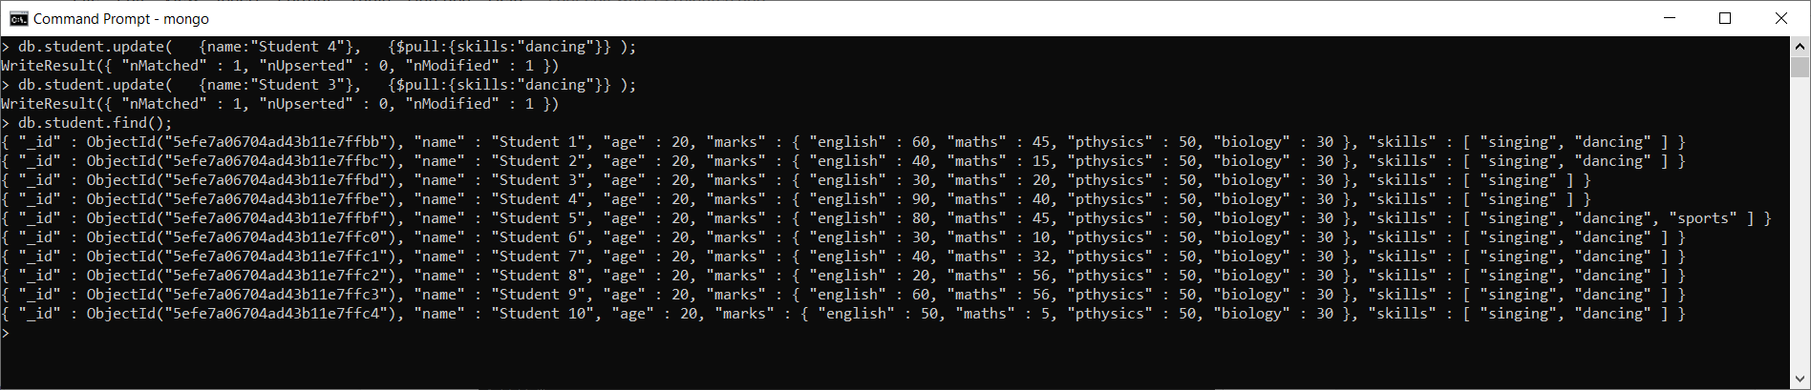

**8.Find over all average for all students.**

db.student.aggregate(

[

{$match:{}},

{

$group: {

_id:"$name" ,

Average: { $avg: { $avg: [

"$marks.english",

"$marks.maths",

"$marks.pthysics",

"$marks.biology"

]

}

}

}

}

])

