**2.WEB API HANDSON  
  
Title:**

Swagger, Postman, and Routing in ASP.NET Core Web API

**1. Objectives**

List the objectives clearly:

• Demonstrate Swagger installation and listing of WebAPI methods in the browser

• Use Postman to test WebAPI methods (GET, POST)

• Modify Route attribute and use ActionName in HTTP methods

• Create a simple WebAPI with Read and Write actions

**2. Tools & Technologies Used**

| **Tool** | **Version** |
| --- | --- |
| Visual Studio | 2022 |
| .NET SDK | 6.0 / 7.0 |
| Postman | Latest |
| Swagger (OpenAPI) | Swashbuckle.AspNetCore |

**3. Swagger Setup**

**a. NuGet Package Installed:**

Swashbuckle.AspNetCore

**b. Code Added in Program.cs / Startup.cs**

**In ConfigureServices:**

services.AddSwaggerGen(c =>

{

c.SwaggerDoc("v1", new OpenApiInfo

{

Title = "Swagger Demo",

Version = "v1",

Description = "TBD",

TermsOfService = new Uri("https://example.com"),

Contact = new OpenApiContact() { Name = "John Doe", Email = "john@xyzmail.com", Url = new Uri("https://www.example.com") },

License = new OpenApiLicense() { Name = "License Terms", Url = new Uri("https://www.example.com") }

});

});

**In Configure:**

app.UseSwagger();

app.UseSwaggerUI(c =>

{

c.SwaggerEndpoint("/swagger/v1/swagger.json", "Swagger Demo");

});

**4. Swagger Output**

* URL:  
  https://localhost:[port]/swagger
* Title: Swagger Demo
* Contact Info: John Doe, john@xyzmail.com
* Controller listed: ValuesController, EmployeeController
* Methods: GET, POST, etc.

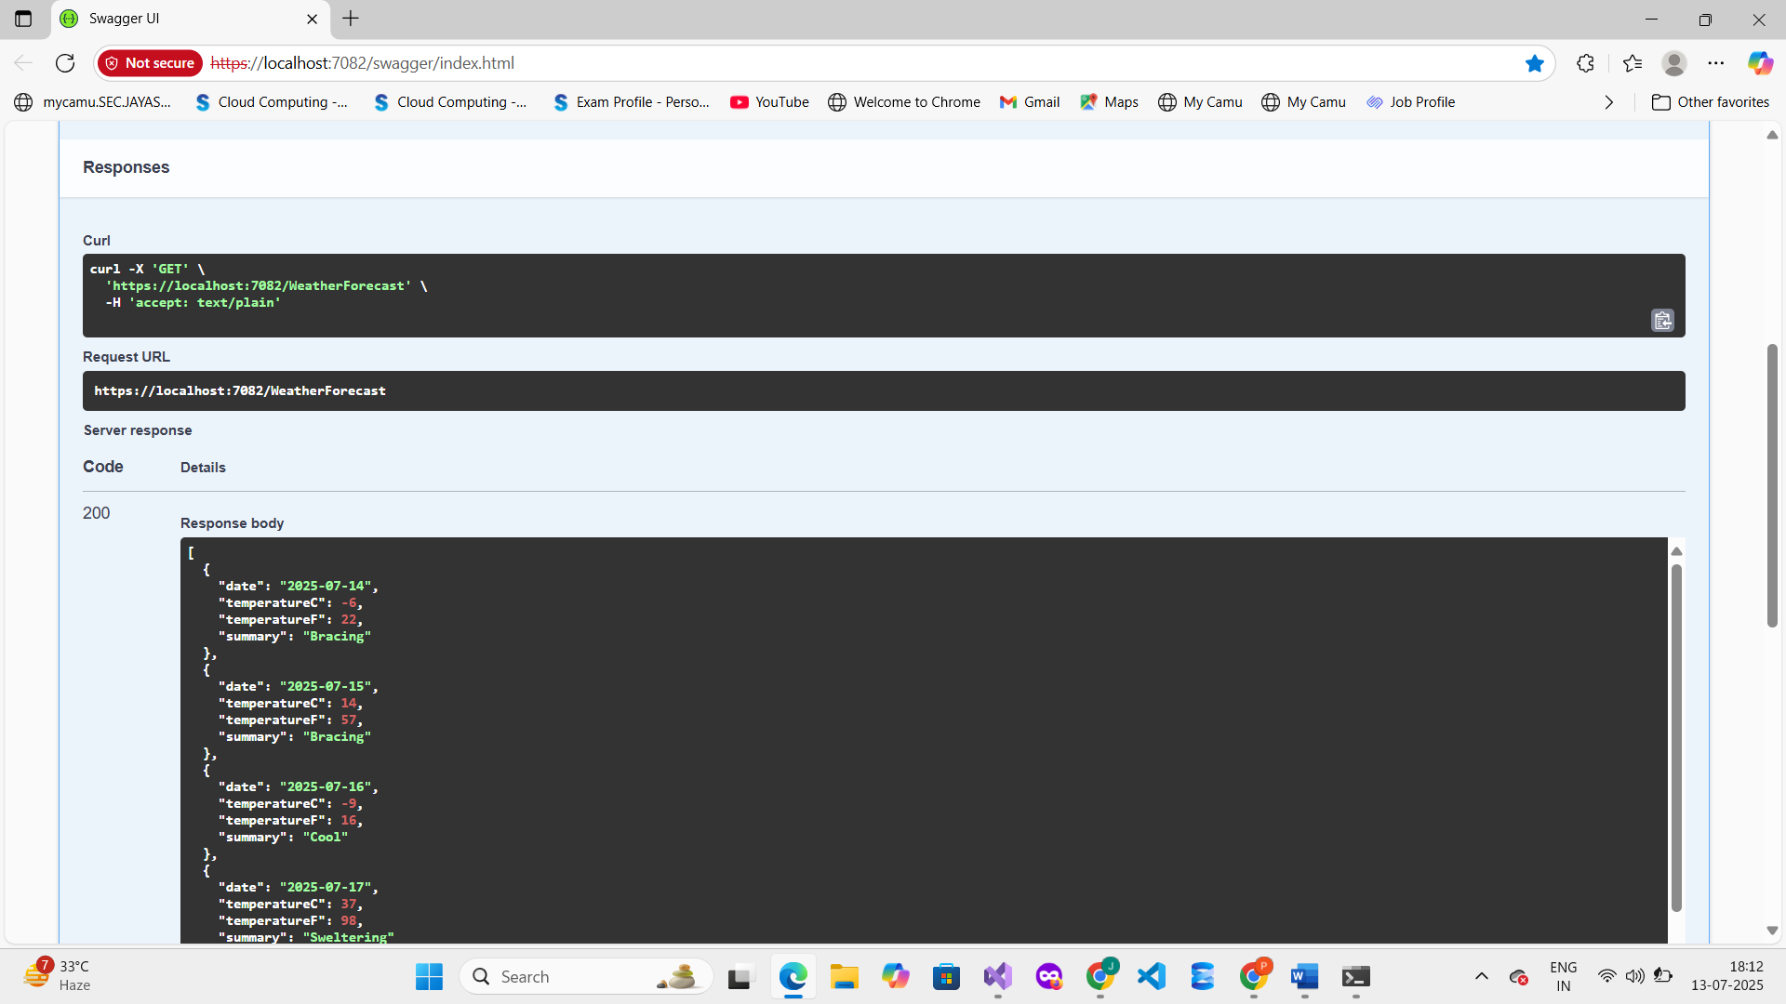  
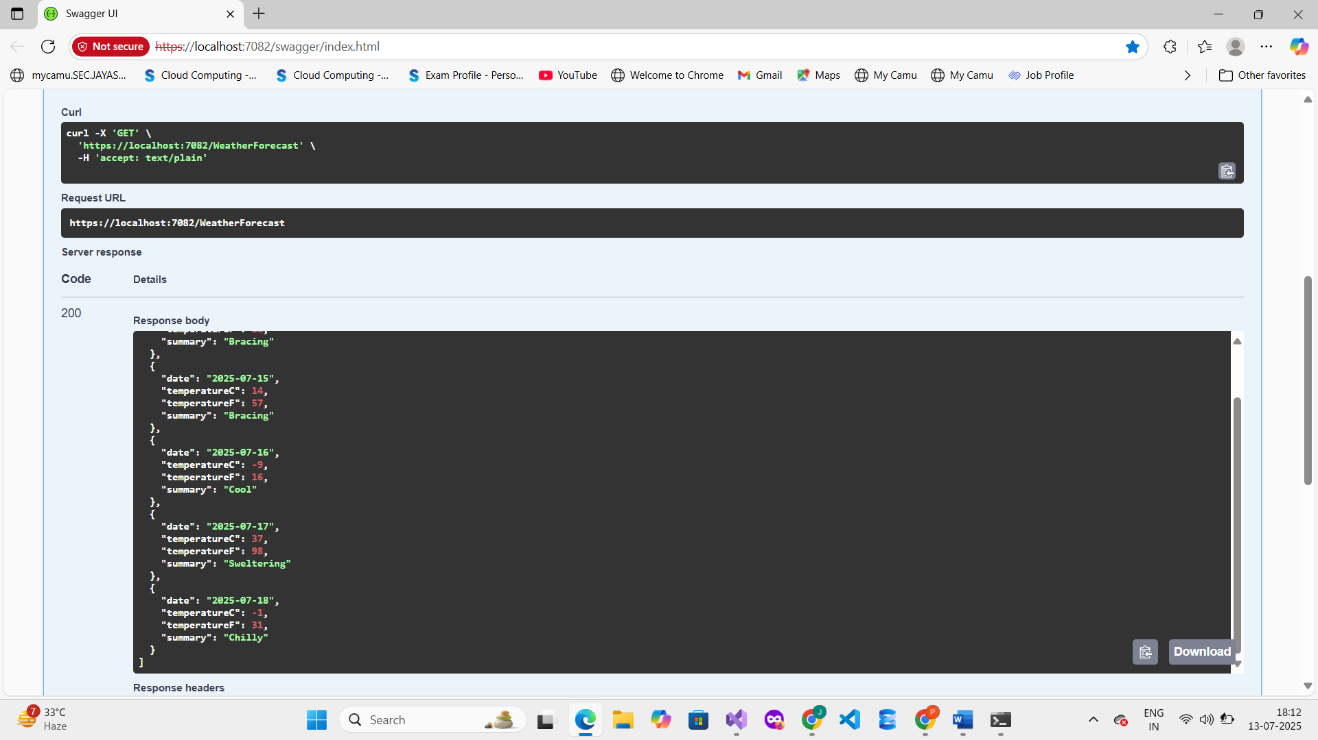  
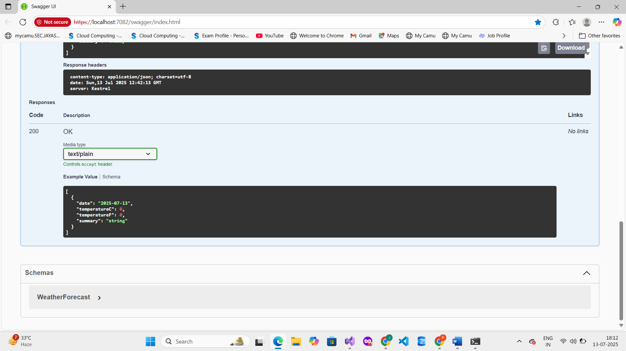

**5. Testing Web API Using Postman**

**a. Steps Performed:**

* Method: GET
* URL: https://localhost:[port]/api/Employee
* Headers: Content-Type: application/json (if POST)
* Clicked **Send**

**6. Route Customization**

**a. Modified Route Attribute**

[Route("api/Emp")]

**b. Tested New URL in Postman**

https://localhost:[port]/api/Emp

✅ Output still worked correctly

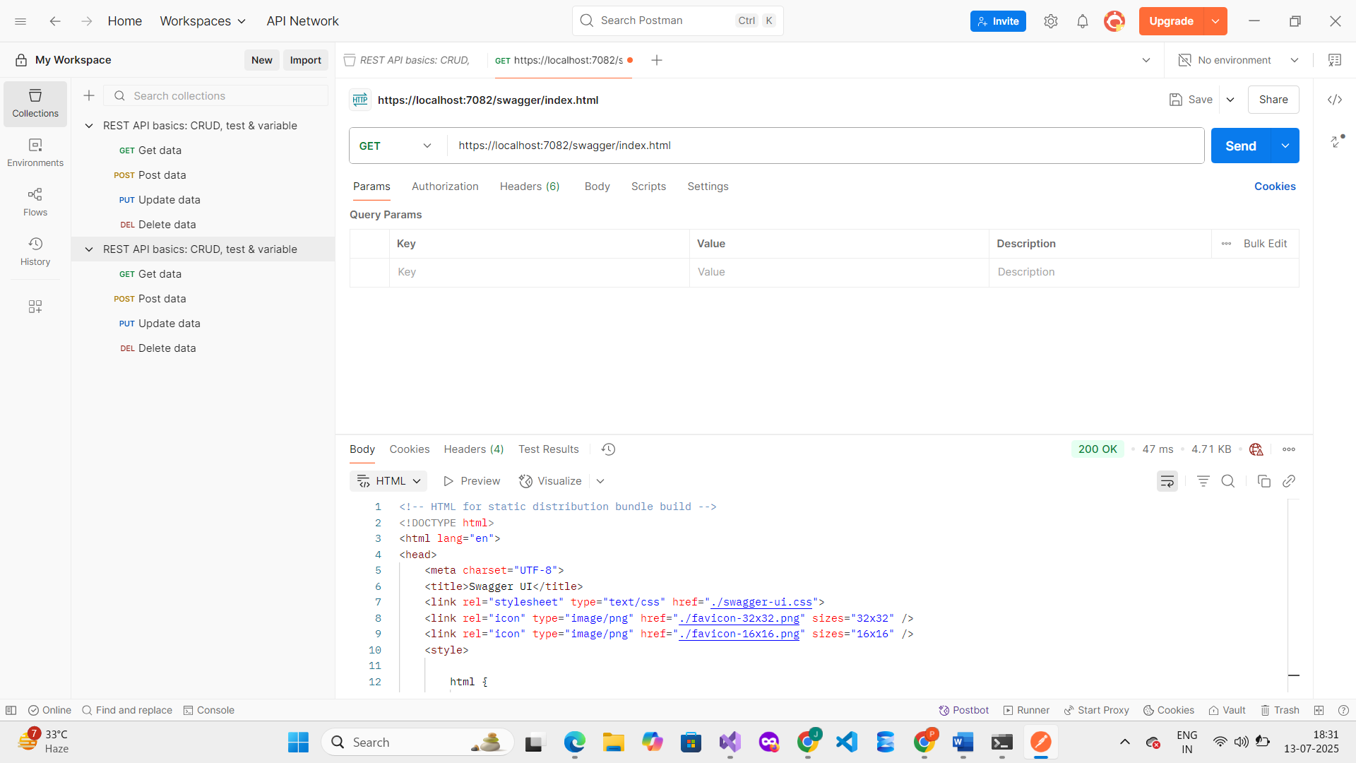

**7. Use of [ActionName] and [ProducesResponseType]**

Explain:

* [ActionName("GetById")] allows same HTTP verb for different methods
* [ProducesResponseType(typeof(Employee), 200)] specifies response model and code

Example:

[HttpGet("{id}")]

[ActionName("GetById")]

[ProducesResponseType(typeof(Employee), 200)]

public IActionResult Get(int id) { ... }

**8. Conclusion**

Swagger was successfully integrated and listed all WebAPI actions.

Postman tested WebAPI methods with valid responses.

Routing was customized, and ActionName and response types were demonstrated.