**1.REACT HOL**

**1. Define SPA and its Benefits**

A **Single Page Application (SPA)** loads a single HTML page and dynamically updates it as the user interacts with the app.

**Benefits:**

* Faster navigation
* No full-page reloads
* Improved user experience
* Efficient client-side rendering

**2. Define React and Identify its Working**

**React** is a JavaScript library used to build fast and interactive user interfaces.

**Working:**

* Breaks UI into **components**
* Uses a **virtual DOM** for efficient updates
* Renders changes without full reloads

**3. Differences between SPA and MPA**

| **Feature** | **SPA** | **MPA** |
| --- | --- | --- |
| Reload | No | Yes |
| Speed | Faster | Slower |
| SEO | Less SEO-friendly | Better SEO |
| Architecture | Client-side routing | Server-side routing |
| Example | Gmail | Amazon |

**4. Pros & Cons of SPA**

**Pros:**

* Fast and smooth user experience
* Less server load
* Better performance after initial load

**Cons:**

* Poor SEO
* Requires JavaScript to be enabled
* Can be complex to set up

**5. Explain about React**

React is an **open-source JavaScript library** maintained by Facebook. It helps in building reusable, component-based user interfaces for web apps.

**6. Define Virtual DOM**

The **Virtual DOM** is a lightweight in-memory representation of the real DOM. React uses it to **detect and apply minimal changes** to the real DOM, making UI updates fast and efficient.

**7. Features of React**

* Component-Based Architecture
* Virtual DOM
* Unidirectional Data Flow
* JSX (JavaScript + XML)
* High Performance
* Reusability

**Prerequisites:**

* Node.js
* NPM
* Visual Studio Code

1. **Installed Node.js and npm from**<https://nodejs.org/en/download/>
2. **Installed Create React App CLI**
3. **Created the React App**

**4. Navigated into the app**

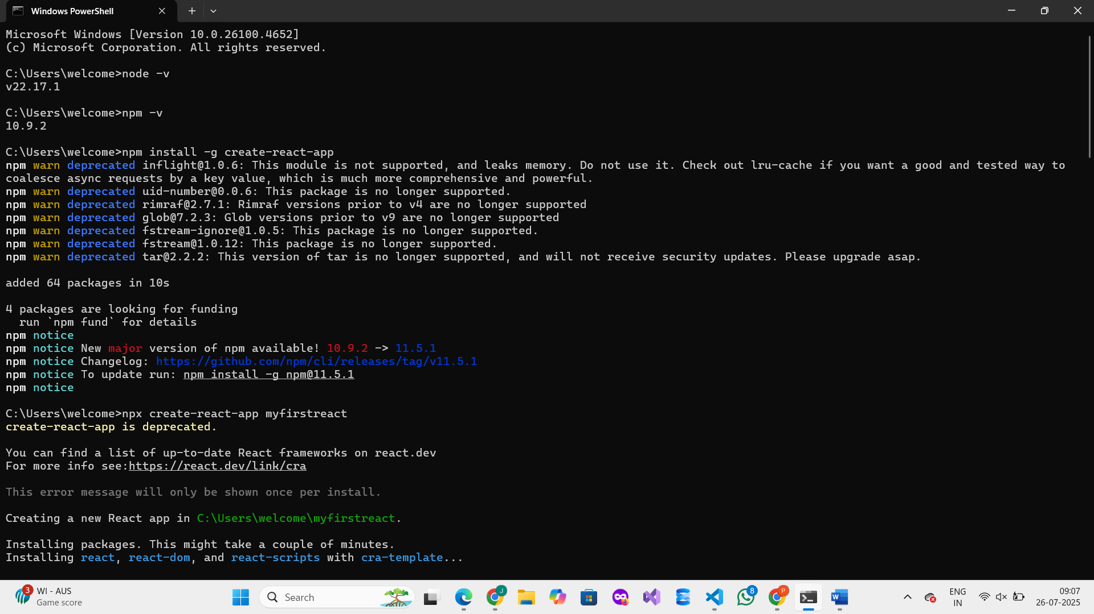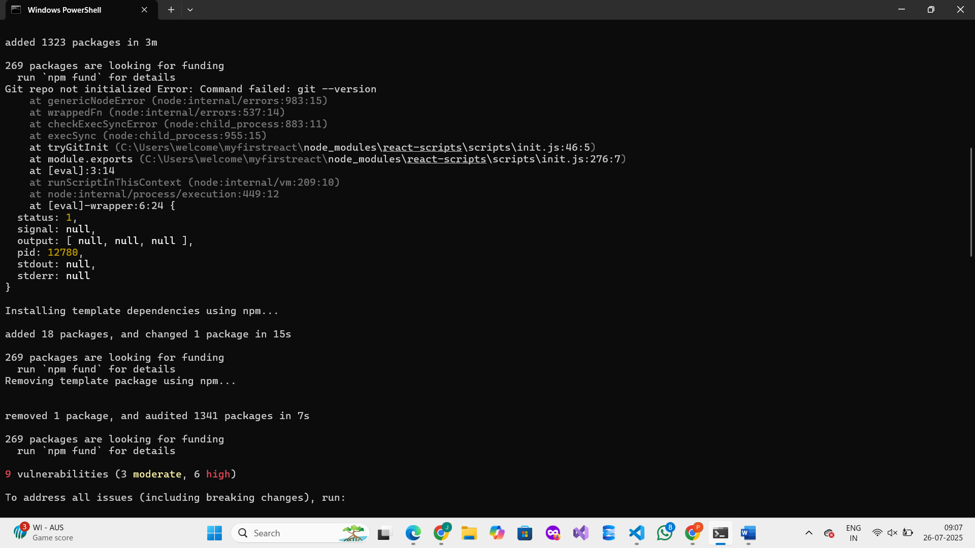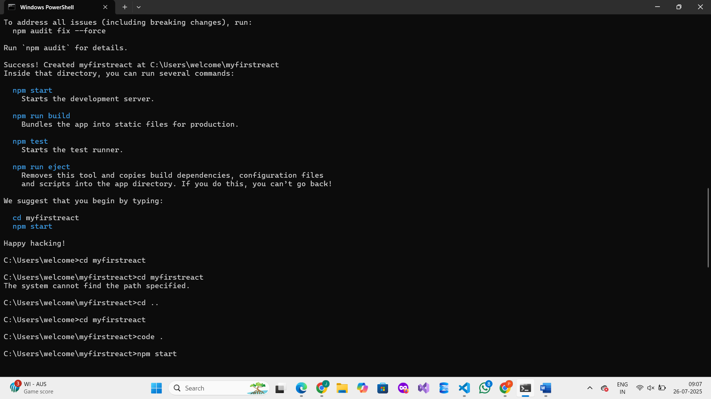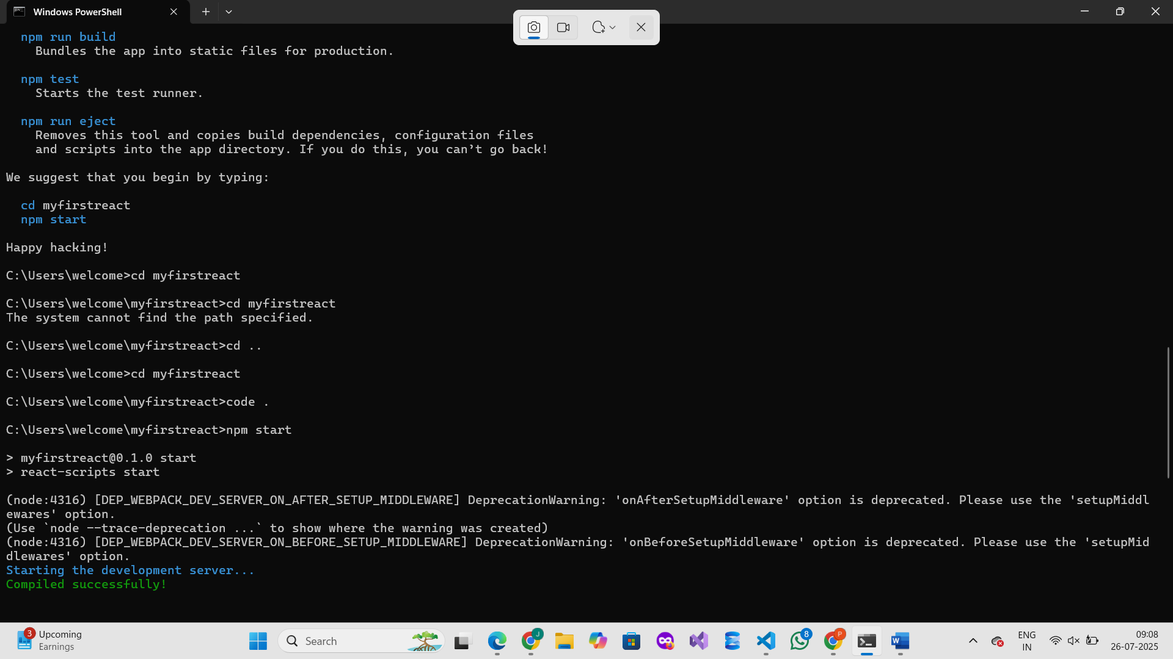

**5. Opened in Visual Studio Code:**

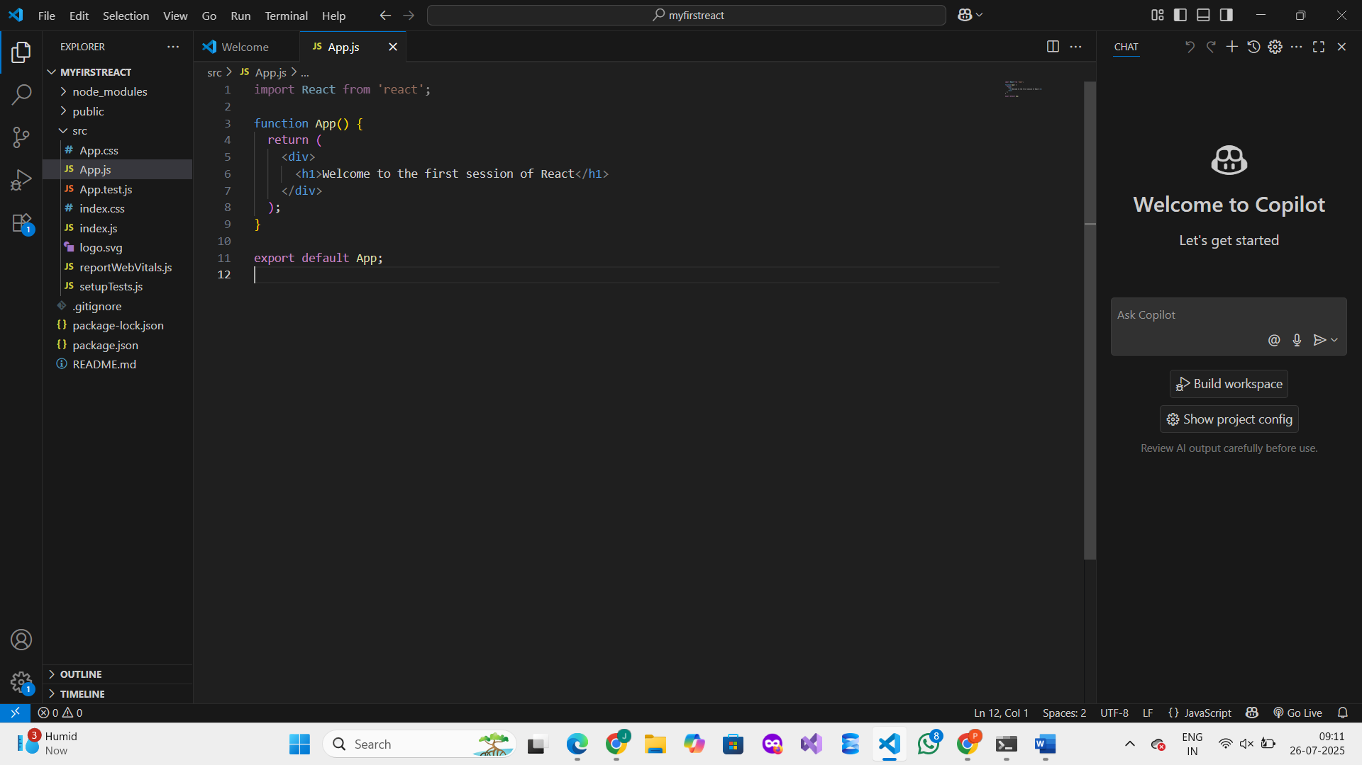**6. Modified App.js inside src folder:**

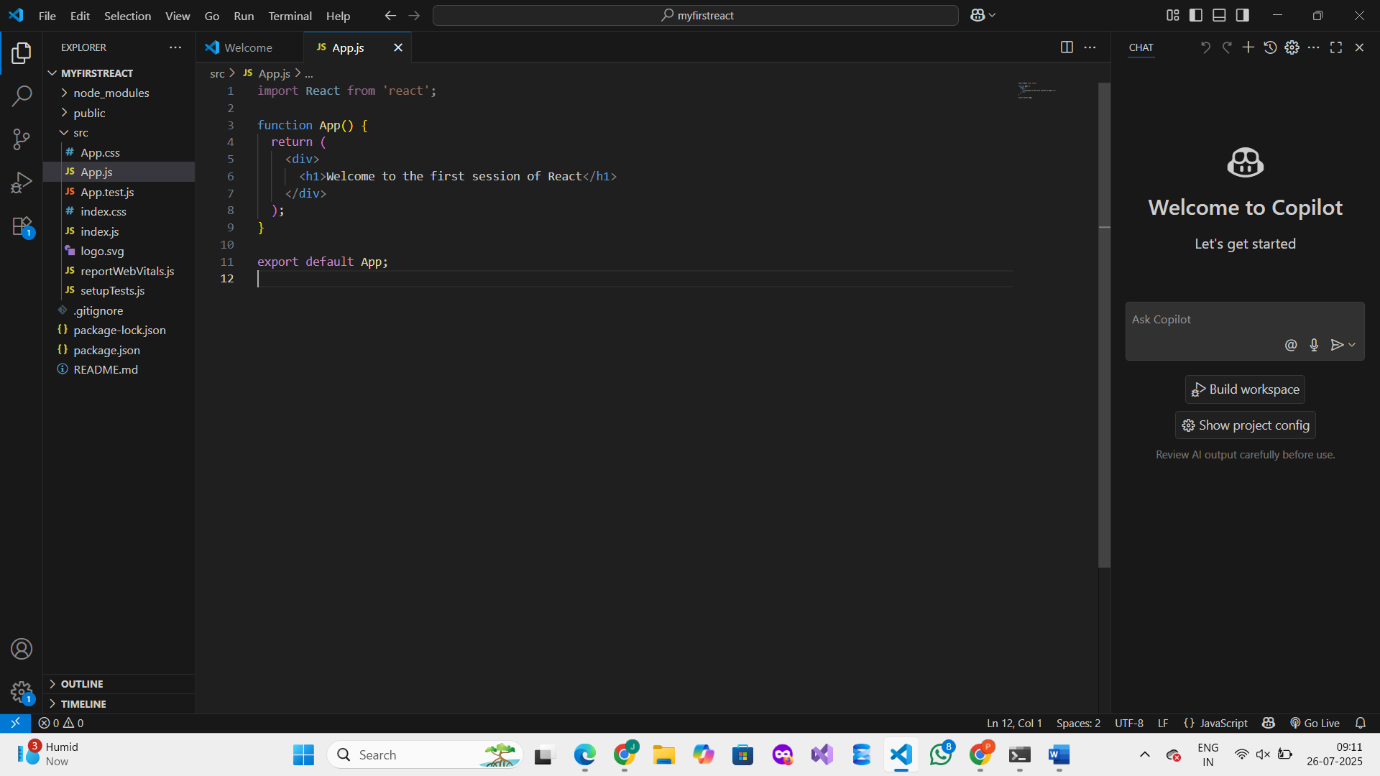

**7. Started the application:**

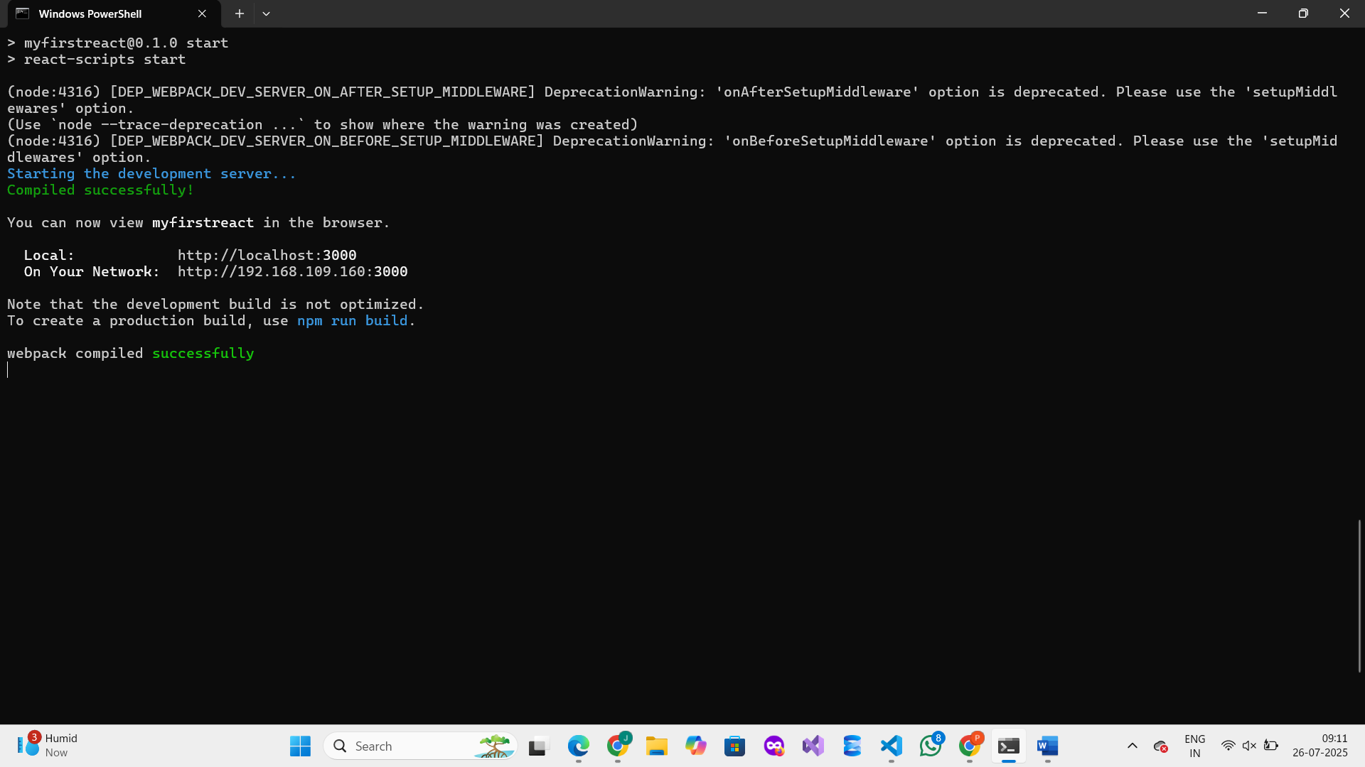

**OUTPUT :**

