**6. REACTJS – HOL**

**Step 1: Setup React App**

Open Terminal or PowerShell and run:

npx create-react-app trainersapp

After it's created, open it in VS Code:

cd trainersapp

code .

**Step 2: Install React Router**

In the terminal:

npm install react-router-dom

**Step 3: Create Folder Structure**

In the src folder, create a new folder called components.

Inside components, create these files:

src/

├── components/

│ ├── Dashboard.js

│ ├── TrainerList.js

│ └── AddTrainer.js

├── App.js

├── index.js

**Step 4: Add Code to Dashboard.js**

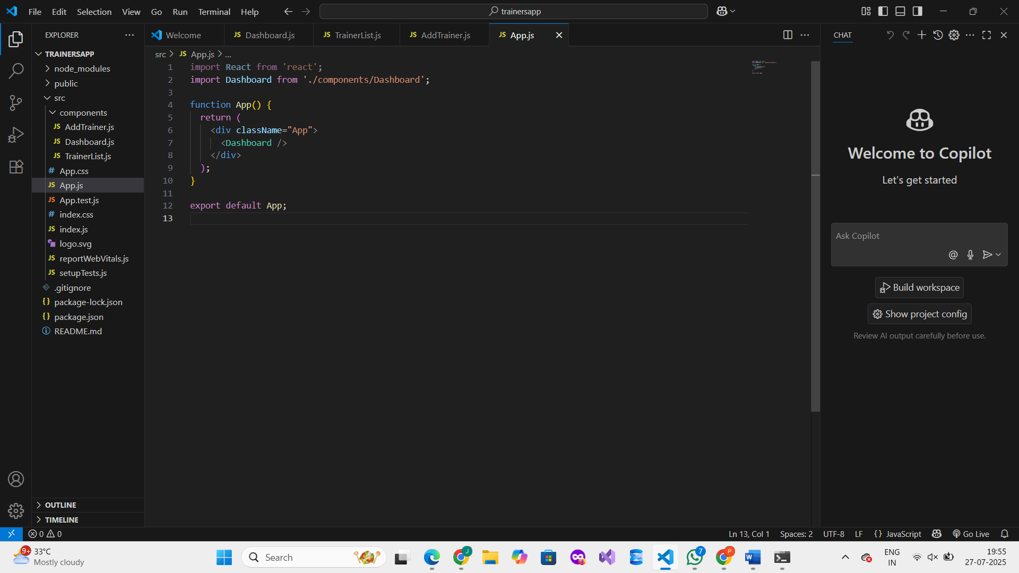

**Step 5: Add Code to TrainerList.js**

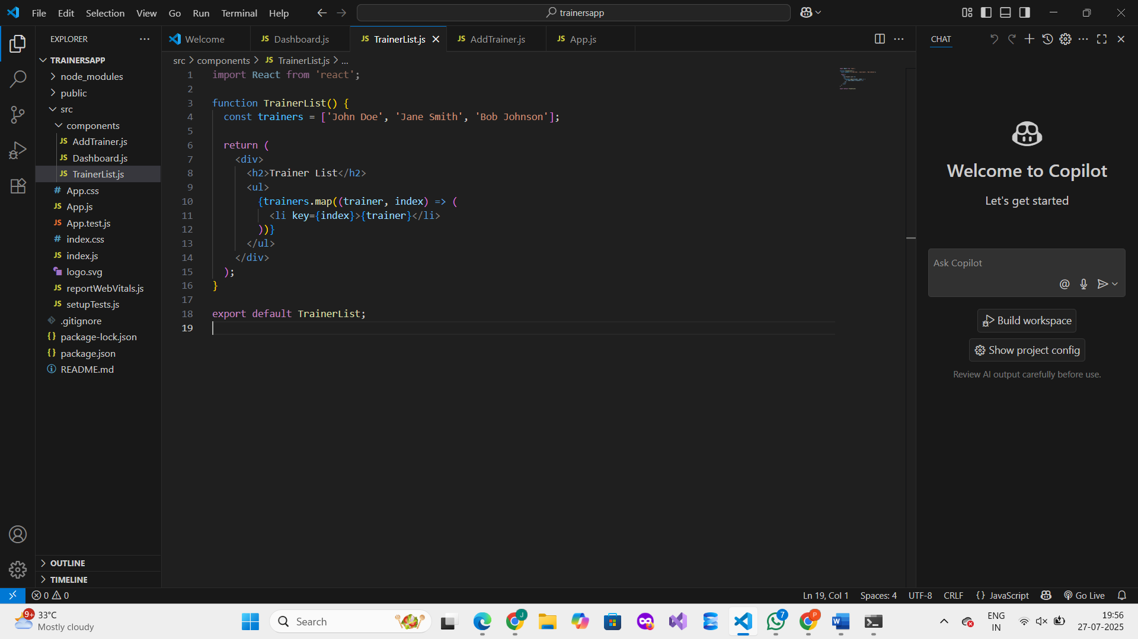

**Step 6: Add Code to AddTrainer.js**

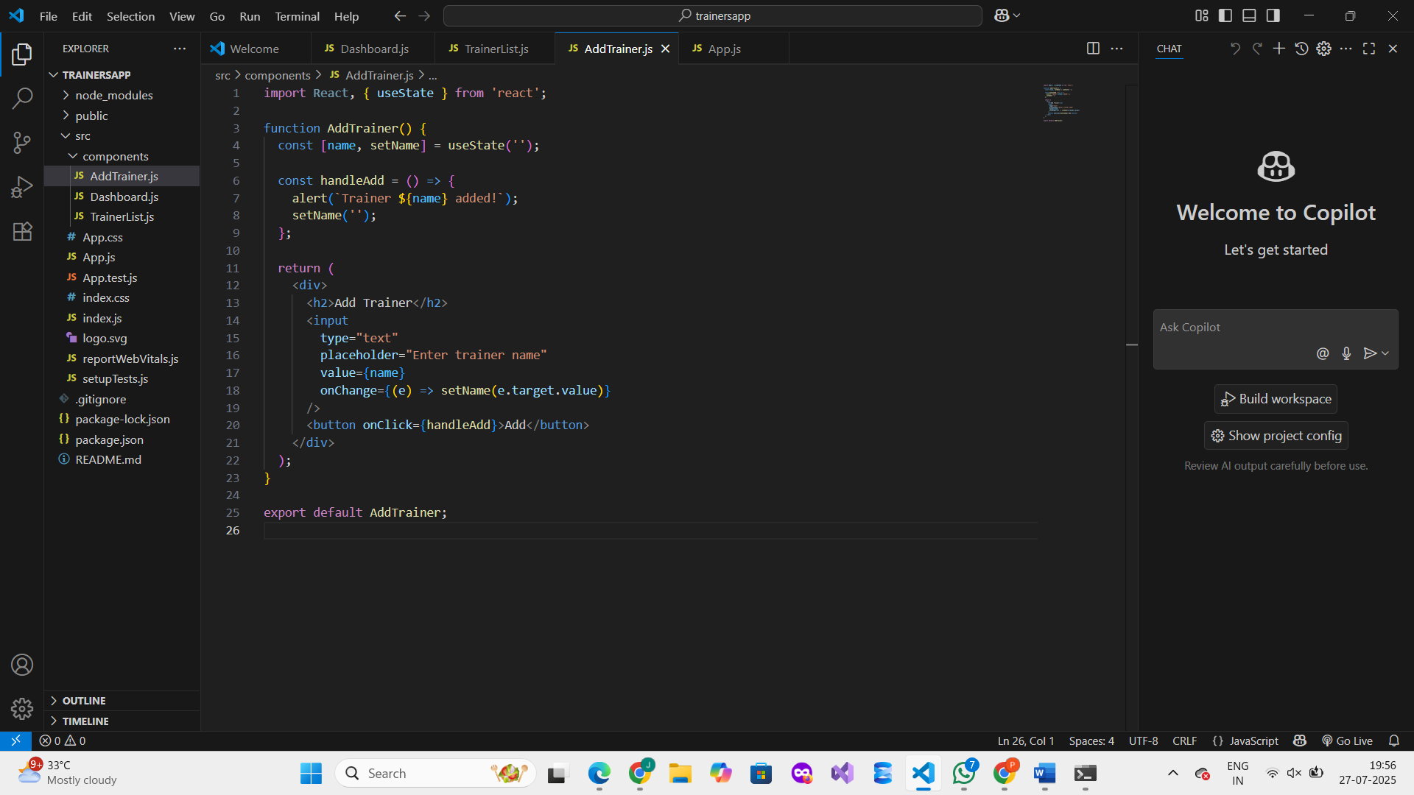

**Step 7: Update App.js**

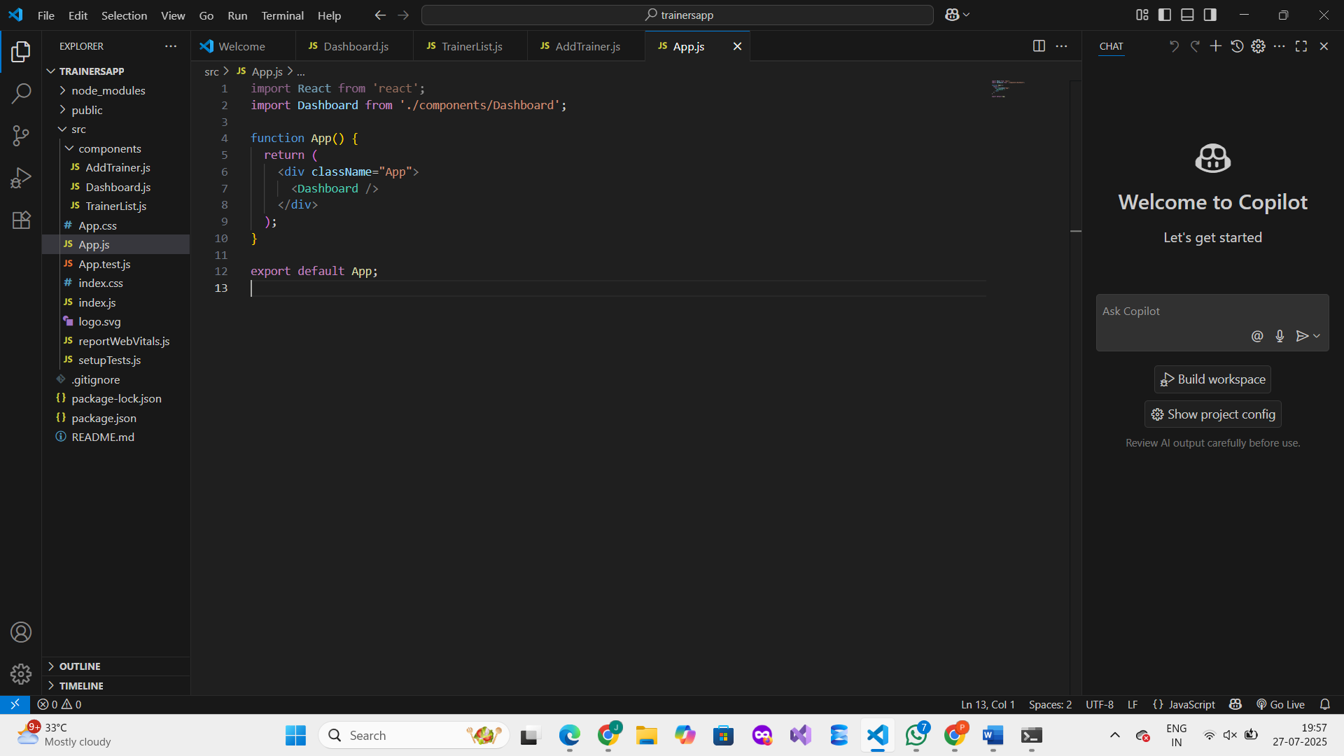

**Step 8: Run Your App**

**In the terminal:**

npm start

**This will open your React app in the browser at** [**http://localhost:3000**](http://localhost:3000)**.**

**OUTPUT :**

