**7.REACTJS – HOL**

**Step 1: Create React App**

Open terminal and run:

npx create-react-app shoppingapp

cd shoppingapp

code .

**Step 2: File Structure**

Inside src folder:

Create two files:

* Cart.js
* OnlineShopping.js

Update App.js to use OnlineShopping

**Step 3: Cart.js (Class Component with Props)**

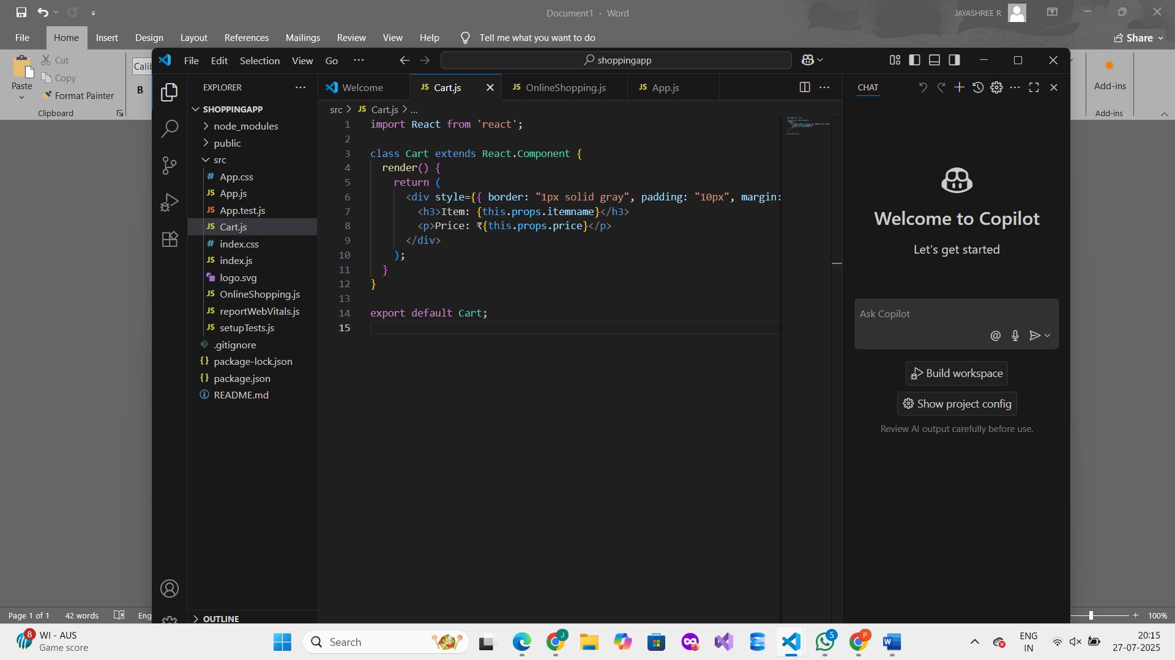

**Step 4: OnlineShopping.js (Parent Component Passing Props)**

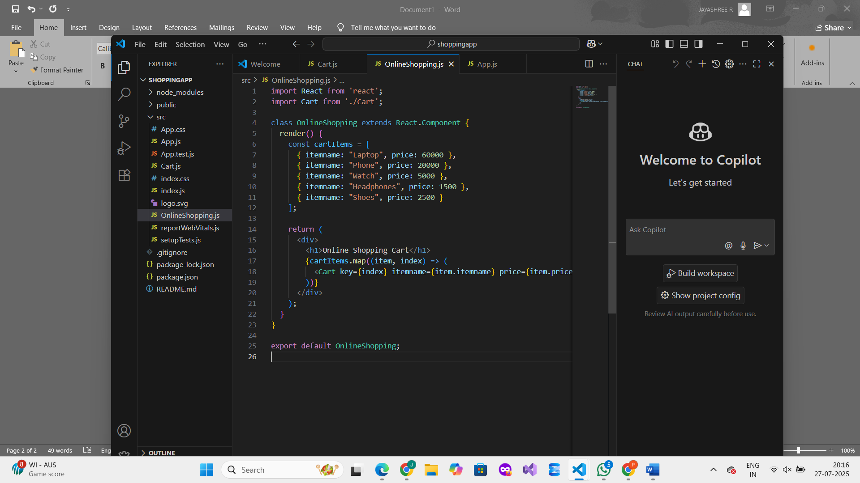

**Step 5: Update App.js to Render OnlineShopping**

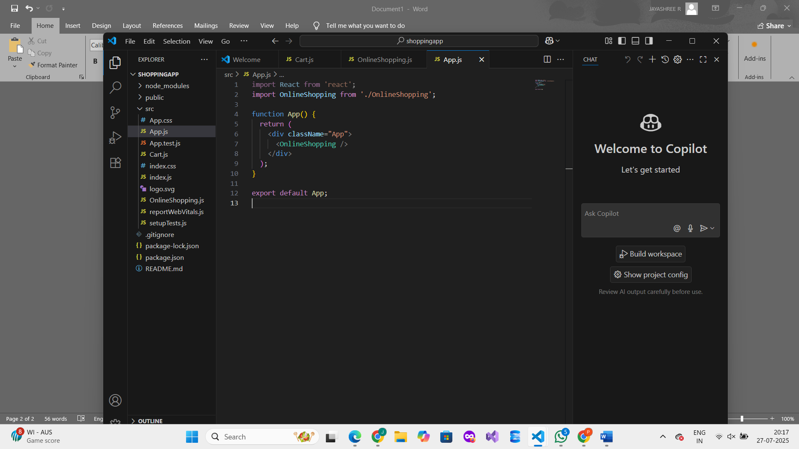

**Step 6: Start the React App**

Open your terminal (in the shoppingapp folder) and run:

npm start

**OUTPUT :**

