**8. REACTJS – HOL**

**"React State Management – Mall Entry and Exit Counter"**

**Step 1: Create the React App**

Open VS Code terminal and run:

npx create-react-app counterapp

cd counterapp

**Step 2: Create CountPeople.js component**

Inside the src folder, create a new file:  
src/CountPeople.js

Type this code:

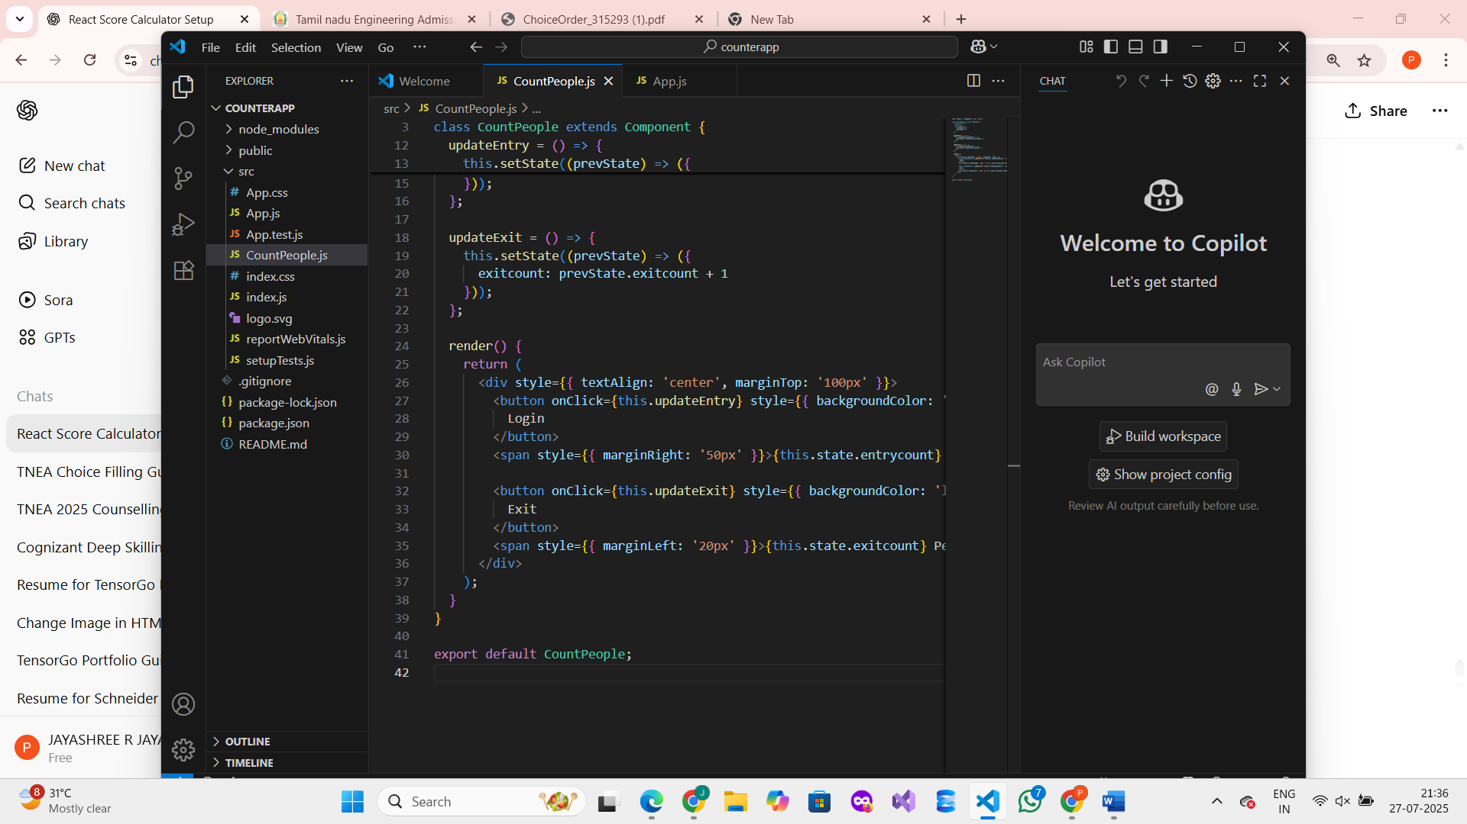

**Step 3: Modify App.js to include the component**

In src/App.js, replace everything with:

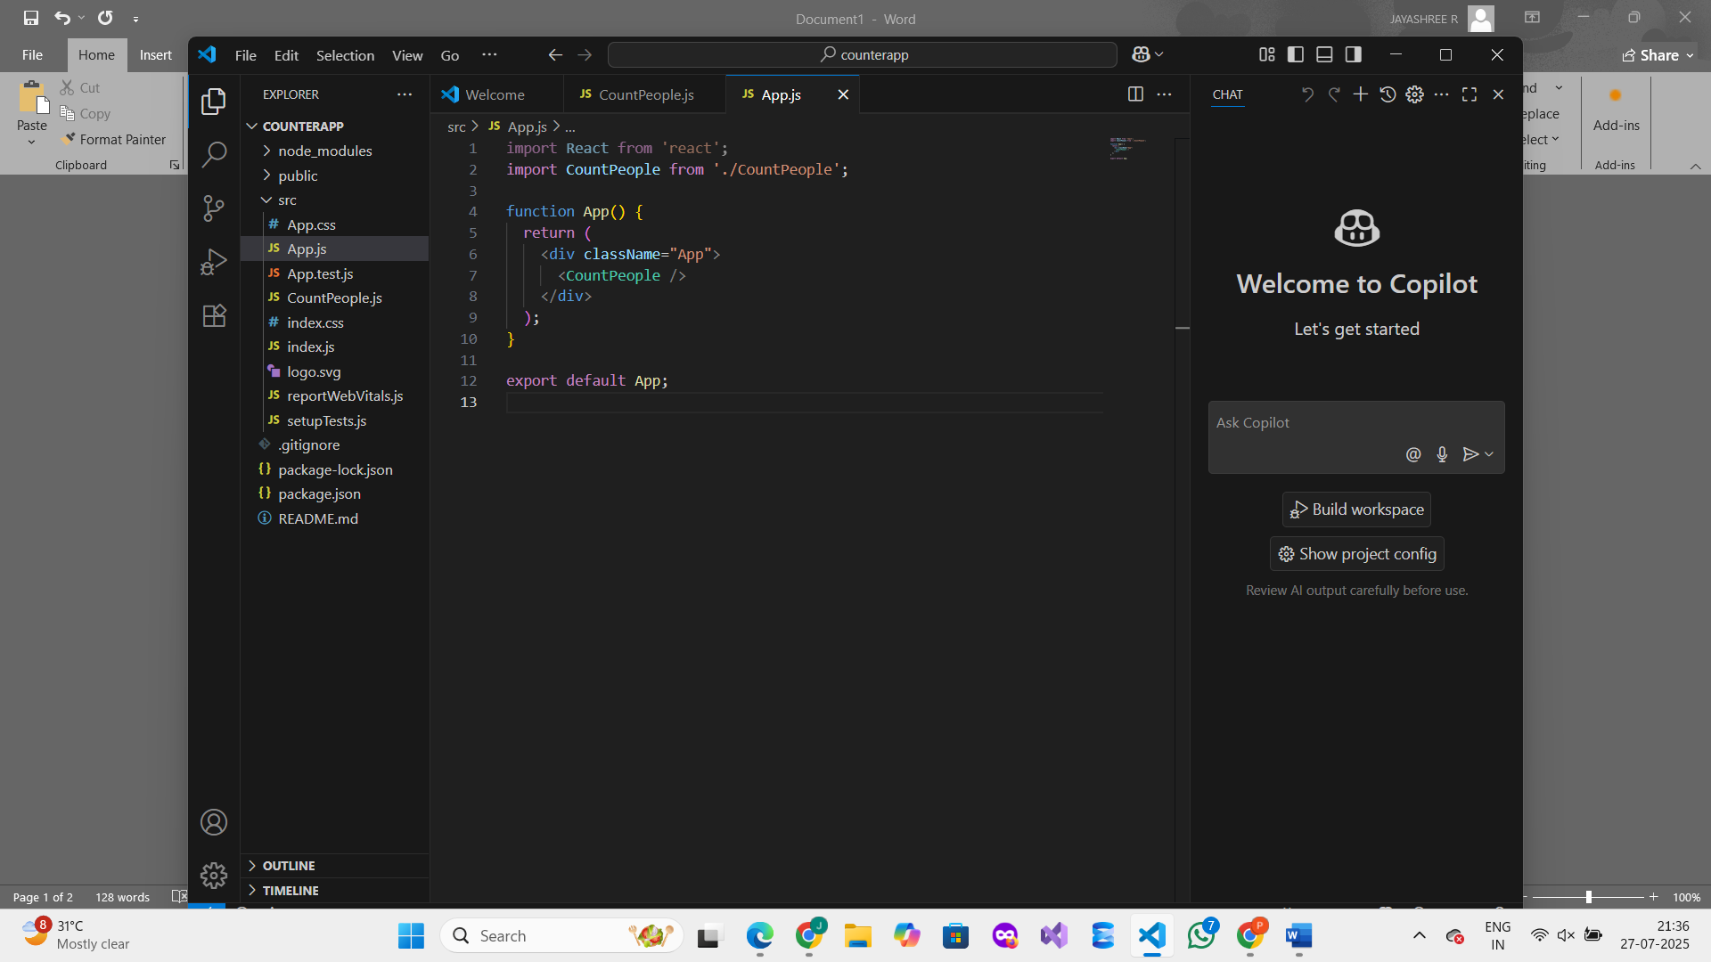

**Step 4: Run the App**

**In the terminal, run:**

npm start

This will open the browser at http://localhost:3000/  
You will see two buttons:

**OUTPUT :**

