**13 . REACTJS – HOL**

**"Conditional Rendering and List Rendering in React – BloggerApp Project"**

**Step 1: Create the React App**

**Type command :**

npx create-react-app bloggerapp

cd bloggerapp

npm start

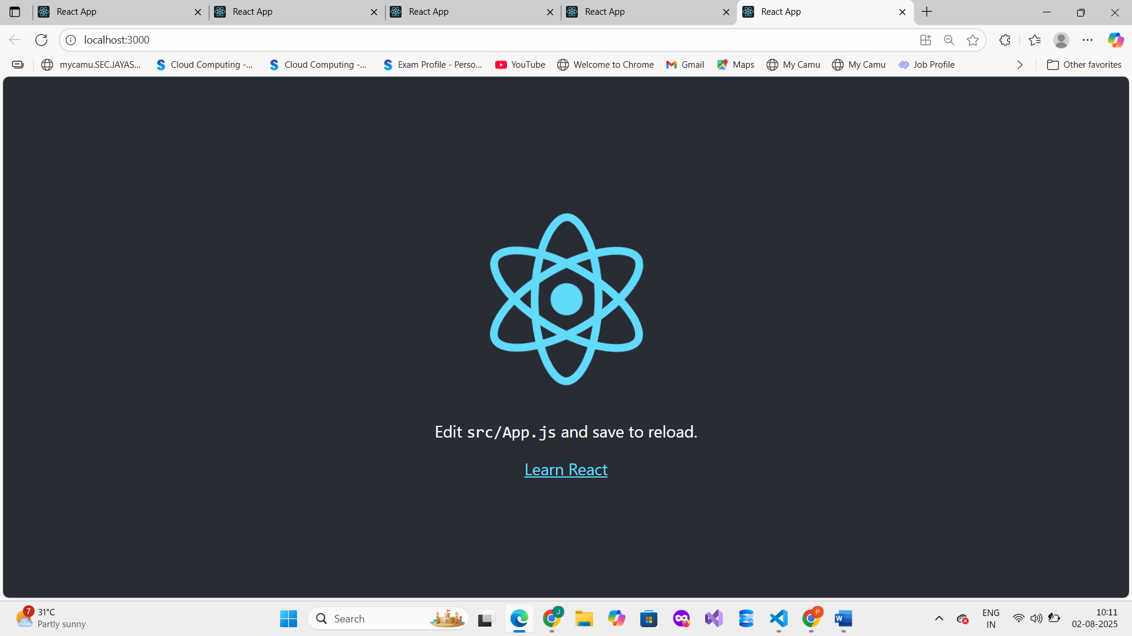

**Step 2: Clean Up Default Code in app.js   
replace with new code**

import React, { useState } from 'react';

import './App.css';

import BookDetails from './BookDetails';

import BlogDetails from './BlogDetails';

import CourseDetails from './CourseDetails';

function App() {

const [componentToShow, setComponentToShow] = useState('book');

const renderComponent = () => {

if (componentToShow === 'book') return <BookDetails />;

else if (componentToShow === 'blog') return <BlogDetails />;

else if (componentToShow === 'course') return <CourseDetails />;

else return null;

};

return (

<div className="App">

<h1>Blogger App</h1>

<button onClick={() => setComponentToShow('book')}>Show Book</button>

<button onClick={() => setComponentToShow('blog')}>Show Blog</button>

<button onClick={() => setComponentToShow('course')}>Show Course</button>

{/* Conditional rendering using function */}

{renderComponent()}

{/* Ternary Operator */}

{componentToShow === 'book' ? <p>You are viewing Book Details</p> : null}

{/* && Operator */}

{componentToShow === 'course' && <p>You are viewing Course Details</p>}

</div>

);

}

export default App;

**Step 3: Create Components**

**src/BookDetails.js**

import React from 'react';

function BookDetails() {

const books = ['Atomic Habits', 'Deep Work', 'Clean Code'];

return (

<div>

<h2>Book Details</h2>

<ul>

{books.map((book, index) => (

<li key={index}> {book}</li>

))}

</ul>

</div>

);

}

export default BookDetails;

**src/BlogDetails.js**

import React from 'react';

function BlogDetails() {

const blogs = [

{ id: 1, title: 'React Basics' },

{ id: 2, title: 'Advanced Hooks' },

{ id: 3, title: 'Conditional Rendering' }

];

return (

<div>

<h2>Blog Details</h2>

{blogs.map((blog) => (

<div key={blog.id}>📝 {blog.title}</div>

))}

</div>

);

}

export default BlogDetails;

**src/CourseDetails.js**

import React from 'react';

function CourseDetails() {

const show = true;

let message;

if (!show) return null; // Prevent rendering

if (show) {

message = <p>🎓 Course is available for enrollment</p>;

}

return (

<div>

<h2>Course Details</h2>

{message}

</div>

);

}  
export default CourseDetails;

**Step 4: Run the App**

npm start

**Step 5: Output**

