**14. REACTJS – HOL**

**Using React Context API to Manage Theme in Employee Management App**

**Objective**

To implement the React Context API for managing and propagating a theme (Light/Dark) across components in an employee management React application.

**Tools & Technologies**

* React (Create React App)
* Node.js and npm
* Visual Studio Code
* Web Browser

**Steps to Implement**

**Step 1: Create React App**

npx create-react-app employeeapp

cd employeeapp

npm start

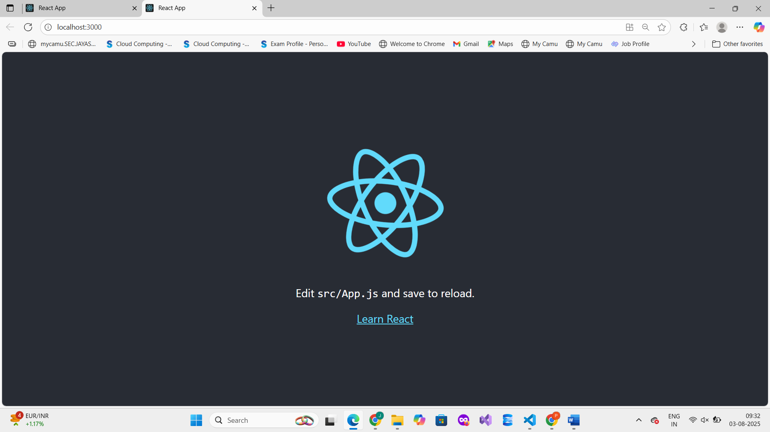

**Step 2: Install Dependencies**

Run:

npm install

**Step 3: Create Context File**

File: src/ThemeContext.js

import { createContext } from 'react';

const ThemeContext = createContext();

export default ThemeContext;

**Step 4: Update App.js**

File: src/App.js

import React, { useState } from 'react';

import EmployeesList from './EmployeesList';

import ThemeContext from './ThemeContext';

function App() {

const [theme, setTheme] = useState('light');

const toggleTheme = () => {

setTheme(prev => (prev === 'light' ? 'dark' : 'light'));

};

return (

<ThemeContext.Provider value={theme}>

<div className={`app-container ${theme}`}>

<button onClick={toggleTheme}>Toggle Theme</button>

<EmployeesList />

</div>

</ThemeContext.Provider>

);

}

export default App;

**Step 5: Create EmployeesList.js**

**File: src/EmployeesList.js**

import React from 'react';

import EmployeeCard from './EmployeeCard';

const employees = [

{ id: 1, name: 'Alice', role: 'Developer' },

{ id: 2, name: 'Bob', role: 'Designer' },

];

function EmployeesList() {

return (

<div>

{employees.map(emp => (

<EmployeeCard key={emp.id} employee={emp} />

))}

</div>

);

}

export default EmployeesList;

**Step 6: Create EmployeeCard.js**

**File: src/EmployeeCard.js**

import React, { useContext } from 'react';

import ThemeContext from './ThemeContext';

function EmployeeCard({ employee }) {

const theme = useContext(ThemeContext);

const cardStyle = {

backgroundColor: theme === 'dark' ? '#333' : '#eee',

color: theme === 'dark' ? '#fff' : '#000',

margin: '10px',

padding: '15px',

borderRadius: '8px'

};

return (

<div style={cardStyle}>

<h3>{employee.name}</h3>

<p>{employee.role}</p>

</div>

);

}

export default EmployeeCard;

**Output :**

