**9. REACTJS – HOL**

**React Hands-On Lab: cricketapp**

**1. Introduction**

This React hands-on lab demonstrates ES6 JavaScript features such as map(), arrow functions, destructuring, let/const/var, and ES6 classes in a web app named "cricketapp". The app displays and filters cricket players using dynamic components**.**

**2. Technologies Used**

React.js (via Create React App)

JavaScript (ES6 features)

Node.js and NPM

Visual Studio Code

Chrome browser

**3. Project Structure**

cricketapp/

├── src/

│ ├── App.js

│ ├── components/

│ │ ├── ListofPlayers.js

│ │ └── IndianPlayers.js

**4. Features Implemented**

1. ListofPlayers Component:

- Uses ES6 arrow functions and map()

- Displays all players

- Filters players with scores below 70

2. IndianPlayers Component:

- Uses ES6 destructuring and spread operator

- Separates odd/even team players

- Merges two player lists (T20 and Ranji Trophy)

**5. Sample Code Snippets**

**App.js**

import ListofPlayers from './components/ListofPlayers';

import IndianPlayers from './components/IndianPlayers';

function App() {

const flag = true;

return (

<div>

{flag ? <ListofPlayers /> : <IndianPlayers />}

</div>

);

}

export default App;

**ListofPlayers.js**

const players = [

{ name: 'Rohit', score: 80 },

{ name: 'Virat', score: 55 },

{ name: 'Dhoni', score: 68 },

];

const ListofPlayers = () => {

return (

<div>

<h2>All Players</h2>

{players.map(p => (

<p key={p.name}>{p.name} - {p.score}</p>

))}

<h2>Score Below 70</h2>

{players.filter(p => p.score < 70).map(p => (

<p key={p.name}>{p.name} - {p.score}</p>

))}

</div>

);

};

export default ListofPlayers;

**IndianPlayers.js**

const IndianPlayers = () => {

const team = ['Rohit', 'Virat', 'Jadeja', 'Bumrah', 'Rahul'];

const odd = team.filter((_, i) => i % 2 !== 0);

const even = team.filter((_, i) => i % 2 === 0);

const T20 = ['Surya', 'Gill'];

const RanjiTrophy = ['Shaw', 'Jaiswal'];

const merged = [...T20, ...RanjiTrophy];

return (

<div>

<h2>Odd Team Players</h2>

{odd.map(name => <p key={name}>{name}</p>)}

<h2>Even Team Players</h2>

{even.map(name => <p key={name}>{name}</p>)}

<h2>Merged Team (T20 + Ranji Trophy)</h2>

{merged.map(name => <p key={name}>{name}</p>)}

</div>

);

};

export default IndianPlayers;

**6. Output Screenshots**

**ListofPlayers Component Output (flag = true)**

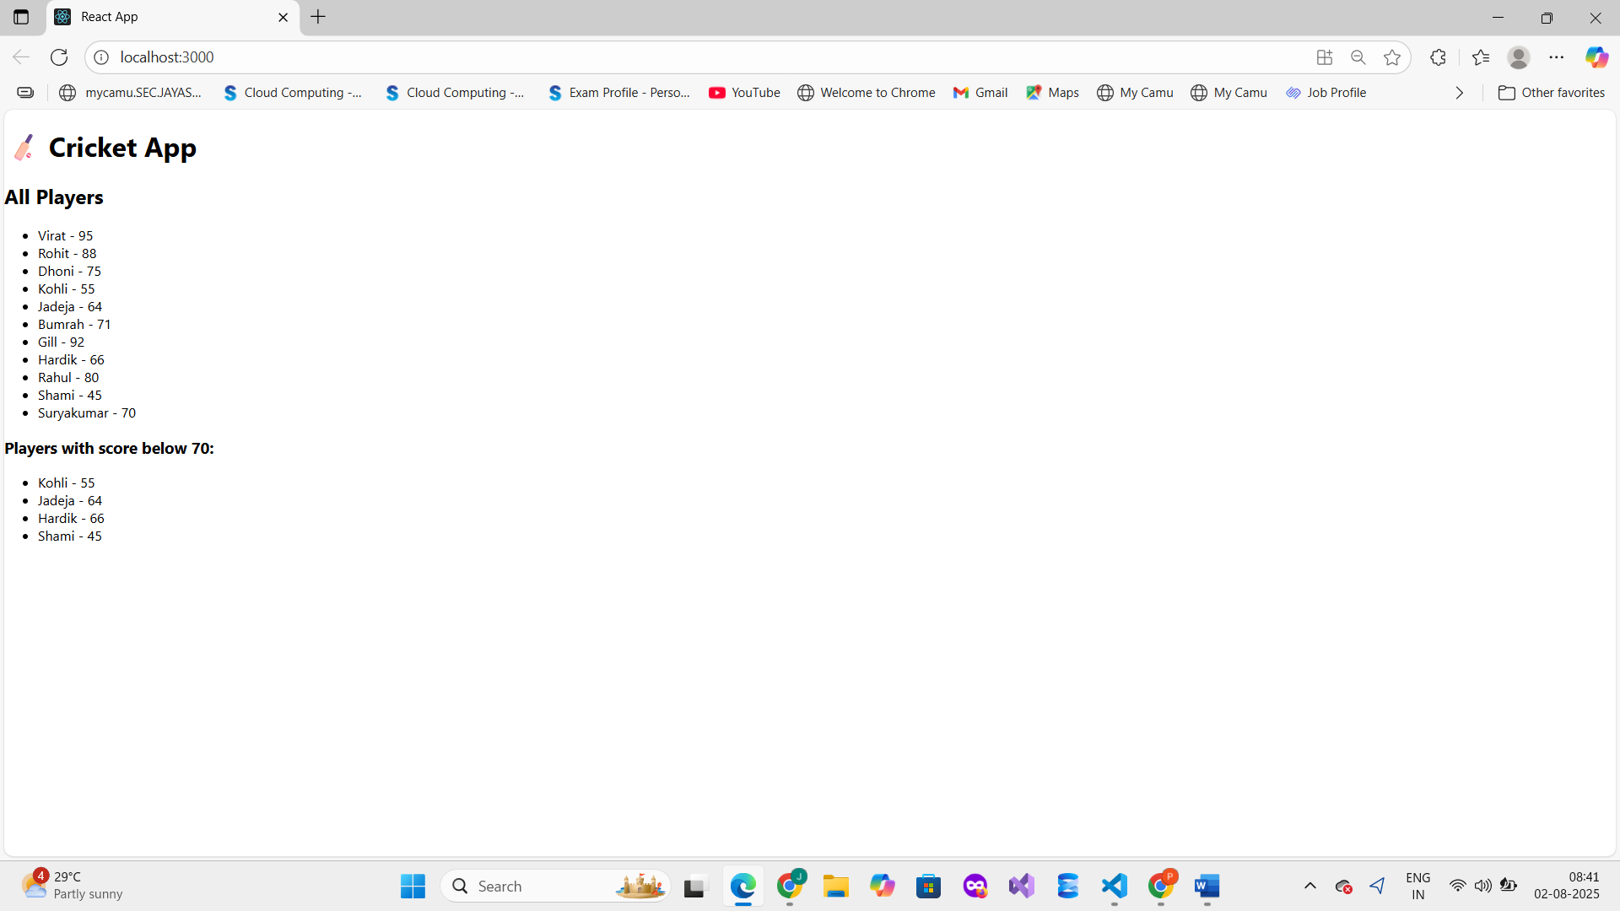

**IndianPlayers Component Output (flag = false)**

