LAB EXPERIMENT RECORD
SET-05
Department | AIML
Course Code / Course Name | DSA0602 / Data Handling and Visualization
Experiment | Data Visualization using R
Name | M.Reddy Jayasree
Register Number | 192325140
Date | 01 October 2026
Day | Thursday

Set 5: Website Analytics Using R

Aim
To analyze website traffic data using R programming by creating a line chart for daily page views, a bar chart for the top days based on click-through rate, and a stacked area chart for user interactions. Also, to create a Tableau dashboard for interactive exploration of website traffic data.

Dataset
Date | Page Views | Click-through Rate
2023-01-01 | 1500 | 2.3%
2023-01-02 | 1600 | 2.7%
2023-01-03 | 1400 | 2.0%
2023-01-04 | 1650 | 2.4%
2023-01-05 | 1800 | 2.6%

Procedure
- Create the website traffic dataset in R using vectors and a data frame.
- Convert the Date column into date format.
- Create a line chart to visualize the daily page-view trend.
- Sort the click-through rates in descending order and select the top N days.
- Create a bar chart showing the top days with the highest click-through rates.
- Create sample user-interaction data containing likes, shares, and comments.
- Create a stacked area chart to visualize the distribution of user interactions.
- Export the website traffic data to a CSV file.
- Import the CSV file into Tableau.
- Create a Tableau dashboard containing the line chart and bar chart for interactive analysis.

R Program
# Website Traffic Dataset

date <- as.Date(c(
"2023-01-01",
"2023-01-02",
"2023-01-03",
"2023-01-04",
"2023-01-05"
))

page_views <- c(1500, 1600, 1400, 1650, 1800)

ctr <- c(2.3, 2.7, 2.0, 2.4, 2.6)

website <- data.frame(date, page_views, ctr)

# 1. Line Chart - Daily Page Views

plot(
website$date,
website$page_views,
type = "o",
main = "Daily Page Views",
xlab = "Date",
ylab = "Page Views",
pch = 19
)
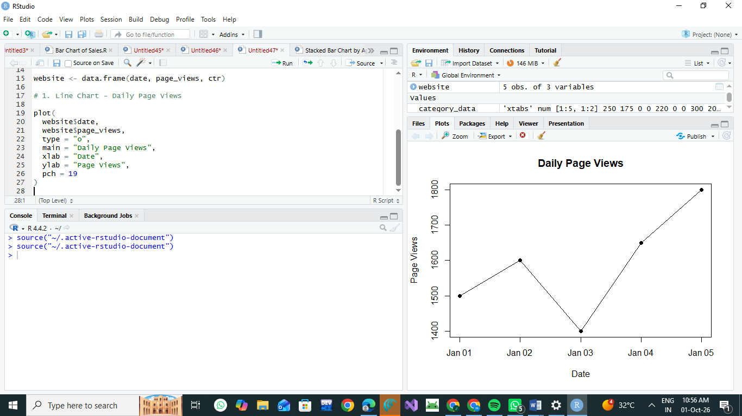

# 2. Bar Chart - Top N CTR Days

top_n <- 3

top_days <- website[order(-website$ctr), ][1:top_n, ]

barplot(
top_days$ctr,
names.arg = format(top_days$date, "%d-%b"),
main = "Top Days by Click-through Rate",
xlab = "Date",
ylab = "Click-through Rate (%)",
col = "skyblue"
)
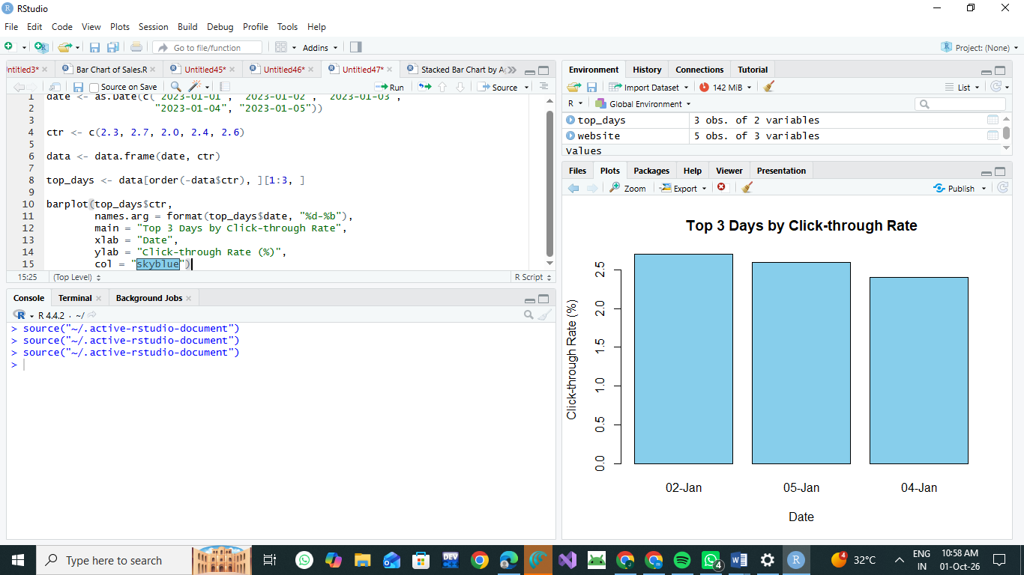

# 3. Stacked Area Chart - User Interactions

interactions <- data.frame(
date = date,
likes = c(300, 350, 280, 400, 450),
shares = c(100, 120, 90, 150, 180),
comments = c(50, 60, 40, 70, 80)
)

matplot(
interactions$date,
interactions[, 2:4],
type = "l",
lty = 1,
lwd = 2,
main = "Website User Interactions",
xlab = "Date",
ylab = "Number of Interactions"
)

legend(
"topleft",
legend = c("Likes", "Shares", "Comments"),
lty = 1,
col = 1:3
)

# Export data for Tableau

write.csv(
website,
"website_traffic.csv",
row.names = FALSE
)
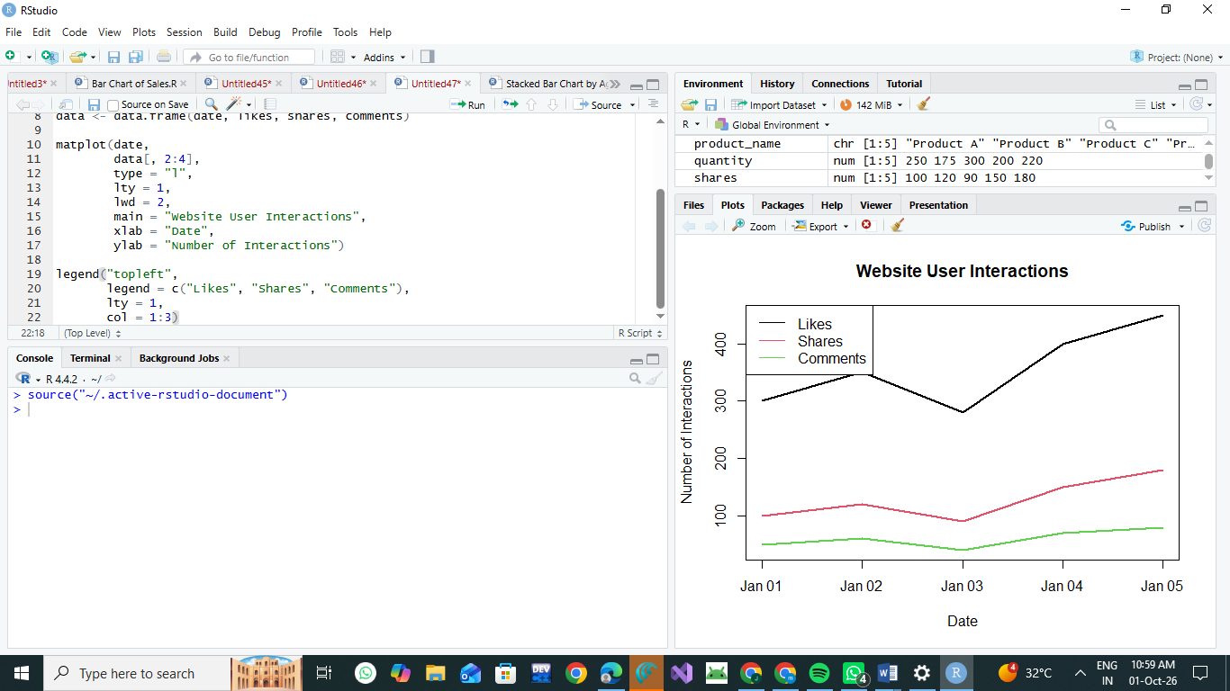

Note about the Stacked Area Chart
The question does not provide actual likes, shares, and comments data. Therefore, the interaction values in the program are sample values for demonstrating the chart. If your faculty provides interaction data, replace those values with the given data.

Explanation of Charts

1. Line Chart
The line chart displays the change in daily page views from January 1 to January 5, 2023.
- January 1: 1500 views
- January 2: 1600 views
- January 3: 1400 views
- January 4: 1650 views
- January 5: 1800 views
The highest number of page views is 1800 on January 5, while the lowest is 1400 on January 3.

2. Bar Chart
The top 3 days based on click-through rate are:
Rank | Date | CTR
1 | 2023-01-02 | 2.7%
2 | 2023-01-05 | 2.6%
3 | 2023-01-04 | 2.4%
Therefore, January 2 has the highest click-through rate of 2.7%.

3. Stacked Area Chart
The stacked area chart represents three types of website user interactions:
- Likes
- Shares
- Comments
It helps compare how different types of interactions contribute to overall user engagement over time.

Tableau Dashboard Procedure
- Run the R program.
- The file website_traffic.csv will be created.
- Open Tableau.
- Select Connect → Text File.
- Select website_traffic.csv.
- Create Sheet 1 – Daily Page Views:
  - Drag Date to Columns.
  - Drag Page Views to Rows.
  - Select Line Chart.
- Create Sheet 2 – Click-through Rate:
  - Drag Date to Columns.
  - Drag CTR to Rows.
  - Select Bar Chart.
- Sort the CTR values in descending order.
- Create a Dashboard.
- Drag both sheets into the dashboard.
- Add filters for Date and other available fields.
- Use the dashboard to interactively explore website traffic.

Result
The website traffic data was successfully analyzed using R programming.
- A line chart was created to visualize the daily page-view trend.
- A bar chart was created to identify the top days with the highest click-through rates.
- A stacked area chart was developed to display likes, shares, and comments over time.
- The website traffic data was exported to CSV and used to create an interactive Tableau dashboard.
Conclusion: R programming provides effective visualization of website traffic trends, while Tableau allows users to interactively explore and analyze the website analytics data.

