LAB EXPERIMENT RECORD
SET-06
Department | AIML
Course Code / Course Name | DSA0602 / Data Handling and Visualization
Experiment | Web Analytics
Name | M.Reddy Jayasree
Register Number | 192325140
Date | 01 October 2026
Day | Thursday

Set 6

Q)Product Sales Analysis

Dataset: Monthly Product Sales
Product ID | Product Name | January Sales | February Sales | March  Sales
1 | Product A | 2000 | 2200 | 2600
2 | Product B | 1500 | 1800 | 1600
3 | Product C | 1200 | 1400 | 1100

1. Create a grouped bar chart to visualize the sales of each product for the first quarter. Label the chart

elements.

2. Generate a stacked area chart to represent the overall sales trend for all products over the three

months.

3. Build a table to show the monthly sales data for each product. Label the table elements.

4. Develop a Tableau dashboard combining the grouped bar chart, stacked area chart, and the table

for interactive exploration of sales data.Set 5: Website Analytics

Aim
To analyze website traffic data by creating a line chart for daily page views, a bar chart for the top N click-through rates, a stacked area chart for user interactions, and an interactive Tableau dashboard for effective visualization and exploration of website analytics.

Procedure
- Prepare the website traffic dataset containing Date, Page Views, and Click-through Rate.
- Create a line chart using Date on the X-axis and Page Views on the Y-axis to visualize the daily page-view trend.
- Create a bar chart using Date and Click-through Rate to identify the top N days with the highest click-through rates. Add suitable labels and a title.
- Prepare additional data containing Likes, Shares, and Comments for each date.
- Create a stacked area chart using Date, Likes, Shares, and Comments to visualize the distribution of user interactions.
- Open Tableau and connect the website traffic dataset.
- Create separate worksheets for the line chart and bar chart.
- Combine the charts into a single interactive dashboard and add suitable filters, labels, and titles.
- Analyze the dashboard to identify trends and high-performing days.

R Program
1.date <- as.Date(c("2023-01-01", "2023-01-02", "2023-01-03",
"2023-01-04", "2023-01-05"))

page_views <- c(1500, 1600, 1400, 1650, 1800)

plot(date, page_views,
type = "o",
main = "Daily Page Views Trend",
xlab = "Date",
ylab = "Page Views")
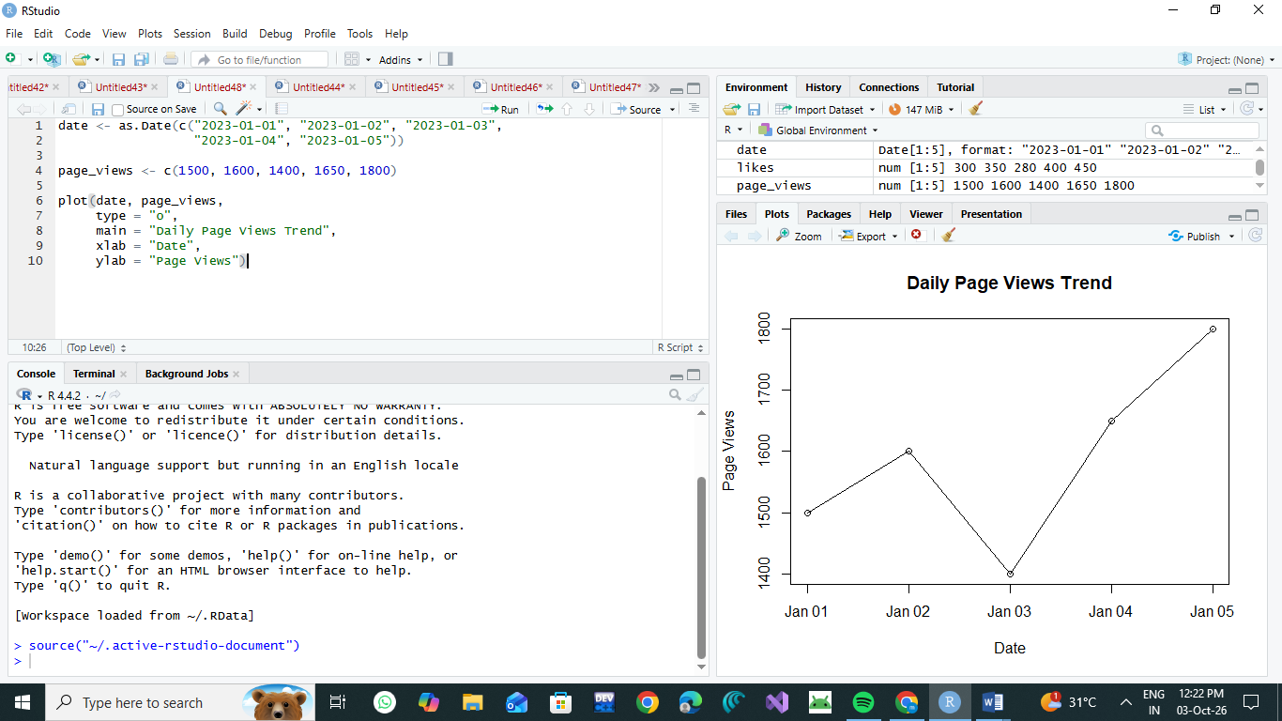
2.date <- c("Jan 1", "Jan 2", "Jan 3", "Jan 4", "Jan 5")
ctr <- c(2.3, 2.7, 2.0, 2.4, 2.6)
top_n <- 3
index <- order(ctr, decreasing = TRUE)[1:top_n]

barplot(ctr[index],
names.arg = date[index],
main = "Top N Days by Click-Through Rate",
xlab = "Date",
ylab = "Click-Through Rate (%)",
ylim = c(0, 3))
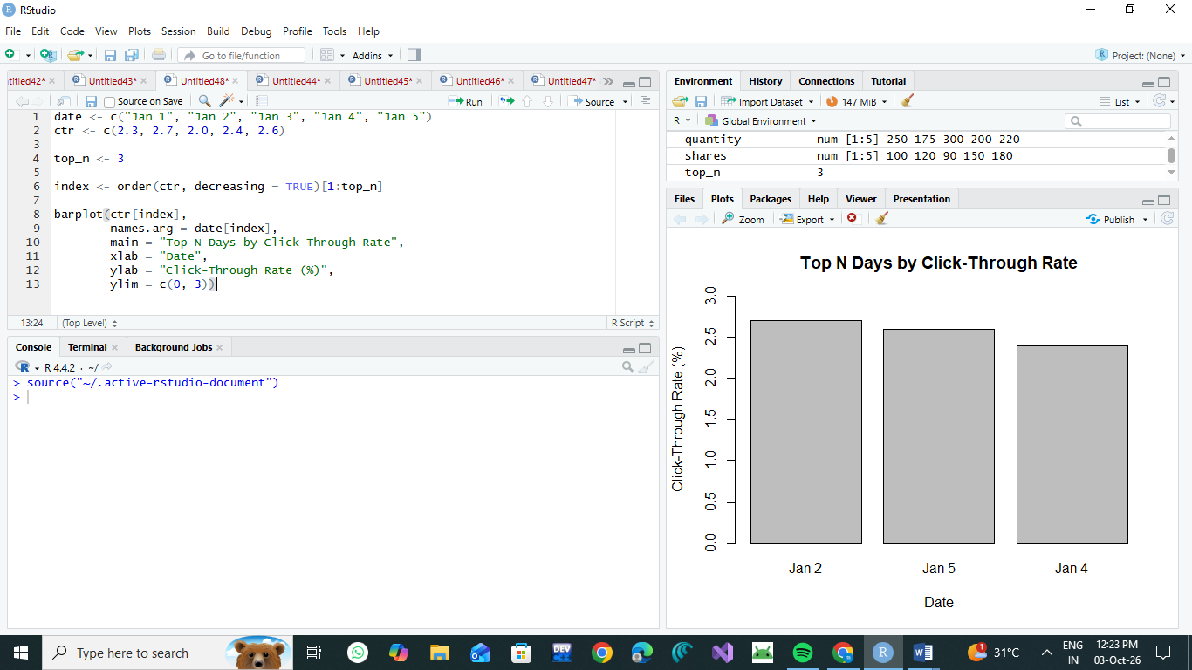

3.date <- as.Date(c("2023-01-01", "2023-01-02", "2023-01-03",
"2023-01-04", "2023-01-05"))

likes <- c(120, 150, 100, 180, 200)
shares <- c(50, 70, 40, 80, 90)
comments <- c(30, 40, 25, 50, 60)

data <- rbind(likes, shares, comments)

matplot(date, t(data),
type = "l",
lty = 1,
lwd = 2,
main = "Website User Interactions",
xlab = "Date",
ylab = "Number of Interactions")

polygon(c(date, rev(date)),
c(likes, rev(likes)),
col = "lightblue")

polygon(c(date, rev(date)),
c(likes + shares, rev(likes + shares)),
col = "lightgreen")

polygon(c(date, rev(date)),
c(likes + shares + comments,
rev(likes + shares + comments)),
col = "lightpink")

legend("topleft",
legend = c("Likes", "Shares", "Comments"),
fill = c("lightblue", "lightgreen", "lightpink"))
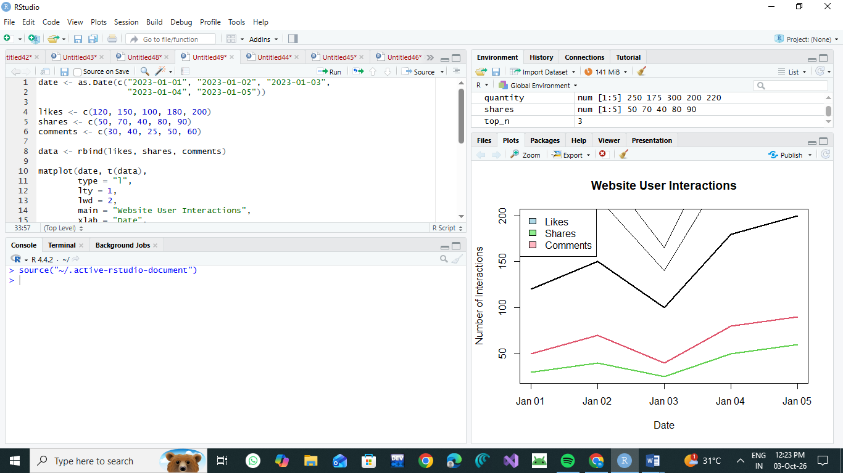

4.date <- as.Date(c("2023-01-01", "2023-01-02", "2023-01-03",
"2023-01-04", "2023-01-05"))

page_views <- c(1500, 1600, 1400, 1650, 1800)
ctr <- c(2.3, 2.7, 2.0, 2.4, 2.6)

website_data <- data.frame(
Date = date,
Page_Views = page_views,
Click_Through_Rate = ctr
)

print(website_data)

write.csv(website_data,
"website_traffic.csv",
row.names = FALSE)

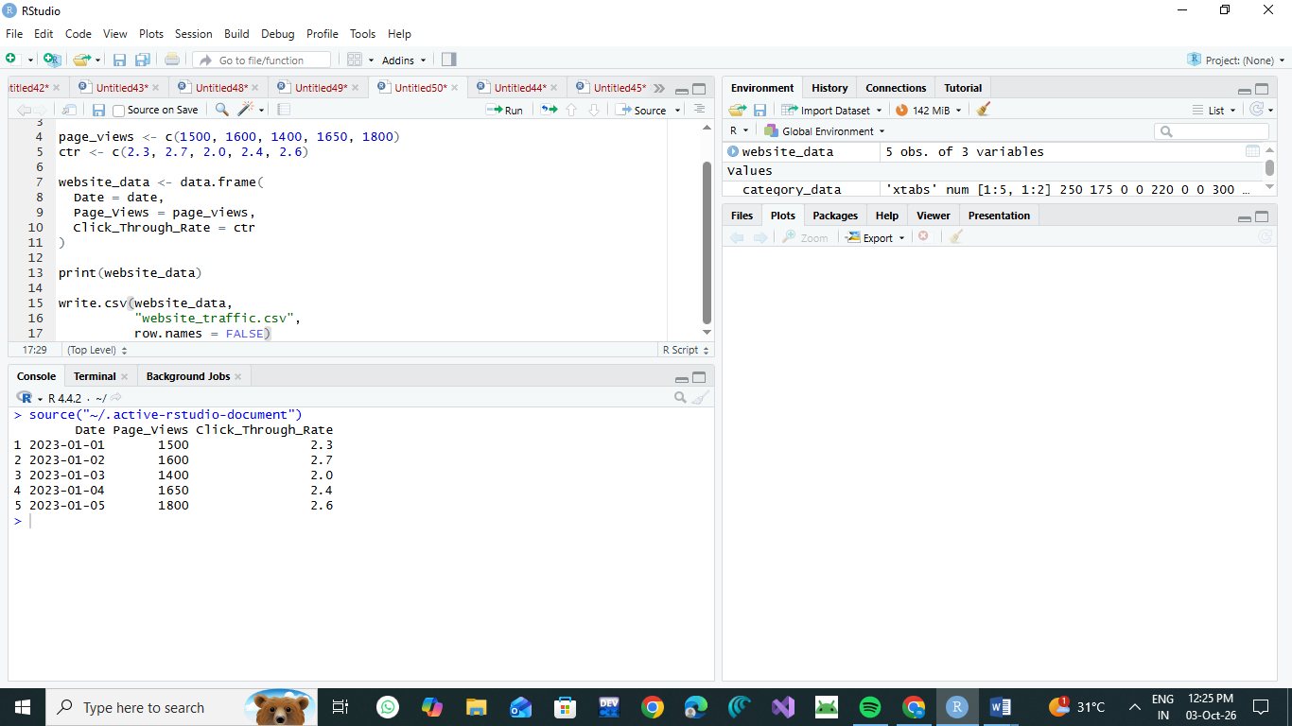

Conclusion
The website analytics data was successfully visualized using different charts and a Tableau dashboard. The line chart shows the trend in daily page views, while the bar chart identifies days with higher click-through rates. The stacked area chart helps understand the distribution of likes, shares, and comments. The Tableau dashboard provides an interactive way to explore and compare website traffic data, making it easier to identify important trends and patterns.

