LAB EXPERIMENT RECORD
SET-07
Department | AIML
Course Code / Course Name | DSA0602 / Data Handling and Visualization
Experiment | Customer Demographics analysis
Name | M.Reddy Jayasree
Register Number | 192325140
Date | 01 October 2026
Day | Thursday
SET 7: CUSTOMER DEMOGRAPHICS ANALYSIS
AIM
To analyze customer demographic data using R programming by creating a bar chart for customer ages, a pie chart for gender distribution, and a table displaying customer demographic information. The visualizations can also be combined into a Tableau dashboard for interactive exploration.
DATASET
Customer ID: 1, 2, 3
Age: 28, 35, 42
Gender: Female, Male, Female
Income ($): 50000, 60000, 75000
PROCEDURE
- Open RStudio and install/load the required ggplot2 package.
- Create a data frame containing Customer ID, Age, Gender, and Income.
- Use ggplot2 to create a bar chart showing the age of each customer.
- Add a suitable title and label the X-axis and Y-axis.
- Count the number of customers in each gender category.
- Use the pie() function to create a pie chart showing the gender distribution.
- Display the complete customer information using a table.
- Open Tableau and connect the same dataset.
- Create separate worksheets for the age bar chart, gender pie chart, and demographic table.
- Combine the worksheets into a single dashboard for interactive exploration.

R PROGRAMMING
- Bar Chart – Customer Age
library(ggplot2)
data <- data.frame(
Customer_ID = c(1, 2, 3),
Age = c(28, 35, 42),
Gender = c("Female", "Male", "Female"),
Income = c(50000, 60000, 75000)
)
ggplot(data, aes(x = factor(Customer_ID), y = Age)) +
geom_bar(stat = "identity") +
labs(title = "Distribution of Customer Ages",
x = "Customer ID",
y = "Age") +
theme_minimal()
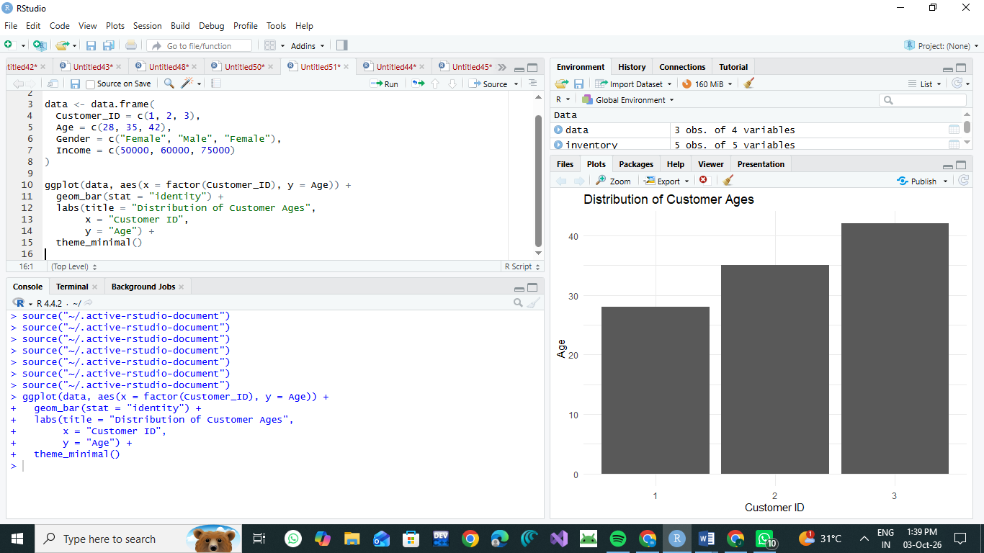
- Pie Chart – Gender Distribution
gender_count <- table(data$Gender)
pie(gender_count,
main = "Customer Distribution by Gender",
labels = paste(names(gender_count),
gender_count,
sep = ": "))
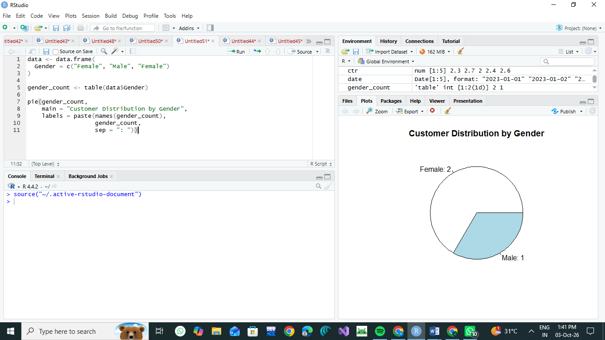
- Demographic Table
data <- data.frame(
Customer_ID = c(1, 2, 3),
Age = c(28, 35, 42),
Gender = c("Female", "Male", "Female"),
Income = c(50000, 60000, 75000)
print(data)

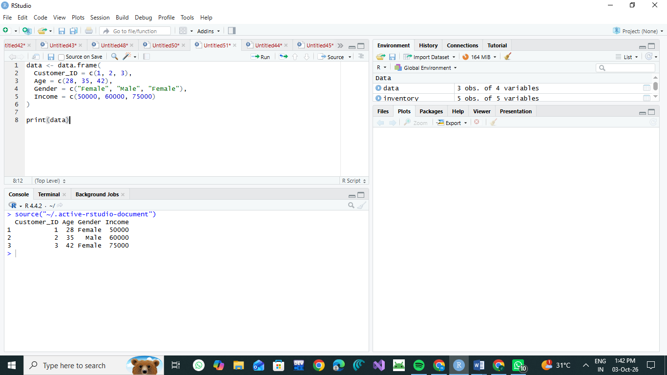
4.library(ggplot2)
data <- data.frame(
Customer_ID = c(1, 2, 3),
Age = c(28, 35, 42),
Gender = c("Female", "Male", "Female"),
Income = c(50000, 60000, 75000)
)

# Bar Chart
ggplot(data, aes(x = factor(Customer_ID), y = Age)) +
geom_bar(stat = "identity") +
labs(title = "Distribution of Customer Ages",
x = "Customer ID",
y = "Age") +
theme_minimal()

# Pie Chart
gender_count <- table(data$Gender)

pie(gender_count,
main = "Customer Distribution by Gender",
labels = paste(names(gender_count),
gender_count,
sep = ": "))

# Table
print(data)
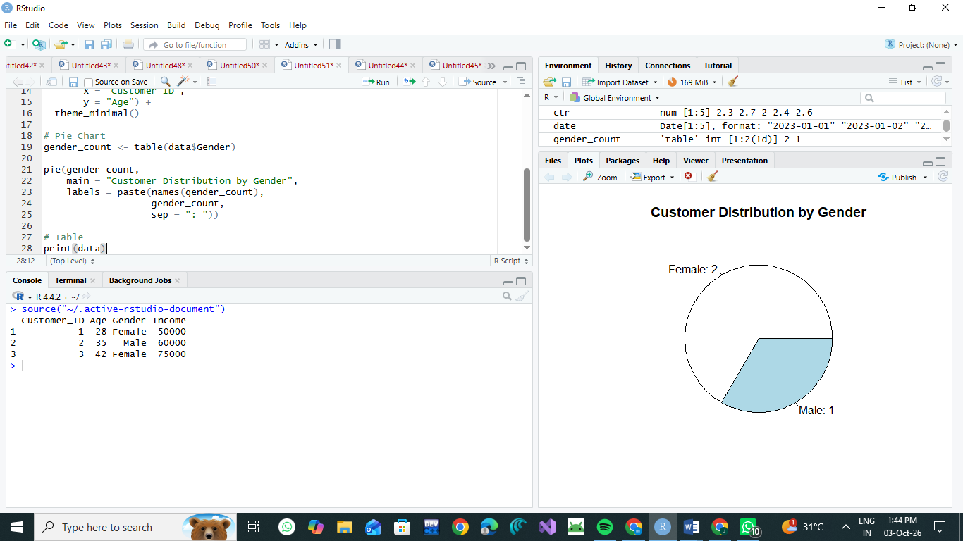
RESULT
The R programs successfully created the required visualizations.
- The bar chart displays the age of each customer.
- Customer 3 has the highest age of 42 years, while Customer 1 has the lowest age of 28 years.
- The pie chart shows that there are 2 female customers and 1 male customer.
- The demographic table displays Customer ID, Age, Gender, and Income for all customers.
- The visualizations can be combined with the table in Tableau to create an interactive customer demographics dashboard.
CONCLUSION
The Customer Demographics dataset was successfully analyzed using R programming. The bar chart represents customer ages, the pie chart represents gender distribution, and the table provides complete demographic information. These visualizations provide a simple and clear understanding of the customer data and can be combined in Tableau for interactive exploration.

