LAB EXPERIMENT RECORD
SET-08
Department | AIML
Course Code / Course Name | DSA0602 / Data Handling and Visualization
Experiment | Employee Performance Analysis
Name | M.Reddy Jayasree
Register Number | 192325140
Date | 03 October 2026
Day | Saturday

Set 8 – Employee Performance Analysis

Dataset
Employee ID | Department | Years of Service | Performance Score
1 | Sales | 5 | 85
2 | HR | 3 | 92
3 | Marketing | 7 | 78

1. Line Chart – Performance Trend
data <- data.frame(
Employee_ID = c(1, 2, 3),
Department = c("Sales", "HR", "Marketing"),
Years_of_Service = c(5, 3, 7),
Performance_Score = c(85, 92, 78)
)

plot(data$Years_of_Service, data$Performance_Score,
type = "o",
main = "Employee Performance Trend",
xlab = "Years of Service",
ylab = "Performance Score")
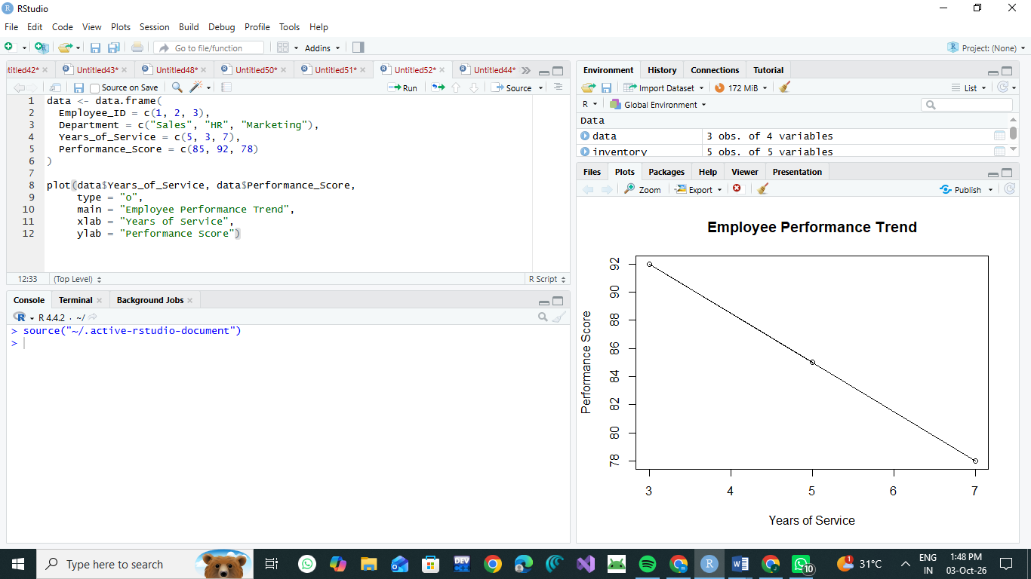

2. Bar Chart – Employees by Department
data <- data.frame(
Employee_ID = c(1, 2, 3),
Department = c("Sales", "HR", "Marketing"),
Years_of_Service = c(5, 3, 7),
Performance_Score = c(85, 92, 78)
)

dept_count <- table(data$Department)

barplot(dept_count,
main = "Employees by Department",
xlab = "Department",
ylab = "Number of Employees",
col = "skyblue")
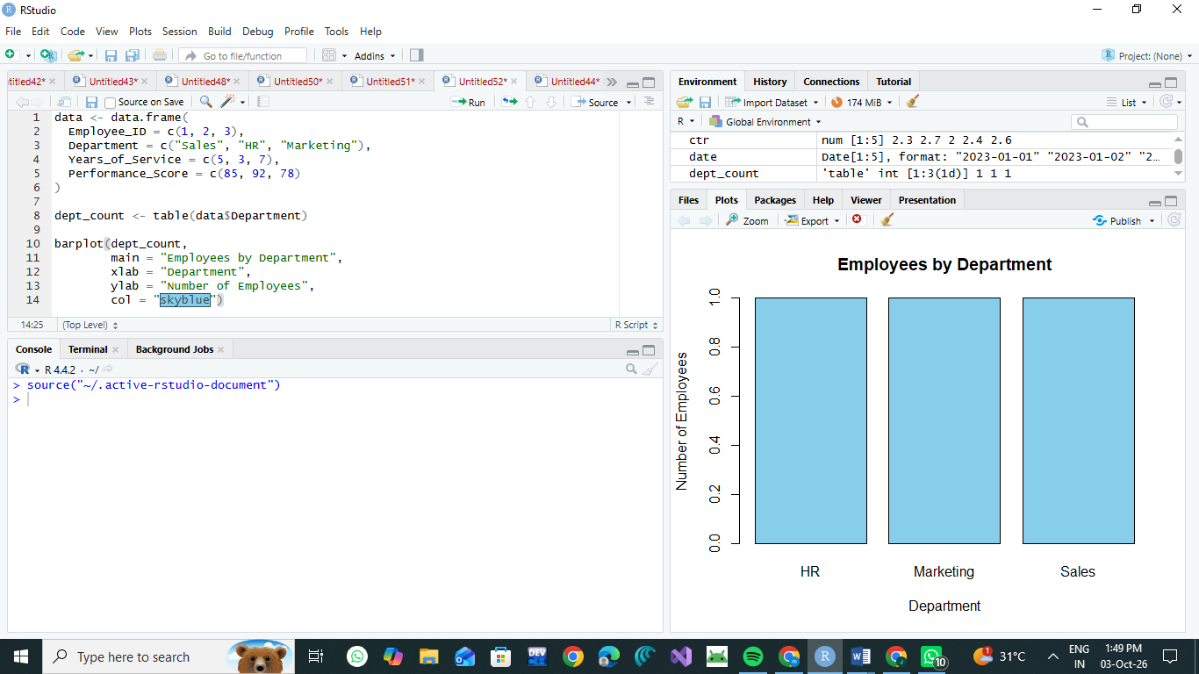

3. Table – Employee Performance Data
data <- data.frame(
Employee_ID = c(1, 2, 3),
Department = c("Sales", "HR", "Marketing"),
Years_of_Service = c(5, 3, 7),
Performance_Score = c(85, 92, 78)
)

print(data)
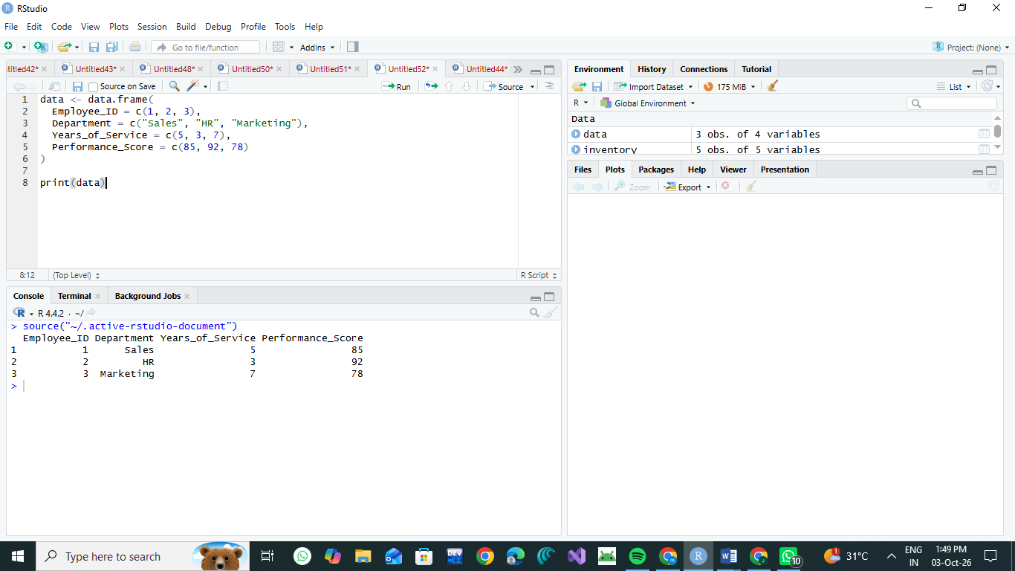

4. Tableau Dashboard

Procedure:
- Open Tableau and connect to the Employee Performance dataset.
- Create a Line Chart:
  - Columns → Years of Service
  - Rows → Performance Score
- Create a Bar Chart:
  - Columns → Department
  - Rows → Employee ID → Count
- Create a Table:
  - Employee ID
  - Department
  - Years of Service
  - Performance Score
- Create a new Dashboard.
- Add the Line Chart, Bar Chart, and Table to the dashboard.
- Add filters for Department and Employee ID for interactive exploration.

Result
The employee performance data is successfully visualized using a line chart, department-wise bar chart, and employee performance table. The Tableau dashboard combines all three visualizations for interactive analysis.

