LAB EXPERIMENT RECORD
SET-09
Department | AIML
Course Code / Course Name | DSA0602 / Data Handling and Visualization
Experiment | Employee Performance Analysis
Name | M.Reddy Jayasree
Register Number | 192325140
Date | 03 October 2026
Day | Saturday

Set 9 – Online Learning Activity Analysis

Dataset
Student ID | Gender | Age | Course | Study Time (hrs) | Videos Watched | Quiz Score | Login Date
L01 | Male | 20 | R | 3.5 | 12 | 78 | 2025-01-05
L02 | Female | 22 | R | 4.2 | 15 | 85 | 2025-01-05
L03 | Male | 19 | SQL | 2.0 | 8 | 65 | 2025-02-08
L04 | Female | 21 | R | 5.0 | 18 | 92 | 2025-02-08
L05 | Male | 23 | R | 2.5 | 9 | 70 | 2025-03-12
L06 | Female | 20 | SQL | 4.0 | 14 | 88 | 2025-03-12

Question 1 – Histogram and Boxplot

R Programming Code
data <- data.frame(
Student_ID = c("L01","L02","L03","L04","L05","L06"),
Gender = c("Male","Female","Male","Female","Male","Female"),
Age = c(20,22,19,21,23,20),
Course = c("R","R","SQL","R","R","SQL"),
Study_Time = c(3.5,4.2,2.0,5.0,2.5,4.0),
Videos_Watched = c(12,15,8,18,9,14),
Quiz_Score = c(78,85,65,92,70,88),
Login_Date = c("2025-01-05","2025-01-05","2025-02-08",
"2025-02-08","2025-03-12","2025-03-12")
)

hist(data$Quiz_Score,
main = "Distribution of Quiz Scores",
xlab = "Quiz Score",
ylab = "Number of Students")

boxplot(Quiz_Score ~ Course,
data = data,
main = "Quiz Score by Course",
xlab = "Course",
ylab = "Quiz Score")
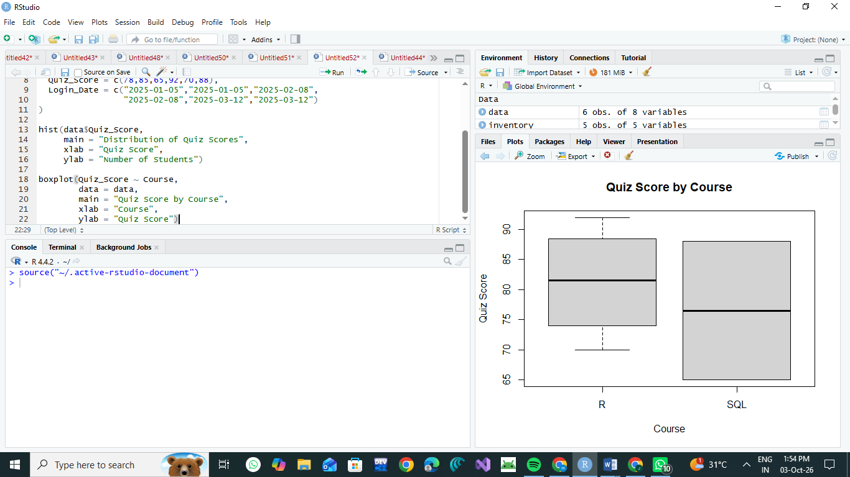

Interpretation
The quiz scores range from 65 to 92. Most students have scores between 70 and 90. The R course contains scores of 70, 78, 85 and 92, while SQL contains scores of 65 and 88. The boxplot helps compare the distribution of quiz scores between the two courses.

Question 2 – Scatter Plot with Bubble Size

R Programming Code
data <- data.frame(
Study_Time = c(3.5,4.2,2.0,5.0,2.5,4.0),
Videos_Watched = c(12,15,8,18,9,14),
Quiz_Score = c(78,85,65,92,70,88)
)

plot(data$Study_Time, data$Quiz_Score,
cex = data$Videos_Watched / 5,
pch = 19,
col = rgb(0, 0, 1, 0.5),
main = "Study Time vs Quiz Score",
xlab = "Study Time (Hours)",
ylab = "Quiz Score")

Explanation
The scatter plot shows the relationship between study time and quiz score. Students who spend more time studying generally have higher quiz scores. The bubble size represents the number of videos watched. Larger bubbles indicate that more videos were watched.
For example, the student with 5 hours of study time, 18 videos watched, and a score of 92 has the highest values in the dataset.

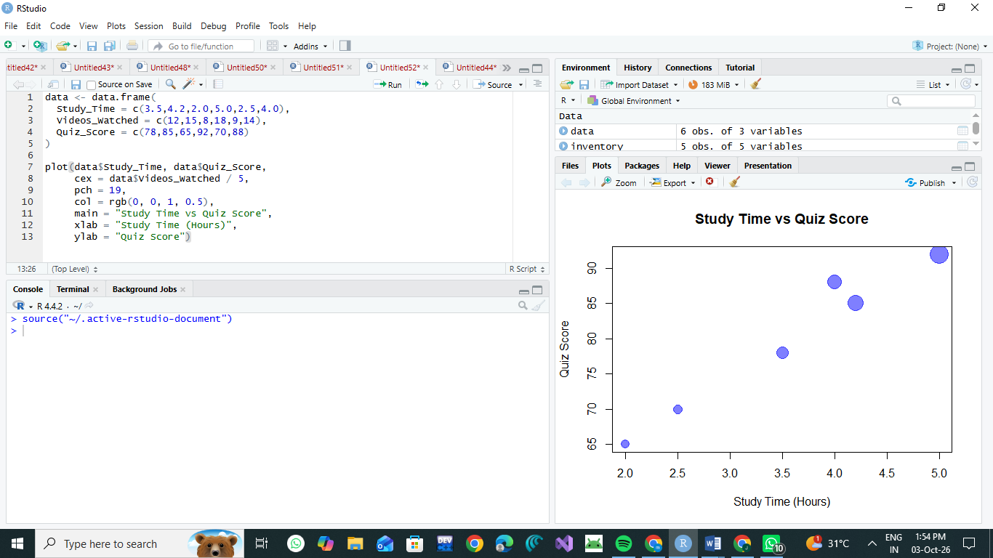

Question 3 – Monthly Average and Moving Average

R Programming Code
data <- data.frame(
Login_Date = c("2025-01-05","2025-01-05",
"2025-02-08","2025-02-08",
"2025-03-12","2025-03-12"),
Quiz_Score = c(78,85,65,92,70,88)
)

data$Login_Date <- as.Date(data$Login_Date)

data$Month <- format(data$Login_Date, "%Y-%m")

monthly_avg <- aggregate(Quiz_Score ~ Month,
data = data,
FUN = mean)

print(monthly_avg)

plot(monthly_avg$Month,
monthly_avg$Quiz_Score,
type = "o",
main = "Average Quiz Score per Month",
xlab = "Month",
ylab = "Average Quiz Score")

moving_avg <- stats::filter(monthly_avg$Quiz_Score,
rep(1/2, 2),
sides = 1)

lines(monthly_avg$Month,
moving_avg,
type = "o",
lty = 2)

Monthly Average
- January = 81.5
- February = 78.5
- March = 79.0

Interpretation
The average quiz score decreases from 81.5 in January to 78.5 in February, then increases slightly to 79.0 in March. Therefore, the data shows a small decrease followed by a slight improvement.
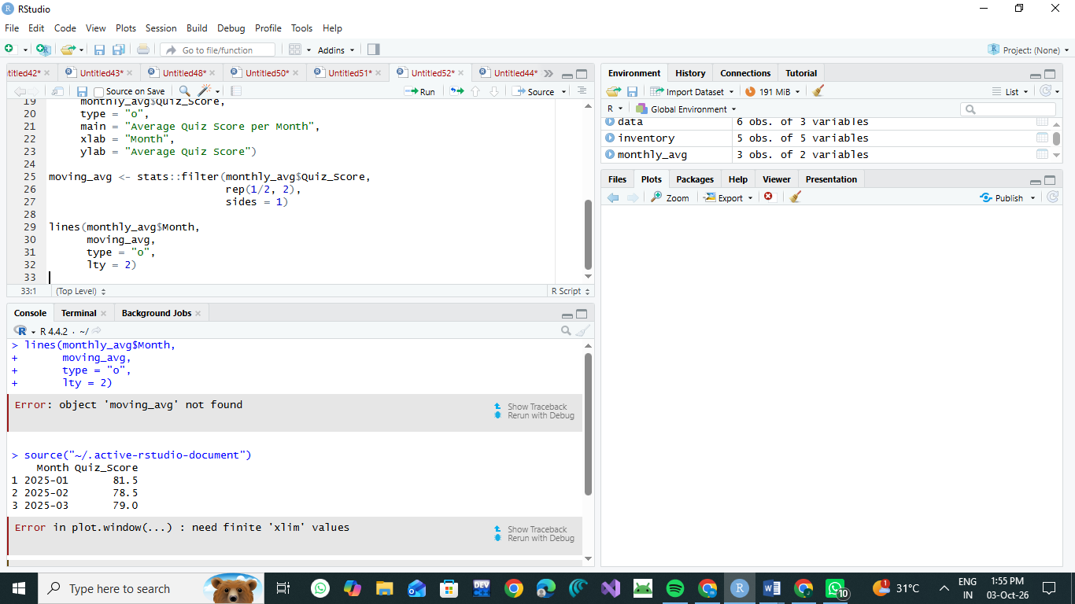

Question 4 – Tableau Mini Interactive Dashboard

Procedure
- Open Tableau.
- Select Connect → Text File.
- Import Online_Learning_Activity.csv.
- Create a worksheet named Average Quiz Score by Course.
- Drag Course to Columns.
- Drag Quiz_Score to Rows.
- Change Quiz_Score aggregation to Average.
- Create another worksheet named Study Time vs Quiz Score.
- Drag Study_Time (hrs) to Columns.
- Drag Quiz_Score to Rows.
- Drag Videos_Watched to Size.
- Drag Gender and Course to Filters.
- Create a new Dashboard.
- Add both charts to the dashboard.
- Add the Gender and Course filters for interactive exploration.

Expected Dashboard Components
Dashboard: Online Learning Activity
- Average Quiz Score by Course — Bar Chart
- Study Time vs Quiz Score — Scatter Plot
- Gender Filter
- Course Filter

Result
The Online Learning Activity dataset was successfully analyzed using R. The histogram and boxplot show quiz-score distribution, the scatter plot shows the relationship between study time and quiz performance, and the monthly line chart shows changes in average quiz scores. A Tableau dashboard combines the visualizations with Gender and Course filters for interactive analysis.

Conclusion
The analysis indicates that study time and learning activity are associated with quiz performance in this small dataset. Students with higher study time and more videos watched generally have higher quiz scores. The Tableau dashboard provides an interactive way to explore these patterns by gender and course.

