LAB EXPERIMENT RECORD
SET-04
Department | AIML
Course Code / Course Name | DSA0602 / Data Handling and Visualization
Experiment | Data Visualization using R
Name | M.Reddy Jayasree
Register Number | 192325140
Date | 01 October 2026
Day | Thursday
Set 4: Product Inventory Management
Dataset: Product Inventory
Product ID | Product Name | Quantity Available
1 | Product A | 250
2 | Product B | 175
3 | Product C | 300
4 | Product D | 200
5 | Product E | 220

1. Create a bar chart to visualize the quantity of each product in the inventory. Label the axes and title
the chart.
2. Generate a stacked bar chart to show the quantity of each product within different product
categories.
3. Build a scatter plot to explore the relationship between product price and quantity available. Explain
the findings.
4. Develop a Tableau dashboard with the bar chart and stacked bar chart to allow users to interact
with the data.

Set 4: Product Inventory Management Using R

Aim
To analyze and visualize product inventory data using R programming by creating a bar chart, stacked bar chart, and scatter plot, and to develop a Tableau dashboard for interactive inventory analysis.

Dataset
Product ID | Product Name | Quantity Available
1 | Product A | 250
2 | Product B | 175
3 | Product C | 300
4 | Product D | 200
5 | Product E | 220

Procedure
- Create the product inventory dataset in R using vectors and a data frame.
- Create a bar chart to visualize the quantity available for each product.
- Add a Product Category column and create a stacked bar chart to display quantities according to categories.
- Add Product Price data and create a scatter plot to study the relationship between price and quantity available.
- Export the inventory data as a CSV file.
- Import the CSV file into Tableau.
- Create separate worksheets for the bar chart and stacked bar chart.
- Combine the worksheets into a Tableau dashboard and add filters for interaction.

R Program
1.product_id <- c(1, 2, 3, 4, 5)
product_name <- c("Product A", "Product B", "Product C", "Product D", "Product E")
quantity <- c(250, 175, 300, 200, 220)

inventory <- data.frame(
product_id,
product_name,
quantity
)

# 1. Bar Chart
barplot(
inventory$quantity,
names.arg = inventory$product_name,
col = "skyblue",
main = "Product Inventory",
xlab = "Product Name",
ylab = "Quantity Available"
)

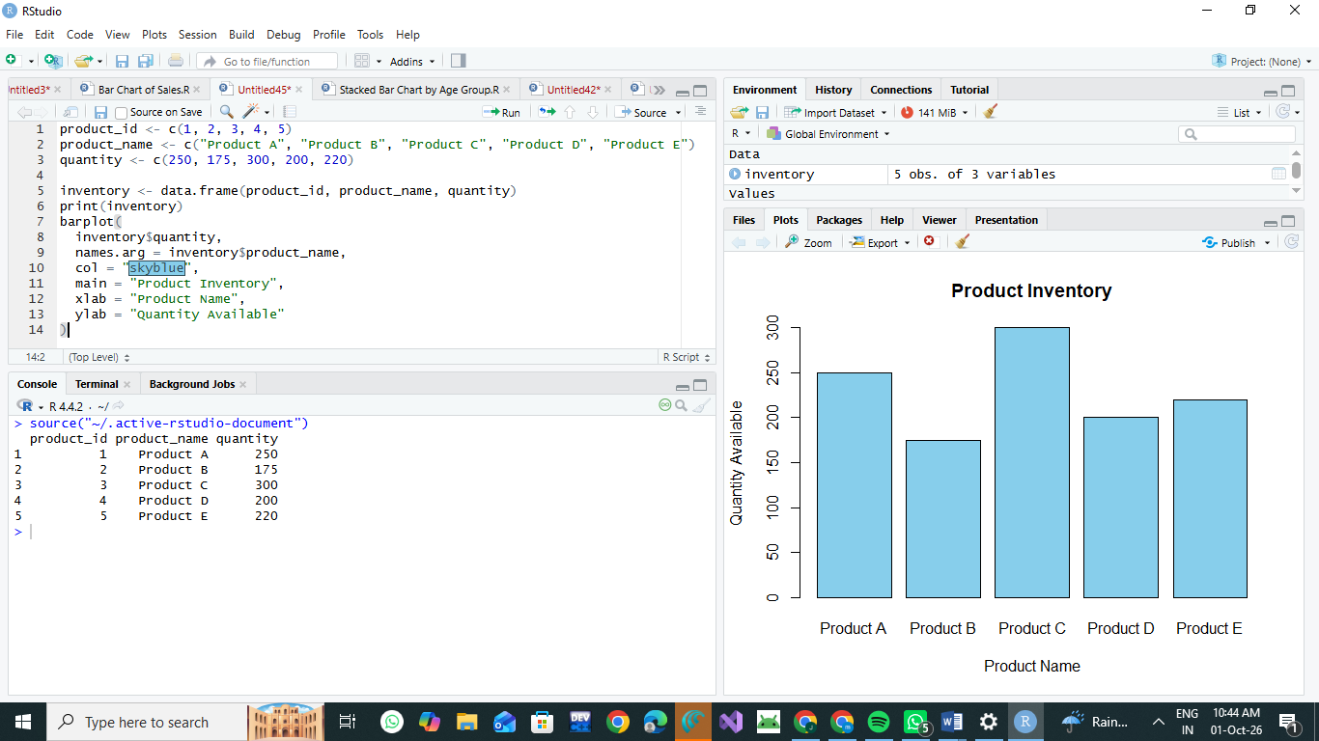

2.# Product Categories
inventory$category <- c(
"Electronics",
"Electronics",
"Furniture",
"Furniture",
"Electronics"
)

# 2. Stacked Bar Chart
category_data <- xtabs(
quantity ~ product_name + category,
data = inventory
)

barplot(
t(category_data),
beside = FALSE,
col = c("orange", "lightblue"),
main = "Product Quantity by Category",
xlab = "Product Name",
ylab = "Quantity Available",
legend.text = TRUE
)

# Product Prices
inventory$price <- c(500, 700, 450, 600, 550)
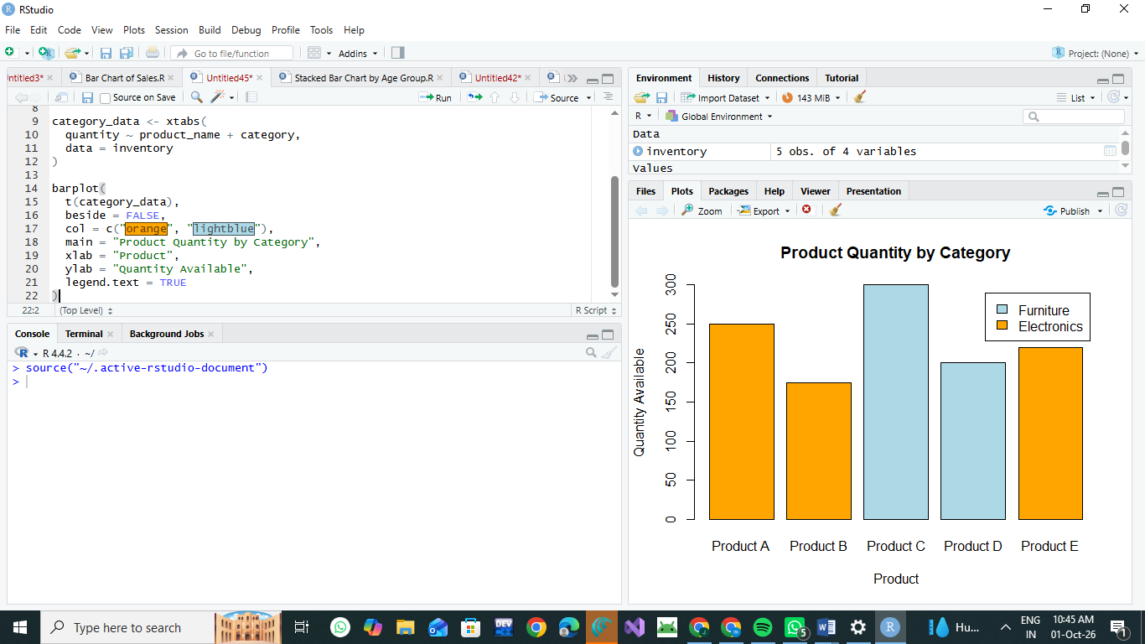

3. Scatter Plot
plot(
inventory$price,
inventory$quantity,
main = "Product Price vs Quantity Available",
xlab = "Product Price",
ylab = "Quantity Available",
pch = 19,
col = "blue"
)

# Export for Tableau
write.csv(
inventory,
"product_inventory.csv",
row.names = FALSE
)
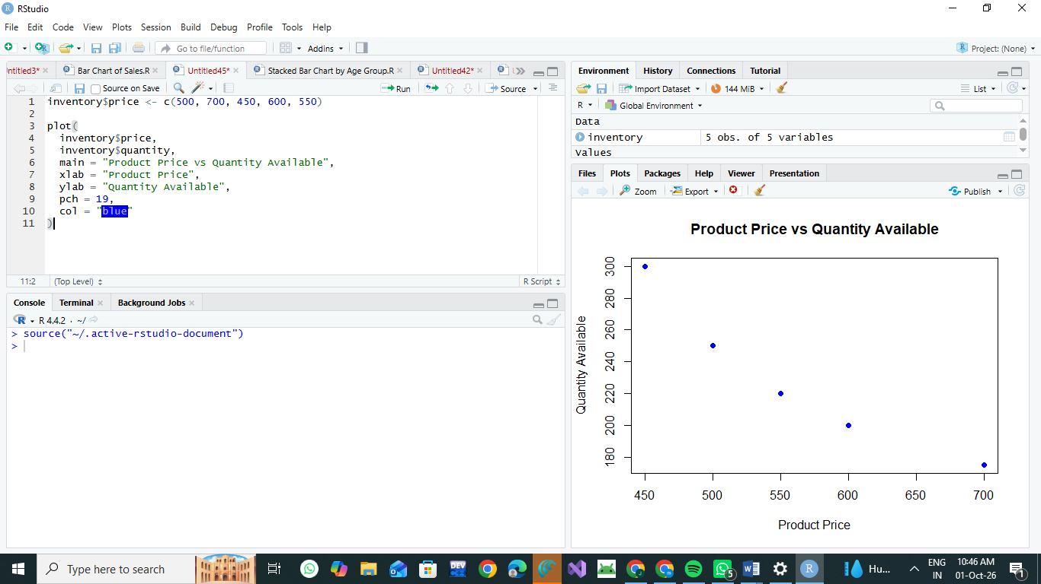

4.product_id <- c(1, 2, 3, 4, 5)
product_name <- c("Product A", "Product B", "Product C", "Product D", "Product E")
quantity <- c(250, 175, 300, 200, 220)

inventory <- data.frame(
product_id,
product_name,
quantity
)

# 1. Bar Chart
barplot(
inventory$quantity,
names.arg = inventory$product_name,
col = "skyblue",
main = "Product Inventory",
xlab = "Product Name",
ylab = "Quantity Available"
)

# Categories for stacked bar chart
inventory$category <- c(
"Electronics",
"Electronics",
"Furniture",
"Furniture",
"Electronics"
)

# 2. Stacked Bar Chart
category_data <- xtabs(
quantity ~ product_name + category,
data = inventory
)

barplot(
t(category_data),
beside = FALSE,
col = c("orange", "lightblue"),
main = "Product Quantity by Category",
xlab = "Product",
ylab = "Quantity Available",
legend.text = TRUE
)

# Example prices for scatter plot
inventory$price <- c(500, 700, 450, 600, 550)

# 3. Scatter Plot
plot(
inventory$price,
inventory$quantity,
main = "Product Price vs Quantity Available",
xlab = "Product Price",
ylab = "Quantity Available",
pch = 19,
col = "blue"
)

# Save data for Tableau
write.csv(
inventory,
"product_inventory.csv",
row.names = FALSE
)

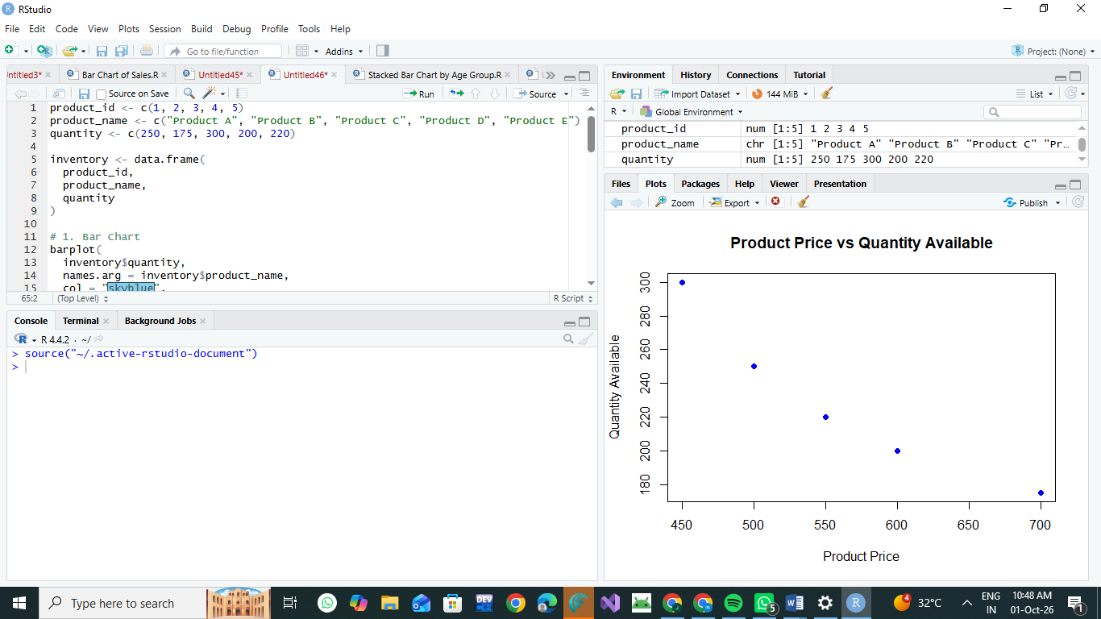

Result
The product inventory data was successfully analyzed and visualized using R.
- Bar Chart: The chart shows the quantity available for each product. Product C has the highest quantity of 300, while Product B has the lowest quantity of 175.
- Stacked Bar Chart: The chart represents the quantity of products according to their categories.
- Scatter Plot: The scatter plot shows the relationship between product price and quantity available. In the example data, higher-priced products generally have lower available quantities.
- Tableau Dashboard: The inventory data was exported to CSV and can be imported into Tableau to create an interactive dashboard containing the bar chart and stacked bar chart.
Conclusion: Product inventory can be effectively analyzed using R visualizations, while Tableau provides an interactive way to explore the inventory data.

