Course Title : Big Data Analytics
Course Code : Z1AMC 702
Name: Jayman Prajapati Registration No: 2511042210016

Experiment 1: Hadoop Single Node Installation

- Objective
To install and configure Hadoop in a single-node environment and verify the successful execution of Hadoop Distributed File System (HDFS) and YARN services.

Procedure
  - Install Java Development Kit (JDK).
  - Download and extract the Hadoop package.
  - Configure environment variables in .bashrc.
  - Configure Hadoop files:
- core-site.xml
- hdfs-site.xml
- mapred-site.xml
- yarn-site.xml

Format the NameNode using:
hdfs namenode -format

Start HDFS services using:
start-dfs.sh

- Start YARN services using: start-yarn.sh

Verify running services using: jps

- Access Hadoop web interfaces:
  - NameNode: http://localhost:9870
  - ResourceManager: http://localhost:8088

Source Code
export JAVA_HOME=/usr/lib/jvm/java-11-openjdk-amd64 export HADOOP_HOME=/usr/local/hadoop
export PATH=$PATH:$HADOOP_HOME/bin:$HADOOP_HOME/sbin
hdfs namenode -format start-dfs.sh
start-yarn.sh jps

Screen Shot
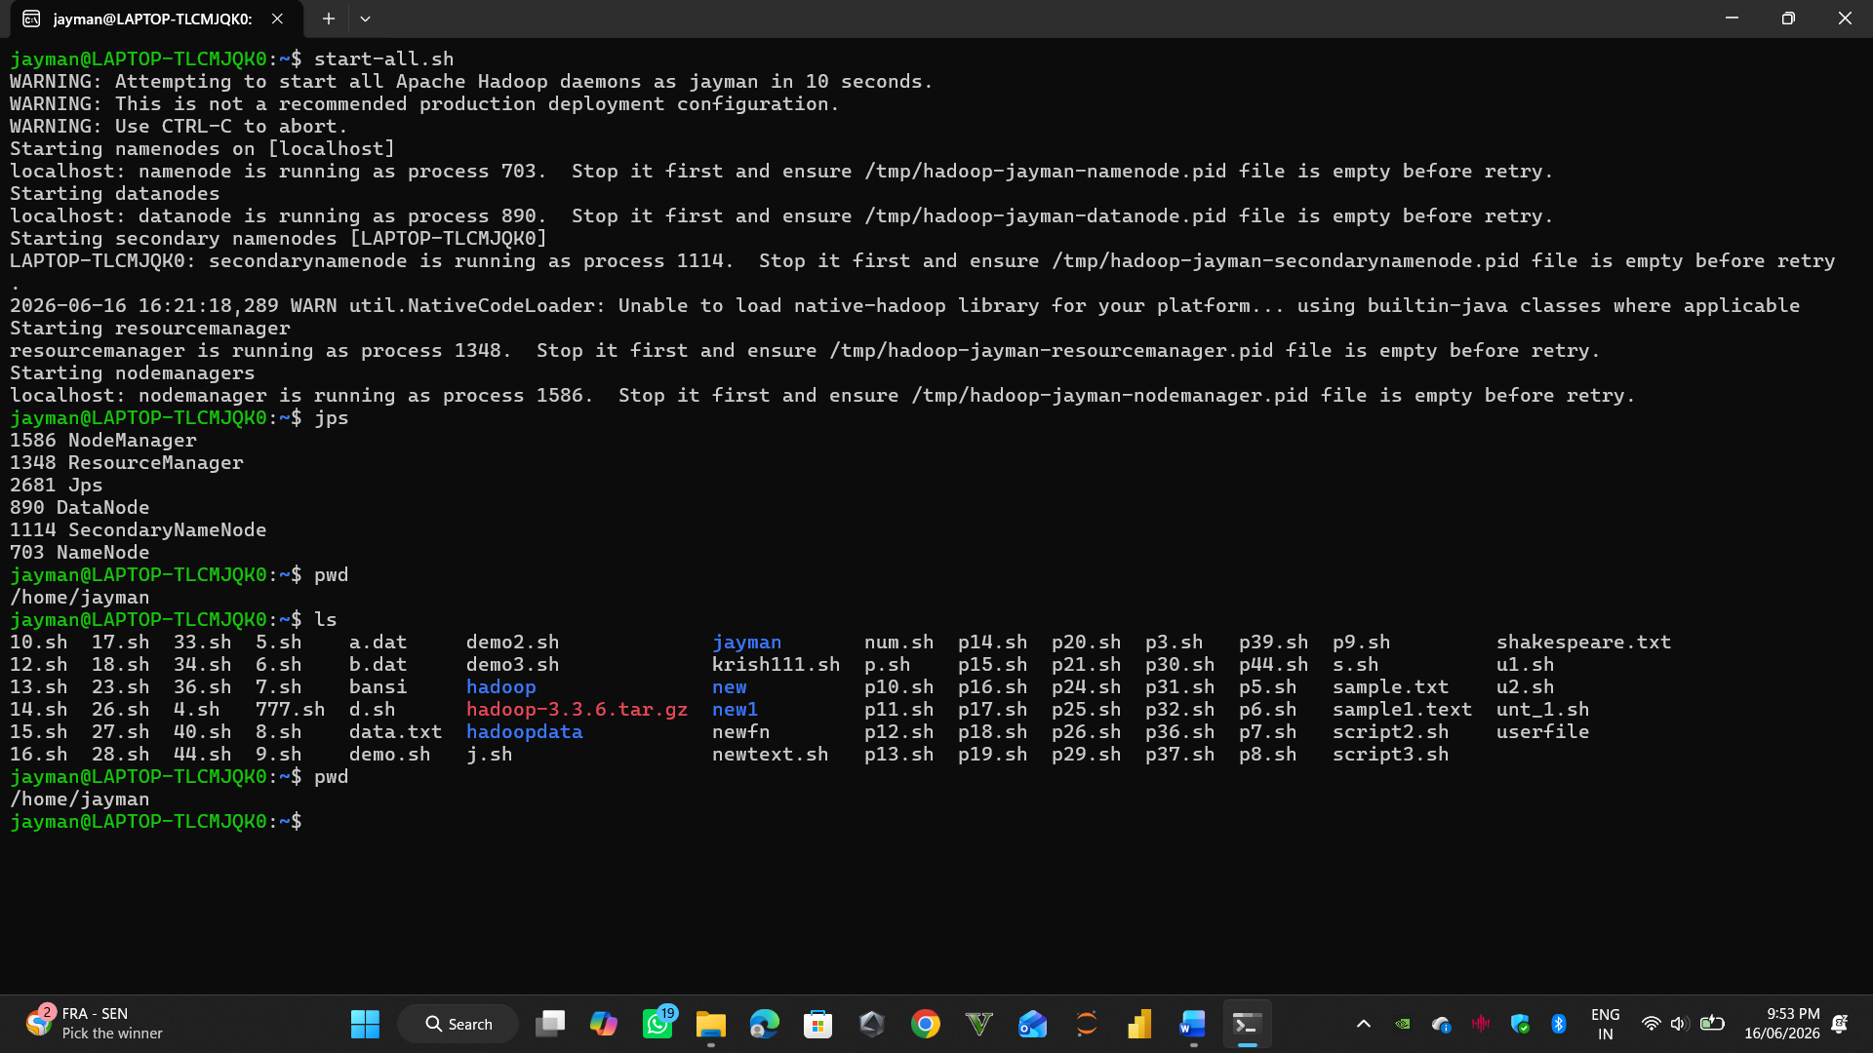

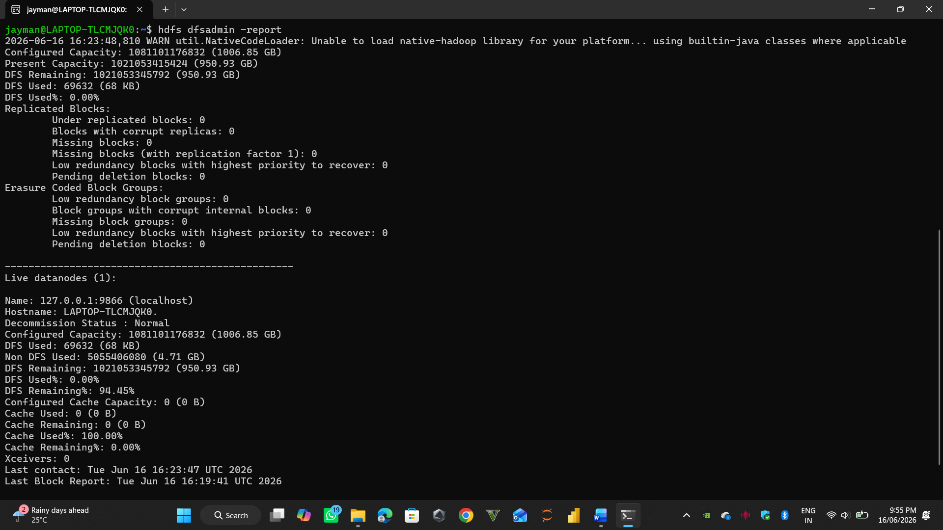

Conclusion
Hadoop was successfully installed and configured in a single-node environment. HDFS and YARN services were started and verified using JPS and web interfaces.

Experiment 2: Hadoop Basic Commands Title: Hadoop Basic Commands
- Objective
To understand and execute basic Hadoop HDFS commands for file and directory management.

Procedure
  - Create a directory in HDFS.
  - Upload files to HDFS.
  - List files and directories.
  - View file contents.
  - Download files from HDFS.
  - Remove files and directories.

Source Code

Create directory
hdfs dfs -mkdir /demo

Upload file
hdfs dfs -put sample.txt /demo

List files
hdfs dfs -ls /demo

View file content
hdfs dfs -cat /demo/sample.txt

Download file
hdfs dfs -get /demo/sample.txt

Delete file
hdfs dfs -rm /demo/sample.txt

Delete directory
hdfs dfs -rmdir /demo

Screen Shot

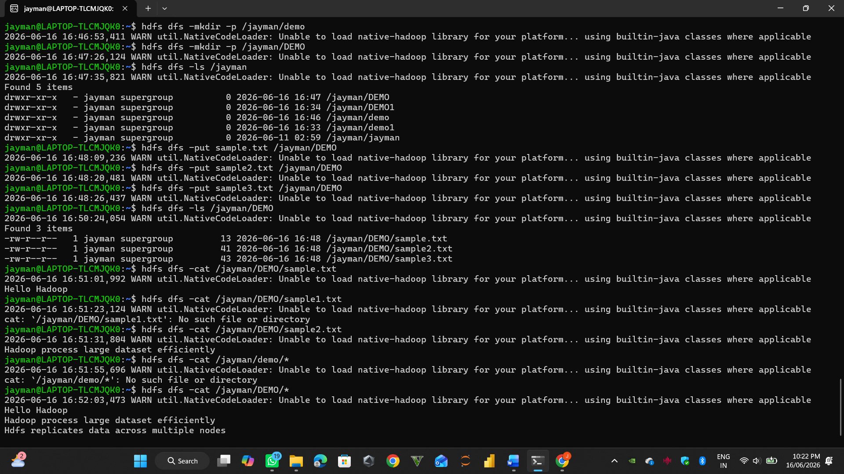

- Conclusion
Basic HDFS commands were executed successfully. Files and directories were created, uploaded, viewed, and deleted using Hadoop commands.

Experiment 3: Simple Word Count Program in Hadoop

Title: Simple Word Count Program in Hadoop
- Objective
To perform word frequency analysis on a text file using the Hadoop MapReduce WordCount program.

Procedure
  - Create an input text file.
  - Upload the file to HDFS.
  - Execute the Hadoop WordCount MapReduce job.
  - View the generated output.
  - Analyze the word frequency results.

Source Code

Create input file
echo "Big Data is the future of analytics" > sample.txt

Create HDFS input directory
hdfs dfs -mkdir /input

Upload file
hdfs dfs -put sample.txt /input

Run WordCount
hadoop jar $HADOOP_HOME/share/hadoop/mapreduce/hadoop-mapreduce-examples-*.jar wordcount /input /output

View results
hdfs dfs -cat /output/part-r-00000

Screen Shot

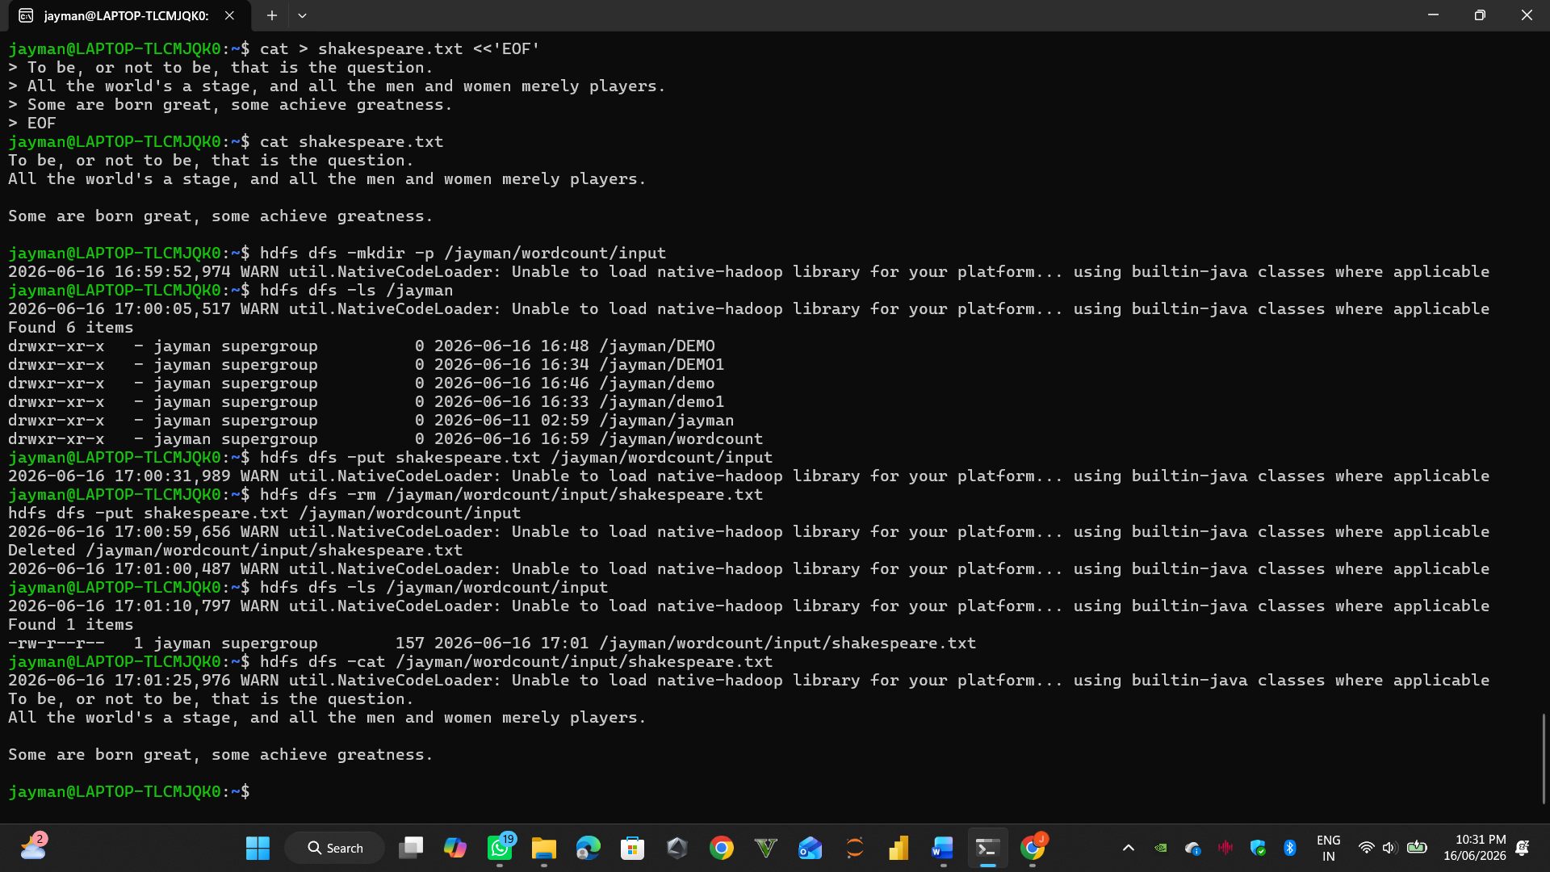

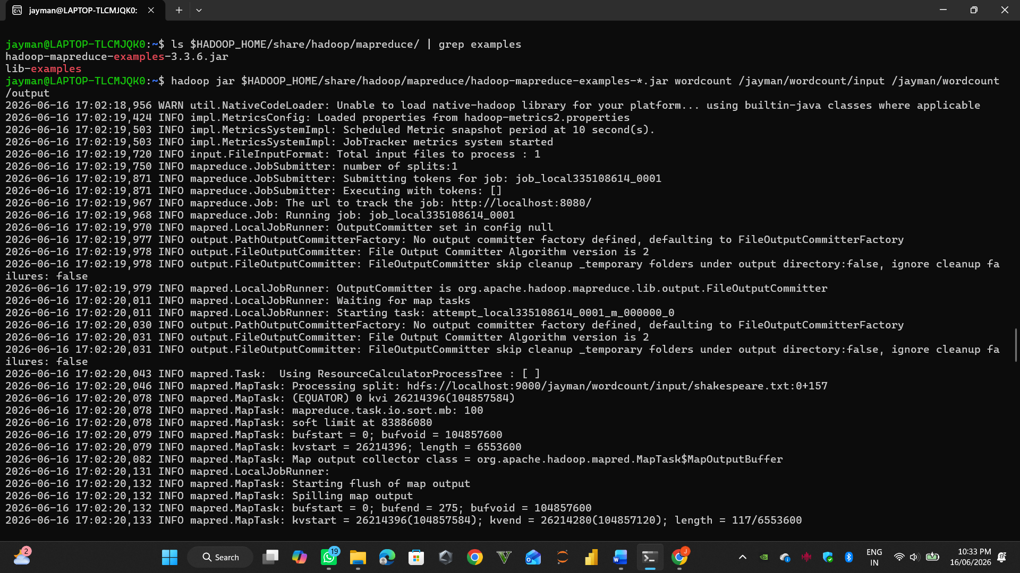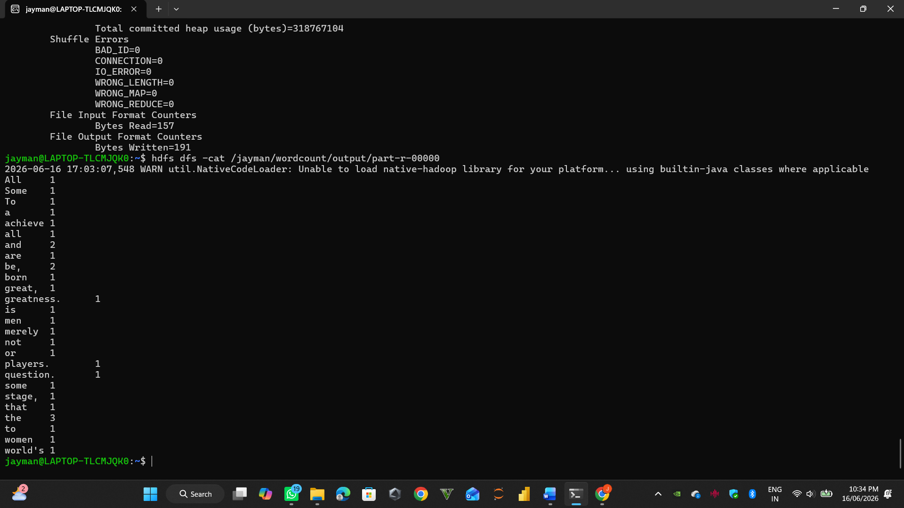

- Conclusion
The Hadoop MapReduce WordCount program was executed successfully. The output displayed the frequency of each word in the input file, demonstrating the distributed processing capability of Hadoop.

