**F M TRANSMITTER**

**A PROJECT REPORT**

***Submitted by***

**ABHIJEET TAKLE**

**& JAY SRIVASTAVA**

***in Electronic Devices and Circuits***

***of***

**Second Year**

in



SCHOOL OF ELECTRONICS AND TELECOMMUNICATION ENGINEERING

**DR VISHWANATH KARAD MIT - WORLD PEACE UNIVERSITY**

SEPTEMBER 2020

**Title: FM TRANSMITTER**

**Components required:**

* 3 X N39904
* V cc power supply
* Inductors
* Capacitors
* Resistors
* Microphone
* 2 X Signal analyzer
* A 9V DC Power supply

**Introduction:**

FM transmission is done by the process of audio pre amplification, modulation and then transmission.

Here we have adapted the same formula by first amplifying the audio signal, generating a carrier signal using an oscillating and then modulating the carrier signal with the amplified audio signal. The amplification is done by an amplifier, whereas the modulation and carrier signal generation is done by an variable frequency. The frequency is set at anywhere between the FM frequency range is from 88MHz to 108MHz.

**Working Principle:**

FM transmission is done by the process of audio pre amplification, modulation and then transmission.

Here we have adapted the same formula by first amplifying the audio signal, generating a carrier signal using an oscillating and then modulating the carrier signal with the amplified audio signal and then transmitted into the space.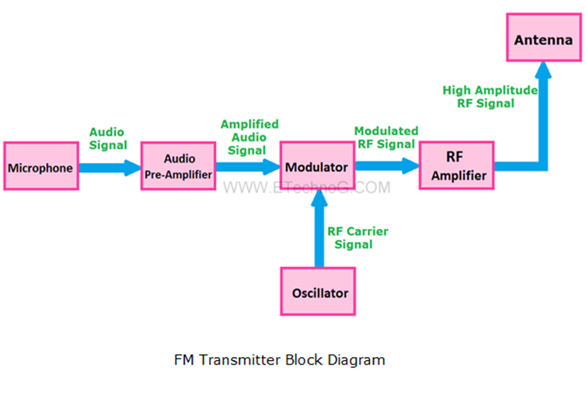

**Design:**

**Design of Audio Pre-amplifier:**

Here we are designing a simple single stage common emitter amplifier as the pre-amplifier**.**

* Selection of V(cc) : Here we have selected the NPN Bipolar Junction Transistor, BC109. Since VCEO for this transistor is around 40V, we choose a much lesser V(cc), of about 9V.
* Selection of Load Resistor, R4: R4=4.5K. We select a 5K resistor for better operation.
* Selection of Voltage Divider Resistors R2 and R3: The voltage divider resistors, R2=22K resistor,R3=90K resistor.
* Selection of Emitter Resistor R5: R5=540 Ohms. Here we select a 500Ohms resistor.  It serves the purpose of bypassing the emitter current.
* Selection of coupling capacitor, C1: Here we select a value of 5 uF.
* Selection of Microphone Resistor R1: Here we select a 18K resistor.
* Selection of Bypass Capacitor, C4: Here we select an electrolyte capacitor of 15 uF, which bypasses the DC signal

**Design of Oscillator Circuit**:

* Selection of tank circuit components L1 and C6: Let us select a 0.2uH inductor. Here we select a variable capacitor in the range 5 to 20pF.
* The frequency of oscillation is given as f=1/2𝜋√𝐿𝐶.
* Selection of Tank Capacitor, C9: Let us select a 5 pF capacitor.
* Selection of bias resistors R6 and R7: We select the values of bias resistors R6 and R7 to be 9 K Ω and 40 K Ω respectively.
* Selection of coupling capacitor, C3: Here we select electrolyte capacitors of about 0.01 μ Farad as the coupling capacitor.
* Selection of emitter resistor, R8: The value of emitter resistor to be around 1KΩ.

**Circuit Diagram:**

1. **Circuit diagram of FM Transmitter**

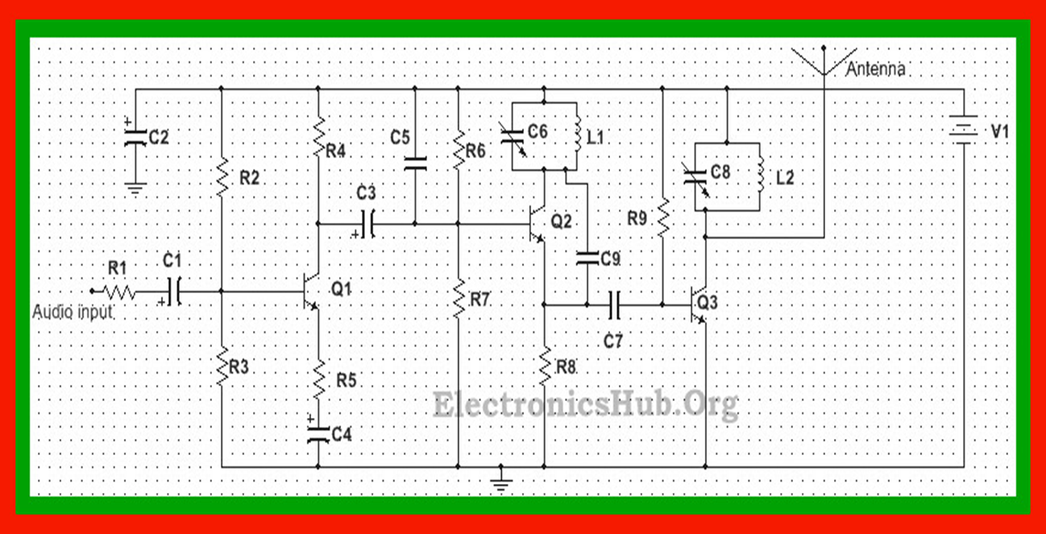

This is the circuit diagram of a FM Transmitter which has three 2N3904 Transistors and use of capacitor and inductor to make voltage divider biased circuits and the oscillators respectively. The FM Transmitter has three basic stages

1. The pre amplification of audio signals
2. The modulation of audio signal by a carrier wave using oscillators
3. Then reamplifying it to lower down the impedance to match with the antenna resistance

These three process then produces a modulated signal wave which is then demodulated at the receiver’s side to get the original wave , which was sent by the transmitting party.

THE FREQUENCY OF OSCILLATION IS GIVEN BY f=1/2 $π√LC$

Since the range is about 2 km, we can prepare an antenna using a stick antenna or a wire of 30 inches approximately which would be about 1/4th of the transmitting wavelength.

THE GIVEN CIRCUIT DIAGRAM IS WHAT WE HAVE IMPLEMENTED IN THE MULTISIM SOFTWARE

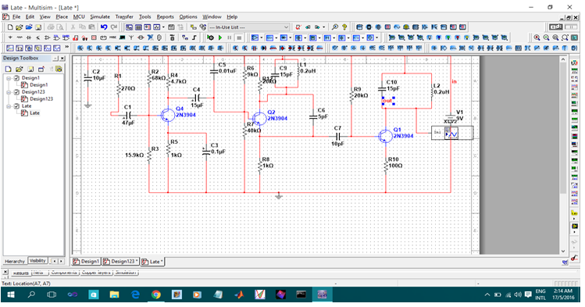

**Results:** Hence by connecting all the above components in the order given in the circuit diagram , we’ve created a FM Transmitter circuit .

**Conclusion:**

The frequency of oscillation is thus given as 91.1MHz . which is in the range of FM Bandwidth .

The FM bandwidth is given from 88MHz to 108 MHz.

The Vceo of the transistor 2N3904 is 40V , Thus we need only 9V DC supply in input form.

The antenna length should be 1/4th of wavelength of modulated signal.