

**School of Electronics and Communication Engineering**

**Second Year B. Tech. (ECE)**

**Microcontrollers Course Code: ECE214A**

**HUMAN DETECTION ROBOT**

**By**

**ATUL KUMAR (PC-44)**

**JAY SRIVASTAVA(PC 46)**

**TANMAY KAPIL(PC 47)**

**Professor SAVITRI JADHAV**

**AKNOWLEDGEMENT**

No work without a teacher is successful. We would first like to thank our Professor Savtri Jadhav Ma’am for helping us throughout this semester regarding this project. We would also like to thank our Almighty for showing us correct way to start the project. We would also like to thank our classmates for helping us in collecting different materials irrespective of their group. We would also like to thank our parents for helping us financially through this project. We would also like to thank our seniors who were at least there to guide us through different materials and stuffs.

In this project “Human Detector Robot”, we have used the concept of motor driving technique and PIR sensors basics to demonstrate and used Proteus 8.10 version simulator to run the circuit.

We would like you to go through this project and thus read each lines of report that clarifies the demonstration of the project. Any critics are warmly welcomed.

**Abstract:**

**INDEX**

|  |  |
| --- | --- |
| 1. **Introduction** | **Page No.** |
| **2. Hardware Design** | 4 |
| 2.1 System Block diagram | 4 |
| 2.2 Description | 5 |
| 2.3 Selection of Components and its specification | 5-8 |
| 2.4 Interfacing Diagram | 9 |
| **3. Software Design**  Flowchart/Algorithm and Embedded C code | 9-12 |
| **4. Conclusion** | 12 |
| **References** | 12 |
| **Data sheet (Referred pages)** | 12 |

**General instructions for report writing**

* Follow the index given to write the report.
* Tables and figures in each of the chapter should be provided immediately after the reference where they are cited. Numbering should be done to every figure and Table.
* The listing of the references should be in the format given below: Name of Authors, “Title of paper”,” Title of Journal,vol ,no,page no . e.g.
* Kumar, H. Y. Shwe, K. J. Wong, and P. H. Chong, "Location-Based Routing Protocols for Wireless Sensor Networks: A Survey," Wireless Sensor Network, vol. 9, no. 01, p. 25, 2017.
* List the websites used in the report.

1. **Introduction**

Human detection robot is not a new technology. Many types of human detection robots have been designed depending on the application. During natural calamities like earthquakes, it is difficult to rescue humans stuck under the buildings. Though detection by rescue team is done, it consumes a lot of time. So, detection of humans in appropriate time becomes very important in such situations. Our project presents a simple human detection robot that is operated manually using RF technology

1. **Hardware Design**
   1. **System Block Diagram**

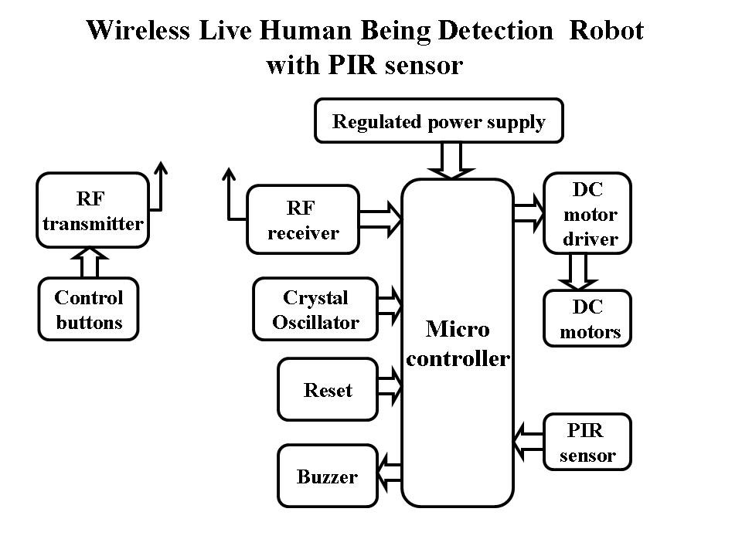

Figure 1

**2.2 Description**

The working of this project depends on the range of PIR sensor we are using. The implementation is quite simple and definite. As we give the power supply, the motors starts rotating in a specified direction. The moment PIR sensor detects a obstacle its suddenly invokes the microcontroller and instruct it to stop the rotating motors. As soon as the motor stops rotating so there will be a pop up displayed on the LCD that is “Human Detected!”. As soon as the human is in the range of PIR sensor, it will make the motors in dormant. The moment he/she is out of its range the logic of PIR Sensors becomes zero the motors again starts moving thus making the LCD to show ” moving”

* 1. **Components Selected**
* C8051F340 microcontroller.
* L293D IC.
* Robot chassis.
* Motors.
* PIR Sensors
* Capacitors
* 16X2 Alphanumeric LCD

1. C8051F340 microcontroller

C8051F340/1/2/3/4/5/6/7/8/9/A/B/C/D devices are fully integrated mixed-signal System-on-a-Chip MCUs. With on-chip Power-On Reset, VDD monitor, Voltage Regulator, Watchdog Timer, and clock oscillator,C8051F340/1/2/3/4/5/6/7/8/9/A/B/C/D devices are truly stand-alone System-on-a-Chip solutions. The Flash memory can be reprogrammed in-circuit, providing non-volatile data storage, and also allowing field upgrades of the 8051 firmware. User software has complete control of all peripherals, and may individually shut down any or all peripherals for power savings

Features

High-speed pipelined 8051-compatible microcontroller core (up to 48 MIPS) • In-system, full-speed, non-intrusive debug interface (on-chip)

Universal Serial Bus (USB) Function Controller with eight flexible endpoint pipes, integrated transceiver, and 1 kB FIFO RAM

Supply Voltage Regulator

True 10-bit 200 ksps differential / single-ended ADC with analog multiplexer

On-chip Voltage Reference and Temperature Sensor

On-chip Voltage Comparators (2)

Precision internal calibrated 12 MHz internal oscillator and 4x clock multiplier

Internal low-frequency oscillator for additional power savings

Up to 64 kB of on-chip Flash memory • Up to 4352 Bytes of on-chip RAM (256 + 4 kB) • External Memory Interface (EMIF) available on 48-pin versions.

SMBus /I2C, up to 2 UARTs, and Enhanced SPI serial interfaces implemented in hardware • Four general-purpose 16-bit timers

Programmable Counter/Timer Array (PCA) with five capture/compare modules and Watchdog Timer function

On-chip Power-On Reset, VDD Monitor, and Missing Clock Detector

Up to 40 Port I/O (5 V tolerant) With on-chip Power-On Reset, VDD monitor, Voltage Regulator, Watchdog Timer, and clock

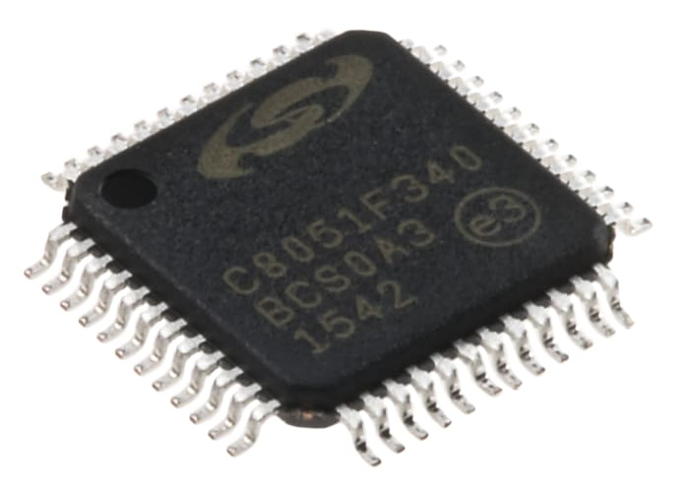

Figure 2.1

1. **L293D**

The L293D is a popular 16-Pin Motor Driver IC. As the name suggests it is mainly used to drive motors. A single L293D IC is capable of running two DC motors at the same time; also the direction of these two motors can be controlled independently

The IC works on the principle of Half H-Bridge. H bridge is a set up which is used to run motors both in clock wise and anti -clockwise direction**.**

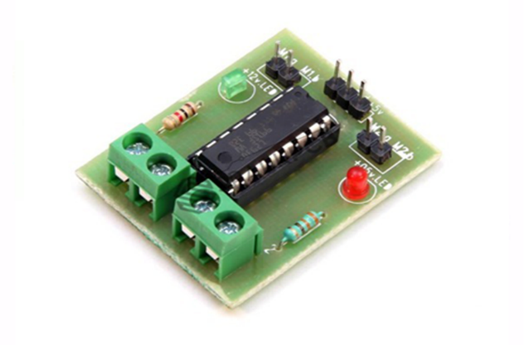

Figure 3

1. **PIR Sensor**

PIR (passive infrared) sensors utilise the detection of infrared that is radiated from all objects that emit heat. This type of emission is not visible to the human eye, but sensors that operate using infrared wavelengths can detect such activity. They are sometimes referred to as ‘motion-based detectors’, as they sense the presence of people, animals and objects through the movement of their infrared wavelengths.

They are referred to as “passive” due to the fact that no heat or energy is emitted by the sensor itself. It is also important to remember that PIR sensors detect the emission of infrared radiation, and not heat.

**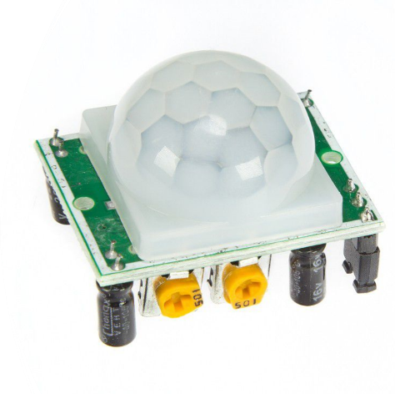   
4. Hitachi HD44780**

Figure 4

The Hitachi HD44780 LCD controller is an alphanumeric dot matrix liquid crystal display (LCD) controller developed by Hitachi in the 1980s. The character set of the controller includes ASCII characters, Japanese Kana characters, and some symbols in two 28 character lines. Using an extension driver, the device can display up to 80 characters.[1] The HD44780 is one of the most popular character LCDs ever made, with numerous third-party displays utilizing its 16-pin interface and instruction set for compatibility**.**

Compatible LCD screens are manufactured in several standard configurations. Common sizes are one row of eight characters (8×1), and 16×2, 20×2 and 20×4 formats. Larger custom sizes are made with 32, 40 and 80 characters and with 1, 2, 4 or 8 lines. The most commonly manufactured larger configuration is 40×4 characters, which requires two individually addressable HD44780 controllers with expansion chips as a single HD44780 chip can only address up to 80 characters.

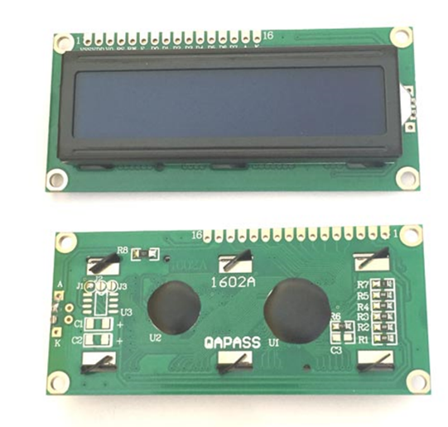

Figure 5

1. **DC Motor**

A DC motor is any of a class of rotary electrical motors that converts direct current electrical energy into mechanical energy. The most common types rely on the forces produced by magnetic fields. Nearly all types of DC motors have some internal mechanism, either electromechanical or electronic, to periodically change the direction of current in part of the motor. A simple DC motor has a stationary set of magnets in the stator and an armature with one or more windings of insulated wire wrapped around a soft iron core that concentrates the magnetic field. The windings usually have multiple turns around the core, and in large motors there can be several parallel current paths. The ends of the wire winding are connected to a commutator. The commutator allows each armature coil to be energized in turn and connects the rotating coils with the external power supply through brushes.

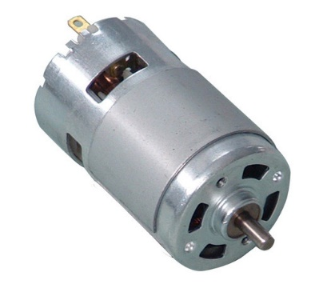

Figure 6

**2.4 Interfacing diagram**

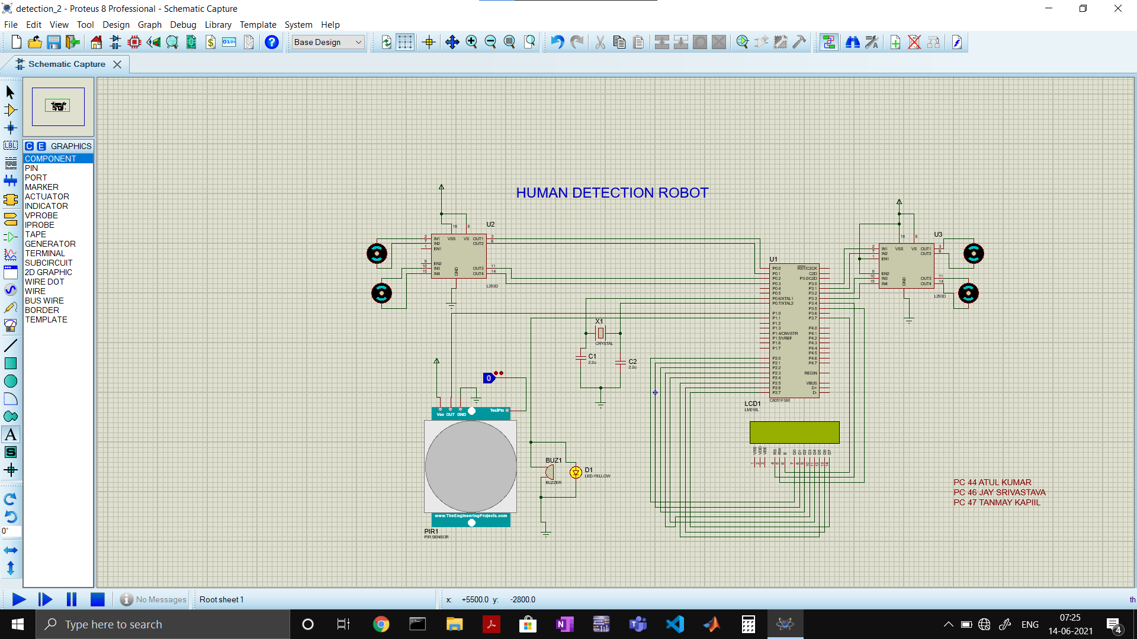

Figure 7

1. **Software Design**

**Algorithm**

* Step 1: **Start**
* Step 2: Initialize micro controller
* Step 3: Initialize the LCD
* Step 4: Initialize motors
* Step 5: Initialize PIR sensor
* Step 6: Switch on power supply
* Step 7: Monitor PIR sensor
* Step 8: If person detected

Buzzer on

motor stops rotating

* Step 9: Monitor PIR sensor again
* Step 10: Repeat steps 5 and 6
* Step 11 : **Stop**

**Flowchart**

Figure 8

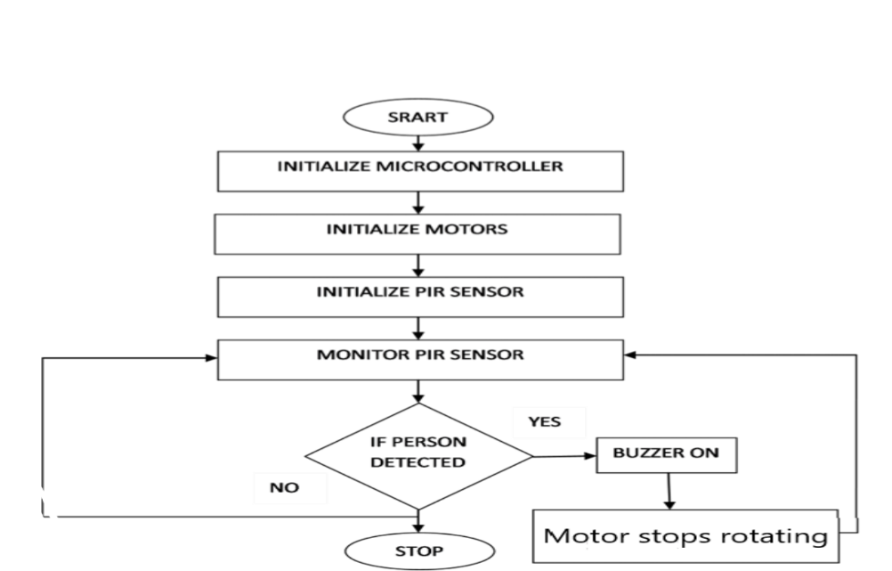

**Embedded C Code**

**#include**<c8051f340.h>

sbit rs=P3^4; // LCD Pins initialisation

sbit rw=P3^5;

sbit en=P3^7;

sbit mot1p=P3^0; // motor pins declaration

sbit mot1n=P3^1; // motor 1

sbit mot2p=P3^2; //motor 2

sbit mot2n=P3^3;

sbit mot3p=P0^0;

sbit mot3n=P0^1;

sbit mot4p=P0^2;

sbit mot4n=P0^3;

sbit sensor=P1^0;

sbit buz=P1^1;

sbit push1=P0^5;

sbit push2=P0^7;

//Delay function

**void** **delay**(){

**unsigned** **int** v;

**for**(v=0;v<3000;v++);

}

//LCD Command Function

**void** **lcdcmd**(**unsigned** **char** val){

P2=val;

rs=0; //Register select 0=> Command_through_P2 , 1=> data_through_P2

rw=0; // READ/~WRITE PIN ; ~= Active low 0=> On,1=> off , in general 1=0n , 0=off;

/* RW PIN rw=1 => read from the LCD

RW pin rw=0 => write into LCD*/

en=1;

delay();

en=0;

}

//LCD DATA FUNCTION

**void** **lcddat**(**unsigned** **char** ch){

P2=ch;

rs=1;

rw=0;

en=1;

delay();

en=0;

}

**void** **lcdinit**(){ //This function helps in initalizing the LCD.

lcdcmd(0x38); // 2 line 5X7 Matrix

lcdcmd(0x10); // shift cursor to left

lcdcmd(0x06); // Increment cursor

lcdcmd(0x0c); // Display on, cursor off

lcdcmd(0x80); // force cursor to beginning

}

**void** **lcddis**(**unsigned** **char** *s) //To display on LCD.

{

**unsigned** **char** w;

**for**(w=0;s[w]!='\0';w++){

lcddat(s[w]);

}

}

**void** **main**(){

mot1p=mot1n=mot2p=mot2n=mot3n=mot3p=mot4p=mot4n=0; //To initialize the motor

buz=0; //To initialize the buzzer

P2MDOUT=0xff;

P0MDOUT=0x0f;

P3MDOUT=0xff;

P1MDIN=0x01;

P1MDOUT=0x02;

XBR1=0x40;

lcdinit(); //To initialize the LCD.

lcddis("HUMAN DETECTION ROBOT");

delay();

delay();

delay();

delay();

delay();

delay();

delay();

delay();

delay();

delay();

delay();

delay();

delay();

lcdcmd(0xc0);

**while**(1){

lcdcmd(0x01);

lcddis("moving");

mot1p=mot2p=mot3p=mot4p=1;

mot1n=mot2n=mot3n=mot4n=0;

buz=0;

**if**(sensor==1){

mot1p=mot1n=mot2p=mot2n=mot3n=mot3p=mot4n=mot4p=0;

buz=1;

lcdcmd(0x01);

lcddis("Human Detected!");

**while**(sensor==1);

}

}

}

**4.Conclusion**

Thus from our above experiment we have made a project on the topic “Human Detection Robot ” where we have implemented the circuit diagram using the Proteus 8.0 version circuit simulator by Lab centre Electronics and thus the sensor used in our project is a PIR sensor.

**References**

* <https://www.electronicshub.org/>
* <https://circuitdigest.com/>

**Data Sheet :**

* <https://www.alldatasheet.com/view.jsp?Searchword=AT8951>
* <https://www.ti.com/lit/ds/symlink/l293.pdf>
* <https://cdn-learn.adafruit.com/downloads/pdf/pir-passive-infrared-proximity-motion-sensor.pdf>