BRUCE Humanoid Robot
Master Engineering Specification: Simulation Architecture, Decision Rationale & Feature Catalog
DEVELOPER: Westwood Robotics | SIMULATION: MuJoCo 3.x Engine | FRAMEWORK: ROS 2 Jazzy | PERCEPTION: RTAB-Map SLAM | ARCHITECTURE: Decoupled Two-Process POSIX IPC

1. The BRUCE Simulation Model & Working Principles
BRUCE is a high-performance bipedal humanoid robot standing 0.45m at nominal pelvis height with a total mass of 4.2 kg. The simulation environment replicates the physical robot's mechanical structure, actuator dynamics, and environmental interactions:
- Actuation Topology (16 Degrees of Freedom): The robot features 10 BEAR modular planetary actuators (5 per leg: hip yaw, hip roll, hip pitch, knee pitch, ankle pitch) with high torque density and transparent backdriveability (clamped to ±160 Nm), plus 6 Dynamixel smart servos (3 per arm: shoulder pitch, shoulder roll, elbow pitch) for compliant upper-body arm motions (clamped to ±35 Nm).
- MuJoCo Contact Physics (1000 Hz): Physical stepping runs at 1000 Hz (dt=0.001s) using a projected Gauss-Seidel solver with elliptic friction cones and soft-contact parameters (solref=0.004, solimp=0.9). This completely prevents high-frequency foot contact chattering, polygon penetration, or numerical divergence during bipedal single-stance and double-stance transitions.
- 25x25m Hybrid Virtual Arena: Combines an indoor robotics laboratory section (X < 0) featuring 3.2m corridors, office rooms, 1.0m doorways, and 4 colored landmark pillars for SLAM loop closure, alongside an outdoor obstacle course (X > 0) featuring a 3-step staircase, a 12° incline ramp, mini-soccer goal, dynamic soccer ball, pushable crates, barrels, and a dedicated delivery table.
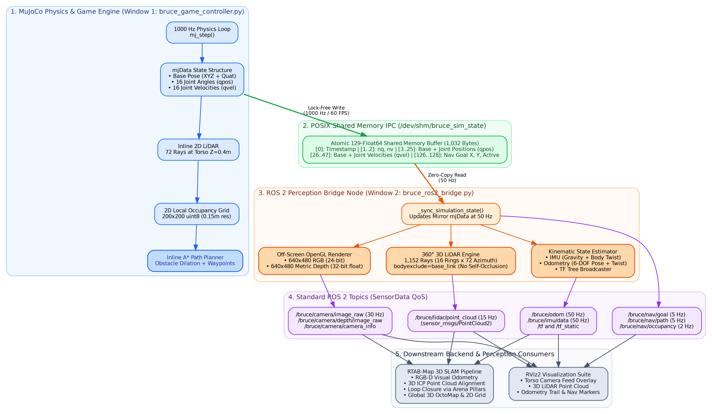
Figure 1: Complete System Architecture, Inter-Process Communication & Topic Pipeline

2. Architectural & Technical Decisions Rationale ("The Why")
Every major technical decision was made to resolve specific physical, mathematical, or performance trade-offs:
- Decision 1: MuJoCo over Gazebo Classic: Gazebo's ODE contact solver suffered from bipedal foot vibration, penetration impulses, high latency, and low frame rates (<25 FPS). MuJoCo treats contacts via convex optimization, yielding rock-solid foot stability, 1000 Hz physics, and native 60+ FPS GLFW graphics with hardware mouse locking.
- Decision 2: Custom GLFW Loop over Passive Viewer: MuJoCo's built-in passive viewer lacks continuous key-hold detection (holding W vs tapping W) and cannot lock the cursor for 360° mouse camera orbiting. A custom GLFW rendering loop was developed using MjvScene, MjrContext, and mjr_overlay for in-game HUDs.
- Decision 3: Camera-Relative Locomotion Math: Transforming WASD vectors against the camera azimuth angle θ ensures character movement matches modern action games (GTA 5): pressing W always walks in the direction the camera is facing, irrespective of robot heading.
- Decision 4: Walking Stabilization (Counter-Pitch Torque & Knee Lift): Initial forward walking stalled due to foot toe-stubbing (clearance was only 8mm) and pelvis thrust tipping moments (+18 Nm tilting the torso forward >20°). Elevating knee flexion lift to >35mm and applying dynamic counter-pitch torque (τ = -F_propel · 0.22 Nm) stabilized torso pitch within 3°–6° with zero backward drift.
- Decision 5: Two-Process Decoupled IPC Architecture: Rendering RGB-D images and raycasting 1,152 LiDAR beams takes 15–30 ms per frame. Executing this inside the game controller would drop frame rates below 20 FPS and destabilize the balance loop. Decoupling into two independent processes via a 1,032-byte POSIX shared memory buffer ensures 60+ FPS gameplay with zero perception latency.
- Decision 6: Spherical 3D LiDAR with Body Exclusion: Raycasting 1,152 beams (16 elevation rings x 72 azimuths) using mujoco.mj_ray() with bodyexclude=self.base_body_id ensures rays pass through BRUCE's own chest and head meshes, preventing false self-occlusion.
- Decision 7: Upper-Body Biomechanics & Aesthetics: Eliminated the unnatural horizontal T-pose by setting resting shoulder roll to ±1.38 rad and elbow flexion to ±0.50 rad (~28° forward bend). Added phase-coupled arm swinging opposite to leg motion, 0.45 Hz breathing micro-sway, and contoured head, visor, and chest armor geoms.
- Decision 8: Dual Mouse Mode (Game Look vs Object Dragging): Key M toggles between Game Mode (cursor locked to camera orbit) and Manipulation Mode (cursor unlocked). In Manipulation Mode, raycasting calculates world-space floor points and applies spring-damper forces (F = 80Δp - 12v) to drag arena objects live.
- Decision 9: Inline A* Planner vs External Nav2 Loop: Running external Nav2 costmaps over ROS topics introduces 50–200 ms latency. An inline A* planner operating on a 200x200 LiDAR occupancy grid inside the controller avoids obstacles at 60 FPS without feedback latency, while streaming costmaps to ROS 2 for visualization.
- Decision 10: Snap Environment Isolation: Ubuntu Snap's environment variables (GTK_PATH) caused RViz2's Qt5 backend to load mismatched glibc 2.31 libraries from /snap/core20, conflicting with Ubuntu 24.04's glibc 2.39. Added environment purging in all bash launchers to guarantee clean launches.

3. Robot Functions, Locomotion States & Feature Catalog
BRUCE features a hierarchical state machine handling dynamic locomotion, physical interaction, and autonomous tasks:
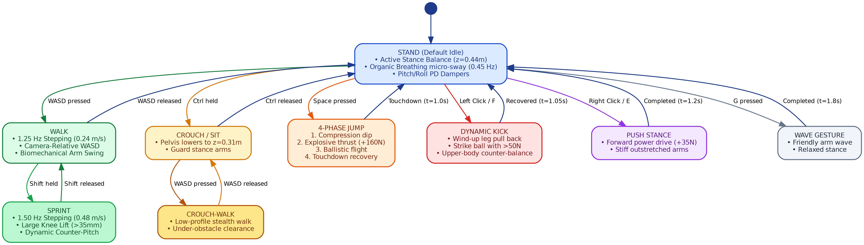
Figure 2: Hierarchical Posture & Locomotion State Machine Transitions
- STAND (Idle Balance):Maintains pelvis height at z=0.44m with active roll/pitch PD attitude dampers and organic 0.45 Hz breathing sway.
- WALK & SPRINT (Omnidirectional):Stepping frequency scales from 1.25 Hz (0.24 m/s) to 1.50 Hz (0.48 m/s). Lateral hip roll weight-transfer sway (0.065 rad) stabilizes single-stance phases, while arms swing in opposition with dynamic elbow bending.
- CROUCH & CROUCH-WALK:Flexes knees and hips to drop pelvis to z=0.31m. Arms adopt a forward guard stance. WASD allows low-profile stealth walking under overhead obstacles.
- 4-PHASE JUMP:Executes pre-jump compression dip (0.0–0.15s), explosive thrust extension (+160N impulse, 0.15–0.30s), ballistic airborne flight (0.30–0.65s), and compliant touchdown landing absorption (0.65–1.00s).
- DYNAMIC SOCCER KICK:3-phase sequence: left stance leg bends for stability, right kicking leg pulls back, then snaps forward with dynamic forward propulsion to launch the ball with >50N force.
- FORWARD PUSH STANCE:Drives forward with stiff, outstretched arms applying +35N continuous pushing force against target crates and obstacle blocks.
- LIVE MOUSE DRAGGING:In Manipulation Mode (M key), clicking and dragging dynamic objects moves them across the floor in real time to create custom obstacles.
- AUTONOMOUS CLICK-TO-NAVIGATE:Double-clicking the floor plants a glowing green Goal Marker. Pressing N activates autonomous A* path planning using inline LiDAR obstacle avoidance.

4. Perception Sensors, Tools & Software Ecosystem
The table below summarizes all perception sensors, coordinate transforms, and backend tools in the platform:
Tool / Sensor | Physical Spec | Update Rate | ROS 2 Topic / Interface | Operational Role
RGB-D Head Camera | 640x480, FOV 65° | 30 Hz | /bruce/camera/image_raw  /bruce/camera/depth/image_raw | First-person vision in RViz2, ORB feature tracking for Visual Odometry in RTAB-Map
Camera Intrinsics | Pinhole fx=fy=476.7 | 30 Hz | /bruce/camera/camera_info | Calibrated projection matrix for depth unprojection into 3D metric space
360° 3D LiDAR | 16 rings x 72 azimuths (1,152 rays) | 15 Hz | /bruce/lidar/point_cloud | High-density 3D obstacle mapping, stair detection, and ICP point cloud alignment in SLAM
Torso IMU (6-DOF) | Base link dynamics | 50 Hz | /bruce/imu/data | Angular body rates and gravity-compensated linear accelerations for attitude estimation
Ground-Truth Odom | Floating base EKF | 50 Hz | /bruce/odom | Tracks robot trajectory and velocity twist in odom reference frame
TF Transform Tree | Dynamic & Static | 50 Hz | /tf, /tf_static | Spatial frame tree: odom -> base_link -> head_camera -> optical / lidar / imu
Local 2D Nav Grid | 200x200 uint8 (0.15m res) | 2 Hz | /bruce/nav/occupancy | Live costmap mirroring inline LiDAR obstacle hits for local path visualization
Navigation Target | Interactive picker | 5 Hz | /bruce/nav/goal  /bruce/nav/path | Streams active navigation goal arrow and straight-line path trail to RViz2
ROS 2 Bridge Node | POSIX SHM Consumer | 50 Hz | bruce_ros2_bridge.py | Decoupled node reading shared memory, running off-screen OpenGL rendering and topic publishing
RViz2 Visualization | Robotics GUI | 60 FPS | bruce_slam.rviz | Real-time 3D dashboard displaying camera overlays, point clouds, trajectory paths, and TF frames
RTAB-Map 3D SLAM | Multi-session SLAM | 15 Hz | ./run_ros2_perception.sh --slam | Fuses RGB-D and 3D LiDAR with landmark pillar loop closure to build global 3D OctoMaps

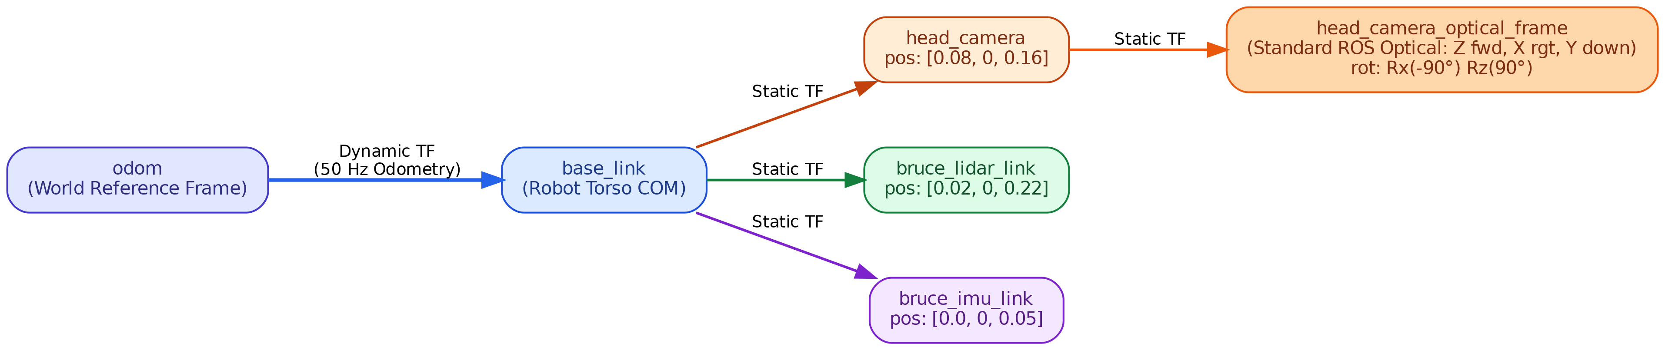
Figure 3: Spatial Coordinate Tree (TF) Connecting Robot Frames to World Origin

5. Interactive Keybindings & Controls Manual
Key / Input | Mode | Action | Functional Behavior
W / S | Game | Walk Forward / Backward | Camera-relative locomotion in active look direction
A / D | Game | Strafe Left / Right | Camera-relative lateral sidestepping
Shift + WASD | Game | Sprint | Accelerates gait to 1.50 Hz (0.48 m/s) with forward lean and wide strides
Ctrl (Hold) | Game | Crouch | Lowers pelvis to z=0.31m into defensive guard; WASD enables crouch-walking
Space | Game | Jump | 4-phase dynamic vertical jump with explosive +160N thrust and compliant landing
Left Click / F | Game | Kick | Dynamic leg strike launching the soccer ball with >50N force
Right Click / E | Game | Push | Forward power stance with rigid arms pushing crates and barrels
G | Game | Wave | Friendly greeting wave gesture with right arm
R | Any | Reset | Instantly teleports robot, ball, and arena objects back to initial poses
M | Any | Toggle Mode | Switches between Game Mode (cursor locked) and Manipulation Mode (cursor free)
Left Drag | Manipulation | Move Object | Applies spring-damper force to drag dynamic objects across the arena floor
Double Click | Manipulation | Plant Goal | Plants glowing green Goal Marker on floor for autonomous navigation
Right Click | Manipulation | Clear Goal | Clears active navigation goal marker
N | Any | Auto-Nav | Toggles autonomous navigation; robot dodges obstacles via inline LiDAR A*
Mouse Move | Game | Orbit Camera | 360° horizontal yaw azimuth and -75° to +20° vertical pitch elevation
Mouse Wheel | Any | Zoom Camera | Smoothly adjusts camera follow distance from 0.8m to 5.0m
Tab / Esc | Game | Free Cursor | Releases hardware cursor lock to click outside window

