BRUCE Humanoid Robot
Sensor Architecture, Dataflow & Process Flow Specification
Platform: BRUCE Open-Platform Bipedal Humanoid | Simulation: MuJoCo 3.x Engine | Framework: ROS 2 Jazzy | IPC: POSIX Shared Memory (/dev/shm)

1. System Architecture & End-to-End Pipeline
The simulation implements a high-performance, two-process decoupled architecture to isolate high-frequency contact physics from perception and rendering:
- Process 1 (MuJoCo Physics & Interactive Game Loop): Runs contact physics at 1000 Hz (dt=0.001s) and the third-person GLFW camera viewport at 60+ FPS. Evaluates balance PD torques, footsteps, and local 2D LiDAR raycasts for inline obstacle avoidance.
- Inter-Process Communication (POSIX Shared Memory): Lock-free atomic shared memory buffer (/dev/shm/bruce_sim_state) carrying a 129-double state vector (timestamps, base pose, 16 joint angles, velocities, and nav goals).
- Process 2 (ROS 2 Perception Bridge): Dedicated ROS 2 Jazzy node attaching to shared memory at 50 Hz. Renders off-screen RGB-D camera feeds, computes 1,152-ray 3D LiDAR point clouds, broadcasts TF transforms, and publishes standard sensor_msgs topics to RViz2 and RTAB-Map SLAM.

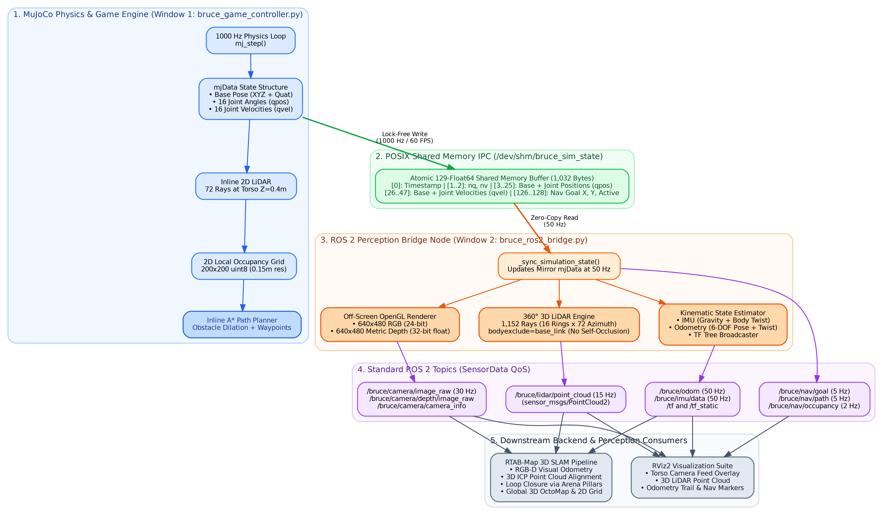
Figure 1: Complete End-to-End Sensor Dataflow and Process Pipeline

2. Sensor Specifications & ROS 2 Topic Catalog
The table below details all active sensor streams generated by the BRUCE humanoid platform:
Sensor Name | Physical Mount | Frame ID | Rate | ROS 2 Topic | ROS 2 Message Type
RGB Head Camera | Torso Base (Z=+0.16m) | head_camera_optical_frame | 30 Hz | /bruce/camera/image_raw | sensor_msgs/msg/Image (RGB8)
Depth Camera | Torso Base (Z=+0.16m) | head_camera_optical_frame | 30 Hz | /bruce/camera/depth/image_raw | sensor_msgs/msg/Image (32FC1)
Camera Intrinsics | Pinhole Model | head_camera_optical_frame | 30 Hz | /bruce/camera/camera_info | sensor_msgs/msg/CameraInfo
360° 3D LiDAR | Torso Crown (Z=+0.22m) | bruce_lidar_link | 15 Hz | /bruce/lidar/point_cloud | sensor_msgs/msg/PointCloud2
Torso IMU (6-DOF) | Torso Base Origin | bruce_imu_link | 50 Hz | /bruce/imu/data | sensor_msgs/msg/Imu
Robot Odometry | Floating Base EKF | odom -> base_link | 50 Hz | /bruce/odom | nav_msgs/msg/Odometry
Coordinate Frames | Static & Dynamic | Multi-frame | 50 Hz | /tf, /tf_static | tf2_msgs/msg/TFMessage
Local 2D Nav Grid | Inline Raycaster | odom | 2 Hz | /bruce/nav/occupancy | nav_msgs/msg/OccupancyGrid
Nav Goal Target | Interactive Picker | odom | 5 Hz | /bruce/nav/goal | geometry_msgs/msg/PoseStamped

3. Detailed Sensor Processing Pipelines

3.1 RGB-D Head Camera Pipeline
The RGB-D vision system is mounted on BRUCE's upper torso (bruce.xml: <camera name="head_camera" pos="0.08 0 0.16" fovy="65" xyaxes="0 -1 0 0 0 1"/>). The xyaxes configuration enforces standard optical conventions (+Z forward along the optical axis, +X rightward, +Y downward).
- Off-Screen Context Synchronization: The bridge updates the scene using the mirror model data: renderer.update_scene(self.data, camera='head_camera').
- Color Rendering (RGB8): Calls renderer.render() to acquire a 640x480x3 uint8 array (1,920-byte row stride), published as sensor_msgs/Image at 30 Hz.
- Metric Depth Extraction (32FC1): Calls renderer.enable_depth_rendering() followed by renderer.render(). Pixel values represent true Euclidean distance in meters as 32-bit floating point numbers (2,560-byte row stride), published as sensor_msgs/Image at 30 Hz.
- Camera Intrinsics Matrix: Computes calibrated pinhole focal lengths (fx = fy = 476.7 px) and principal point (cx = 320.0, cy = 240.0) published as sensor_msgs/CameraInfo.

3.2 360° Multi-Beam 3D LiDAR Pipeline
Mounted on top of the robot torso at bruce_lidar_link (pos=[0.02, 0, 0.22]). It simulates a 16-channel automotive LiDAR (analogous to a Velodyne VLP-16) generating 1,152 rays per sweep across a full 360° horizontal azimuth and ±16° vertical elevation.
- Pre-computed Spherical Geometry: 16 vertical elevation rings (-16° to +16° in ~2.13° increments) multiplied by 72 horizontal steps (5° increments).
- Collision Raycasting: For each local unit ray, rotates by the torso orientation matrix: vec_world = lidar_world_mat @ vec_local. Raycast evaluated using mujoco.mj_ray(..., bodyexclude=self.base_body_id).
- Self-Occlusion Avoidance: The bodyexclude parameter ensures rays pass through BRUCE's own head, chest, and arms unobstructed, preventing false obstacle hits on the robot itself.
- PointCloud2 Serialization: Valid hits (0.15m to 25.0m) packed as binary IEEE 754 float32 XYZ arrays using sensor_msgs_py.point_cloud2.create_cloud_xyz32, published on /bruce/lidar/point_cloud at 15 Hz.

3.3 Coordinate Tree & Spatial Transforms (TF)
Coordinate frames are tracked and broadcasted via tf2_ros. Dynamic transforms represent the floating robot base moving through the world, while static transforms represent rigid sensor mountings.
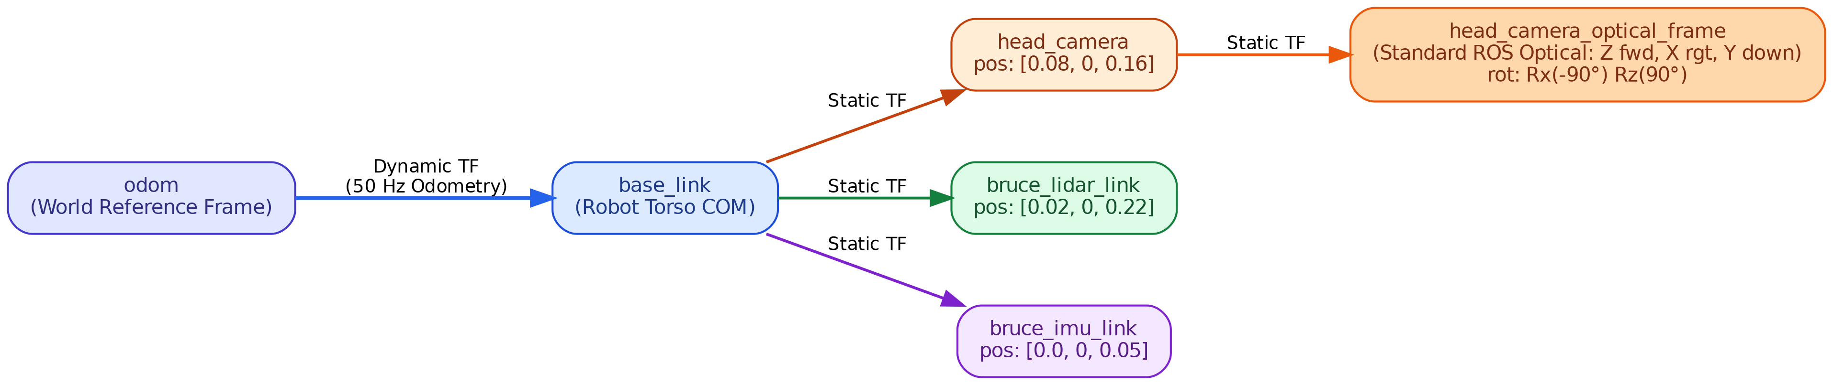
Figure 2: TF Transform Tree and Spatial Relationships

4. POSIX Shared Memory Buffer Specification
The shared memory segment (/dev/shm/bruce_sim_state) provides lock-free, zero-copy state streaming between Process 1 and Process 2. The buffer consists of 129 contiguous double-precision floats (1,032 bytes):
Index Range | Type | Count | Field Description | Update Frequency
[0] | float64 | 1 | Simulation Timestamp (seconds) | 1000 Hz
[1 .. 2] | float64 | 2 | Model Topology Dimensions (nq=23, nv=22) | Static
[3 .. 5] | float64 | 3 | Robot Torso Base Position (X, Y, Z in meters) | 1000 Hz
[6 .. 9] | float64 | 4 | Robot Torso Orientation Quaternion (w, x, y, z) | 1000 Hz
[10 .. 25] | float64 | 16 | Actuated Joint Angles (qpos in radians) | 1000 Hz
[26 .. 28] | float64 | 3 | Torso Base Linear Velocity (vx, vy, vz in m/s) | 1000 Hz
[29 .. 31] | float64 | 3 | Torso Base Angular Velocity (wx, wy, wz in rad/s) | 1000 Hz
[32 .. 47] | float64 | 16 | Actuated Joint Velocities (qvel in rad/s) | 1000 Hz
[48 .. 125] | float64 | 78 | Arena Dynamic Bodies (Soccer ball, Crates, Barrels) | 1000 Hz
[126] | float64 | 1 | Navigation Goal X Coordinate (meters) | On Change
[127] | float64 | 1 | Navigation Goal Y Coordinate (meters) | On Change
[128] | float64 | 1 | Navigation Goal Active Flag (1.0 = Active, 0.0 = Inactive) | On Change

5. Downstream Backend Consumers: RViz2 & RTAB-Map SLAM
All sensor streams terminate in two primary robotic perception and mapping consumers:
- RViz2 3D Robotics Dashboard: Subscribes to /bruce/camera/image_raw (torso video overlay), /bruce/lidar/point_cloud (colored point cloud), /bruce/odom (trajectory trail), /bruce/nav/goal (3D target beacon), and /bruce/nav/occupancy (local 2D costmap).
- RTAB-Map 3D SLAM Suite: Combines RGB-D visual features (ORB/SURF) with 3D LiDAR point cloud registration (Iterative Closest Point). Performs loop closure detection upon viewing the arena's 4 visual landmark pillars, generating persistent 3D OctoMaps and 2D occupancy grid maps for multi-room navigation.

