

Comprehensive Application Practice IV Report

Subject Comprehensive Application Practice IV
College Liangjiang International college
Major Computer Science and technology
Class class 1
Stu.Name 何振宇 ID 12119370118
Guidance teacher Pro.Xiang Nan

1. Requirement
5. Recommendation system-collaborative filtering recommendation Requirements:
Develop a recommendation system based on collaborative filtering and implement it in Python. Utilize similarities and historical behavior data between users to provide users with personalized recommendations. Consider using collaborative filtering algorithms and recommendation evaluation metrics to optimize recommendation results.

2.Design and Implement
Design ideas:
1. Data collection and preparation stage:
Collect movie data: Get movie data including movie title, actors, director, genre, rating, etc. from various sources like IMDb, The Movie Database, etc.
User behavior data: Collect user behavior data such as movie ratings, collections, and viewing history.
2. Data storage and processing:
Database design: Create a database model to store movie information, user information, and user rating data for movies.
Data preprocessing: Clean and transform movie data, and deal with issues such as missing values and duplicate values.
3. Collaborative filtering algorithm selection:
Select algorithm: Choose a suitable collaborative filtering algorithm (such as user-based collaborative filtering (UserCF), item-based collaborative filtering (ItemCF)), or even a hybrid recommendation system that uses a mix of multiple algorithms.
Algorithm optimization: For large-scale data sets, consider algorithm performance optimization, sparsity processing, etc.
4. System architecture design:
Backend Architecture: Use Django framework to build backend services to handle user requests, data storage and processing.
Front-end design: Use the bootstrap framework to design the user interface, including functions such as displaying movie information and user personalized recommendations.
5. Implement recommendation system:
Model training: Train recommendation models based on collected user behavior data.
Recommendation service: Implement a recommendation service based on collaborative filtering, recommending similar users or similar items based on the user's historical behavior or interests.
6. User interaction and personalized recommendations:
User interaction interface: realizes functions such as user registration, login, movie browsing, and viewing personal recommendations.
Personalized recommendation: Implement personalized recommendation function based on the user's historical behavior and preferences.
7. Testing and optimization:
System testing: Carry out functional testing, performance testing and user experience testing on the system.
Feedback and optimization: Based on user feedback and data analysis results, optimize the recommendation algorithm and improve user experience.
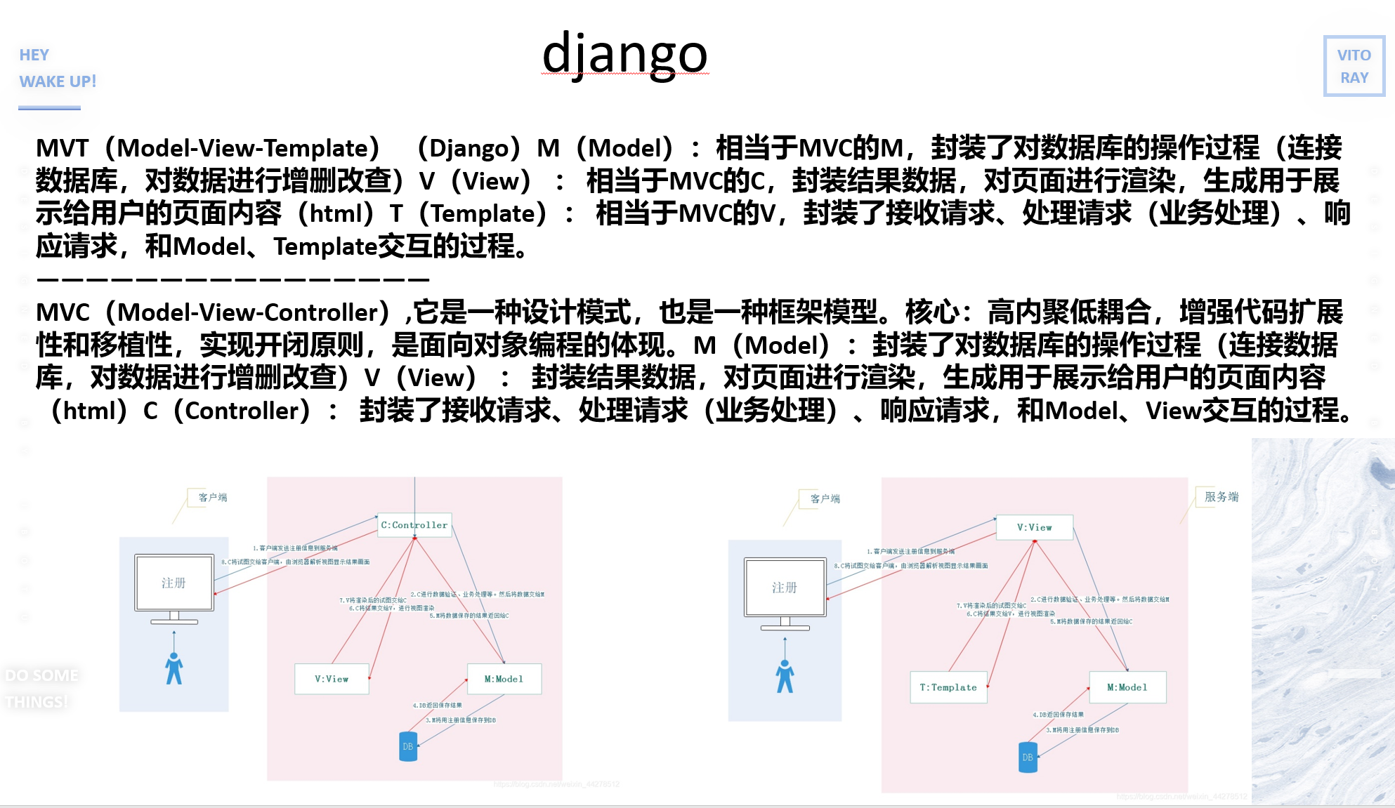
Project structure:
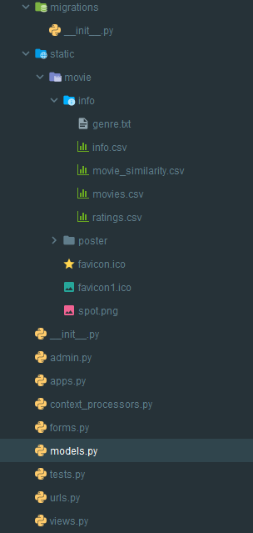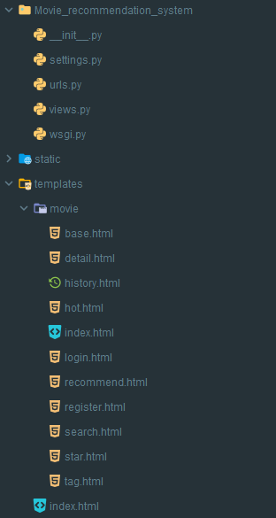
UserCF is used for recommendation. ItemCF calculates the similarity and is used in the column that displays similar movies.
1.admin.py:
Function: Management backend configuration file, allowing application models to be managed in Django's automatically generated management backend.
Features: The backend management interface can be customized through simple code configuration, including registration models, field display, filters, etc.
2.apps.py：
Function: Application configuration file, used for metadata configuration of applications.
Features: You can configure the name, label and other metadata information of the application.
3.context_processors.py：
Function: Custom context processor for injecting specific context variables when rendering templates.
Features: These processors can make variables or functions used globally in templates available.
4.forms.py：
Function: Contains Django form classes for data validation and user interaction.
Features: These form classes can be automatically generated based on models or created manually for data validation and processing user input.
Dependencies: You can rely on models to define form fields, validate and save data.
5.models.py：
Function: Contains Django models, which define the structure and relationships of data in the database.
Features: Models are used to define the data structure in the application and the relationships between models. The database can be operated through ORM (Object Relational Mapping).
Dependencies: Other parts such as forms.py and views.py can rely on these models to access and manipulate data in the database.
6.tests.py：
Function: Contains test code for unit testing.
7.urls.py：
Function: URL routing configuration file, which defines the mapping relationship between request URLs and view functions.
Features: Map URLs to corresponding view functions through regular expressions or path matching to implement request processing and response.
Dependencies: Contains the view function name so that requests are dispatched to the correct view handler.
8.views.py：
Function: Contains Django view functions or classes that handle requests and generate responses.
Features: The view function receives the request and processes the logic. It can obtain data from the database, render the template, and then return the response to the user.
Dependencies: Depends on the model to obtain data and interact with the template.
9.settings.py：
Function: The settings file of the Django project, including the project configuration information.
Implementation process:
1. Data collection and preparation stage:
Data set: MovieLens' ml-latest-small data set, about 600 users, about 9,700 movies, and 100,000 rating records.
Movie details: ml-latest-small provides a CSV file, which contains the ID number of the movie on IMDB.
2. Data storage and processing:
Django automatically generates relational mapping, uses models to define the structure and relationships of data in the database, and includes form-related Django form classes for user interaction and data validation.
3. Collaborative filtering algorithm selection and implementation:
UserCF is used for recommendation, and ItemCF calculates the similarity and is used in the similar movie column.
4. System architecture design and implementation:
Technology stack: The web framework uses Django, the database MySQL (MariaDB), HeidiSQL is used to operate the database, and the front-end uses bootstrap for rendering.
5. Test:
Register a user and the test results are as shown below

Core algorithm code:
UserCF:
def get_user_sim(self):
#获取与当前用户相似度最高的 K 个用户
# 用户相似度字典，格式为{ user_id1:val , user_id2:val , ... }
user_sim_dct = dict()
'''获取用户之间的相似度,存放在user_sim_dct中'''
# 获取当前用户
cur_user_id = self.request.session['user_id']
cur_user = User.objects.get(pk=cur_user_id)
# 获取其它用户
other_users = User.objects.exclude(pk=cur_user_id)
self.cur_user_movie_qs = Movie.objects.filter(user=cur_user)
# 计算当前用户与其他用户评分过的电影交集数
for user in other_users:
# 记录感兴趣的数量
user_sim_dct[user.id] = len(Movie.objects.filter(user=user) & self.cur_user_movie_qs)
# 按照key排序value，返回K个最相近的用户
print("user similarity calculated!")
# 格式是 [ (user, value), (user, value), ... ]
return sorted(user_sim_dct.items(), key=lambda x: -x[1])[:self.K]
def get_recommend_movie(self, user_lst):
#基于相似用户列表，获取推荐的电影列表。
#遍历相似用户列表，获取这些相似用户评分过的电影，并根据用户评分，计算电影的兴趣值。
#返回按兴趣值排序的前N个电影。
# 电影兴趣值字典，{ movie:value, movie:value , ...}
movie_val_dct = dict()
# print(f'cur_user_movie_qs:{self.cur_user_movie_qs},type:{type(self.cur_user_movie_qs)}')
# print(Movie.objects.all() & self.cur_user_movie_qs)
# 用户，相似度
for user, _ in user_lst:
# 获取相似用户评分过的电影，并且不在前用户的评分列表中的，再加上score字段，方便计算兴趣值
movie_set = Movie.objects.filter(user=user).exclude(id__in=self.cur_user_movie_qs).annotate(
score=Max('movie_rating__score'))
for movie in movie_set:
movie_val_dct.setdefault(movie, 0)
# 累计用户的评分
movie_val_dct[movie] += movie.score
print('recommend movie list calculated!')
return sorted(movie_val_dct.items(), key=lambda x: -x[1])[:self.N]
call model function:
def get_similarity(self,k=5):
#获取与当前电影最相似的前k部电影
# 获取5部最相似的电影的id
similarity_movies=self.movie_similarity.all()[:k]
print(similarity_movies)
# movies=Movie.objects.filter(=similarity_movies)
# print(movies)
return similarity_movies

some functions
Each part contains specific functions and logic, and various functions of interacting with users are implemented through Django views(views) and URL mapping(urls. py). These parts together form a complete movie recommendation system, providing functions such as user login, registration, movie browsing, search, rating and recommendation.
Home (IndexView):

Shows a list of all movies.
May include paginated display, as well as basic movie information, such as movie title, poster, etc.
Popular Movies (PopularMovieView):

Display the most popular movies based on ratings or number of views.
Use Movie_hot or other statistics to get a list of top movies.
Login (LoginView):
Provide user login functions, including user name and password verification.
Authenticate the user's identity and redirect the user to the appropriate page.
Logout (UserLogout):
The user logs out and the user status is set to not logged in.
Register (RegisterView):
Provide a user registration page to receive and verify user registration information.
Save user registration information.
Category View (TagView):
Displays a list of movies based on movie categories.
Accepts user-selected categories, filters movie data, and displays it in a template.
Search function (SearchView):
Provides a movie search function to search for movies based on keywords entered by the user.
Handles a user search request and returns a list of matching movies.
Movie details page (MovieDetailView):
Displays detailed information about a single movie, including movie information, ratings, comments, etc.
Get movie details based on movie ID and display in template.
Rating history page (RatingHistoryView):
Shows a specific user's movie rating history.
Get the rating record based on the user ID and display it in the template.
Delete records (delete_recode):
Handle the user's rating record deletion request.
Delete specific rating records based on user ID and movie ID.
Recommendation page (RecommendMovieView):
Implement movie recommendation algorithm.
Returns a list of movies recommended to the user based on a collaborative filtering algorithm (such as userCF or itemCF) or other recommendation algorithms.
There is relevant code:
Pagination, almost all classes will use it:
def get_context_data(self, *, object_list=None, **kwargs):
def get_pagination_data(self, paginator, page_obj, around_count=2):
some itemcf code:
# 获得电影的pk
pk = self.kwargs['pk']
movie = Movie.objects.get(pk=pk)
similarity_movies = movie.get_similarity()
# 获取与当前电影最相似的电影
context.update({'similarity_movies': similarity_movies})
call model function:
def get_similarity(self,k=5):
#获取与当前电影最相似的前k部电影
# 获取5部最相似的电影的id
similarity_movies=self.movie_similarity.all()[:k]
print(similarity_movies)
# movies=Movie.objects.filter(=similarity_movies)
# print(movies)
return similarity_movies

3. Result Analysis
The details of the test are on the ppt.
Recommended results:
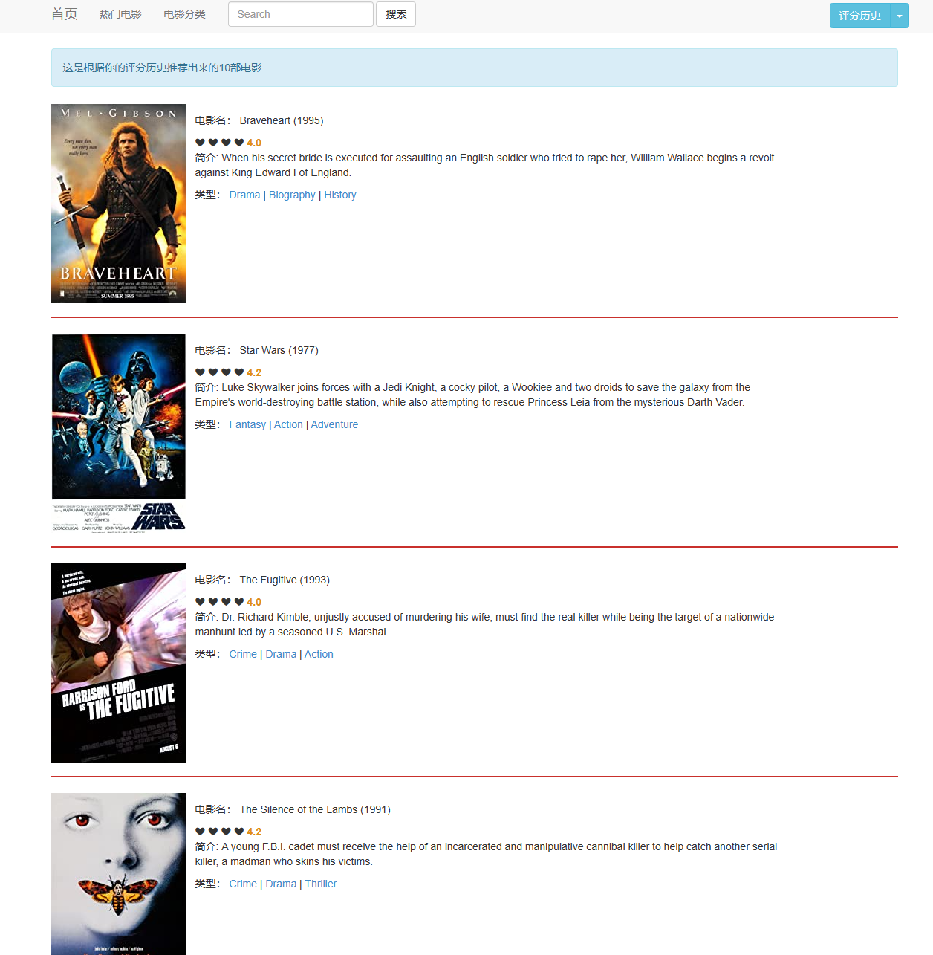
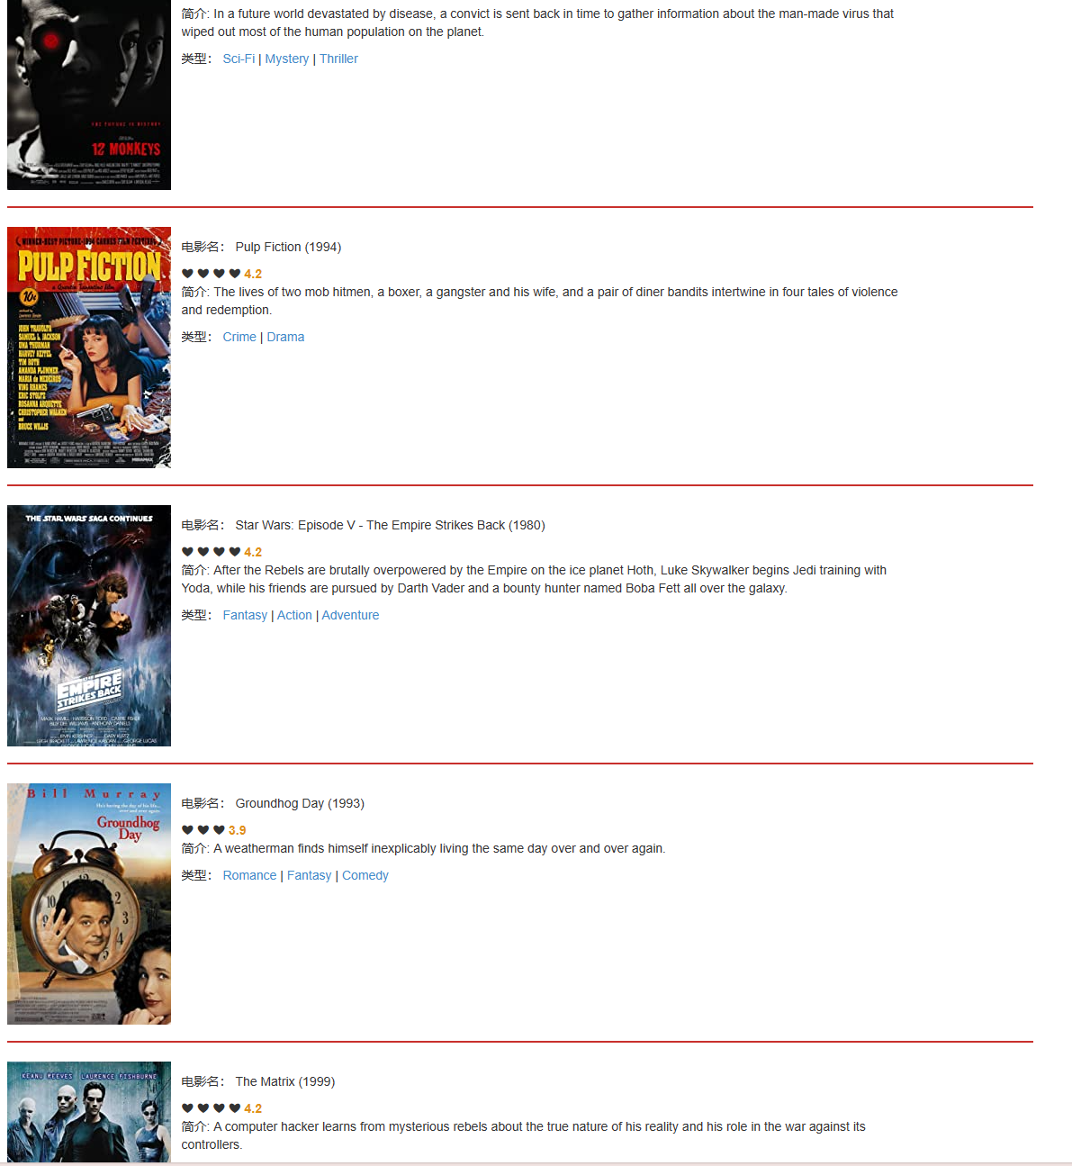
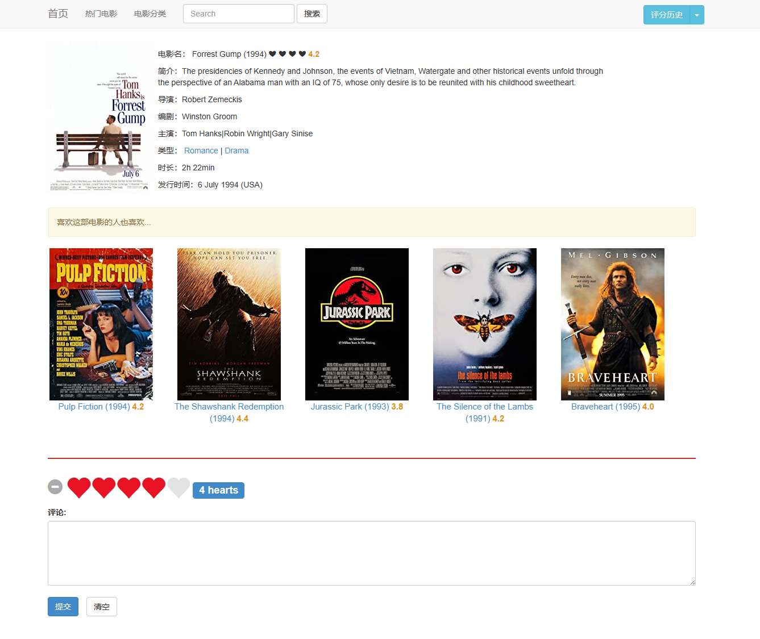
Although collaborative filtering is a very intuitive and interpretable model, it does not have strong generalization capabilities. There is a serious problem - popular items have a strong head effect and are easy to be similar to a large number of items; while tail items have sparse feature vectors and are rarely similar to other items, resulting in them being rarely recommended. .
Similar problems have emerged in multiple tests conducted in this project. Popular movies have a high probability of appearing in recommended movies. For example, The Matrix often appears in recommendations.

4. Learning and Thinking
Through this practice, I understand the collaborative filtering algorithm: Understand the principles of user-based collaborative filtering and item-based collaborative filtering.
Python programming and data processing: Learn to code collaborative filtering algorithms in Python. Master data processing libraries(such as Pandas, NumPy) for data preprocessing and feature engineering. Find a suitable movie rating dataset, such as MovieLens dataset. Use data sets to practice the implementation and evaluation of collaborative filtering algorithms.
Learn similarity calculation methods(such as cosine similarity, Pearson correlation coefficient, etc. ) and how recommendation algorithms work. Collaborative Filtering is a recommendation system technology that discovers the correlation between users and items based on user behavior data(such as ratings, purchase records, etc. ) to make personalized recommendations. There are two main types: User-Based Collaborative Filtering and Item-Based Collaborative Filtering.
The core idea of the algorithm: Recommendation based on historical data: The collaborative filtering algorithm mainly uses the user-item rating matrix for calculation. Discover the similarity of user interests: By analyzing user behavior or the relationship between items, find users or items with high similarity. These methods are widely used in recommendation systems, although they show good results in solving recommendation problems. But there are also some problems, such as cold start problem, data sparsity and scalability. Therefore, in practical applications, multiple recommendation algorithms and other technologies are usually combined to improve the performance and personalization capabilities of the recommendation system.
Moreover, by using the Django framework this time, I have a better understanding of Python programming, and I have an understanding of the advantages and methods of Django web development. For example, through Django's ORM, you can define models(Models), and each model corresponds to a table in the database. You can then use the QuerySet provided by Django to perform operations such as filtering, sorting, updating, and deleting without writing specific SQL statements. And have a better understanding of the MVC and MVT design patterns, as well as the differences and connections between the two.

