

LAB_04

ICS 202

Jalal Ali Zainaddin | 202154790 | 10/04/2023

# Task 1: LargeFloatAddition:

we use the same operation of sum using Integer Stacks, but we create a new variable that holds the index of the dot of the bigger number, and we add extra condition when adding the first and second number to their corresponding stacks, the condition is to not add the dot “’.” To either of stacks, then we add an extra parameter of convertStackContentsToString function for the index of dot “.”

Code:

Output:

Task 2: Priority queue:

I created two primary local stacks to move queue elements, and if queue is not empty, we have three conditions:

1- if the front is bigger than the data provided, we just have to dequeue() all elements to s1 then to s2 to be sorted, then add the data to the front, then enqueue the rest of s2

2- if the last element of queue is less than data, just add it to the end.

3- else if it is in between, we have to create two additional stacks, because s1 will hold the value that is smaller the data, and s2 holds the data that is bigger than the data, then we use s3 (s1 in correct order) and s4 (s2 in ...), then we enqueue all the elements of s3, then we add the data, and lastly, we add all element of s4 into the queue.

Some of Code:

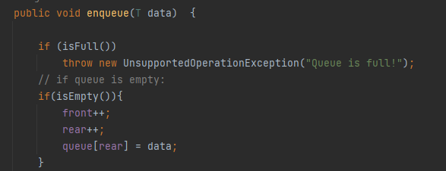

Output:

