**From page 67 to 69**

E-researchers who obtain consent over the Net also have to be aware of the risk of possibly attracting vulnerable populations to their study. As Roberts (2000a) points out, important demographic details, such as age, may be concealed by potential participants. This may lead to vulnerable populations (e.g., children or persons of diminished mental capacity) being recruited and included in a study without the researcher’s knowledge. Schrum (1995) maintans that this alone presents serious problems in obtaining some degree of informed consent and considers this to be the most difficult ethical issue of online research. While the e-researcher will need to acknowledge this as a looming possibility (or a limitation) to conducting Net-based research, Roberts (2000b) maintains there is a counter argument. While attracting vulnerable participants is an ever-present possibility, the Internet also has the ability to access participants who might otherwise be unable to participate or who traditionally may not have been able to have a voice in research projects. For a variety of reasons(e.g., geographic, disabilities, situational) researchers are sometimes not able to access specific people or populations. In certain circumstances, Net-base research can provide greater inclusivity by accessing these populations.

Some researchers who wish to obtain consent have creatively used forms feature on Web pages to obtain information. Figure 5.1 is an example of an online consent form by Nora Boekhout (<http://www.teacherwebsheIf.com/>) at Simon Fraser University (for consent form see <http://modena.intergate.ca/personal/boekhout/technologhyincurruculum/ethicsforms.html>). While the information on the form is standard for Simon Fraser University, notice that this online consent from has a section for a witness information. While there are no guarantees that the witness is credible (or even exists for that matter) this does provide another participation as contrasted with the way most of us casually click past license information (without reading) when first using new software packages purchased or downloaded from the Net.

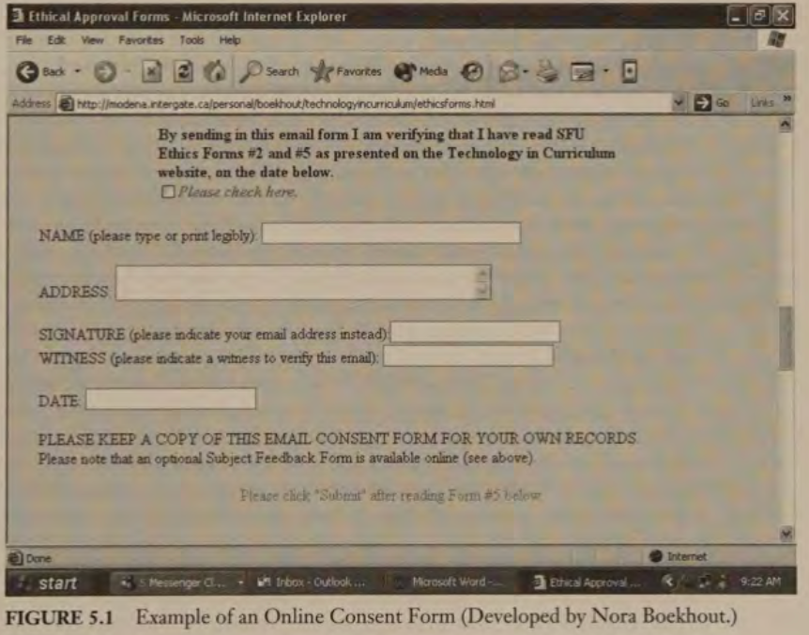

Finally, it needs to be noted that there are certain circumstances when the |Ne should probably note be used to obtain consent. These circumstances include situations where the consent of guardians of minors or that of persons of diminished mental capacity is required. We advise against this for the protection of both the e-researcher and the participant.

**WHEN IS CONSENT NEEDED? THE PUBLIC VERSUS PRIVATE DILEMMA**

Informed consent is needed in almost all types of research with notable exceptions.

First, consent is generally not required to study an activity that is nonintrusive and takes palce in a public space. For example, it is not necessary to obtain consent when undertaking naturalistic observations(for example, when studying linguistic patterns of fans’ chanting at a football game). Neither it is usually necessary to obtain permission when studying a public record or archive. For example, it is not necessary to obtain permission to study the public speeches of politicians, perform content analysis of newspapers or other mass media, or to study the public record of proceedings from a legislature. It is possible to argue that this notion of public space is appropriately extend to the study of activity on public newsgroups, mail lists, chat rooms, or virtual reality environments (e.g, MOOs, MUDs). Specifically, as these kinds of online spaces are open for anyone to join and, hence, can be interpreted as public spaces, informed consent from every participant is not required since the researcher is often not participating and , thus, not affecting the interaction that takes place.

Or is it a public space? Thus interpretation is not as straightforward as some e-researchers would like it to be, as the sense of what is public or private is defined not by the technology, but by the perception of privacy and inclusion that us maintained by the participants. Imagine, for a a moment, that you are in a public park and you need to use the public washroom. As you are leaving this public facility you notice there is a video camera in each of the washroom cubicles. How do you think you might feel to learn that this is a part of a research project? As King (1996) notes, with this kind of example “the sense of violation possible is proportional to the expectation of privacy that group members had prior to learning they were studied”. For example, studies with virtual self-help groups have shown remarkable candor among participants and the publication of this content has been viewed by some participants as a violation of the privacy of the group (Sharf,1999). An additional factor determining private space is the degree of intimacy that the researcher is studying. King notes that, generally, activity in a public place does not require informed consent. For example, noting how people are sitting on park benches. Nevertheless as Waskul and Douglass (1996) point out, if one installs a tape recorder and records conversations that take place on the park bench, a much different level of consent is required for ethical research.

Waskul and Douglass (1996) remind us further that “ethical considerations should entail an interplay between codes of conduct and an intimate understanding of the nature of the online environment.” To behave ethically requires explicit and expert knowledge of the context within the researcher functions. The Net is made up of a diverse set of technological and cultural contexts. For example, the ethics of analyzing the interaction in a large public discussion board sponsored by a media outlet such as the New York Time, call for far different means to protect privacy than research involving private emails. Further, codes of conduct may apply differently to different types of research. For example, the study of anonymous language use in public online chat rooms and the publication of results requires different level of individual disclosure than a study that is focused on identifying appropriate teacher/student interventions during an industrial class using the same Net-based chat technology. Thus, even though the technology is the same, different standards of ethical research behavior are required for these different research investigations.

To help the e-researcher determine when and what type of consent is required, many of the formal professional and research granting bodies provide guidelines that can help address some of the gray areas of ethical research. The 1994 Canadian Code of Ethical Conduct for Research Involving Humans (<http://www.nserc.ca/programms/ethics/english/policy.htm>) defines research participants as “living individuals or groups of living individuals about whom a scholar conducting research obtains(1) data through intervention or interaction with the individual or group, or (2) identifiable private information.” Applying these guidelines can be helpful in determining when naturalistic observations (as, for example, nothing the length of posting or language used in public Usenet groups) become personal interventions. If the researcher has no interaction, then it is generally not necessary to obtain informed consent from the participants. Unfortunately, ethical issues are sometimes very complicated in Net-based research, making it unclear how to apply existing consent guidelines. In these cases, judgment calls must be made to defend choices that require or dispense with requirements for consent. The American Psychology Association ethical code for researchers (Draft 6.1 at <http://www.apa.org/ethics/>) notes that “before determining that planned research (such as research involving only anonymous questionnaires, naturalistic observations, or certain kinds of archival research) does not require the informed consent of research participants, psychologist consider applicable regulations and institutional review board requirements, and they consult with colleagues as appropriate.” In keeping with this guideline, it is advisable that the e-researcher consult with colleague and institutional review boards prior to dispensing with consent.

REDUCING THE POTENTIAL TO HARM

The second core value that underlines e-research is to insure that the e-researcher avoids, through the research process, possible harm to research participants or non-participants who are affected by the researcher’s activities. The most common form of harm comes from inadvertent or purposeful exposure of the participants in ways that are perceived by those involved as damaging or hurtful. Examples of harm may include not only physical injuries but also loss of privileges (an inability to participate in an activity), inconvenience (i.e., wasted time, frustration, boredom), psychological injuries (insults, loss of self-esteem, embarrassment), economic losses (job, entrance into programs), or legal risks (Bickman & Rog, 1998). Further, it should not be assumed that it is only individuals that can be harmed by such exposure.