Justin Abraham

Piyush Bathwal

Assignment 9

MNIST Part 1

To log the accuracy on TensorBoard for the cnn_mnist.py file, I added a for loop around the part of the code where the model was trained/evaluated so that the accuracy would be reported 20 times (once every 100 steps until it reached 2000 steps). The code for this can be found in the cnn_mnist_part1.py file. Then, I was able to run the command (tensorboard --logdir=C:\tmp\mnist_convnet_model_1\eval) to show the TensorBoard graph. The model converged to an accuracy of 84.91% after 2000 steps, as can be seen below.

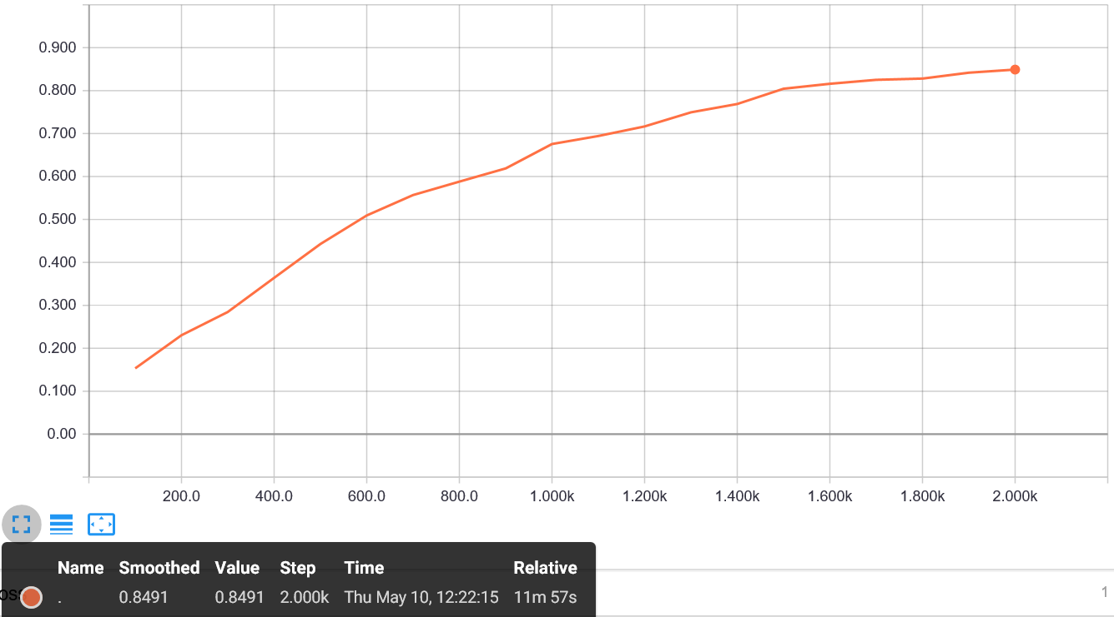

MNIST Part 2

To improve upon the accuracy from Part 1, I decided to change the optimizer from Gradient Descent to Adam to see how the accuracy would change. The code for this can be found in the cnn_mnist_part2.py file. Then, I was able to run the command (tensorboard --logdir=C:\tmp\mnist_convnet_model_2\eval) to show the TensorBoard graph. It turned out that changing the optimizer to Adam caused the accuracy to improve at a much faster rate. By step 100, the accuracy was already in the 90s and it ultimately converged to 99.11% after 2000 steps, as can be seen below.

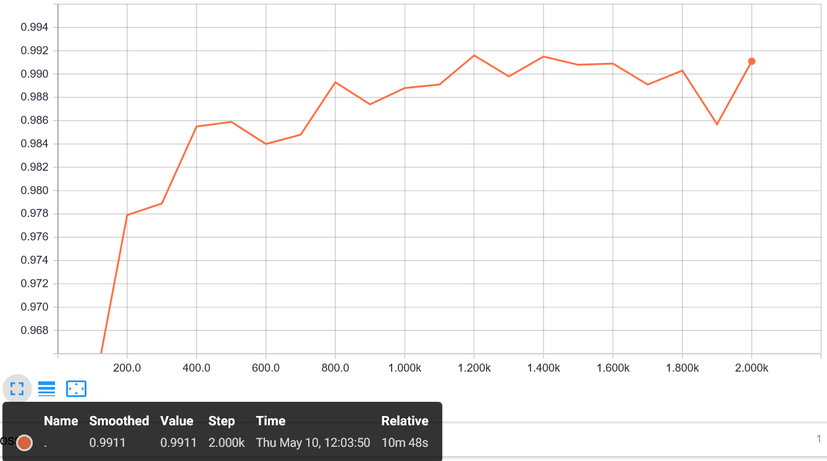

CIFAR-10 Part 3

Baseline tutorial accuracy – 78.01% with 5k steps.

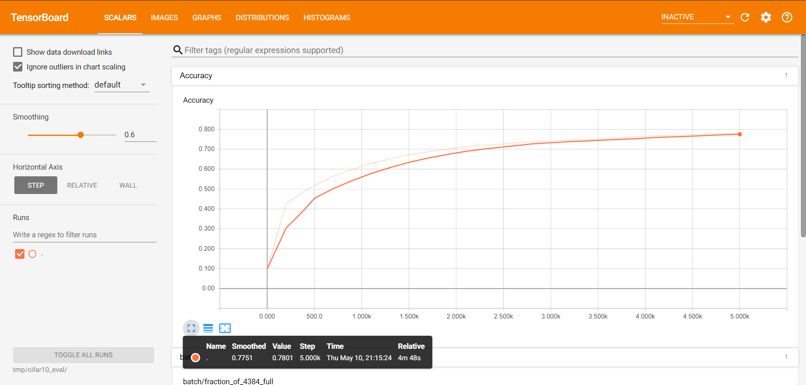

CIFAR-10 Part 4

Improved accuracy – 82.77%

I made the following changes for this improvement –

cifar10.py

* Changed GradientDescentOptimizer to AdamOptimizer(learning_rate=0.001)
* Replaced local response normalization with batch normalization
* Increased batch size to 256

cifar10_input.py

* Increased IMAGE_SIZE = 32 from 24

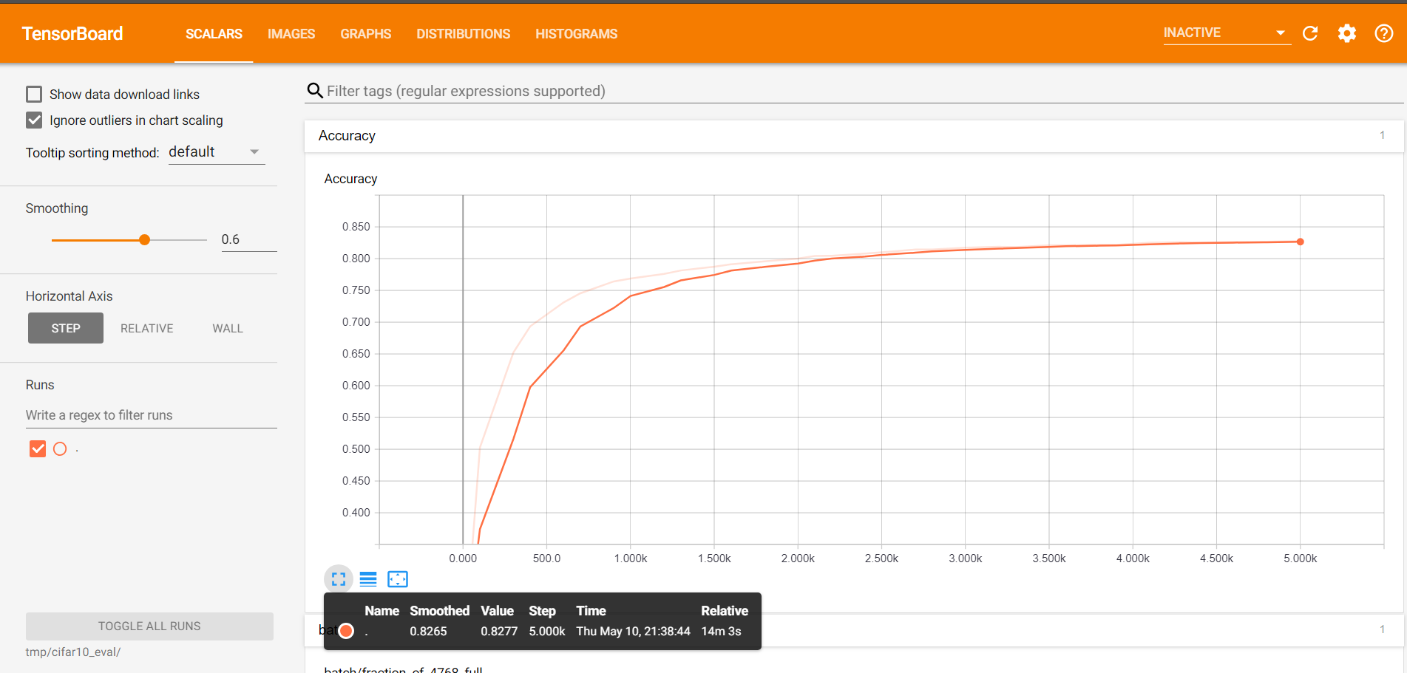

All the code lives in cifar10 directory and the files ending with _modified are the modified files for part 4.