An unordered collection of objects

Objects in the set (aka members of the set)

Set = {//list of elements in set}. Order is not important

N = natural numbers

Z = integers

Z+ = positive integers

R = set of real numbers

R+ = set of positive real numbers

C = set of complex numbers

Q = set of rational numbers

Set = {domain | condition}, s = {x | p(x)}

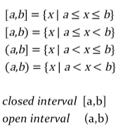

Denoted by u, the universal set contains everything currently under consideration. It is sometimes implicit or explicitly stated depending on the content.

A set with no elements, symbolized as ø, but {} is also used

Two sets are equal if and only if they have the same elements

A set a is a subsetof b, if and only if every element of a is also an element of b, a⊆ b

If a ⊆ b, but a != b, then a is a proper subset of b, denoted by a ⊂ b

If there are exactly n distinct elements in s where n is a nonnegative integer, then s is finite. Otherwise, it is infinite. The cardinality of a finite set a, denoted by |a|, is the number of distinct elements of a

The set of all subsets of a set a, denoted by *p*(a), is called the power set of a

Ordered n-tuple (a1,a2,a3…,an), 2-tuples are called ordered pairs, pairs (a,b) and (c,d) are equal if and only if a = c and b = d

Denoted by a × b, it is the set of ordered pairs (a, b) where a set of ordered pairs (a,b) shows a ∈ a and b ∈ b

A subset of the cartesian product a × b is called a relation from the set a to the set b

Given a predicate p and a domain d, we define the truth set of p to be the set of elements in d for which p(x) is true. The truth set of p(x) is denoted by {x ∈ d | p(x)}

Unionof sets a and b is denoted by a u b

A ∩ b = {x | x ∈ a ^ x ∈ b} – what’s in common between a and b

If a is a set, then the complement of the a (with respect to u), denoted by ā is the set u – a

A and b are sets with respect to u – the difference between them is denoted by a – b – contains elements of a that are not in b

|a u b| = |a| + |b| - |a ∩ b|

Two sets are disjoint if their intersection is an empty set (a ∩ b = ø)

Denoted by a (xor) b. A (xor) b = (a – b) u (b – a)

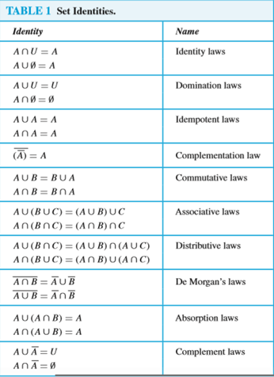

The union of a collection of sets is the set that contains those elements that are members of at least 1 set in the collection

The intersection of a collection of sets is the set that contains those elements that are members of the sets in the collection

A functionf from a to b, denoted f:a à b, is an assignment of each element of a to exactly one element of b, can be specified as an explicit statement of the assignment, a formula, or a computer program

Function f is said to be this if and only if f(a) = f(b), which implies that a = b for all a and b in the domain of f (an injection if it is one-to-one)

Function f from a to b is called onto or surjective if and only if for every element b in b, there is an element a in a with f(a) = b

One-to-one correspondence, if it is both one to one and onto (surjective and injective)

F = bijection from a to b, then the inverse of f (f-1) is the function from b to a defined as

Let *f*:bàc and *g*:aàb. The composition of f with g (denoted f ○ g) is the function from a to c defined as

F(x) = |_x_| – largest integer less than or equal to x

F(x) = |-x-| - smallest integer greater than or equal to x

*F*:nàz+, denoted by f(n) = n!, product of the first n positive integer when n is nonnegative

Function from a subset of the integers to a set s – notation an (term of the sequence)

Sequence of the form where initial term *a* and common ratio *r* are real numbers

Initial term a and the common difference d are real numbers

A finite sequence of characters from a finite set (an alphabet)

{an} is an equation that expresses an in terms of one or more of the previous terms of the sequence (an-1)

A sequence is called a solution of a recurrence relation if its terms satisfy the recurrence relation

Initial conditions for a sequence specify the terms that precede the first term where the recurrence relation takes effect

F0, f1, f2,… represented by initial condition f0 = 0, f1 = 1 and recurrence relation of fn = fn-1 + fn-2

The formula for the nth term of the sequence generated by a recurrence relation

N2, n3, n4, 2n, 3n, n!, fn

Sum of the terms am, am+1, …, an from the sequence {an}

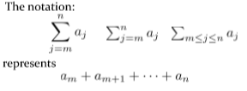

The letter j in the summation notation. It runs through all the integers starting with its lower limit m and ending with its upper limit n

A rectangular array of numbers

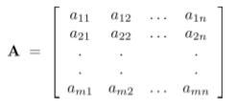

A matrix with m rows and n columns

A matrix with the same number of rows as columns

Two matrices are equal if they have the same number of rows and columns and the corresponding entries in every position are equal

Let a = [aij] and b = [bij] be m x n matrices. The sum of a and b, denoted by a + b, is the m x n matrix that has aij + bij as its (i,j)th element. In other words, a + b = [aij + bij]

Let a be an m x k matrix and b be a k x n matrix. The product of a and b, denoted by ab, is the m x n matrix that has its (i,j)th element equal to the sum of products of the corresponding elements from the ith row of a and the jth column of b.

It is the m x n matrix in = [δij], where δij = 1 if i = j and δij = 0 if i != j

When a is an n x n matrix, we have: a0 = in and ar = aaa...a where a is multiplied by itself r times

Let a = [aij] be an m x n matrix. The transpose of a, denoted by at, is the n x m matrix obtained by interchanging the rows and columns of a

A square matrix a is called symmetric if a = at. Thus, a = [aij] is symmetric if aij = aji for i and j with 1 <= i <=n and i <= j <=n. Square matrices do not change when their rows and columns are interchanged

A matrix all of whose entries are either 0 or 1. Algorithms operating on discrete structures represented by zero-one matrices are based on boolean arithmetic defined by the following boolean operations:

https://lh4.googleusercontent.com/4tjQ0U-tphouayf1wnOxWFews4aaL7F1k_ct5DeI1cV1-efrrnm5hATuW0HNhxP2V5VINT2mg3pLKwgDZcBya3mLJRxajmOC91D9Y4RoaNxViILiW01XEgK1wzXRNrnTKTqG7sSL

Let a = [aij] and b = [bij] be m x n zero-one matrices. The join of a and b is the zero-one matrix with (i,j)th entry aij v bij. The join of a and b is dented by a v b.

Let a = [aij] and b = [bij] be m x n zero-one matrices. The meet of a and b is the zero-one matrix with (i,j)th entry aij ^ bij. The meet of a and b is denoted by a ^ b

Let a = [aij] and b = [bij] be m x n zero-one matrices and b = [bij] be a k x n zero-one matrix. The boolean product of a and b, denoted by a ⊙ b, is the m x n zero-one matrix with (i,j)th entry

Let a be a square zero-one matrix and let r be a positive integer. The rth boolean power of a is the boolean product of r factors of a, denoted by a[r]. Hence a[r] = a ⊙ a ⊙ … ⊙ a where a is multiplied r times.