Logo:

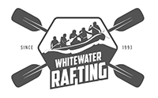

Color Palette:

* URL: <https://coolors.co/47ddff-00758f-76bc84-4d4d4d>
* Primary-color: # 00758f
* Secondary-color: # 47ddff
* Accent1-color: # 4d4d4d
* Accent2-color: # 76bc84

Fonts:

* Heading-font:
  + URL: <https://fonts.google.com/specimen/Vina+Sans?categoryFilters=Appearance:%2FTheme%2FWoodtype&preview.text=WHITEWATER%20RAFTING>
  + Vina Sans, 400.
* Text-font:
  + URL: <https://fonts.google.com/specimen/Tinos?preview.text=Whitewater%20Rafting&categoryFilters=Feeling:%2FExpressive%2FBusiness>
  + Tinos, 400, regular.