Fort Worth Light Rail Feasibility & Connectivity Analysis: A Proposal for the City of Fort Worth and Trinity Metro
Executive Summary:
Fort Worth's cultural and economic hubs are disconnected from one another and inaccessible without a private vehicle, creating a significant mobility gap for residents and visitors alike. This proposal delivers a GIS-based transit demand and light rail feasibility analysis for the City of Fort Worth and Trinity Metro, producing an interactive web map, static maps, and a spatial analysis report to inform future transit investment.
Project Overview
This proposal aims for the re-establishment of rail-based public transportation options within Fort Worth. As the metroplex continues to grow and our roadways become overburdened by private transportation options, we owe it to the residents of the city to provide alternative and clean transportation options. Connecting Fort Worth with the opening of a series of new light rail lines would allow residents and visitors to explore, interact with, and boost the city economically and culturally. Our metropolitan peers have the edge on us with a growing network of light rail transit based in Dallas. Fort Worth cannot fall behind as the metroplex evolves and is reshaped by modern living standards. We propose the following plan for the City of Fort Worth and its transit partner, Trinity Metro, to adopt and put into action to lead the city into the era of modern transportation.
The Issue:
The DFW metroplex is the third fastest growing metropolitan area in the nation. As the region grows and brings in new residents and new tourism, we must rise to the occasion of creating an interconnected city that people enjoy living in. Fort Worth has no shortage of cultural and economic hubs, namely: the stockyards, the museum/cultural district, Sundance Square and downtown, and in the coming years panther island. With so much to see over such a vast geographic area the issue of mobility arises. Fort Worth, like many Texas cities, is almost exclusively car-dependent. This creates a two-fold issue, residents who may not have reliable access to a car are spatially limited to where they can live and work, and tourists must rent a car or hire taxi services to move around. These examples at a basic level highlight the transit gap facing Fort Worth and encourage innovation to create a connected city.
Project Deliverables:
This project aims to deliver an informed analysis to the officials of the City of Fort Worth and Trinity Metro to determine demand for rapid public transit access, best options for lines to connect points of interest throughout the city, and a feasibility study for these lines. A spatial demand analysis will be completed to gauge what populations within Fort Worth have the highest demand for transit lines, this will be done through a mix of demographic data and analysis of existing bus corridors. A hub connectivity analysis will be conducted to identify the best routes for rail lines while taking into account: travel times, route feasibility, existing infrastructure, and location of POIs. This phase of investigation and modeling will result in the creation of static maps modeling transit demands and gaps and suggested focus corridors for construction of rail lines. Additionally, the same datasets will be integrated into interactive web maps to allow City/Trinity Metro staff and community shareholders to investigate this proposal’s recommendations. This partnership will enable grant applications and comprehensive planning to create these transit lines.
Historical Context:
Fort Worth is situated in an interesting urban context. The DFW area historically was host to a vast network of streetcars and interurban rail (reference map 2). Prior to the rise of the automobile, pedestrian access was much greater in DFW, but as urban sprawl has reshaped our city that access has eroded. With a greater emphasis on sustainable development a shift away from car dependent cities is happening globally. This development has already begun at a regional scale. With the development of DART’s light rail network beginning in the 1990s a slow shift in the direction of interconnected urban communities has begun (reference map 1). Fort Worth used to be host to a large network of streetcars that connected communities to each other and brought in workers and finance into the downtown area as its core. While the economic landscape of cities today is different we can imagine new ways to catch up to our contemporaries and connect our communities as well as our financial and cultural hubs to create a powerhouse of a city.
Qualifications:
I am particularly passionate about the promulgation of sustainable design and its integration in transportation networks. In the summer of 2025 I interned at the North Central Texas Council of Governments with their transportation team. In this role I conducted a network analysis of micromobility and pedestrian mobility throughout the region. Within my collegiate experience I have taken a number of courses centered around ArcGIS mapping tools, such as: ArcGIS Online, Pro, Business Analyst, StoryMaps, and Experience Builder. I have worked with a number of styles of analysis and datasets that have prepared me to lead the design of a project such as this.
Resources:
To effectively analyze where to best place these rail routes throughout the city I will make use of a split of publicly available data and shared data from the relevant organizations, namely Trinity Metro. If Trinity Metro would share GTFS data and ridership data I would be able to model which existing bus lines would be best augmented by their replacement with light rail and which areas have the highest demand. Contributions from the City of Fort Worth through its open data program for micromobility and pedestrian infrastructure and planned development would help in the design of the light rail lines.
Conclusion:
The addition of light rail lines connecting all of North Texas would be a mass economic and cultural driver, bringing our city into the modern era of mobility. The opportunity to bridge the gap between Fort Worth’s history and its future trajectory in the re-establishment of the streetcar is too great an opportunity to pass up. Modern cities demand modern and sustainable transit and mobility solutions; we can make this a reality for Fort Worth.
Appendix:
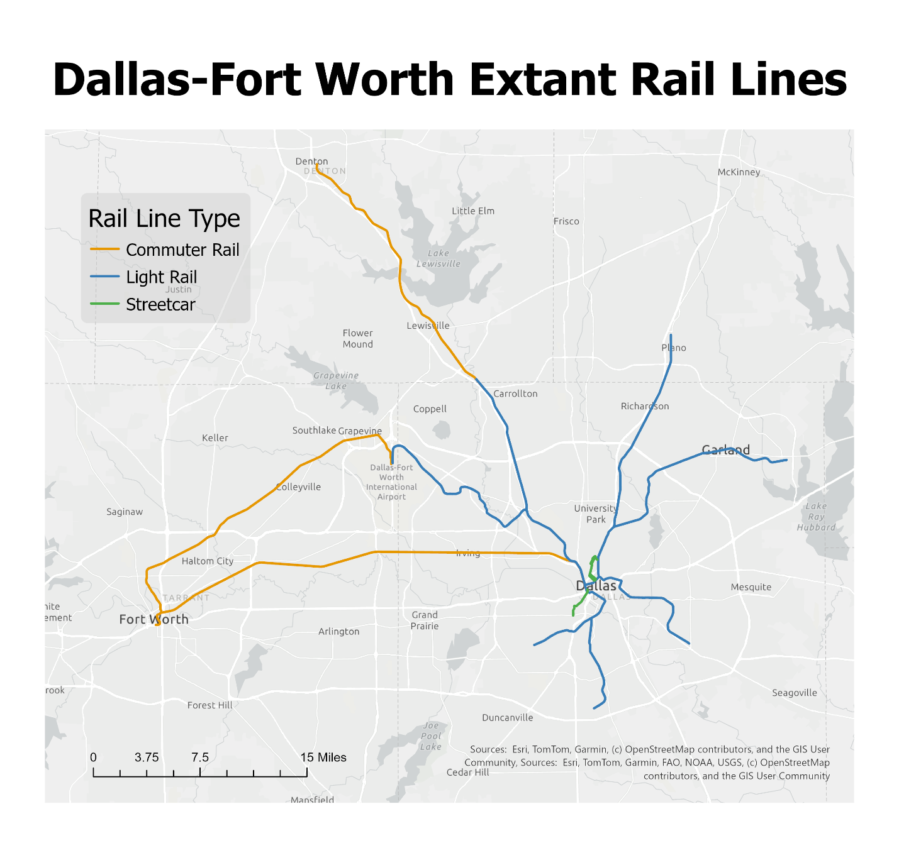
Map 1: Dallas-Fort Worth Extant Rail Lines. Current passenger rail lines of the metroplex, as of 2026. Data provided by NCTCOG.
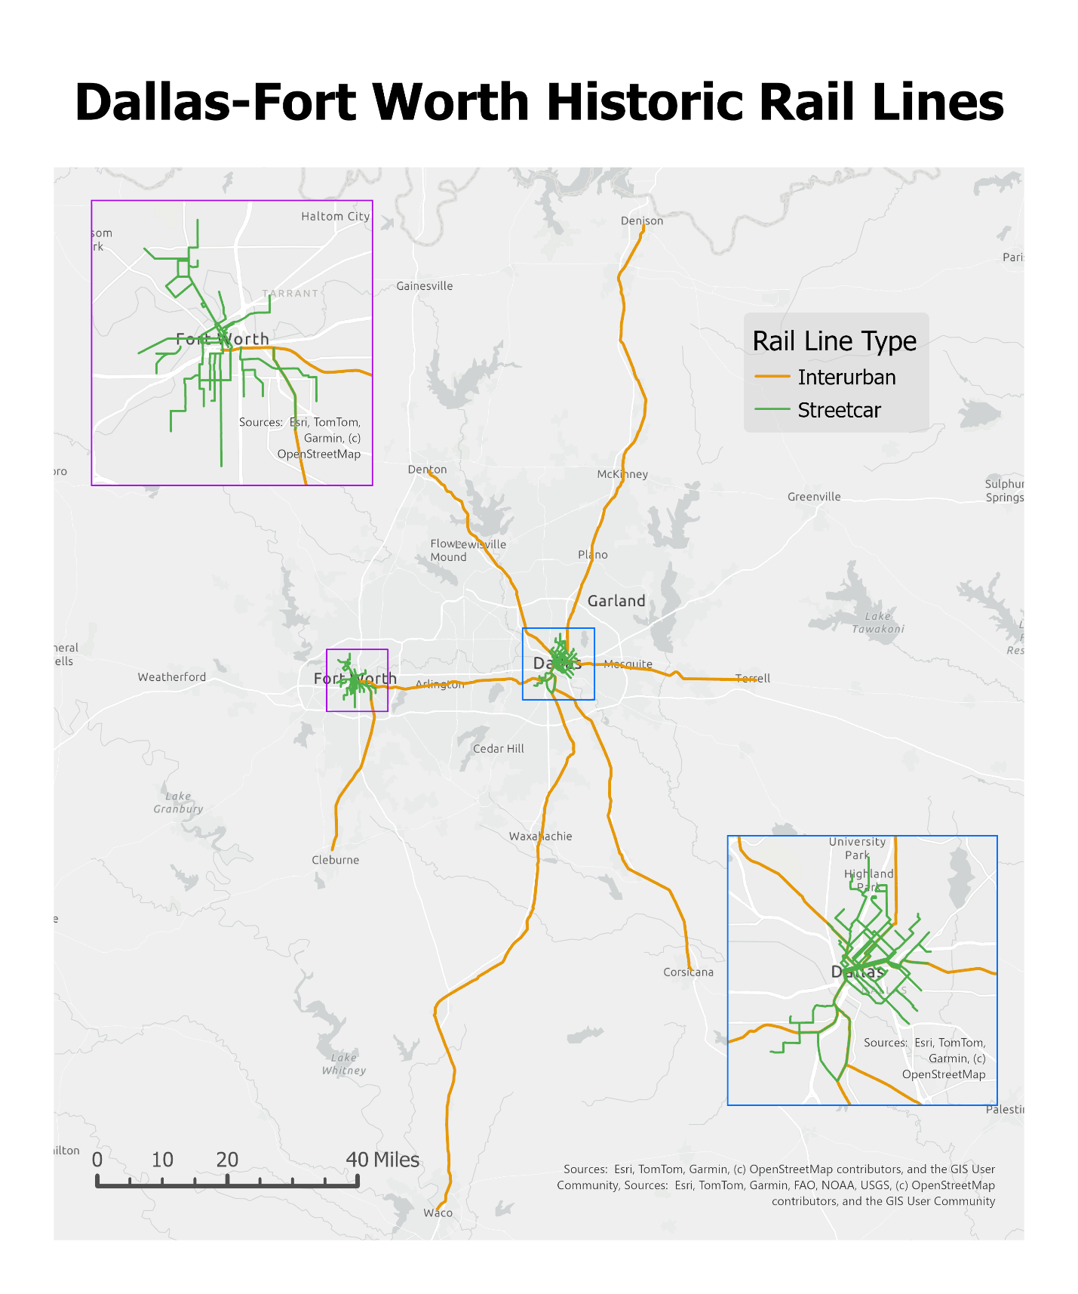
Map 2: Dallas-Fort Worth Historical Streetcar Network. Historic network of intercity and intracity passenger rail lines of the region. Data provided by NCTCOG.

