Andres Gamez
GEOG 30763.045
Dr. Crotty
2/28/26
Lab 3 Writeup
This analysis looked at the spatial distribution of four different types of drinking establishments within the Dallas-Fort Worth metroplex. Craft breweries were looked at because of their distinct demographic market, heavily male and generally younger. Wineries were looked at for their increased land input necessary to operate. Wine bars were analyzed as spatially unrestricted vendor for wine. Applebee’s locations were looked at to capture the commercial spread of these establishments, and as a sort of density control. Businesses follow a distinct spatial logic for their locations, weighing their necessary facility inputs, target demographics, and other metrics that determine where they will locate.
The least spatially dense business of these four is Applebee’s. The strategy employed by their site selection aims at placing these commercial eateries away from each other to capture all of a certain area. It is a very run of the mill bar/restaurant so does not have a particular niche that customers would flock to in the same way as some of the other business types. Map 1 shows at a basic level that all of the other business types have at least one trend for how they are spread out, but the Applebee’s strategy is a widespread throughout suburban areas. Map 3 compares Applebee’s locations to Wine Bars which has a definite spatial concentration, making the contrast starker. All together Applebee’s does not have specific niche with their service, offerings, or demographics much, so they are spread to capture convenience diners and drinkers.
Breweries are the most populous of these establishments. The spatial concentration of craft breweries is pretty easy to extrapolate from Maps 1 and 2. Best highlighted in map 2, craft breweries have a spatial concentration that lean towards being in or near a city’s CBD. More specifically, they favor economically active or up-and-coming areas that tend to cluster young adult demographics. This demographic generally defines what areas may be ‘cool’ in a city and as such define where these types of ‘vibes dependent’ businesses may cluster. In the case of DFW there are major clusters around the downtowns of Dallas and fort worth, specifically in young affluent neighborhoods. These businesses also tend to be in these neighborhoods because of the availability of foot traffic that generates most of their revenue, while there are other ways they make their money like wholesale distribution.
In contrast to the dense urban environment of breweries, Wineries have a set of land and environmental needs that govern where they locate. Wineries need land to grow grapes first and foremost, a characteristic that is not in line with most urban environments or have enough large parcels within a city. A second characteristic important to the experience and therefore location is nature and quietness. Wineries often are destination points for visitors so they are willing to travel further to have an enjoyable and relaxing experience. The key things that make wineries attractive activities lend themselves to not being in cities, which falls in line with their physical business needs. In DFW they are generally located on the urban fringe areas, yet still near or along major highway or thoroughfares, because at the end of the day, if people cannot find a place they cannot go to it. So, they present a spaced-out distribution to avoid competition and make use of the needs of their businesses for good growing and relaxing conditions.
Wine bars are a related place to wineries. They take the product of a winery and make it more accessible in an urban context since they do not have the same land and facility needs as wine makers. Wine bars have a highly spatially concentrated market because of their demographic targeting. There is a spatial concentration of these types of businesses in the two CBD’s of the metroplex. Thes establishments have different demographic targeting as opposed to Applebee’s, which their spatial distribution is compared to in Map 3. Wine bars aim for a specific demographic, think downtown Dallas into the Park Cities, so they cluster into areas where people of their target demographic live and work, so they have a higher exposure and interaction with them. Throughout the rest of the metroplex there are more of these businesses, likely spring up in places that are geared towards these demographics as well.
To look at how these dynamics play out I created map 4 to study if my theory of the spread of these businesses holds up. I found a clustering of Breweries and a Wine Bar within the downtown of Denton, with a Applebee’s away from the CBD but within the city. This clustering of breweries particularly was interesting to me. From my understanding, this clustering exists as part of the bar or nightlife district of downtown Denton that is about equidistant from both the mains campuses of Texas Women’s University and the University of North Texas. This concentration of nightlife and these businesses at the confluence between these two college campuses makes sense.
These businesses are prime examples of hoe spatial logic is applied to determine the best locations for business based on demographic, physical inputs and other needs. These examples supports the theory that these businesses cluster in particular places to meet their target demographics and where they can logistically be housed to have successful businesses. All of these businesses have different needs, customer bases, and inputs that they needed to succeed and locational analysis helped them all achieve what they need.

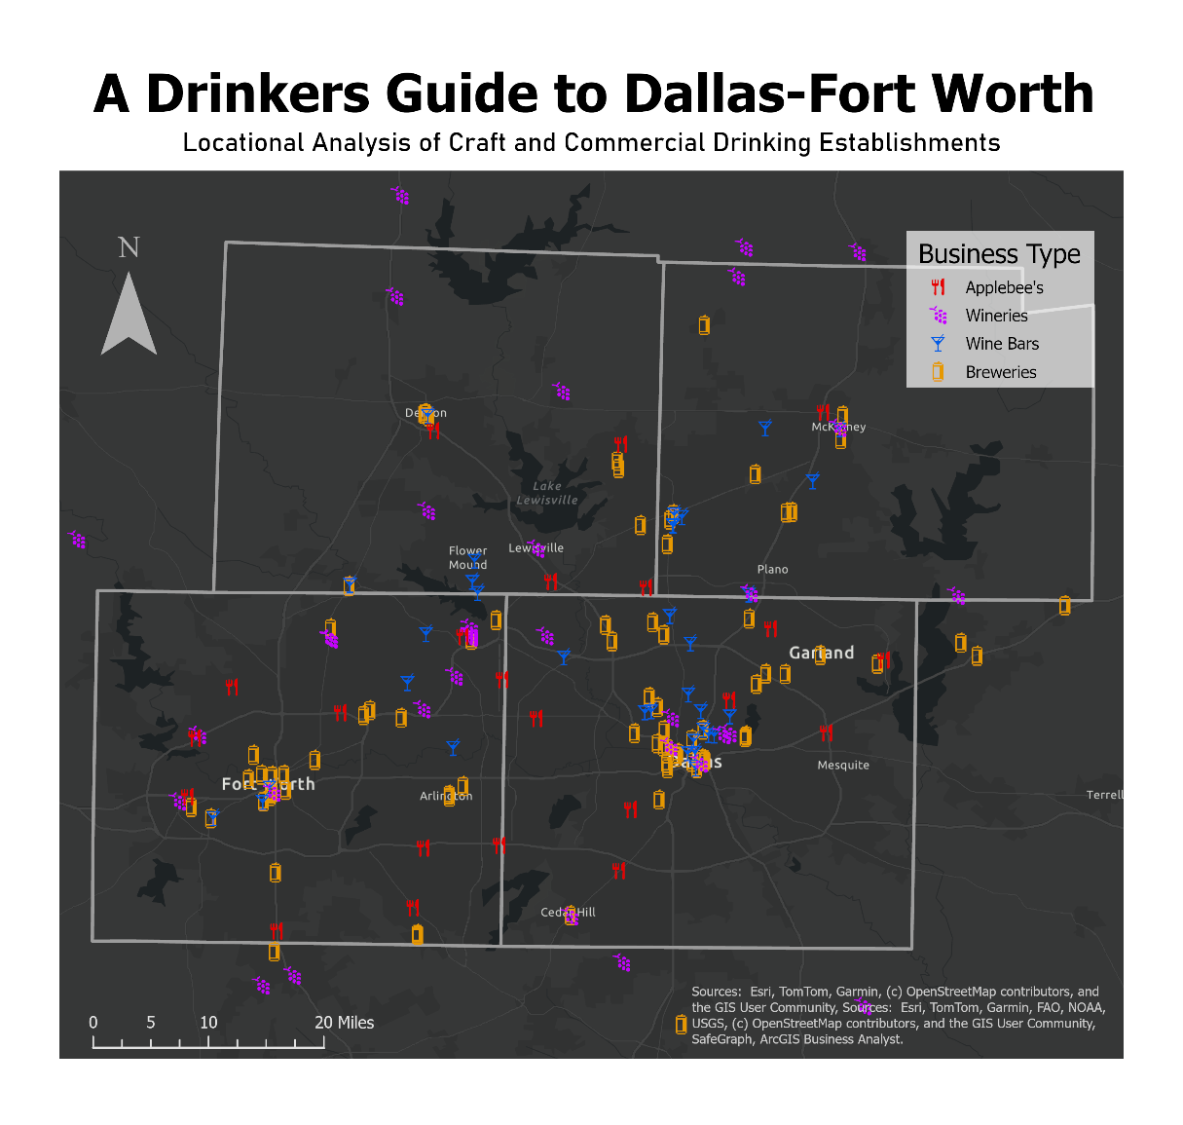
Appendix

Map 1: “A Drinkers Guide to Dallas-Fort Worth.” Map of locations of various craft and commercial drinking establishments. Andres Gamez.

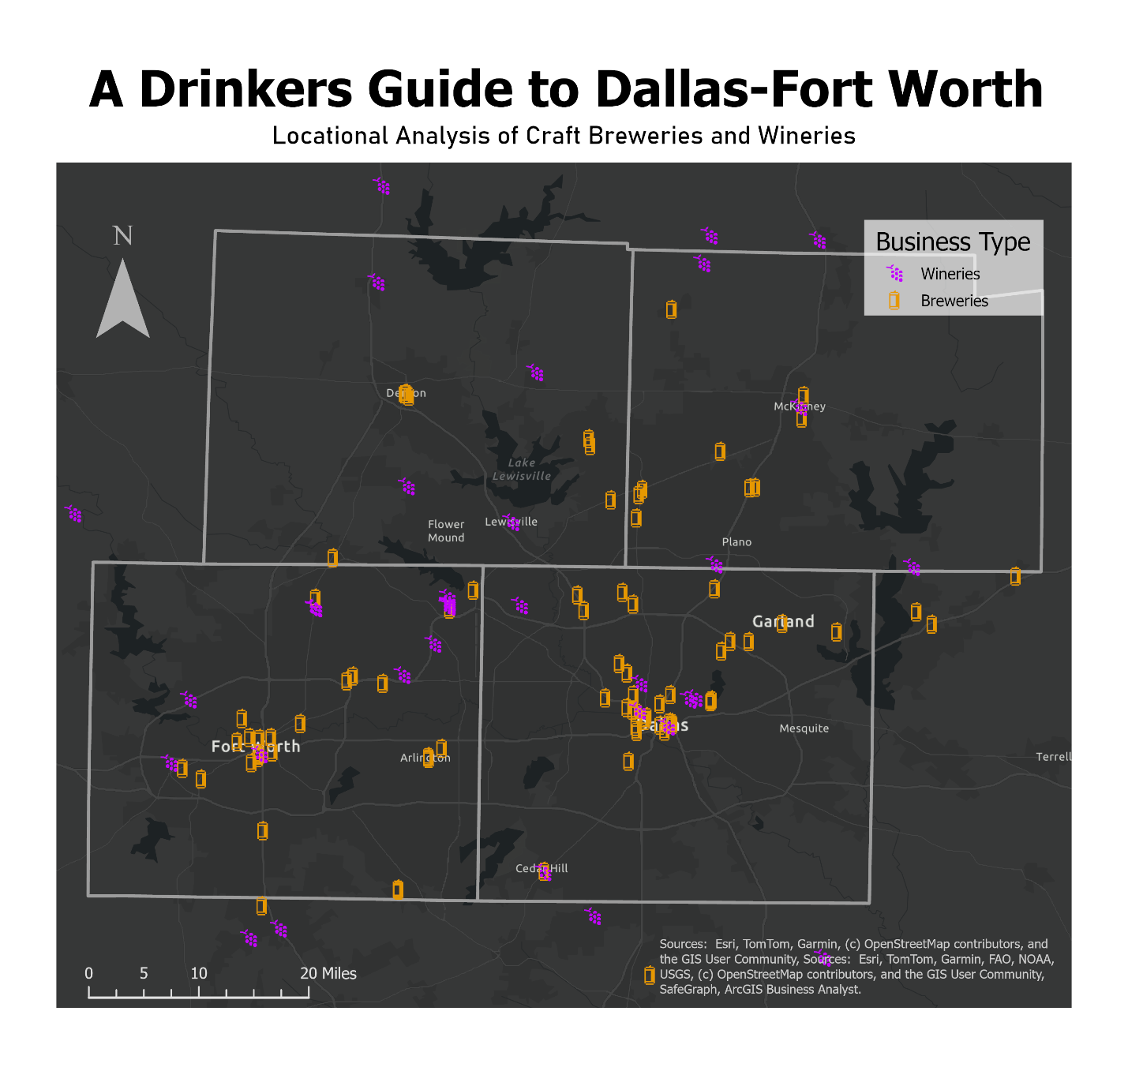
Map 2: “A Drinkers Guide to Dallas-Fort Worth.” Map of locations of various wineries and breweries. Andres Gamez.

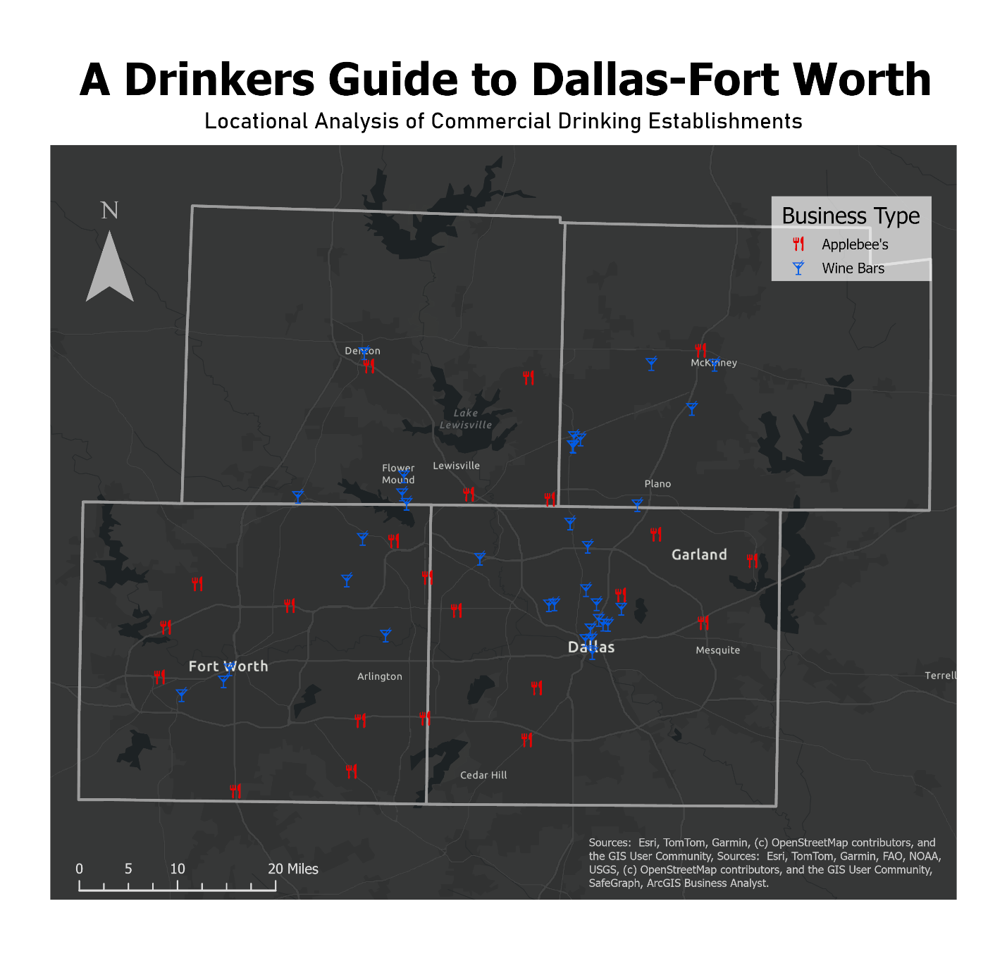
Map 3: “A Drinkers Guide to Dallas-Fort Worth.” Map of locations of various commercial drinking establishments. Andres Gamez.

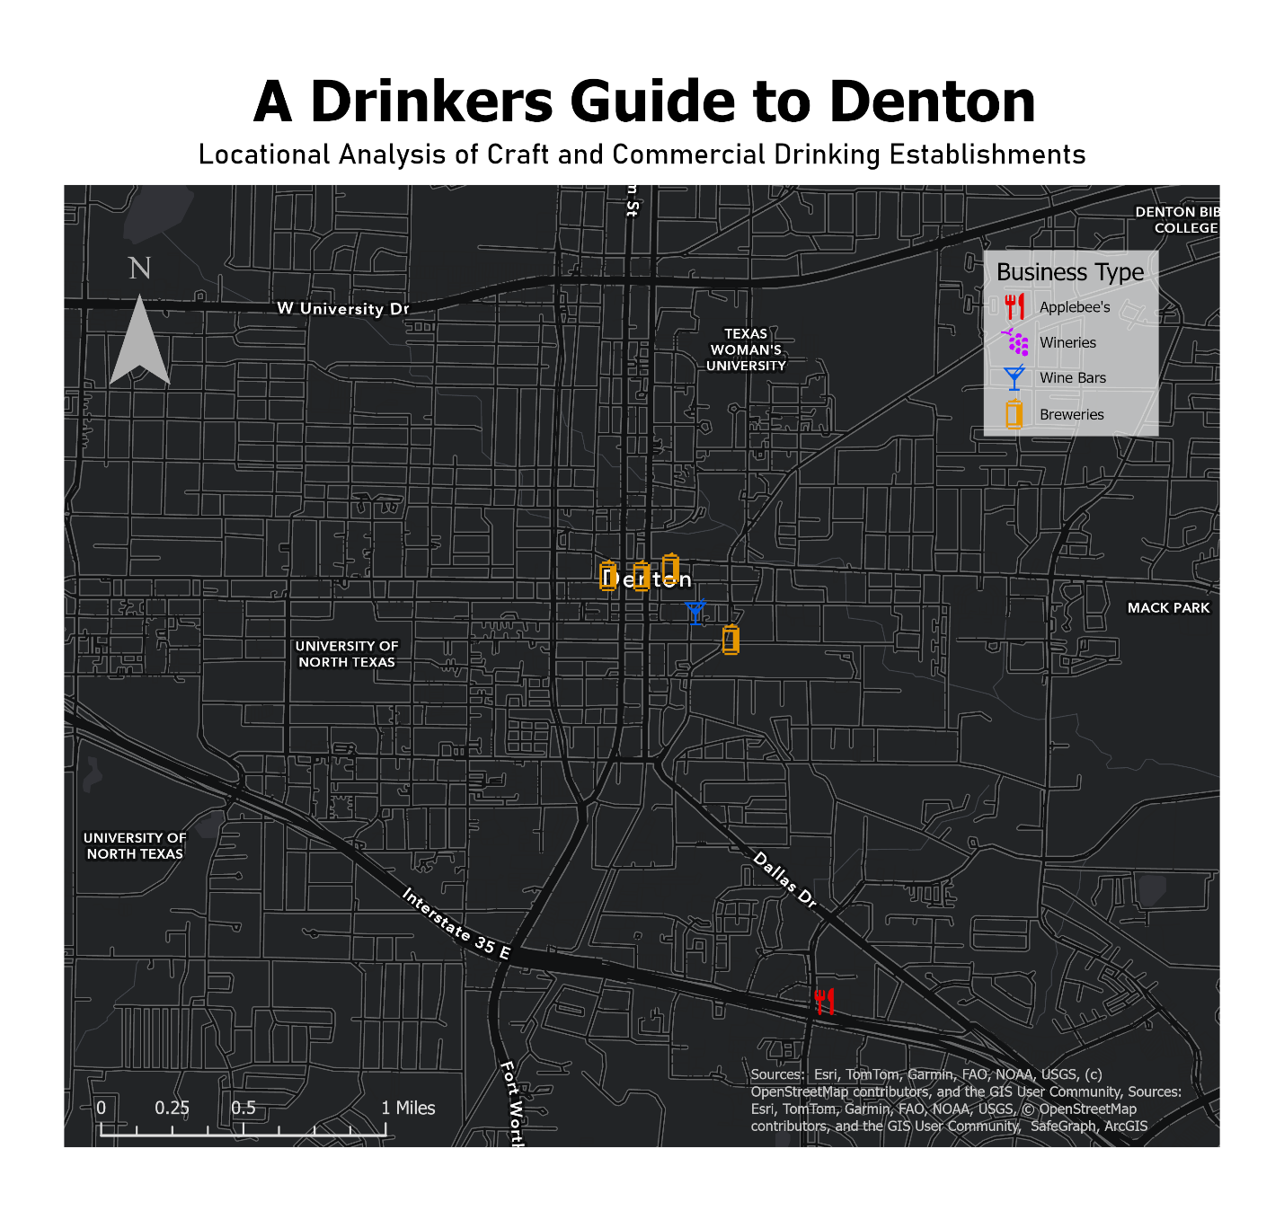
Map 4: “A Drinkers Guide to Denton.” Map of locations of various craft and commercial drinking establishments in Denton, Texas. Andres Gamez.

