Game Design Document (GDD)

Project Title: Last order’s

Author: Jonathan Andrews, Harrison Buck, Morgan McGovern
Email: jonathan.andrews@students.plymouth.ac.uk

URL for project GIT repo: https://github.com/JAndrews004/COMP3013
URL for project blog: <insert active link to blog using insert menu>
Youtube link: <insert active link to youtube playthrough using insert menu>

Module: COMP3013
Version 0.5

Table of Contents

1. Introduction
2. Scope
3. Target platform(s)
4. Development software
4.1 Engine software
4.2 Programming software
4.3 Artwork software
5. Specification
5.1 Concept
5.2 Story
5.3 Setting
5.4 Game structure
5.5 Players
5.6. Actions
5.7 Objectives
6. Graphics
6.1 Styles
6.2 Fonts
6.3 Colours
6.4 Influences
6.5 Look & Feel
7. Data storage
7.1 Local data
7.2 Online data
7.3. Social data
7.4 Statistical data
7.5 Legal and Ethical Considerations
8. Gameplay
8.1 World
8.2. Object types
8.3 Controls
8.4. Direct control
8.5 Indirect control
9. Supported hardware
10. Screens & menus
10.1. Splash Screen
10.2 Game Interface
10.3. Pause menu
10.4 Options
10.5 Game Over

1. Introduction
This document is to specify the details about Last Orders to allow uninitiated members to understand the design and development of the product. This games genre is primarily a simulation game that is fast-paced and intense. This product is unique because of the combination of these elements. Last Orders is a prototype to allow for third parties to show interest in continued development.

2. Scope
This document is intended to be used by games programmers, designers and anyone with interest in this products development. This document will include design decisions and decisions to do with the planning and development of the game. This document will not include specific code or any technical information relating to the game’s architecture and systems.

3. Target platform(s)
The target platform for this game is Windows pc systems. This is due to the mouse precision it offers and ease of development. Mobile is not supported due to additional design considerations but may be possible in the future. Consoles are also not supported due to the lack of access to testing apparatus and capital for licences.

4. Development Software
4.1 Engine software
For the development of this product Unity version 2023.3.38f1 will be used for the main reason that Last Orders is very UI heavy and Unity offers easy development for this. The team is also quite experienced in Unity so this will speed up development.

4.2 Programming software
The software used for programming is visual studio 2022 and will be using C# for the Unity integration and OOP support.

4.3 Artwork software
Any 3d models produced will be in blender 4.3 and textures will be developed in Last Orders. Almost all assets will be acquired through the creative commons license as to avoid legal issues. This is due to the limited timeline for the development of this project. Some more simple geometry models will be produced by us. To ensure consistency in style we will be using low poly models with simple textures.

5. Specification
5.1 Concept
The concept of this game is that the player is working at a bar serving drinks to various customers. The aim of the game is to make enough drinks correctly for customers to then earn enough ‘money’ to pay the rent due at the end of each day. The ‘money’ received will be based on drink accuracy and speed of delivery. The core gameplay loop: Order ticket arrives -> make drink -> serve -> get reputation and money -> repeat until night ends -> upgrade and repeat. The player will be pressured by the time the order is available if they do not complete it beforehand, they receive a reputation and monetary penalty. The difficulty will increase through new recipes being added through the game to a maximum of 5 for the demo.

5.2 Story
The player owns a bar and is the sole bartender trying to earn a living and keep their business alive or even thrive.

5.3 Setting
A rundown bar the player owns primarily working at night. The bar will be a medieval style that is well lit. The player will go through multiple nights, but the setting will remain the same.

5.4 Game structure
The player works each night to earn enough money to survive during the night. If more money is earned it can be invested into upgrades for the bar which could earn more money or get more customers during the day. A player can fail a night by resetting the drink being made too many times and can fail the day if there isn’t enough money to pay rent with. The upgrades will affect the money earned, the lifetime of order tickets and reduction in rent. This will allow players to customise a run better. Currently only an endless mode is available to show off the core mechanics. If the player fails to pay rent they return to the main menu where they can restart.

5.5 Players
Single player offline game.

5.6 Actions
Add ingredients to a drink to complete a recipe with steps for mixing in the correct order. Then move completed drinks to the correct space to complete the order. To select ingredients the player clicks them to select then clicks on the drink to add. The garnishes such as ice and lemon slices can also be dragged but is an optional addition. For the shaking a mini game is started where the player must click and hold a shaker and move the mouse until the progress bar is full. A similar mini game for stirring occurs but the player must move the mouse in a circle.

5.7 Objectives
Get the bar back to its former glory and satisfy your customers drinking needs. Short-term goals: complete orders and earn money to pay rent. Long-term goals: Upgrade the bar to make gameplay a bit easier and survive as many nights as possible.

6. Graphics

6.1 Styles
Low-poly medieval style for aesthetics and clarity.

6.2 Fonts
Arial

6.3 Colours
#9C230B orangey brown for the environment with some variation for accents, highlights etc, #D5E0ED steel colour for the metal on parts of cups or the shaker for example.

6.4 Influences
Overcooked’ s ticket and ordering system. Schedule 1 low poly style. Va11 Hall-a’s bar tender simulation.

6.5 Look & Feel
The UI will consist of a reputation bar at the top of the screen with a current order steps queue to the left of the screen to allow players to see what they have added. A large submit button at the top of the screen and the order tickets at the bottom of the screen.

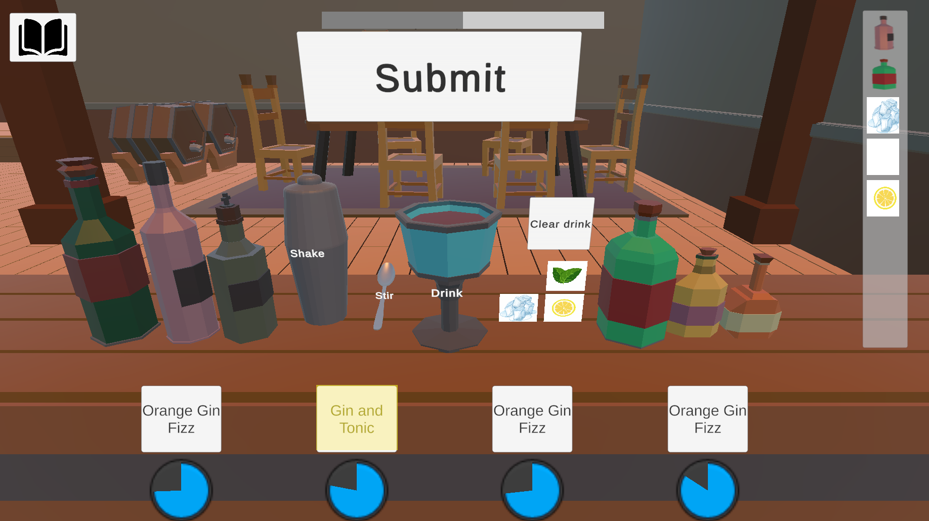

For feedback systems there are some visual indicators such as selected ingredients having a slight animation and an audio queue. The order tickets have a remove sound to let the player know one was removed.

There is also a recipe book that shows the steps required to complete a drink.
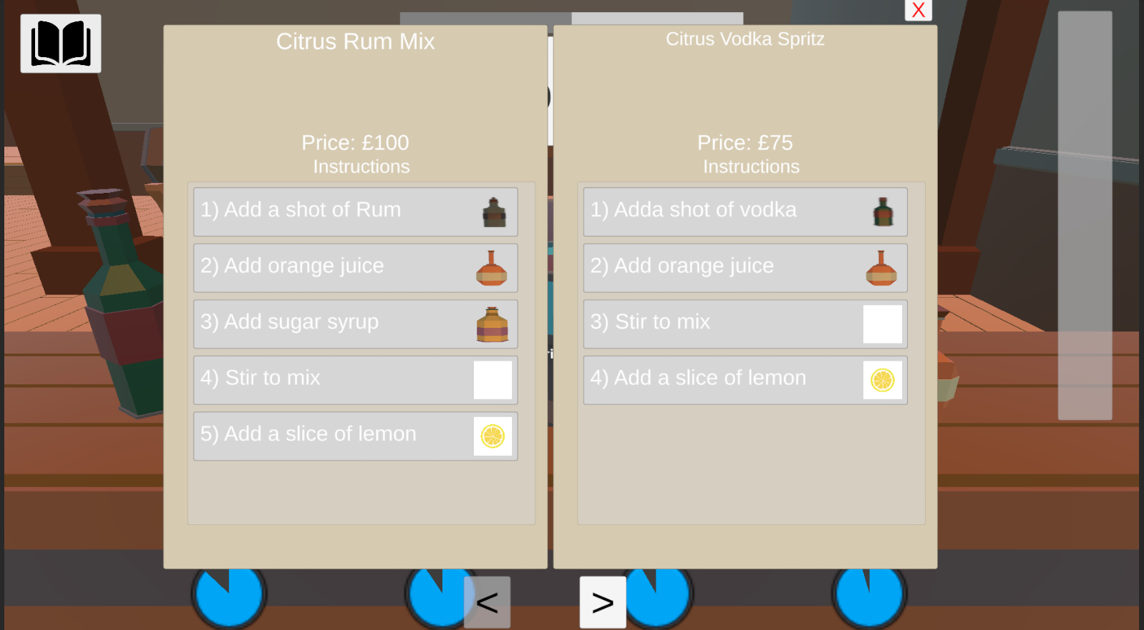
There is also the hub menu with a night overview in the centre with the upgrade list on the right to be purchased.
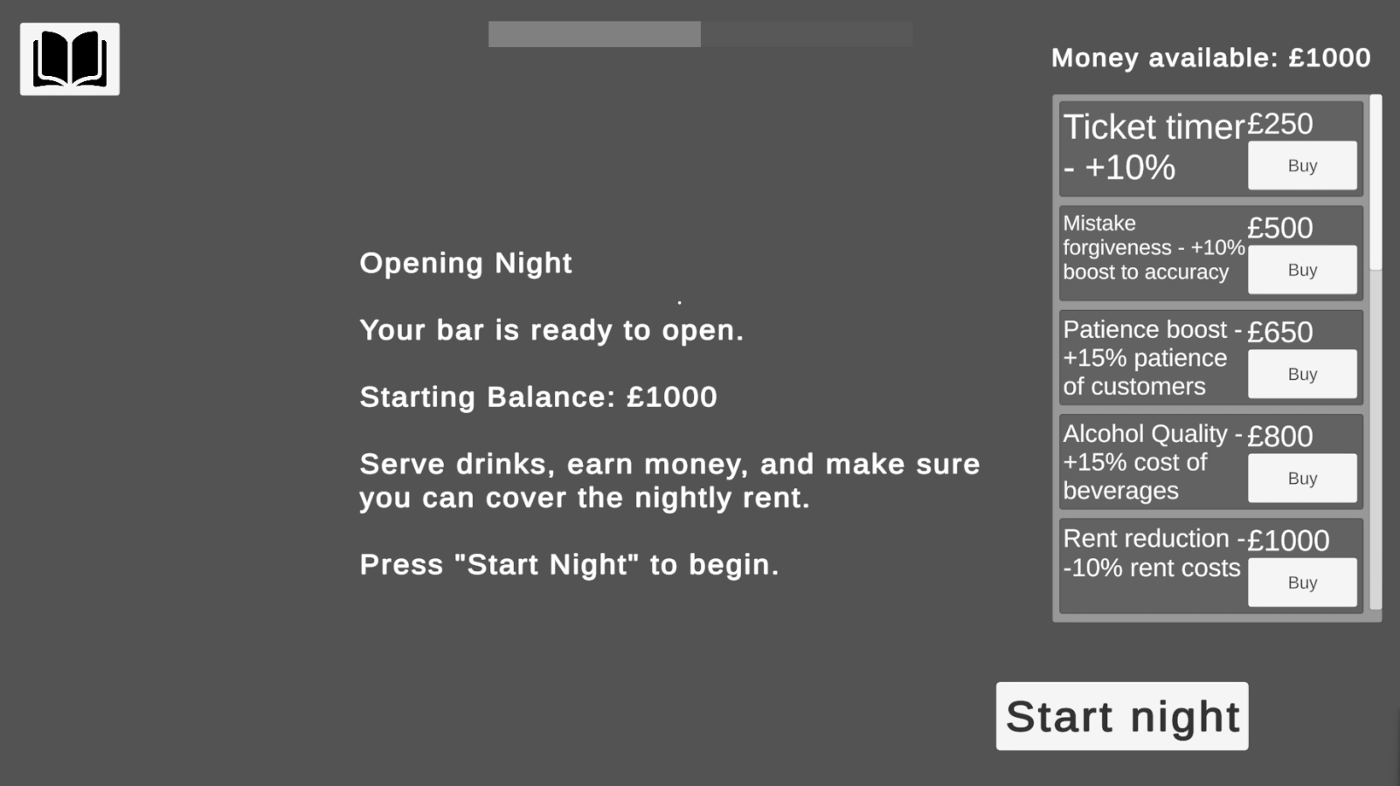

7. Data storage

7.1 Local data
Player preferences for demo (game volume settings), Game progress in the future

7.2 Online data
None.

7.3 Social data
None.

7.4 Statistical data
Money and reputation during runtime. None saved permanently.

7.5 Legal and Ethical Considerations
Target audience is 16+ due to the alcohol content included as PEGI 16 guidelines suggest this. No personal data collected. Only correct Copyright assets will be used (Creative Commons) with credits given. Disclaimer of alcohol content at start of the game.

8. Gameplay

8.1 World
A late medieval tavern scene of mainly the bar area which is where the ingredients will be stored. Some background scene will be included to show NPC’s ordering and their feedback and price they pay.

8.2 Object types
The player will be able to interact with the ingredients such as the alcohol, mixers, ice, garnishes, the glass the drink will be served in, the mixing instruments and the order tickets and serving area.

8.3 Controls
Mouse controls only (click, hold, drag).

8.4 Direct control
Mouse left click for selections, dragging, holding. Esc key for pause menu pop-up.

8.5 Indirect control
Order generation logic assigning NPC types to orders and selecting recipe to be made. Patience of the customer being tied to time remaining on order.

9. Supported hardware/platforms/devices
Keyboard and mouse only.

10. Screens & Menus
10.1 Splash Screen
Main menu (Play, settings, quit).

10.2 Game Interface
Amount of money. NPC comments about service. Drink ingredients and glass to hold current drink. Reputation bar and current steps queue. Order tickets with timers and a recipe book with steps to make it other information.

10.3 Pause menu
Resume, options and return to menu buttons.

10.4 Options
Game volume slider to adjust sound volumes.

10.5 hub world
Previous nights performance with money made and lost due to rent. Upgrade purchasing list.

11. Credits
Audio
Background Music
- “Tavern Loop One” by Alexander Nakarada
Source: https://www.free-stock-music.com/alexander-nakarada-tavern-loop-one.html
License: Free Stock Music License (attribution required)
Background Bar Chatter
- “People Bar Chatter”
Source: https://pixabay.com/sound-effects/people-bar-chatter-5979/
License: Pixabay License (free for use, no attribution required)
Bottle Pickup Sound
- “Glasses Clinking”
Source: https://pixabay.com/sound-effects/film-special-effects-glasses-clinking-73558/
License: Pixabay License
Ticket Fail Sound
- “Paper Rip Twice”
Source: https://pixabay.com/sound-effects/film-special-effects-paper-rip-twice-252619/
License: Pixabay License
Ticket Creation Sound
- “Paper Sound Effect”
Source: https://pixabay.com/sound-effects/film-special-effects-paper-245786/
License: Pixabay License
Drink Restart Sound
- “Slurping Sound”
Source: https://pixabay.com/sound-effects/people-slurping-sound-335897/
License: Pixabay License
Visual Assets
Lemon Slice Icon
- Source: https://www.freepik.com/free-vector/slice-lemon-icon-isolated-design_74221270.htm
Author: Freepik
License: Freepik License (attribution required)
Ice Cubes Illustration
- Source: https://www.freepik.com/free-vector/pile-ice-melting-white_6822595.htm
Author: Freepik
License: Freepik License (attribution required)
Mint Leaves Illustration
- Source: https://www.freepik.com/free-vector/mint-vector-leaves-plant-mint-green-leaf-mint-organic-fresh-mint-illustration_11059478.htm
Author: Freepik
License: Freepik License (attribution required)
3D Assets
Spoon Model
- “Cutlery / Silverware PBR”
Source: https://assetstore.unity.com/packages/3d/props/food/cutlery-silverware-pbr-106932
License: Unity Asset Store License
Environment Assets
- “Fries and Seagulls – Bar/Interior” (Unity Asset Store)
License: Unity Asset Store License

