| **Group** 13 | *Spring 2024 Design Challenge* |
| --- | --- |
| **Major:** | **Team members:** |
| *ITC* | *David Kajuna* |
| *CEG* | *Joshua Andrews* |
| *CS* | *Jason Byrum* |
| *ITC*  *CS* | *John Armlovich*  *Kennedy Eziolise* |

**Design Functionality**

1. Li-Fi Transmission System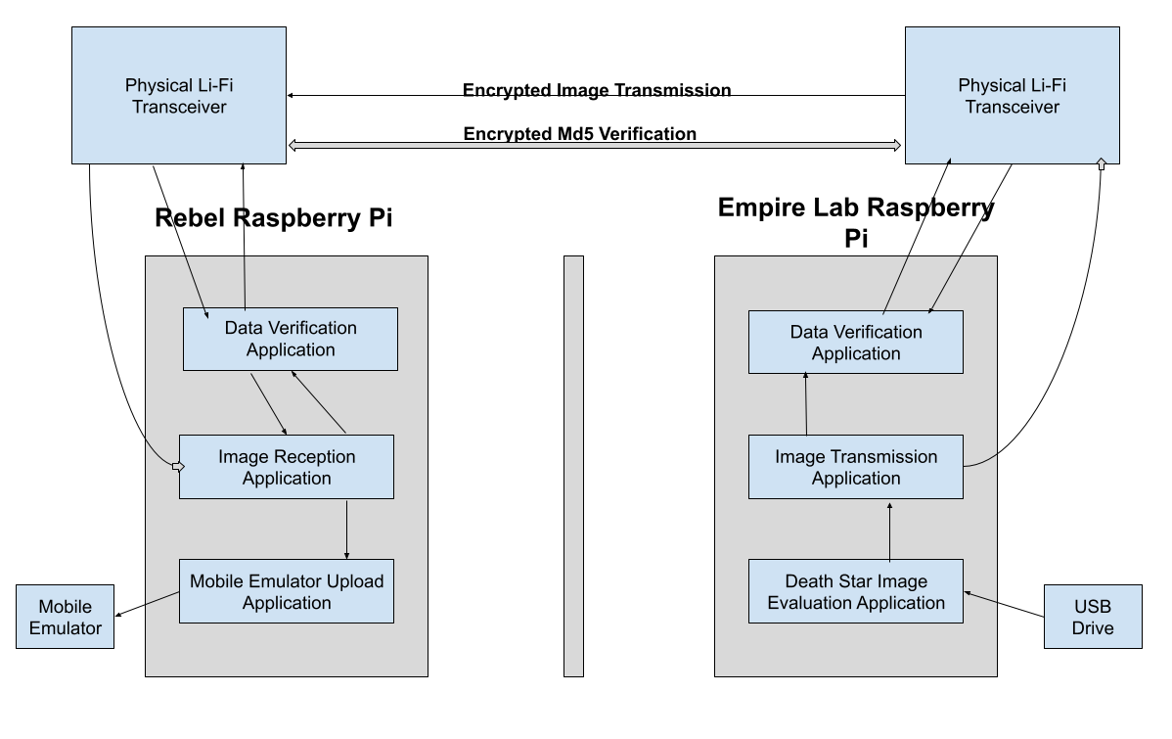

* Death Star images are uploaded to the Death Star image evaluation application of the Empire Lab Raspberry Pi.
* Once the 10 Death Star images are found, they are sent to the image transmission application.
* The image transmission application converts images into binary bits and sends them to the Li-Fi transceiver.
* The Li-Fi transceivers send and receive the image data and md5 sums in bidirectional communication.
* The Rebel Li-fi transceiver transfers the image data to the Image Reception Application.
* The Images are reconverted to PNG files and sent to the Data Verification Application.
* The Data Verification Application will hash each image using md5 sum and transfer each hash to the Rebel Li-Fi transceiver.
* The Imperial Li-Fi transceiver will transfer the md5 sum data to the Imperial Data Verification Application.
* The Imperial Data Verification Application will compare the transmitted md5 sum hash with the original image data hash and transmit it back if verified correctly.
* The Rebel Data Verification Application will pass the final verification of all image md5 sum data to the Image Reception Application.
* The Image Reception Application, upon receiving final verification, will transfer the images to the Mobile Application Emulator.

1. Image Encryption and Data Verification System

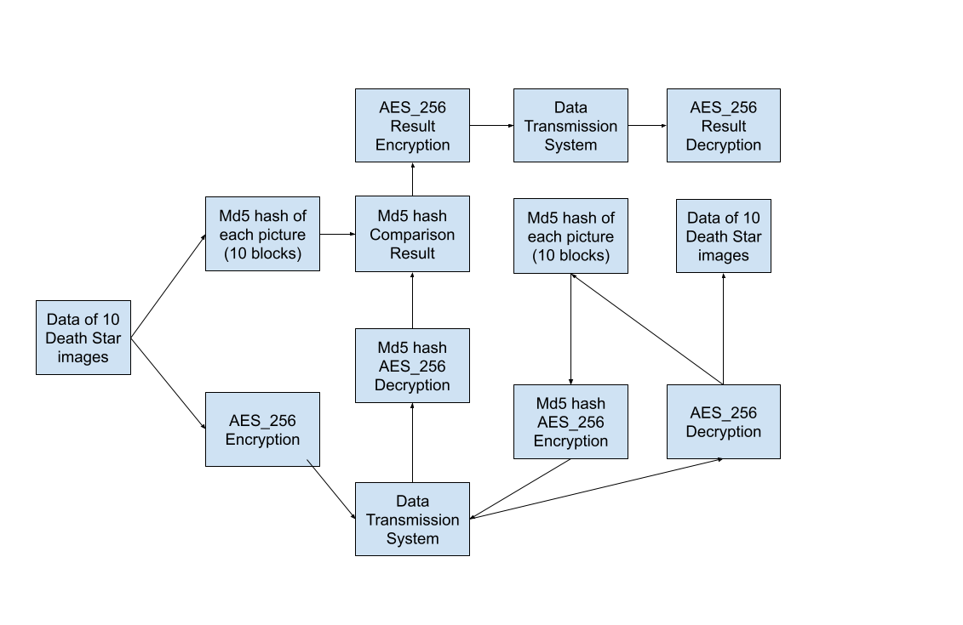

* The Md5 hash of each Death Star image is taken and stored for later comparison
* All data that is transmitted is first encrypted using AES_256
* All encrypted image data is decrypted before any actions are performed on the images
* Hashes of the images must be retaken after decryption to verify lossless transmission
* Post-decryption hashes will be encrypted and transmitted back to the source
* Encrypted post-decryption hash data will be decrypted and compared to the original hashes of the images

1. Mobile Application to Server System

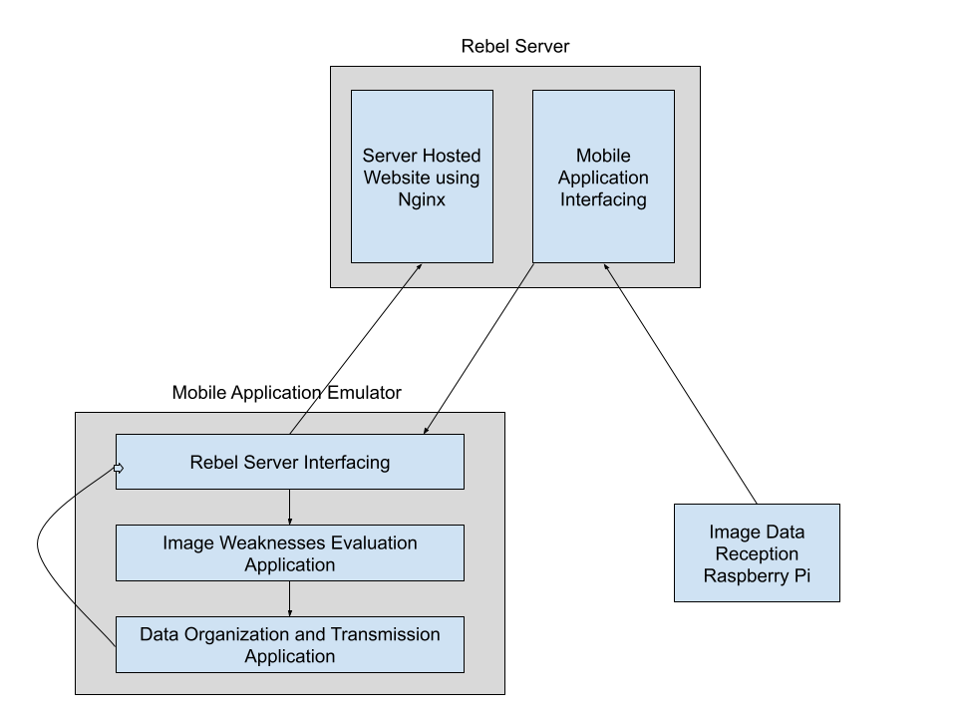

* The Rebel server receives the image data transmitted from the Imperial Lab.
* The Rebel server transmits the image data to the Mobile Application Emulator.
* Image data is evaluated for possible Death Star weaknesses and said weaknesses are recorded.
* Recorded weakness data is organized into a spreadsheet within the mobile application
* Data is prepared to be sent back to the Rebel Server.
* The Rebel Server takes the weak point data and hosts the data locally on a website.