| **Group** 13 | *Spring 2024 Design Challenge* |
| --- | --- |
| **Major:** | **Team members:** |
| *ITC* | *David Kajuna* |
| *CEG* | *Joshua Andrews* |
| *CS* | *Jason Bynum* |
| *ITC*  *CS* | *John Armlovich*  *Kennedy Eziolise* |

**System Architecture**

Hardware Architecture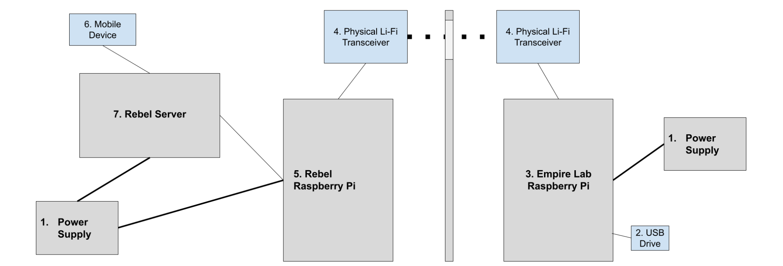

Hardware functional block definitions

1. Power Supply- An electrical device that will supply power to Rebel Raspberry Pi and Rebel Server.
2. USB Drive- Supplied USB drive with the 100 images stored on it.
3. Empire Lab Raspberry Pi- Raspberry Pi within the Lab with the attached USB that contains the images.
4. Physical Li-Fi Transceiver- The wireless data transmission system. Transmits image data between the Lab and the Rebel Raspberry Pi.
5. Rebel Raspberry Pi- Raspberry Pi within the Lab that will receive the transferred images.
6. Mobile Device- An Android device that sorts and displays the Death Star images.
7. Rebel Server- Host server where a webpage to display the 10 Death Star images will be hosted.

Software Architecture

Software Functional Block Definitions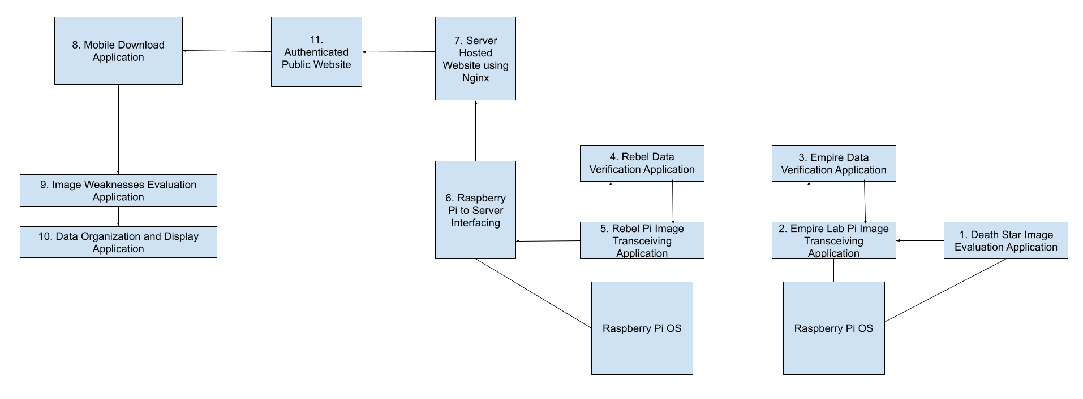

1. Death Star Image Evaluation application - Evaluates which of the 100 images are the 10 Death Star images.
2. Empire Lab Pi Image Transceiving application - Converts the images from PNG to binary in preparation for transmission and transmits and receives image data.
3. Empire Data Verification Application - An application used to encrypt, decrypt, hash each image, and verify the hashes of transmitted or received data.
4. Rebel Data Verification Application - An application used to encrypt, decrypt, hash each image, and verify the hashes of transmitted or received data.
5. Rebel Pi Image Transceiving application - Converts the images and hashes from PNG to binary in preparation for transmission and transmits and receives image data.
6. Raspberry Pi to Server Interfacing - Sends packaged image data to the Rebel Server using a wired connection.
7. Server Hosted Website using Nginx - Locally hosted website that will use Nginx to take image data, and allow for the user to download the uploaded images.
8. Mobile Download application - Application that will be used to package and download images to the mobile application.
9. Image Weakness Evaluation Application - An application that will sort through the 10 downloaded images to determine weaknesses in the Death Star.
10. Data Organization and Display Application - An application that will sort the image weaknesses into a scrollable table and then display them on the mobile device.
11. Authenticated Public Website - Website hosted by Rebel Server that allows for all users to view a Youtube video. Only authenticated users with the correct ssh keypair can download images and view secondary Youtube video.