| **Group** 13 | *Spring 2024 Design Challenge* |
| --- | --- |
| **Major:** | **Team members:** |
| *ITC* | *David Kajuna* |
| *CEG* | *Joshua Andrews* |
| *CS* | *Jason Bynum* |
| *ITC*  *CS* | *John Armlovich*  *Kennedy Eziolise* |

**Implementation Plan**

**Interface Control**

**Hardware:**

**Empire Raspberry Pi - USB Drive;** The USB drive will interface with the Raspberry Pi over the USB 3.0 port on board

**Empire Raspberry Pi / Rebel Raspberry Pi - Power Supply;** Both Raspberry Pi’s will interface with a 5V power supply from a wall outlet to USB-C module.

**Empire Raspberry Pi / Rebel Raspberry Pi - LiFi System;** The LiFi System will interface with the Raspberry Pi using the on board GPIO pins directly pinned out to the LiFi System I/O.

**Rebel Raspberry Pi - Rebel Server;** The Rebel Raspberry Pi will interface with the Rebel Server using a male to male USB-A cable

**Software:**

**Death Star Image Evaluation Application - Empire Lab Image Tranceiving Application;** The Death Star images will be transferred to the Image Transmission Application by storing .png files in the OS file system.

**Empire / Rebel Image Tranceiving Application - Data Verification Application;** The Death Star image data will be transferred to the Data Verification Application by storing .png files in the OS file system.

**Data Verification Application - Empire / Rebel Image Tranceiving Application;** The Death Star image data will be transferred to the Image Transmission Application by storing .png files in the OS file system. Calculated hash data will be transmitted as binary value back to the Rebel Image Transmission Application after calculation.

**Rebel Pi Image Tranceiving Application - Rebel Server Interfacing;** The Death Star image data will be transferred to the Rebel Server Interfacing Application by storing .png data in the OS file system.

**Rebel Server Interfacing - Rebel Server Host using Nginx;** The Death Star image data will be transferred to the Rebel Server Host by sending stored .png files in the OS file system over USB-A using a shell script that keeps the file format.

**Rebel Server Host using Nginx - Authenticated Public Website;** The Death Star image data will be transferred from the Rebel Server Host to the Authenticated Website by opening stored .png files from the local host. All website active data will be transferred to and from the server using the ssh data protocol.

**Authenticated Public Website - Mobile Download Application;** The Death Star image data will be transferred from the Authenticated Website to the Mobile Download Application using https data format. Any YouTube url data will be sent over https as well. Mobile Download Application will send login and authentication data over ssh using a pre-generated keypair.

**Mobile Download Application - Image Weakness Evaluation Application;** The Death Star image data will be transferred from the Mobile Download Application to the Image Weakness Evaluation Application accessing created .png files in the OS file system of the evaluated weaknesses.

**Image Weakness Evaluation Application - Data Organization and Display Application;** The Death Star image data will be transferred from the Image Weakness Evaluation Application to the Data Organization and Display Application by accessing stored .png data in the OS file system of evaluated weaknesses.

**Budget**

| **Hardware component** | **Approved Vendor** | **Price in USD** | **Total Price in USD** |
| --- | --- | --- | --- |
| Raspberry Pi 4 4GB RAM | Adafruit | 55.00 | 55.00 |
| 5V 0.3W Mini Solar Panel (x3) | Adafruit | 5.95 | 17.85 |
| Laser Diode - 5mW 650nm Red (x4) | Adafruit | 5.95 | 23.80 |
| Miniature 5V Cooling Fan (x3) | Adafruit | 2.95 | 8.85 |
| NPN Bipolar Transistors (PN2222) - 10 pack | Adafruit | 1.95 | 1.95 |
| Official Raspberry Pi Power Supply 5.1V 3A (x2) | Adafruit | 7.95 | 15.90 |
| USB WiFi (802.11b/g/n) Module | Adafruit | 13.95 | 13.95 |
| USB AM TO USB C, USB 2.0 - 150MM (x2) | Digikey | 1.29 | 2.58 |
| CBL USB2.0 A PLUG TO A PLG 6.56' (x2) | Digikey | 3.18 | 6.36 |
| bbasi 3Pcs LM393 3.5-24V Voltage Comparator Module with LED Indicator High Level Output Analog Comparator Control | Amazon | 7.08 | 7.08 |
| JUMPER KIT VARIOUS 26AWG 65PCS | Digikey | 6.10 | 6.10 |
| BREADBOARD TERM STRIP 3.20X2.08" (x2) | Digikey | 4.80 | 9.80 |
| 64GB 3D MICROSD CARD (-25C - +85 | Digikey | 11.87 | 11.87 |
| Alternate source: Micro SD Card 64 GB High-Speed Memory Card Waterproof Micro SD | Amazon | 7.93 | 7.93 |
|  |  |  |  |
| **Total components:** |  | **Subtotal:** 188.82 | **Subtotal + Shipping:** 198.82 |

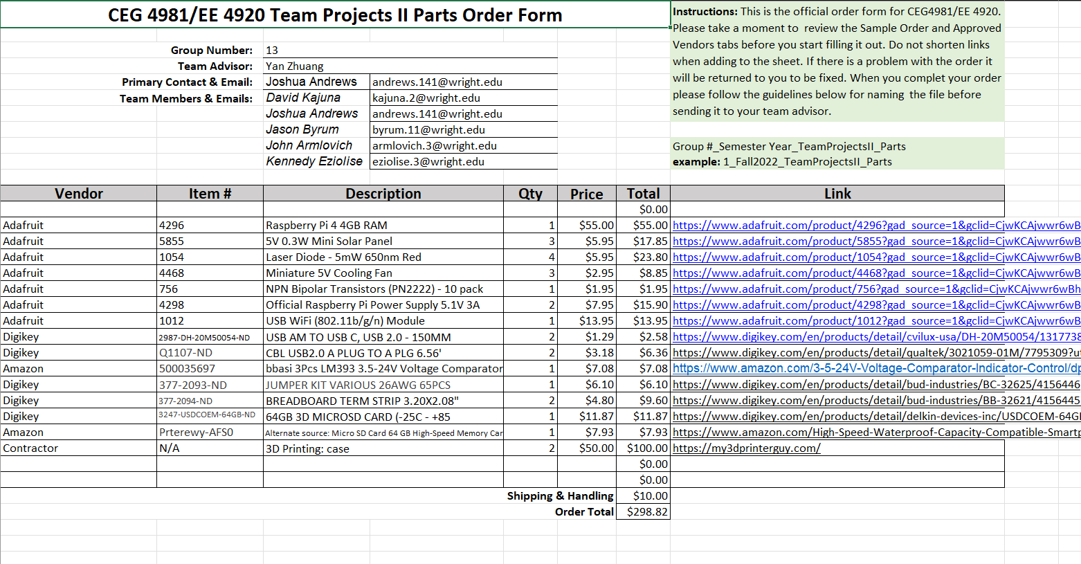

**Schedule**

**Josh - Li-Fi/Programing**

* Verify that all parts needed for successful project completion are present.
* Interface WiringPi library to GPIO pins of Empire Raspberry Pi
* Verify Empire Raspberry Pi GPIO pins can send and receive data from expected I/O signals
* Verify Image identification program can identify a single Death Star image form a set of 10 .png images on the Empire Pi
* Verify 10 Death Star .png images can be stored separately from the sample 100
* Verify 10 images totalling 30 MB can be transmitted under 10 minutes
* Verify transceiving application can send formatted .png data over Pi GPIO pins
* Demonstrate that our created weakness identification program can install and compile on the Android device.

**Kennedy - public site / server work**

* Demonstrate that the Empire Raspberry Pi can successfully download files from the USB.
* Demonstrate that the Rebel Server can successfully host a test website using Nginx.
* Implement any necessary Javascript or PHP interfacing to download a single image.
* Implement Javascript or PHP to update website based on type of user
* Create our custom website with a html file and css file.
* Demonstrate that the website requires a RSA key for identity verification.
* Demonstrate that the website can show the required video.
* Demonstrate an authenticated user can download all necessary images and view both YouTube videos

**John - Li-Fi Implementation**

* Demonstrate a successful Li-Fi transmission using a single image one direction.
* Setup all of the hardware needed to connect the PI’s and their transceiving, and ensure the system can boot up.
* Verify lossless transmission of data over 3MB
* Demonstrate a successful Li-Fi transmission using a single image in both directions.
* Demonstrate a successful Li-Fi transmission in both directions from at least 5 meters apart.
* Demonstrate that the transceiving system is powered by 10V or less using voltage readings.
* Demonstrate that both PI’s can be powered using 5V or less to power their transceiving system using voltage readings.
* Demonstrate full image transmission and hash reception for a single image

**Jason - Encryption/Mobile Device**

* Demonstrate a successful AES encryption done to a single image.
* Demonstrate that when given a password a successful encryption will occur.
* Demonstrate successful AES encryptions done to 100 images chosen by the group.
* Demonstrate execution of application containing a scrollable table of sample .png images
* Verify .png images can be pulled from Android filesystem
* Verify c++ programs can be compiled on Android device with necessary libraries
* Stretch - get OpenCV to compile on Android

**David - Encryption/Mobile Device**

* Demonstrate a successful md5sdum hash comparison between a transferred image and its original md5sum hash.
* Gather the given Death Star sample images and other images for a combined 100 sample images.
* Demonstrate that the Mobile application can display 100 images via a scrollable table.
* Demonstrate the mobile application containing one single image can be displayed on the mobile device.
* Demonstrate that our weakness identification program can identify a red circle on a sample image.
* Demonstrate that our weakness identification program can identify 10 red circles out of 100 given sample images.

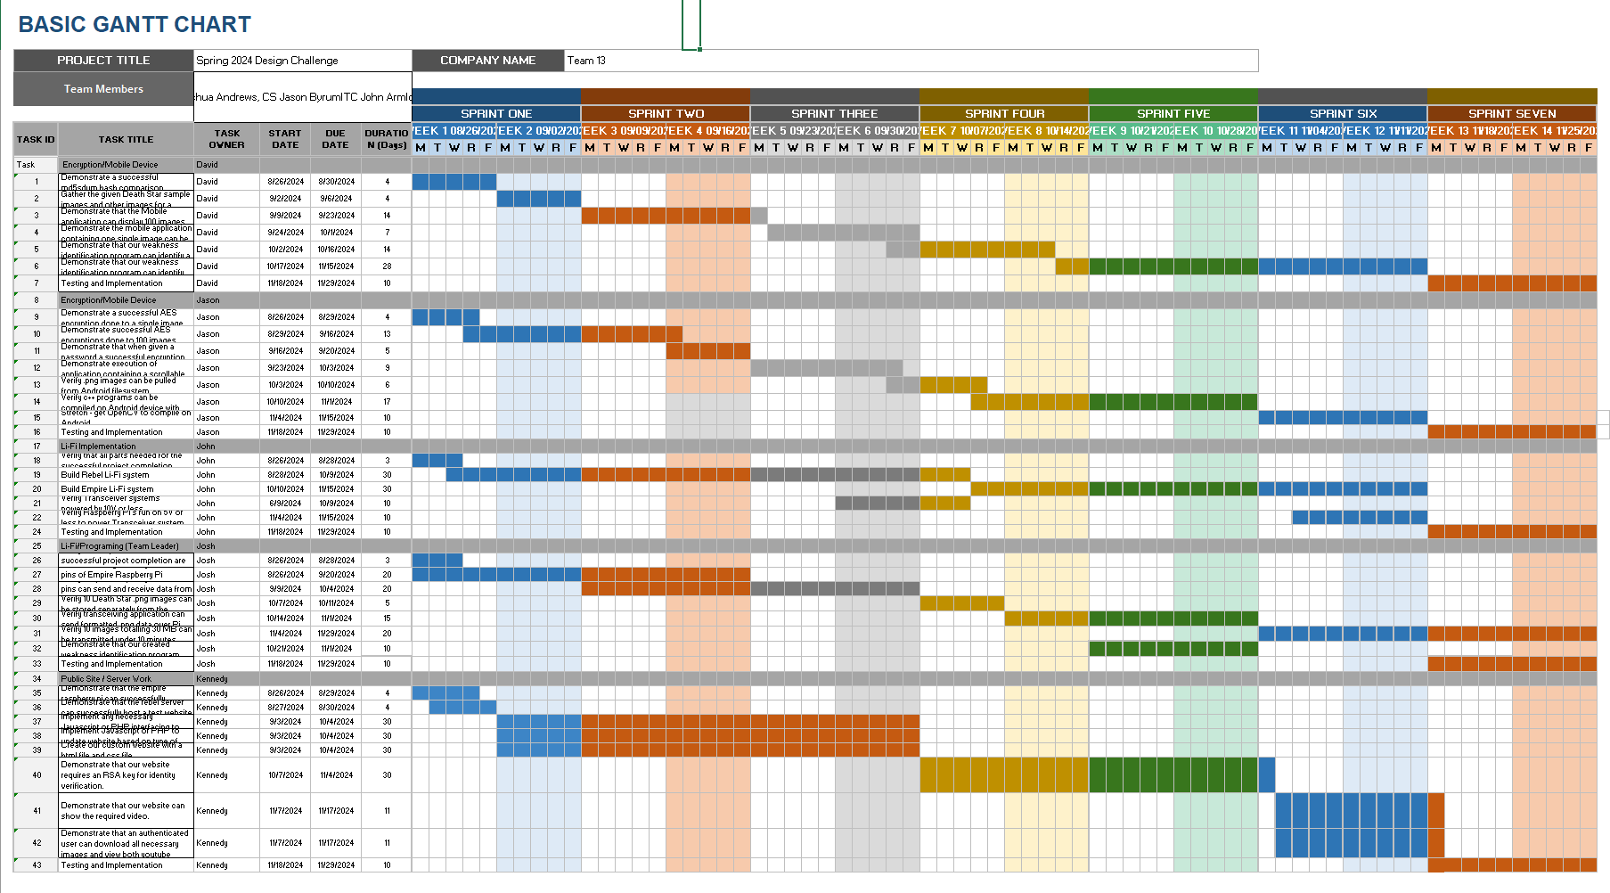

**Risk Analysis**

**Risk:** ETA for project parts is later than the time parts are needed or parts do not arrive

**Mitigation**: Order project parts as soon as possible to give time for parts to arrive before the time needed. Plan to order parts before summer break begins.

**Risk:** Parts are lost or broken during delivery

**Mitigation:** Each specialty part that we order will have at least one backup while staying under budget.This is reflected in our Parts Order List.

**Risk:** Lasers from Li-Fi systems could cause eye damage to the users.

**Mitigation**: Prevent from looking into lasers when the system is in use. Lasers are class II which specify that eye damage can only be caused if a user looks directly into the line of sight. This will never take place during implementation.

**Risk:** Electrocution when assembling parts.

**Mitigation**: Do not plug in the Raspberry Pi to the outlet until all components are properly connected. Do not use 5V Raspberry Pi GPIO pins until the Li-fi System is ready to be utilized.

**Risk:** Ordered parts are not functional and not operable.

**Mitigation:** Make sure parts are functional once they are delivered. This will be the first task performed by the group so that any parts that need reordered are ordered as soon as possible. Resource allocation will be adjusted to focus on software development if parts are not operational past what is scheduled.

**Risk:** Physical injury from tripping over wired connections.

**Mitigation:** Exterior system wired connections will either hang from the ceiling or be taped to the floor.

**Risk:** Team member gets sick for an extended period of time.

**Mitigation:** Schedule will be completed in a way that allows for tasks to be assigned differently between sprints. All members of the team will understand the baseline specifications for all aspects of the system so they are prepared if tasking must change.