Elaborating pipelines for image analysis in the context of cellular biology

A day to day experiment for a molecular biologist is to image cells in a specific medium, and to measure the response of the cell. Often, this response is quantified using image analysis.
In this white paper, I will detail the main steps involved in creating a pipeline for image analysis and quantification of rna expression in cells. The main steps and ideas should very valid accross a series of cell structures and biological questions.

We can measure fluorescence the levels of rna expression using FISH (fluorescence in situ hybridisation). Briefly, oligos are designed to bind specifically to gene sequences, and these oligos are linked though other complementary molecules, to fluorophores, small fluorescent molecules that absorb light at a a given wavelength and emit back light at a higher wavelength. In one of our collaborations, our collaborators targeted HOX genes which are genes involved in patterning the body plan of animals during embryonic development. Through image analysis, we could quantify the expression of two of them (HOXC8 and HOXA10) when stimulated with different grownth differentiation factors, and try to get biological insights about the temporal course of expression of these hox genes, in presence of three different factors (GDF-FDF, GDF and NT).
In the following I will detail how I built an analysis pipeline, focusing on the architecture of the folders, on the data format

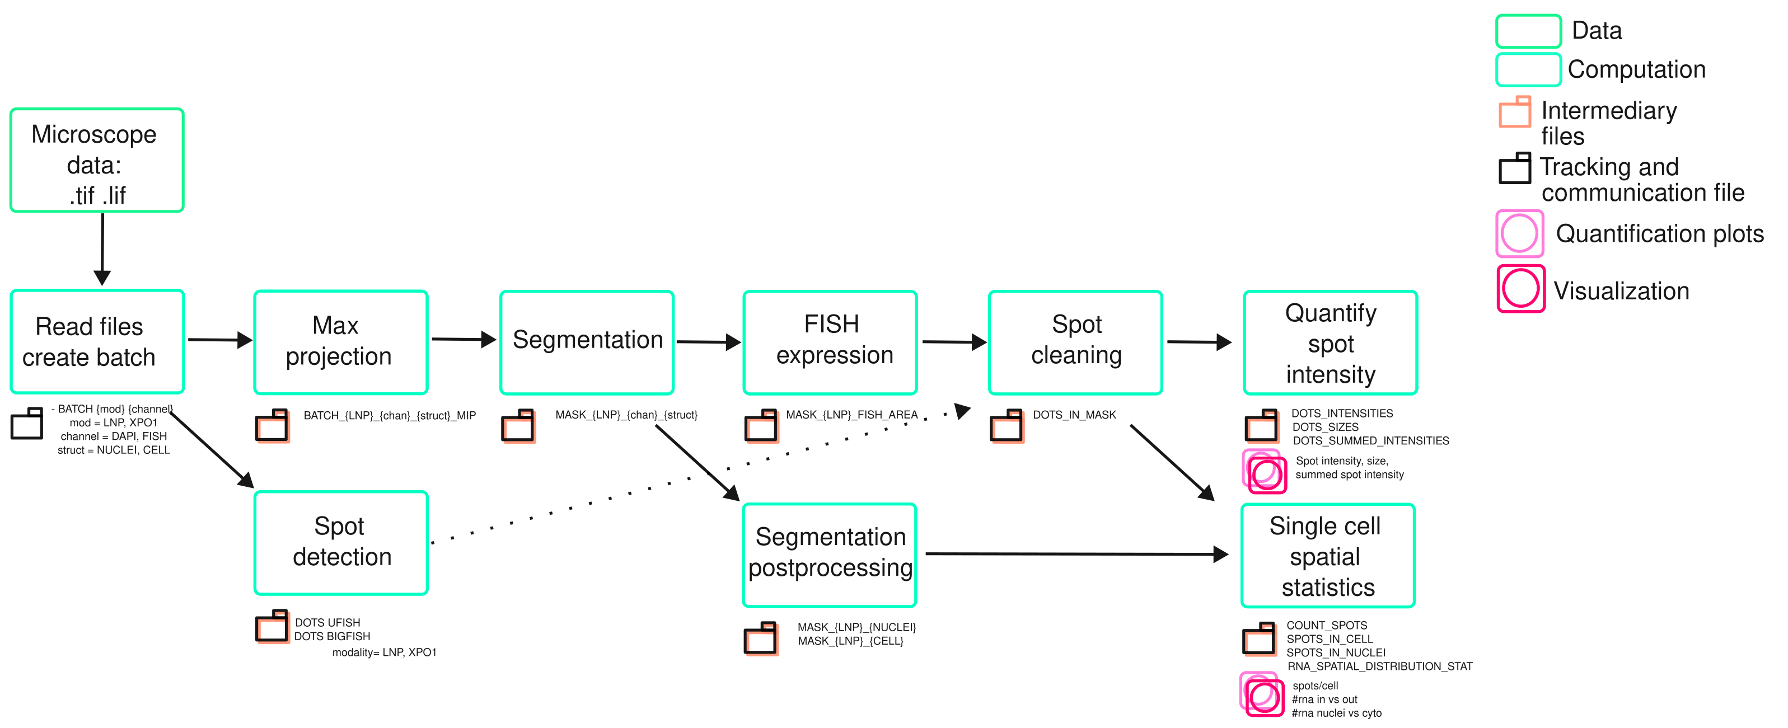
Plan
1 Pipeline overview
2
3 File format
4 Folder format

Segmentation and postsegmentation
In this study there are two structures of interest : the nuclei and the cell membrane. The cells used were densely packed nuclei, from organoids, in which the cytoplasm was invidible. I then trained Cellpose on the nuclei, and in order to account for the rnas which are close to the nucleus, I did a small dilation of the cellpose masks (using watershed algorithm) and then deduced the cell masks. Those cellmasks are stored in the corresponding folder (see folder structure).

Sometimes cellpose models, even well trained ones do not detect a cell for instance, but detect the nuclei (in fact there is a different model for detecting and segmenting nuclei and cell membrane). In this case, we apply a postprocessing consisting in removing cell segmentations in which there is no nuclei segmentation inside of the cell or the converse. In the case of this particular pipeline, this never happens, since out of the detected nuclei, we deduce a mask for the cellbody segmentation, and this mask has the same label number as the nuclei, but in many cases this has to be sorted. Another common problem is that nuclei have to be inside the cells. In the case in which the segmentation mask of the nuclei overfills the segmentation mask of the cell. In this case, the cell mask is updated taking the union of the two masks.

3 Intermediary file formats and data manipulation

Results were stocked following standarized fish omics formats. https://fish-omics-format.readthedocs.io/en/latest/intro.html.

This format is specially interesting since it

For each field of view or imaging session, we create a separate .csv file. In here I show a file with all the spots found. Spots are detected with their coordinates (2D or 3D). Therefore, after spot detection, an unique spot identifier is assigned to each spot (RNA_Spot_ID), together with its coordinates. This is fundamental for tracability and quality control along the pipeline. Further measures can add new columns, (for instance, measuing the intensity). For some spots we do not measure some properties, but it is due to the spot cleaning procedure.

In order to be able to load and save the data in an easy way, I stored together with the .csv files a numpy file (.npy) containing a dictionary, with the addresses of all the csv files, in such a way that, though appropriate functions, I could charge in one line a dictionary with as keys the file names and as values, dataframes with all the information needed.

Example of header for spot format :

RNA_Spot_ID | Y | X | in_mask | intensity | spot_width | sum_intensity | snr | background | in_cell | cell_mask_num | in_nuclei | in_cyto
1 | 186 | 1271 | True | 595.0 | 8.6 | 185 | 32 | 126 | 1.0 | 1.0 | 1.0 | 0.0
2 | 206 | 1275 | True | 499.0 | 7.7 | 190 | 24 | 125 | 1.0 | 1.0 | 1.0 | 0.0
3 | 234 | 1337 | False |  |  |  |  |  | 1.0 | 1.0 | 1.0 | 0.0
4 | 240 | 1252 | True | 1113.0 | 7.9 | 285 | 57 | 130 | 1.0 | 1.0 | 1.0 | 0.0

…

in_cell | cell_mask_num | in_nuclei | in_cyto
1.0 | 3.0 | 0.0 | 1.0
1.0 | 7.0 | 1.0 | 0.0
1.0 | 8.0 | 1.0 | 0.0
1.0 | 8.0 | 0.0 | 1.0

Example of header for single cell statistics

Cell_ID | counts | count_nuclei | count_cyto | pol_ind | disp_ind | per_dist_ind
1 | 5.0 | 3 | 2.0 | 0.52 | 0.76 | 1.00
2 | 13.0 | 4 | 9.0 | 0.31 | 1.12 | 1.12
3 | 5.0 | 1 | 4.0 | 0.92 | 0.24 | 0.57

For cellmasks, we stored them in .png files.

5 Parameters tracking and communication between notebooks

In Code, I put the jupyter notebooks. Jupyter notebooks have to be run in a certain order, the order proposed in the pipeline overview. Also, in order to communicate between notebooks and to track all the important variables I save in a .json file all the variables that are necessary to reproduce the figures, and to communicate between notebooks.

The way I found this to do this is to name important variables in uppercase and then, at the end of the notebook look and store in the .json file all the variables that are written in uppercase with their respective values.

6 Code modularity

Notebooks like ‘Max projection’ may have to be run twice, one for the cell and one for the nucleus. This is due to the fact that in some experiments we use the DAPI channel to do the max projection that will be used to segment the nuclei. However, in order to segment the cell, it depends on the experiment. In some experiments, we use the fish channel (with the spots) to detect the cell membrane, which gives imperfect results, but it is the best we can do. Finally, in some experiments,
we add to the DAPI, a cell mask that allows to stain the cytoplasm, and then to use only one channel for the nuclei and cell membrane detection.

The way we achieve code modularity is by defining constants at the beginning and through the pipeline, loading them, and storing them in the .json file. This also implies to creating different
folders to store the intermediary files.

The way to create for instance a new variable in uppercase with the right name is done using « dynamic programming ». For instance, in the first notebook, Read_files_create_batch, I created a simple widget to enter the list of genes observed, for instance HOXC8 and HOXA10. These names are stored in the .json. When we load the .json file in another notebook as a dictionary that I call constants, the key CHANNELS contains two values : HOXC8 and HOXA10.

A user can then choose manually, through a Dropdown widget, the variable chan_f that will contain the value HOXC8 for instance.

In order to load the max projection of the corresponding 3D image with the gene HOXC8, I call the variable :

batch_fish_mip = constants[f'BATCH_{modality}_{chan_f}_{struc_cell}_MIP']

modality, chan_f and struc_cell variables were previously loaded.

4 Folder Structure

The project starts with two folders placed side to side : HOX pipeline and src. The src folder contains the main functions called in the pipeline. HOX pipeline contains three folders Acquisition, Analysis and Code. Code contains the jupyter notebooks that constitute the pipeline. In the folder Acquisition one can put the raw files, in the folder Analysis, we will put all the results (figures and intermediary files).

The arborescence of folders in Analysis is built as the execution of the pipeline progresses. We define, in the first notebook a batchname as a collection of experiments. This batchname can for example be subdivided in what I call modalities, which are experiments conditions, for instance Experiment and Control. Each condition can be defined as a subset of experiments over which all the pipeline will run. Then, for each modality, I create a folder per channel : the DAPI, the HOXA10 and HOXC8. DAPI corresponds to the fluorescence coming from the nucleus (DAPI is a fluorescent molecule that binds to A and T nucleotides from the DNA). HOXA10 and HOXC8 corresponds to the channels that sense the fluorescence coming from that particular genes.

In the DAPI folder there are three folders NUCLEI, CELL and FISH_AREA. In nuclei, when the images are 2D, we directly copy them into the folder NUCLEI/train_2D. When images are 3D, we do a maxprojection of the original stack of images (in fact we do a subselection of the z’s at which the focus is better, and then we do a maxprojection). With these 2D images, we train a model in Cellpose. Cellpose stores the segmentation masks together with the images and creates a folder called models in which he stores the models.
In this pipeline in particular, as we can’t segment the cellbodies, we create artificially a mask dilating the cellpose masks, and store them in DAPI/CELL/masks. Nonetheless, for other cell types, in which we use cellmask for instance in the DAPI channel or just using a FISH channel, it is possible to segment the cellbody. That is why it is important to create a separate folder for each structure (cell and nuclei). For instance in the case in which we use cell mask, we copy the same 2D projected images of the DAPI channel into DAPI/CELL/train_2D and DAPI/NUCLEI/train_2D.
In this way, the masks generated by cellpose won’t erase themselves, and the models will be unambiguously identified.

This example aims at highlighting the complexity of creating a good folder structure that can adapt to every condition.

There is another example of the same kind in our pipeline, when detecting spots, we might choose between two methods called BIGFISH and UFISH. For each gene therefore we have to create a folder BIGFISH and a folder UFISH in which we will store the results. Now, when doing the single cell statistics, we don’t have to forget that there are two methods to detect spots on which the statistics rely. Therefore, we have to create folders stats/{method}/{gene}, where method = BIGFISH and UFISH and gene = HOXA10 and HOXC8.

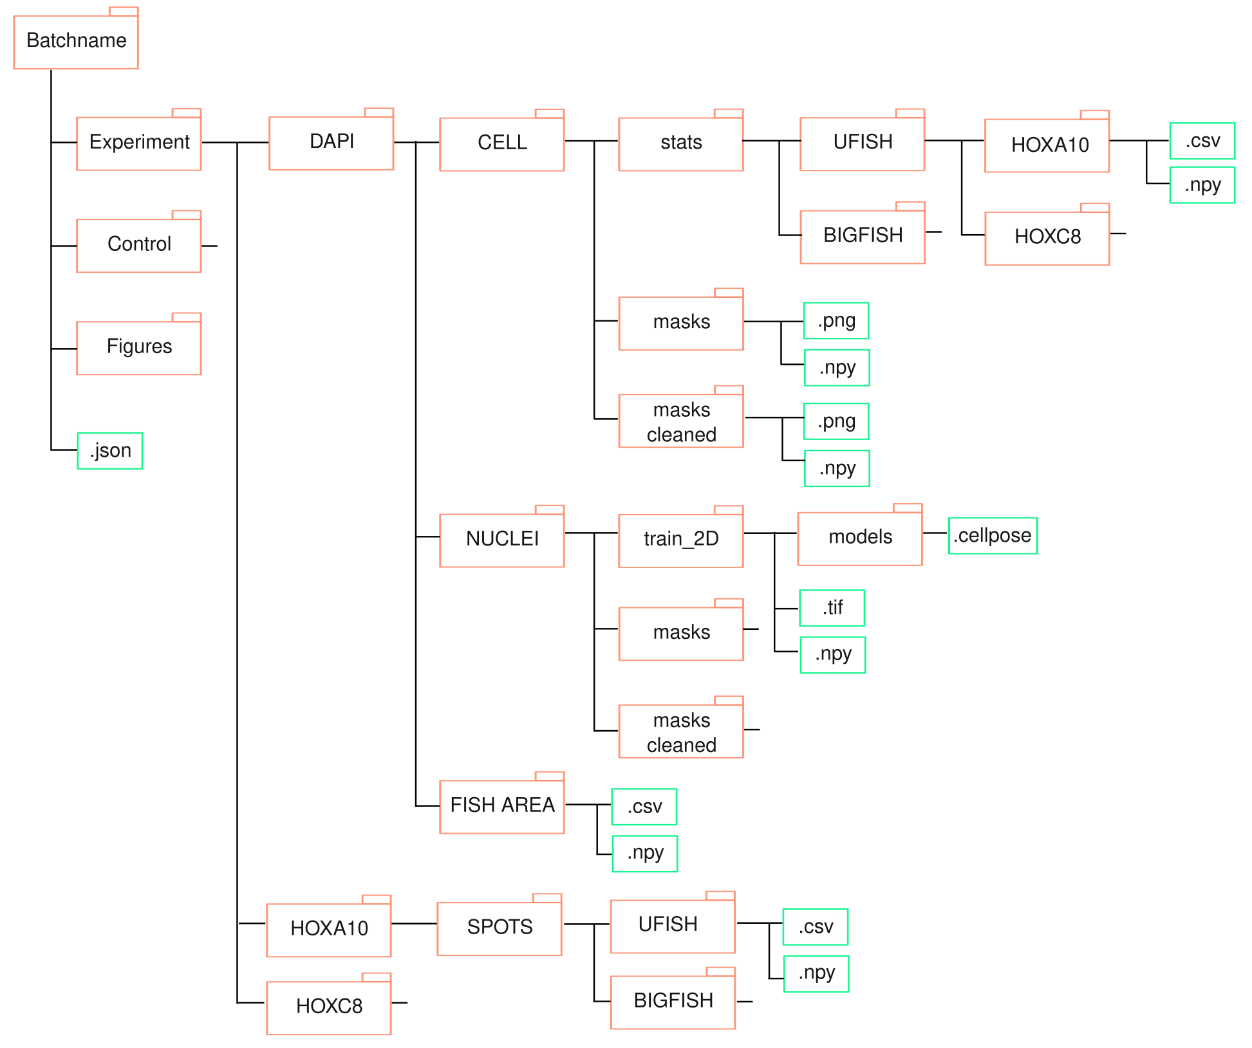

Quality control

As much as possible, in each processing step, we must be able to visualize the result of the processing on the raw data. To this effect, I use napari viewers, that allow to overlay images, labels (masks) and points (spots). Therefore when considering the .csv of a given gene in a given condition, we can pick a given point and to check if it corresponds to a real spot on the raw image, if it is in the mask in the vicinity of cells, on which we accept spots, and if the algorithm classified it as a spot to exclude for further analysis (example RNA_Spot_ID = 3) in the above table.

