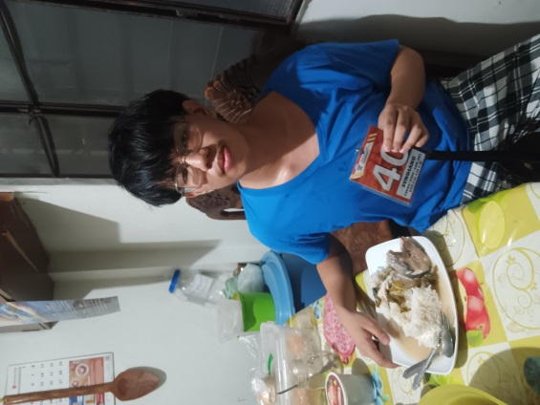

Day 1

(July 12, 2024)

Healthy Eating Principal

Eating whole grains and fish.

Day 2

(July 13, 2024)

Healthy Eating Principal

Meal is focused on getting enough protein.

Day 3

(July 14, 2024)

Healthy Eating Principal

Avoid processed food

Day 4

(July 15, 2024)

Healthy Eating Principal

Cut back on added sugars

Day 5

(July 16, 2024)

Healthy Eating Principal

Prioritizing healthy fats, and fat soluble vitamins

Name: Sundiang Rinan Geo M Section: Cpe-201