1. A machine has an initial cost of P50,000.00 and a salvage value of P10,000.00 after 10 years. What is the book value after five years using straight-line method depreciation?

2. A broadcasting corporation purchased equipment for P53,000 and paid P1,500 for freight and delivery charges to the job site. The equipment has a normal life of 10 years with a trade-in value of P5,000 against the purchase of a new equipment at the end of the life. Determine the annual depreciation cost and assume interest at 6.5% compounded annually.

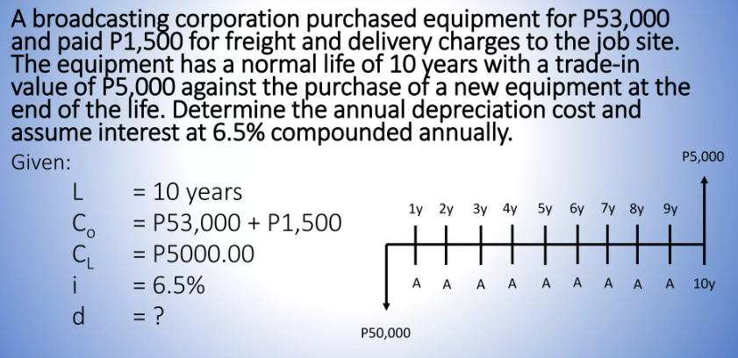

<https://www.slideshare.net/slideshow/engineering-economics-231210400/231210400#25>

3. The equipment bought at a price of Php 450,000 has an economic life of 5 years and a salvage value of Php 50, 000. The cost of money is 12% per year. Compute the first-year depreciation using Declining Balance Method.

4. An equipment costs Php 1,500,000. At the end of its economic life of five years, its salvage value is Php 500,000. Using Sum of the Years Digit Method of Depreciation, what will be its book value for the third year?

5. Cost of machine = P1,400,000

Useful life = 8 years

Salvage Value = P10,000

Determine the 4th year depreciation using double declining balance method

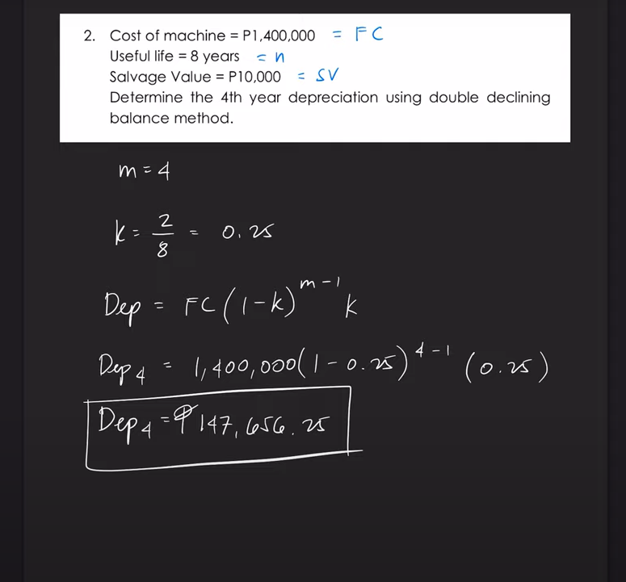

Others

A construction equipment costs P180,000. It has a salvage value of P15, 000 at the end of its life of 12 years. Find the 5th year depreciation using a constant percentage of the declining balance method.

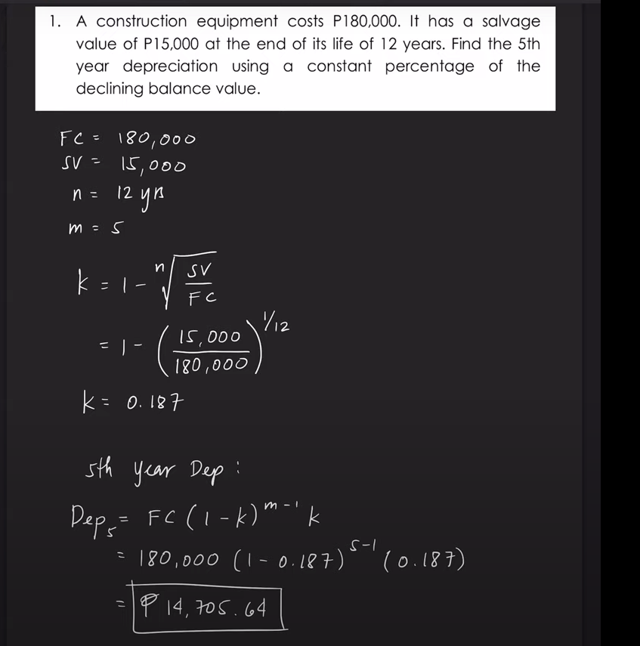

An old machine was purchased 3 years ago at a cost of P50,000. It was estimated to have a useful life of 8 years, with a salvage value of P5,000. It is now going to be replaced by a new machine costing P70,000 and a trade-in of P30,000 will be allowed for the old machine. Determine the sunk cost if depreciation has been computed by the (a) straight line method, (b) sinking fund method at 16%, and (c) SYD method.

<https://www.youtube.com/watch?v=H7dmDiGw-5w&list=PLnSQKeGTilrHftT-AljQPJUkt6ZkWsn0i&index=22>

<https://www.youtube.com/watch?v=B5zGIrz0mdY&list=PLnSQKeGTilrHftT-AljQPJUkt6ZkWsn0i&index=23>