Dashboard Design Practices

The first step to building any dashboard is to clearly define what you’re trying to achieve. What‘s the purpose of your dashboard? Who’s it for? What do you want them to do differently because of it?

##### Analytical Dashboards

Analytical dashboards are used to present key data sets to the user, always reflected against previous performance. They should be data-centric, and show as many relevant data views as is feasible.

Analytical dashboards should lead with key account data front and center, and should minimize graphical elements. They serve as a barometer of the user’s status in your application, and make it easier for a user to spot problems.

##### Strategic Dashboards

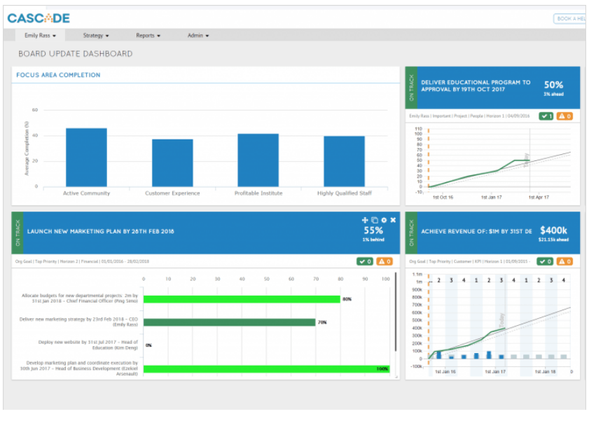

Strategic dashboards are used to indicate performance against a set of key performance indicators (KPIs). As seen in this great example from [Cascade](https://www.executestrategy.net/), a strategic dashboard should reflect how your user is performing against their strategic goals… and not much else.

##### Dashboard Designing

When putting any metric on your dashboard you should make sure they:

* Match the purpose of your board
* Can be influenced by your team
* Can be easily understood
* Change reasonably often (you don’t want to be staring at numbers that never change)
* Don’t vary so much that you can’t easily detect trends

## Give your numbers context

To know if a number’s good or bad your viewers need context. Would they know, for instance, that 100 new leads today is out of the ordinary?

One of the easiest ways to do this is to include past data. You could include the same metric for the previous day, or even a line or column chart showing how the metric tracks over a longer period of time. Another technique is to include the average or previous highs and lows.

If you’re working towards a goal, include the target as well as your current progress.

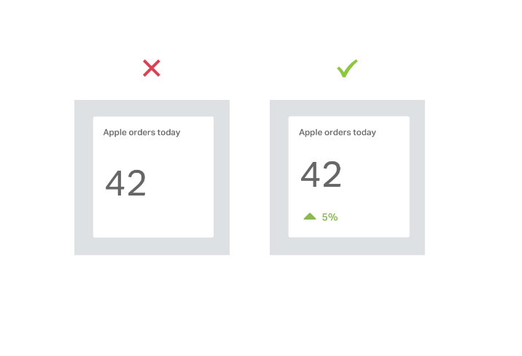You can also add warnings for when a metric is above or below a certain threshold to make it easier to spot problems.

## Use clear labels your audience will understand

A key part of your dashboard are the labels that describe each metric or chart. They should be self explanatory, and unambiguous for your viewers At the same time, you should try and keep them as short as possible to avoid cluttering up your board and getting in the way of the data.

## Round your numbers

When displaying numbers, don’t include more precision than you need. Showing your conversion rate to 3 decimal places or your revenue to the nearest cent when you only care about much bigger changes just distracts from what’s important. Plus, including too much detail can make a mountain out of a molehill.

## Keep evolving your dashboards

Our final piece of advice is the most important. Once you’ve built your dashboard don’t just leave it. Ask you team for feedback.

* What do they look at most often or find most useful, and why?
* What do they never look at or find least useful, and why?
* Is there anything missing that they’d find useful?
* Has it changed anything about the way they work?