Graphs

**Development Efforts in each Category based on no of weeks spen**t

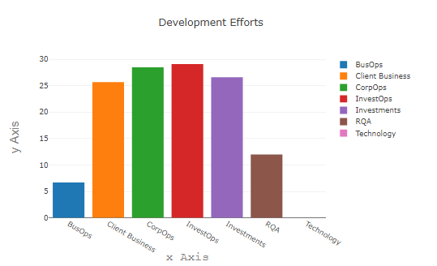

**Development Efforts Trends Velocity Graph**

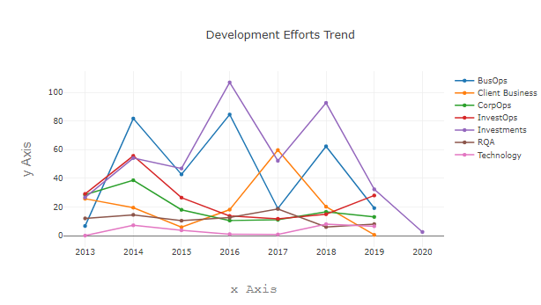

**Increase/Decrease of development effort cards** (compared to previous year 2016 in this case

**Project Status per Developer**

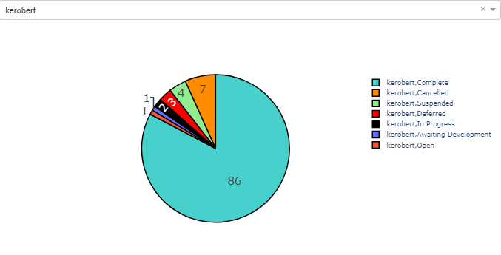

**Horizontal Scrolling Card Carousel for selected year** – shows all the tech used in that year along with no of projects and increase/decrease compared to last year

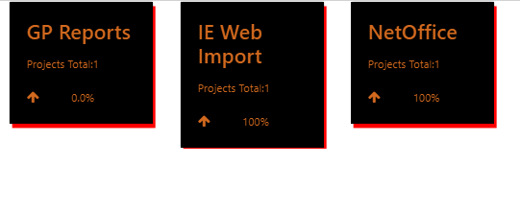

**Velocity Area Chart for no of project completed each year** – requires limiting the no of languages to declutter the graph

