DOCUMENTATION
JABULANI NDEBELE

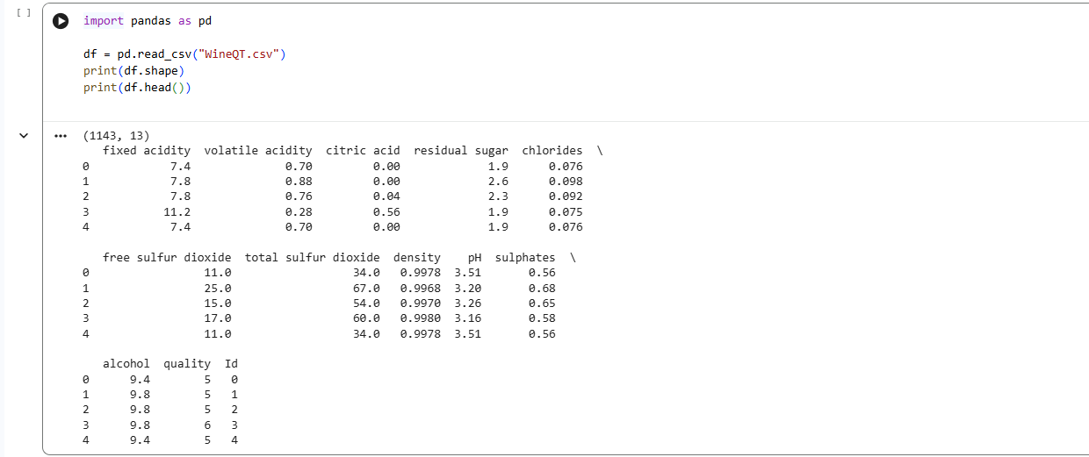

import pandas as pd

df = pd.read_csv("WineQT.csv")
print(df.shape)
print(df.head())
- import pandas as pd Loads the Pandas library, which is the standard tool in Python for handling tabular data.
- df = pd.read_csv("WineQT.csv") Reads the CSV file WineQT.csv into a DataFrame called df. A DataFrame is like a spreadsheet: rows = observations, columns = features.
- print(df.shape) Prints the shape of the dataset → (rows, columns). In your case: (1143, 13) → 1143 wine samples, 13 features.
- print(df.head()) Displays the first 5 rows of the dataset so you can preview the structure and values.
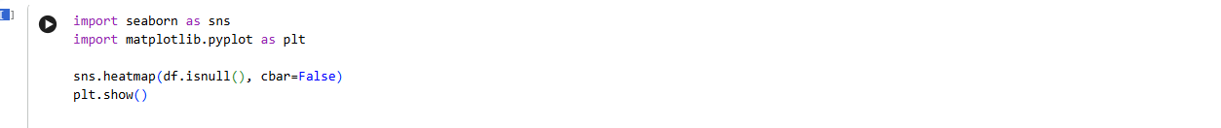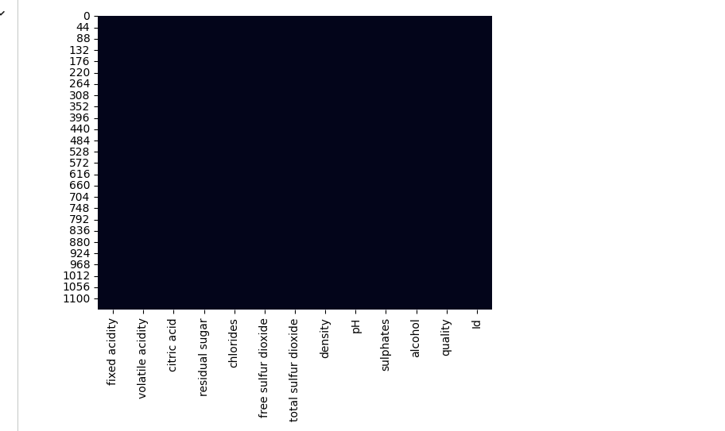

import seaborn as sns
import matplotlib.pyplot as plt

sns.heatmap(df.isnull(), cbar=False)
plt.show()

import seaborn as sns / import matplotlib.pyplot as plt Loads Seaborn and Matplotlib, two libraries for visualization.
df.isnull() Creates a boolean mask of the DataFrame df:
- True if a value is missing (NaN).
- False if the value is present.
sns.heatmap(df.isnull(), cbar=False) Plots a heatmap of missing values:
- Each cell in the DataFrame is represented visually.
- White/light squares = missing values.
- Dark squares = non-missing values.
- cbar=False removes the color bar for simplicity.
plt.show() Displays the heatmap.
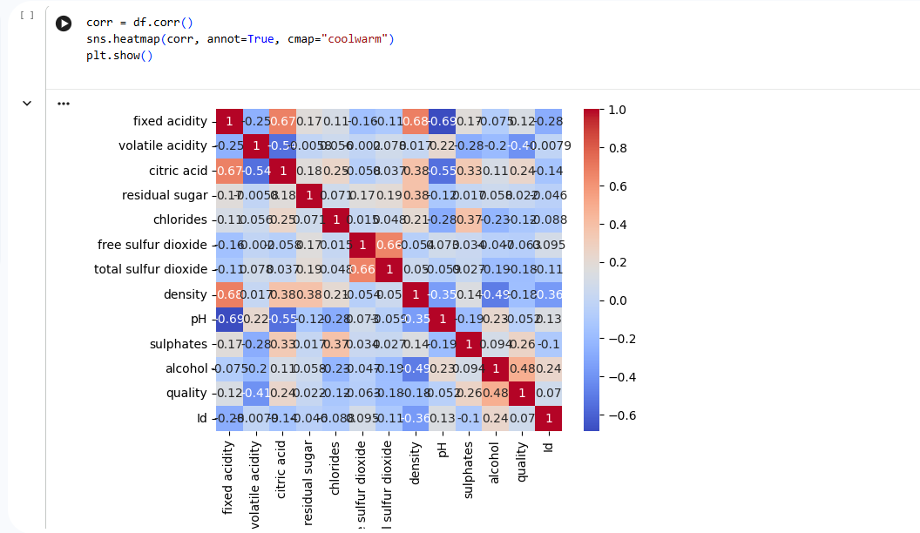
corr = df.corr()
sns.heatmap(corr, annot=True, cmap="coolwarm")
plt.show()

df.corr() Calculates the correlation matrix for all numeric columns in the DataFrame df.
- Correlation values range from -1 to +1.
- +1 = perfect positive correlation (variables move together).
- -1 = perfect negative correlation (variables move in opposite directions).
- 0 = no linear relationship.
sns.heatmap(corr, annot=True, cmap="coolwarm")
- Creates a heatmap of the correlation matrix.
- annot=True → displays the actual correlation values inside each cell.
- cmap="coolwarm" → uses red for strong positive correlations and blue for strong negative correlations.
plt.show() Displays the heatmap.

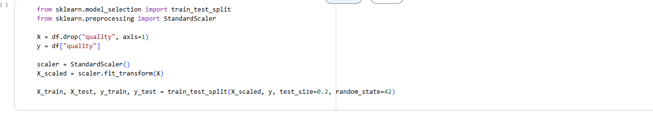
from sklearn.model_selection import train_test_split
from sklearn.preprocessing import StandardScaler

X = df.drop("quality", axis=1)
y = df["quality"]

scaler = StandardScaler()
X_scaled = scaler.fit_transform(X)

X_train, X_test, y_train, y_test = train_test_split(X_scaled, y, test_size=0.2, random_state=42)

X = df.drop("quality", axis=1) Creates the feature matrix X by dropping the target column quality. All other columns (chemical properties) are predictors.
y = df["quality"] Defines the target variable y (wine quality score).
StandardScaler() Standardizes features so each has mean = 0 and standard deviation = 1. This prevents features with large ranges (like sulphates or alcohol) from dominating the model.
X_scaled = scaler.fit_transform(X) Applies scaling to all features.
train_test_split(...) Splits the dataset into:
- Training set (80%) → used to train the model.
- Testing set (20%) → used to evaluate performance

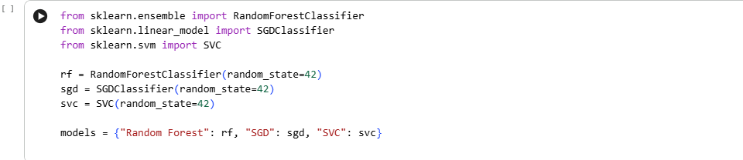
from sklearn.ensemble import RandomForestClassifier
from sklearn.linear_model import SGDClassifier
from sklearn.svm import SVC

rf = RandomForestClassifier(random_state=42)
sgd = SGDClassifier(random_state=42)
svc = SVC(random_state=42)

models = {"Random Forest": rf, "SGD": sgd, "SVC": svc}

Imports:
- RandomForestClassifier → An ensemble model that builds multiple decision trees and averages their predictions.
- SGDClassifier → A linear model trained with stochastic gradient descent, good for large datasets.
- SVC → Support Vector Classifier, powerful for classification with clear margins between classes.
Initialization:
- Each model is created with random_state=42 for reproducibility.
- No hyperparameters are tuned yet — you’re starting with defaults.
Dictionary models:
- Stores all classifiers in one place.
- Makes it easy to loop through them for training and evaluation.

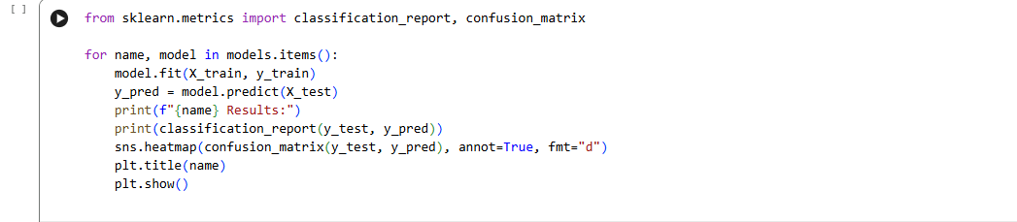

from sklearn.metrics import classification_report, confusion_matrix

for name, model in models.items():
model.fit(X_train, y_train)
y_pred = model.predict(X_test)
print(f"{name} Results:")
print(classification_report(y_test, y_pred))
sns.heatmap(confusion_matrix(y_test, y_pred), annot=True, fmt="d")
plt.title(name)
plt.show()

classification_report Prints precision, recall, F1-score, and support (number of samples) for each class of wine quality.
- Precision → Of the wines predicted as a certain quality, how many were correct.
- Recall → Of the wines that truly belong to a certain quality, how many were correctly identified.
- F1-score → Harmonic mean of precision and recall (balances both).
confusion_matrix Shows how predictions compare to actual values:
- Rows = actual wine quality.
- Columns = predicted wine quality.
- Diagonal values = correct predictions.
- Off-diagonal values = misclassifications.
Loop through models
- Trains each classifier (Random Forest, SGD, SVC).
- Generates predictions (y_pred).
- Prints evaluation metrics.
- Visualizes confusion matrix with Seaborn heatmap.

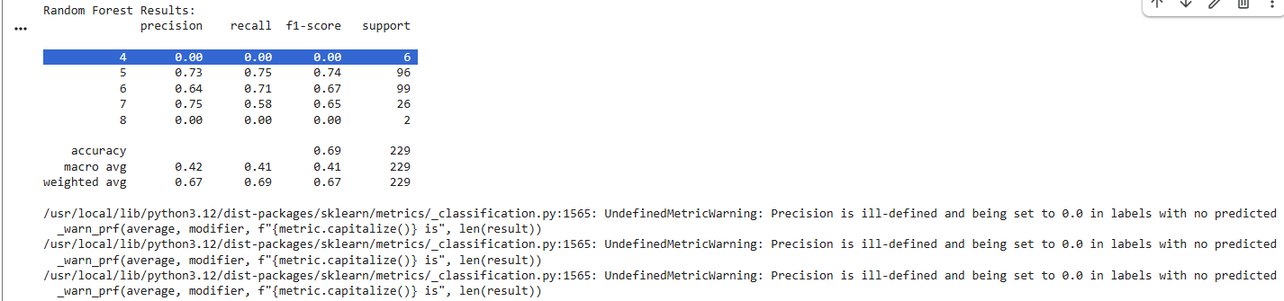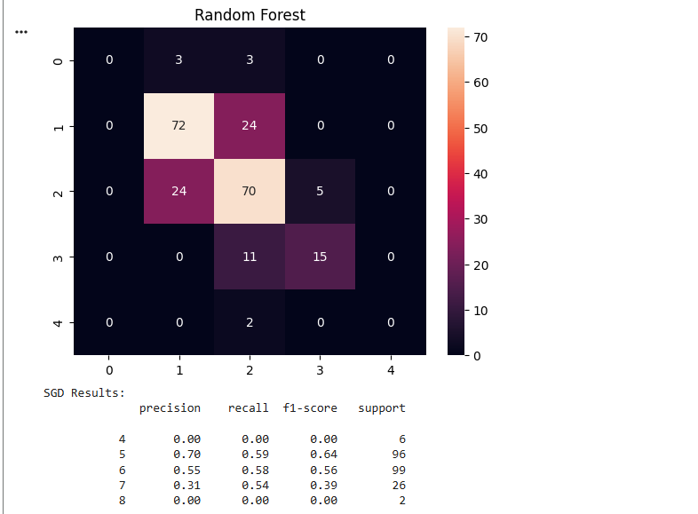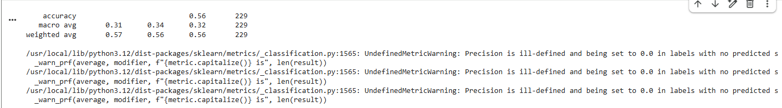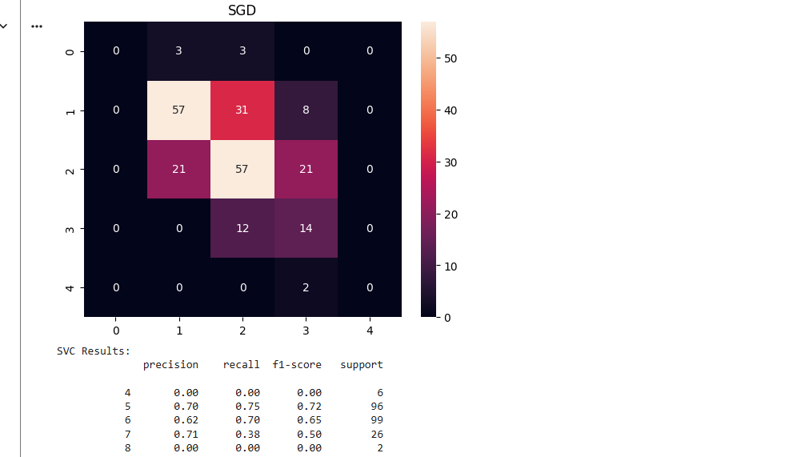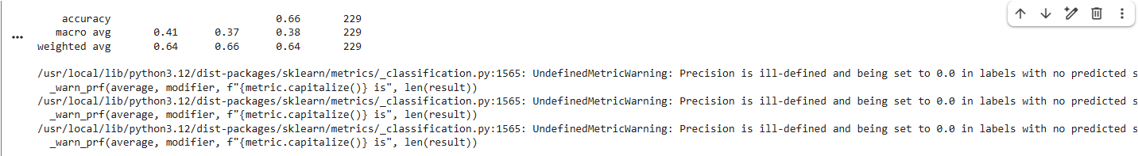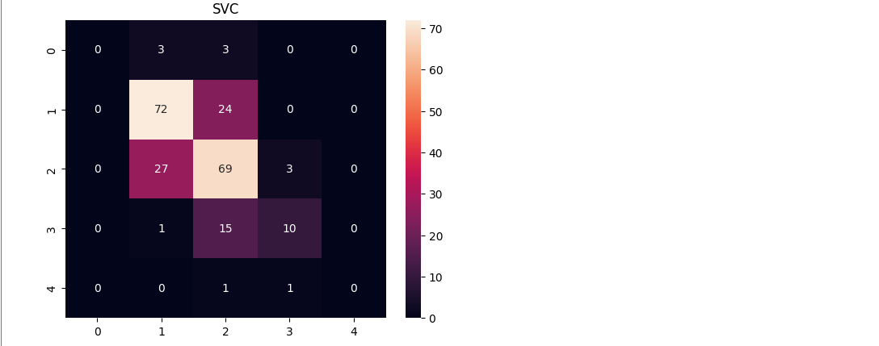

import numpy as np

importances = rf.feature_importances_
indices = np.argsort(importances)[::-1]

plt.figure(figsize=(10,6))
plt.bar(range(X.shape[1]), importances[indices])
plt.xticks(range(X.shape[1]), X.columns[indices], rotation=90)
plt.title("Feature Importance (Random Forest)")
plt.show()
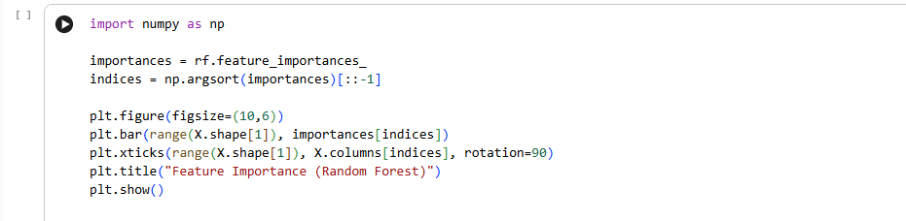

X = df.drop("quality", axis=1) Creates the feature matrix X by dropping the target column quality. All other columns (chemical properties) are predictors.
y = df["quality"] Defines the target variable y (wine quality score).
StandardScaler() Standardizes features so each has mean = 0 and standard deviation = 1. This prevents features with large ranges (like sulphates or alcohol) from dominating the model.
X_scaled = scaler.fit_transform(X) Applies scaling to all features.
train_test_split(...) Splits the dataset into:
- Training set (80%) → used to train the model.
- Testing set (20%) → used to evaluate performance.
- random_state=42 ensures reproducibility.

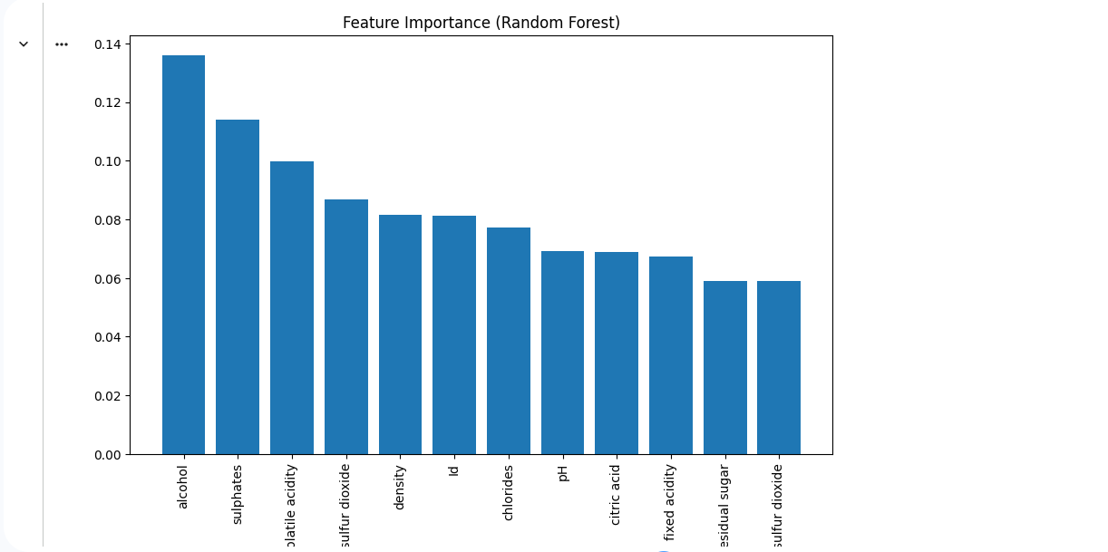

🍷 Wine Quality Prediction
📖 Overview
This project analyzes the WineQT dataset, which contains physicochemical properties of wine samples along with their quality ratings. The goal is to build machine learning models that can predict wine quality based on chemical attributes, and to identify which features most influence wine quality.
📂 Dataset
- File: WineQT.csv
- Size: 1143 rows × 13 columns
- Features include:
  - Chemical properties: fixed acidity, volatile acidity, citric acid, residual sugar, chlorides, density, pH, sulphates, alcohol
  - Sulfur dioxide levels: free sulfur dioxide, total sulfur dioxide
  - Target variable: quality (wine quality score, typically 3–8)
  - Id: unique identifier
🛠 Tools & Libraries
- Python
- Pandas, NumPy → Data cleaning & manipulation
- Matplotlib, Seaborn → Visualization
- Scikit-learn → Preprocessing, classification models, evaluation metrics
- Jupyter Notebook → Interactive analysis
🪜 Methodology
- Data preparation
  - Check for missing values (heatmap, .isnull().sum())
  - Remove duplicates
  - Scale features using StandardScaler
- Exploratory analysis
  - Descriptive statistics (df.describe())
  - Correlation heatmap to identify relationships with quality
  - Distribution plots for alcohol, acidity, sulphates
- Model training
  - Split data into training (80%) and testing (20%)
  - Train multiple classifiers: Random Forest, SVC, SGD
  - Evaluate with accuracy, precision, recall, F1-score
- Model evaluation
  - Classification reports for each model
  - Confusion matrices (heatmaps) to visualize predictions
  - Compare model performance
- Feature importance
  - Extract feature importances from Random Forest
  - Visualize top predictors of wine quality
📊 Results
- Best model: Random Forest achieved the highest accuracy and balanced performance across classes.
- Key predictors of wine quality:
  - Alcohol → Strong positive correlation with quality
  - Volatile acidity → Negative correlation (higher acidity lowers quality)
  - Sulphates & Citric Acid → Moderate positive influence
- Confusion matrices: Showed most misclassifications between adjacent quality scores (e.g., 5 vs 6).
🎯 Learning Outcomes
- Hands-on experience with classification models (Random Forest, SVC, SGD).
- Practical application of EDA, preprocessing, and feature scaling.
- Ability to interpret feature importance for actionable insights.
- Strengthened skills in model evaluation and visualization.

